Archlinux系统环境配置

1. add users
2. 新增用户：

$useradd-m -s /bin/bash hexu

1. 安装sudo，root用户授权

$pacman-S sudo

1. 修改sudo配置文件

$vi /etc/sudoers



1. net-tools (ifconfig& route)

安装net-tools

$pacman-S net-tools

PS：ifconfig,route在net-tools中，nslookup,dig在dnsutils中，ftp,telnet等在inetutils中,ip命令在iproute2中。

1. sshd
2. 安装sshd

$ pacman -S openssh

1. 启动sshd

$ systemctl start sshd

1. 开机启动sshd

$ systemctl enable sshd

1. ssh允许root用户登录

$ vi /etc/ssh/sshd\_config

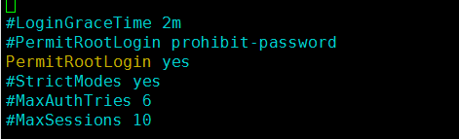

将PermitRootLogin值改yes

1. vim
2. 安装vim

$ pacman -S vim

1. 配置.vimrc

$ cp /usr/share/vim/vim74/vimrc\_example.vim .vimrc

1. 设置Tab键宽度4个字符

settabstop=4

C:\Documents and Settings\Administrator\Application Data\Tencent\Users\783997762\QQ\WinTemp\RichOle\{2(@J17$}(MJRDD3_5L7ACJ.png

1. 设置统一缩进为4

set softtabstop=4

set shiftwidth=4



1. 不用空格扩展制表符

set noexpandtab

C:\Documents and Settings\Administrator\Application Data\Tencent\Users\783997762\QQ\WinTemp\RichOle\[X_~]~KC{PC{4~DP3LJE78K.png

1. 颜色配置

colorscheme desert

(colorschemer on)

C:\Documents and Settings\Administrator\Application Data\Tencent\Users\783997762\QQ\WinTemp\RichOle\OQ7L`I55OKBNM590Q{4($03.png

1. 编码设置

set encoding=utf-8

set termencoding=utf-8

set fileencodings=utf-8,gb18030,gbk,gb2312,cp936

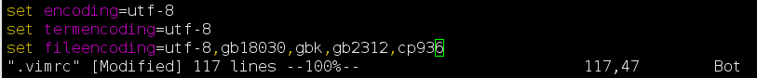

1. mysql
2. 安装mysqld
3. $ pacman -S mariadb

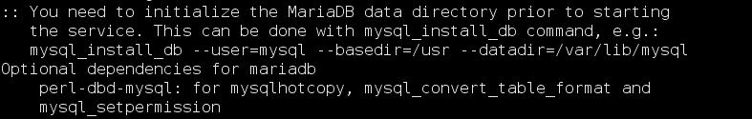

1. 初始化数据库

$ mysql\_install\_db --user=mysql --basedir=/usr --datadir=/var/lib/mysql

C:\Documents and Settings\Administrator\Application Data\Tencent\Users\783997762\QQ\WinTemp\RichOle\BQH4MNNX%9H3(EHQZ]P%]88.png

1. 启动mysqld

$ systemctl start mysqld

1. 开机启动mysqld

$ systemctl enable mysqld

1. boost

安装boost

$ pacman -S boost

1. thrift

安装thrift

$ pacman -S thrift

1. bc

安装bc

$ pacman -S bc

1. cvs

安装cvs

$ pacman -S cvs

1. wget

安装wget

$ pacman -S wget

1. date

设置系统时间

$ date -s YYYYMMDD

$ date -s hh:mm:ss

1. gtest

安装gtest

$ pacman -S gtest

1. crontab
2. 安装cronie

$ pacman -S cronie

1. 启动cronie.service

$ systemctl start cronie.service

1. 开机自启动

$ systemctl enable cronie.service

1. profile

$ vim~/.bash\_profile

set -o vi

export CVSROOT=~/hx\_cvs



1. ntpdate
2. 同步时间：

$ ntpdate s1a.time.edu.cn

1. 开机自动同步时间

$ vim/usr/lib/systemd/system/ntpdate.service

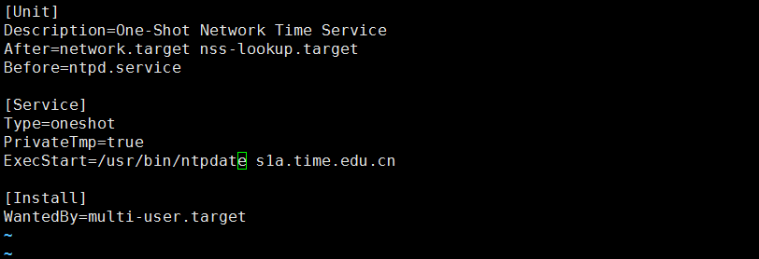

$ systemctl enable ntpdate.service

1. bash- completion：

$ pacman -S bash- completion

$ vim .bashrc

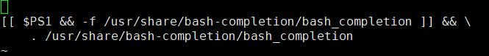

1. 更新安装秘钥

$ sudo pacman -Sy archlinux-keyring

1. 安装yaourt

$ sudo pacman -S --needed base-devel git wget yajl

$ cd /tmp

$ git clone https://aur.archlinux.org/package-query.git

$ cd package-query/

$ makepkg -si && cd /tmp/

$ git clone https://aur.archlinux.org/yaourt.git

$ cd yaourt/

$ makepkg -si

4．

5．

6．

7．

8.

9.

10.

11.

12.

13.

14.

15. staticip

配置静态IP

$ ifconfig enp0s9 192.168.0.99 netmask 255.255.255.0

开机启动生效

$ cp/etc/netctl/examples/ethernet-custom /etc/netctl/ethernet-custom

$ vim /etc/netctl/ethernet-custom

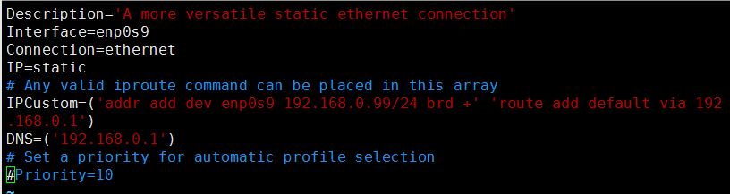

$ netctl enable ethernet-custom

16. bash-completion

$ pacman -S bash-completion

$ vim ~/.bash\_profile

增加

[[ $PS1 && -f /usr/share/bash-completion/bash\_completion ]] && \

. /usr/share/bash-completion/bash\_completion

C:\Users\aa\AppData\Roaming\Tencent\Users\783997762\QQ\WinTemp\RichOle\KIZF9IZ5B5[~EWAZ}4LY2J0.png

17. 防火墙

$ systemctl status iptables.service

$ systemctl start iptables.service

$ systemctl stop iptables.service

$ systemctl enable iptables.service

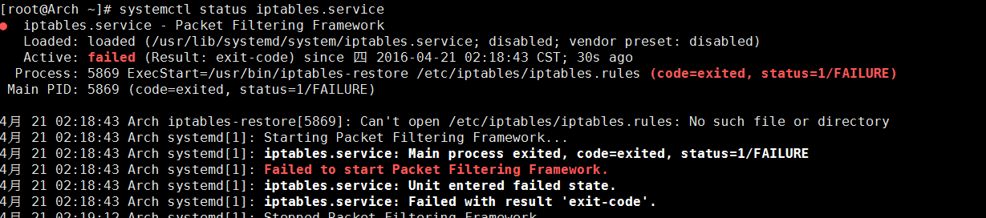

如果启动失败，且原因如上图，cp /etc/iptables/empty.rules /etc/iptables/iptables.rules

通过iptables增加或删除防火墙规则，例如：

iptables -A INPUT -s 192.168.1.54 -d 192.168.1.54 -p tcp --dport 9999 -j REJECT --reject-with tcp-reset