1. 查看系统内存

1.1）free

# free



# free -h



1.2）top

# top

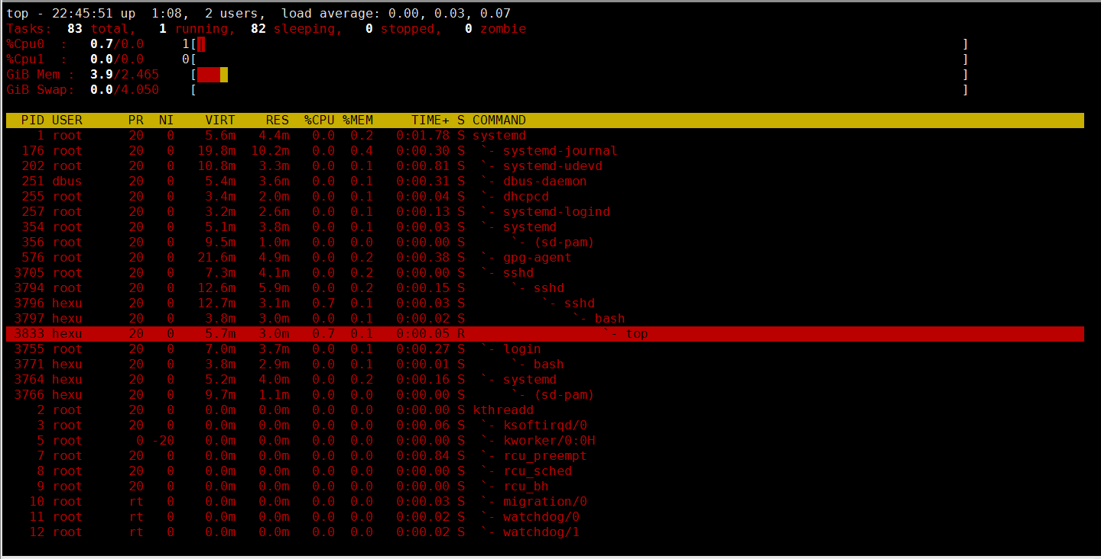

1.3）/proc/meminfo

# cat /proc/meminfo

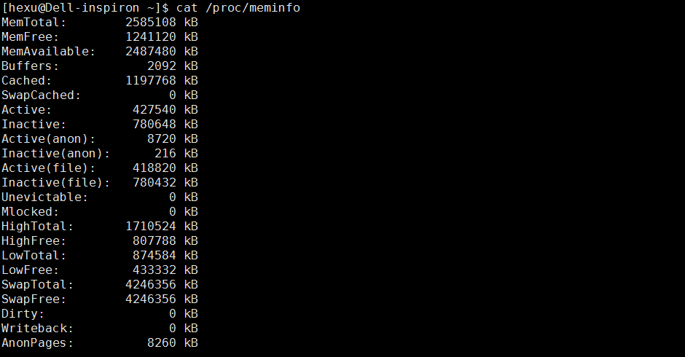

2）查看磁盘

2.1）df

# df -h

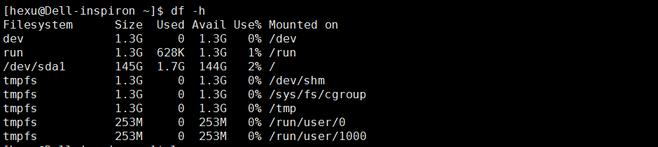

2.2）du

# du -sh

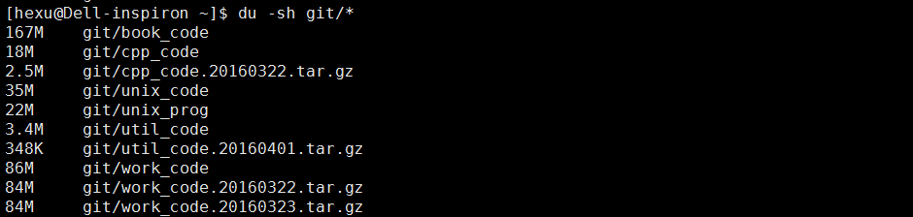

3）查看CPU

2.1）top

# top



2.2）/proc/cpuinfo

# cat /prov/cpuinfo

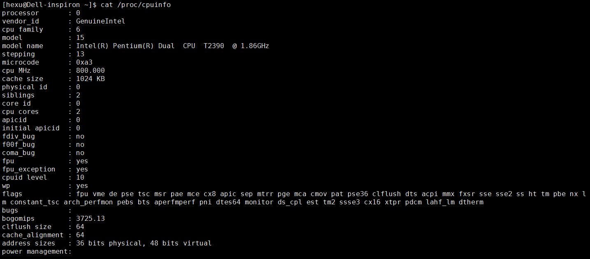

2.3）uptime

# uptime

C:\Users\Administrator\AppData\Roaming\Tencent\Users\783997762\QQ\WinTemp\RichOle\KK0LDS(G[V@C[PV23A$H}7G.png