1．登录mysql

不指定db

# mysql –u root

指定mysql db

# mysql –u root mysql

2．查看mysql版本

# mysqladmin -u root version

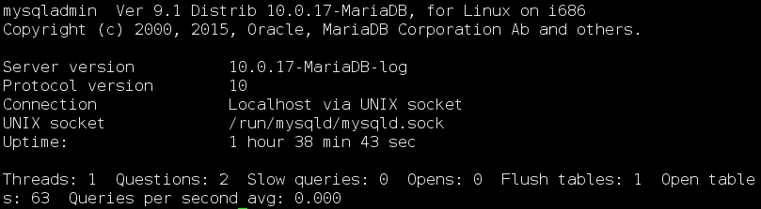

3．切换数据库

> use mysql;

4．查看用户信息

> select host, user, password from user;

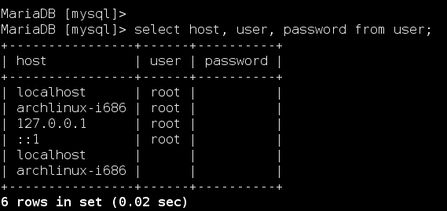

5．创建用户账号

> create user hexu identified by ‘123456’;

6. 重命名用户账号

> rename user hexu to hex;

7. 删除用户账号

> drop user hex;

8. 查看用户账号权限

> show grants for hexu;

8. 授权用户账号

> grant all on *.* to hexu@localhost identified by '123456';