DITHERTRON
by Tom Hargreaves (@hexwab)

This is a fork of 8-Bit Workshop's Dithertron tool. Take a mugshot with the laptop’s webcam, dither it and send it as audio through the headphone jack to the BBC’s cassette port!

Instructions
- Take photo
- Select crop region
- Choose screen mode
- Adjust brightness, contrast etc.
- Send!

Click “Finished!” to go back to the start when you’re done.

Recommended settings are MODE 1, "Perceptual" colour and “Stucki” dithering (but feel free to experiment!).

BBC Master (1986)
- Upgraded BBC Micro
- 65SC12 (6502 variant) at 2MHz
- 128KiB DRAM
- 2MiB/sec video bandwidth
- 8-colour palette (one bit for red, green, and blue, same as teletext)
- Standard video resolutions 640×256@1bpp, 320×256@2bpp, 160×256@4bpp (but you can overscan it!)
- Cassette interface running at 1200 baud (but you can overclock it!)

Online gallery
While your picture is transferring you’ll get a QR code with a link to the gallery. Or head to https://sphere.chronosempire.org.uk/~HEx/tetley/ and look for your picture ID.

Load up pictures on your own vintage hardware or try the in-browser emulator JSBeeb, written by Matt “Compiler Explorer” Godbolt.

TECH PAGE :)

Screen modes
The Beeb’s custom video chip can read 832 bits per scanline. Normally only 640 are used to ensure no information gets lost off the sides of the screen but here we use all 832, filling the screen right to the edge! They can be displayed as 832 pixels with one bit each (MODE 0), 416 pixels with two bits each (MODE 1), or 208 pixels with four bits each (MODE 2; one bit goes unused), so you get to choose high resolution or lots of colours but not both. We also use 288 lines instead of 256: this is the maximum possible overscan.

Compression
Pictures are compressed using Magnus Lind’s Exomizer. It uses LZ77, the same algorithm used in Zip files, and typically squeezes 29¼KiB bitmaps (832×288 bits) down to 10-20 KiB depending on detail. The more detailed your picture the longer it’ll take to transfer.

Tape overclocking
The audio format is a variant of the 1975 Kansas City Standard, normally running at 1200 baud (120 bytes/sec). Ones and zeros are represented using high and low tones, a form of frequency-shift keying. The Beeb times the zero crossings to distinguish between the two tones.
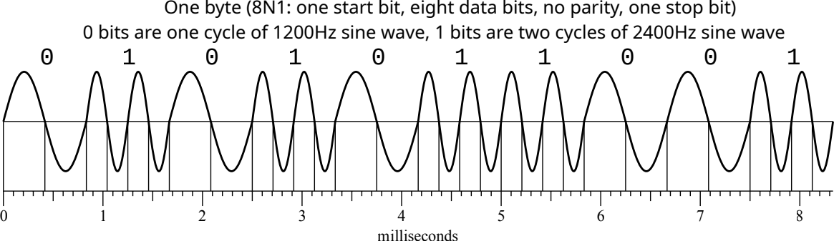
If you want to push the boundaries you can use higher frequencies to increase the data rate and decrease loading time! Up to a point. Loading time is displayed on the audio seek bar at the bottom of the screen: how fast can you go?

The Beeb’s screen turns magenta if it detects something awry and has given up on loading this image.

