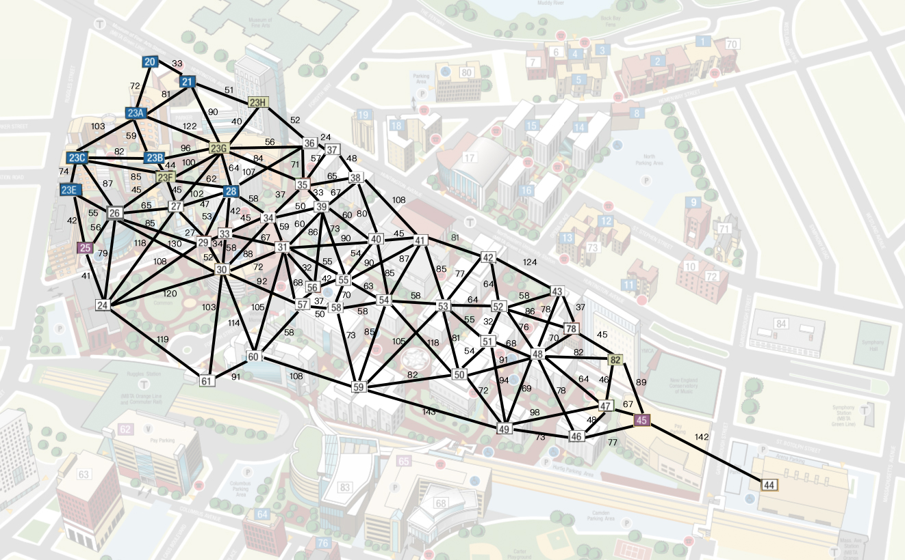**The drawing of the undirected graph:**

**First sample: From 61 to 52**

Running result:

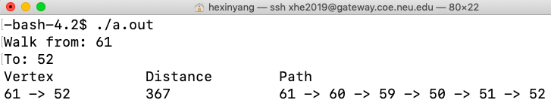

Shortest path in my graph:

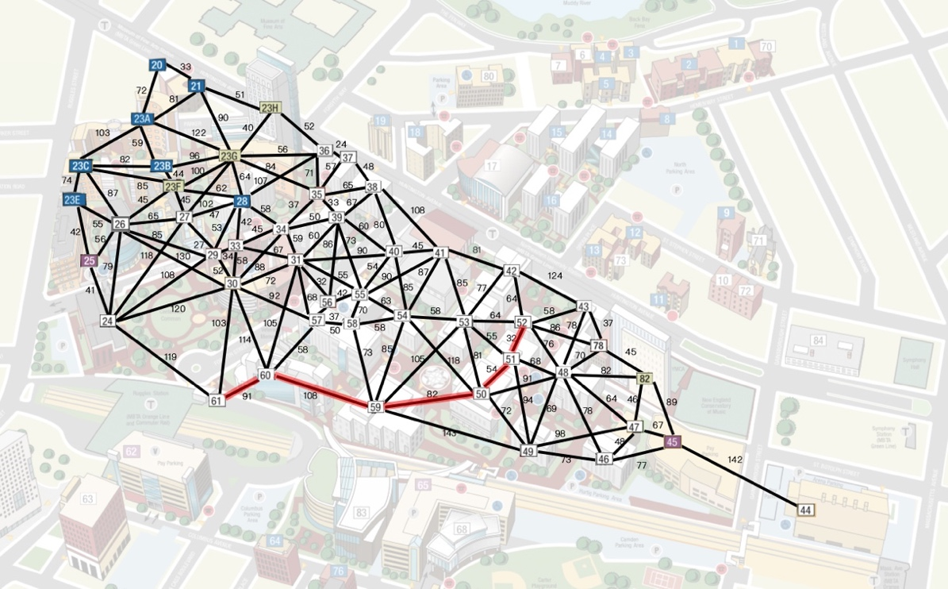

Shortest path in google map direction:

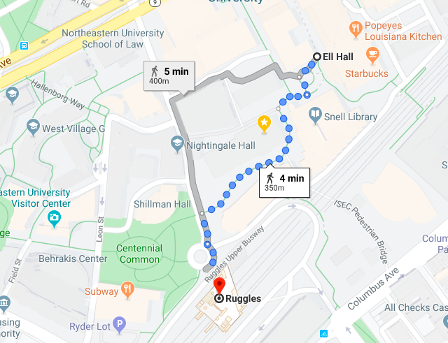

**Second sample: From 23H to 82**

Running result:

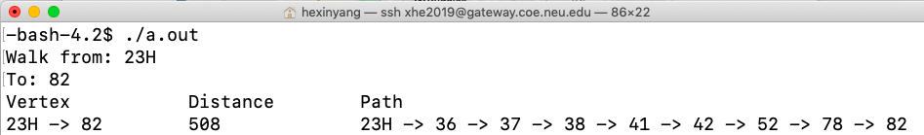

Shortest path in my graph:

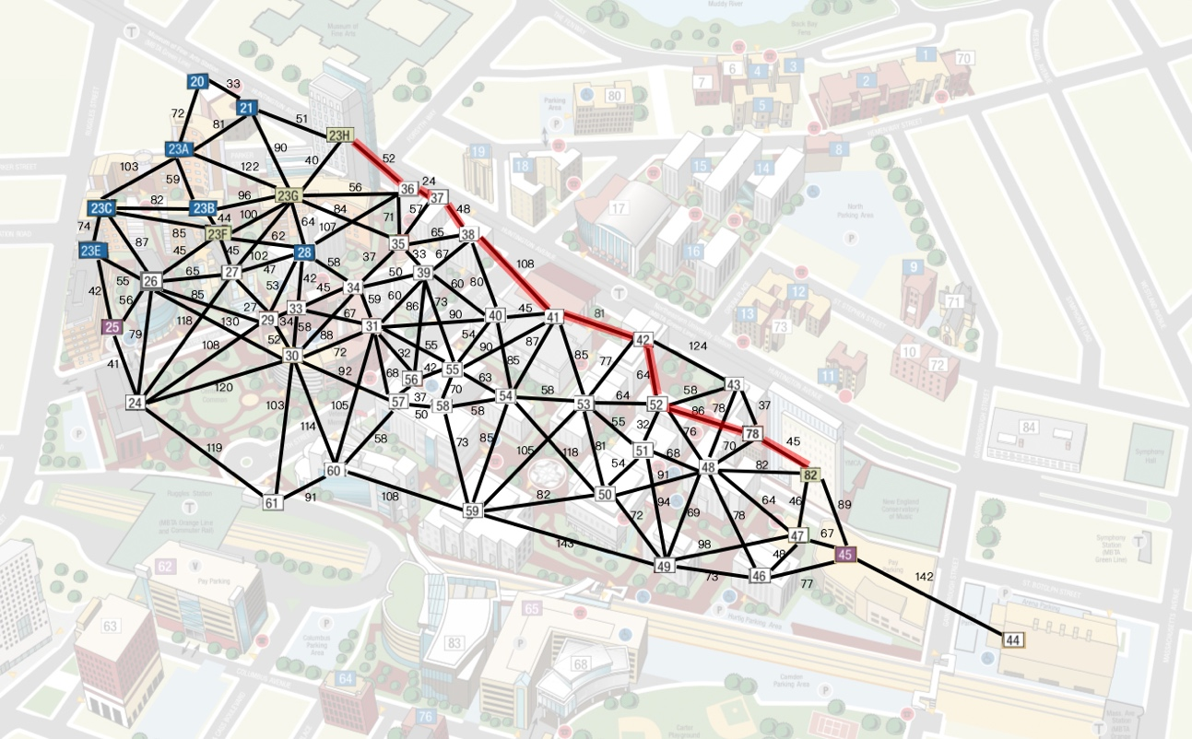

Shortest path in google map direction:

