**Project Report On**

**Student Management System (UCS310)**



**Submitted By:**

|  |  |
| --- | --- |
| **DEV SATIJA** | **102116036** |
| **DEEPANSHU THAKUR** | **102296003** |
| **SAMRIDHI WADHWA** | **102116060** |
| **SUKHMANDEEP BRAR** | **102116056** |

# 

# Submitted to:

**Dr Manisha Kaushal**

# INDEX

|  |  |
| --- | --- |
| **CONTENTS** | **PAGENUMBER** |
| Problem Statement | 3 |
| ER Diagram | 3 |
| ER Diagram to Table | 4 |
| Normalized Tables | 5 |
| Creating tables | 5 |
| Insertion of data in the tables | 7 |
| SQL Output Screenshots | 13 |
| PL/SQL Codes and screenshots | 16 |

# Problem Statement

To develop a system that can efficiently and accurately identify students by their facial features and retrieve their academic and personal information from a database. The system should be able to capture and store the images of students, as well as their personal and academic data, in a secure and organized manner.

# Entity-Relationship Diagram

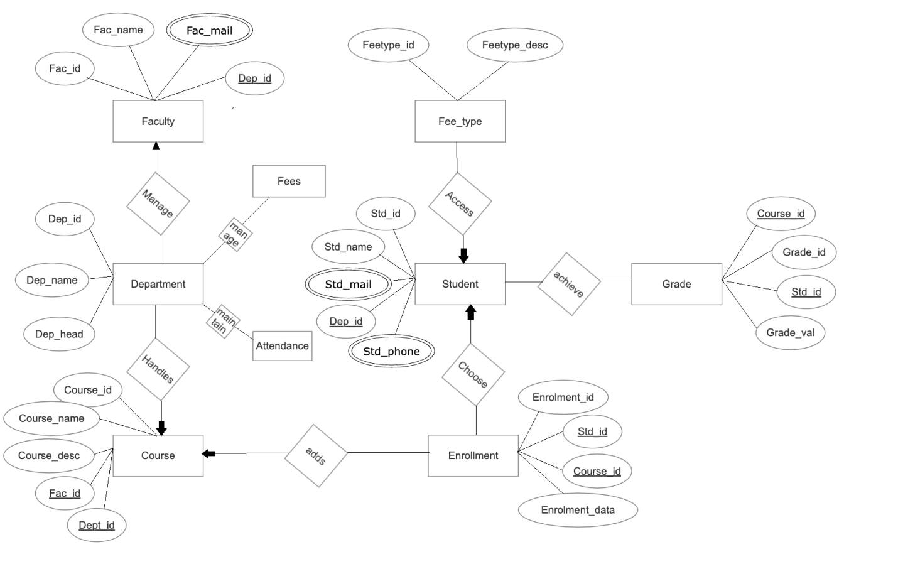

**Normalized Table**

department: department_id -> department_name, department_head

student: student_id -> student_name, student_email, student_phone, department_id

faculty: faculty_id -> faculty_name, faculty_email, department_id

course: course_id -> course_name, course_description, faculty_id, department_id

enrollment: enrollment_id -> student_id, course_id, enrollment_date

attendance: attendance_id -> student_id, course_id, attendance_date, attendance_status

grade: grade_id -> student_id, course_id, grade_value

fee_type: fee_type_id -> fee_type_description

fees: fee_id -> student_id, fee_type_id, fee_amount, fee_date

# ER TO TABLE

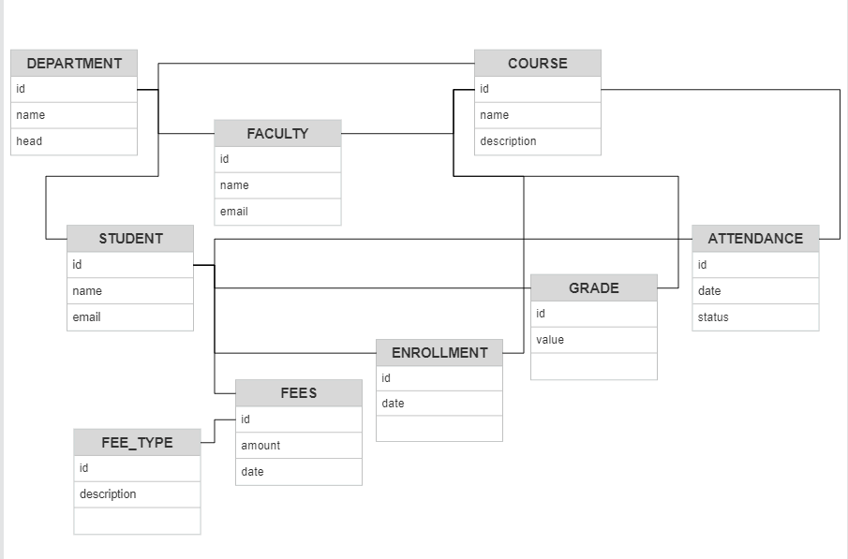

**Creating Table**

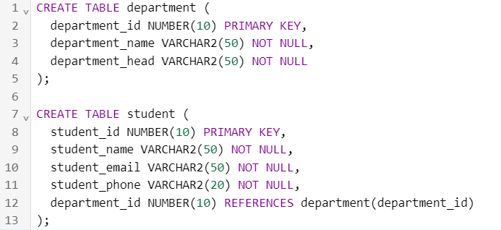

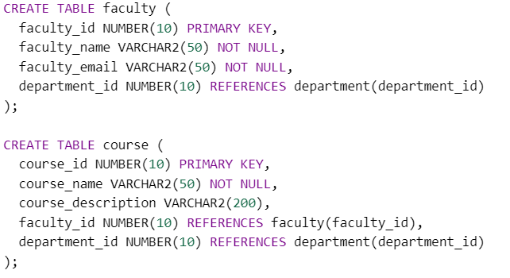

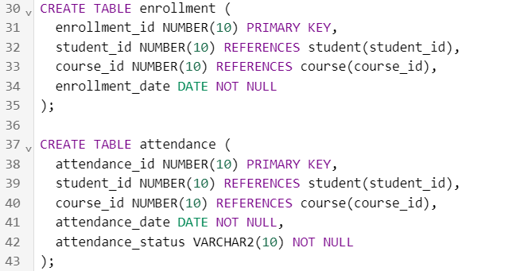

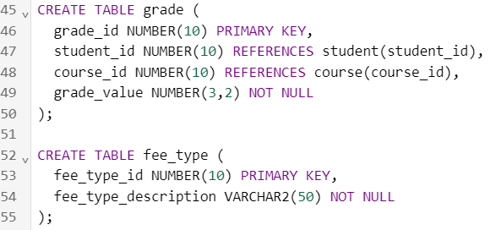

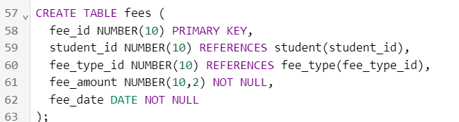

# SQL Output Screenshots

Table-1

COURSE

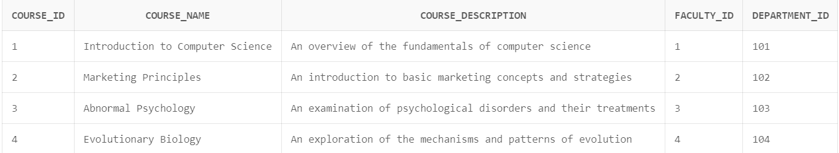

Table-2

DEPARTMENT

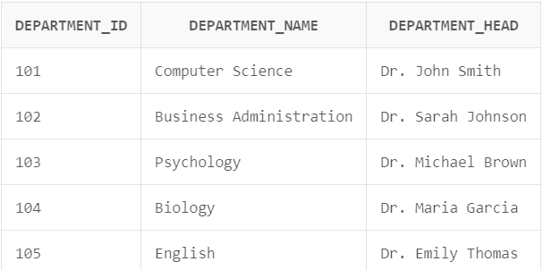

Table-3

STUDENT

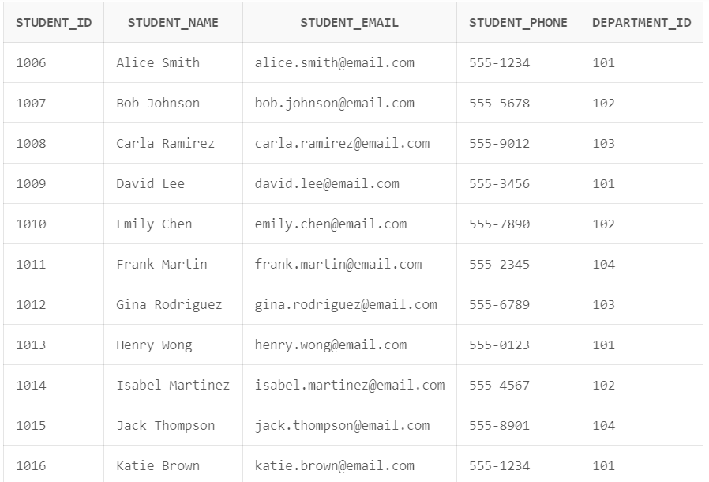

TABLE-4

FACULTY

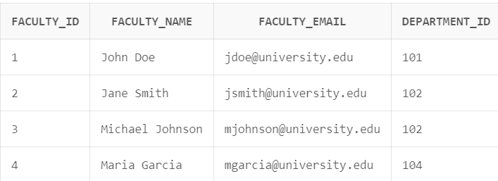

TABLE-5

FEE

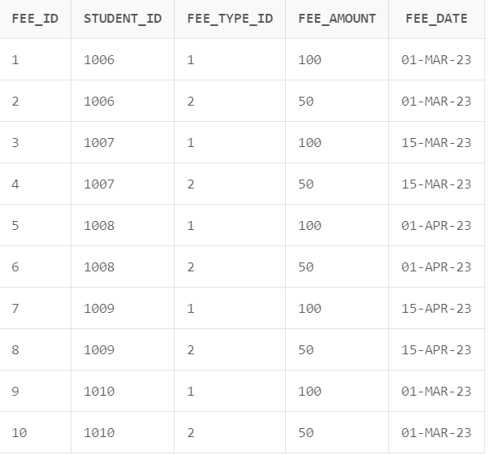

TABLE-6

FEE TYPE

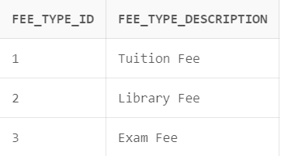

TABLE-7

ENROLLMENT

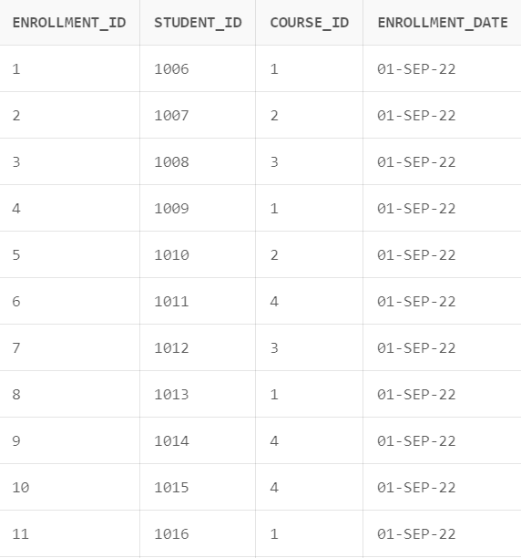

TABLE-8

GRADE

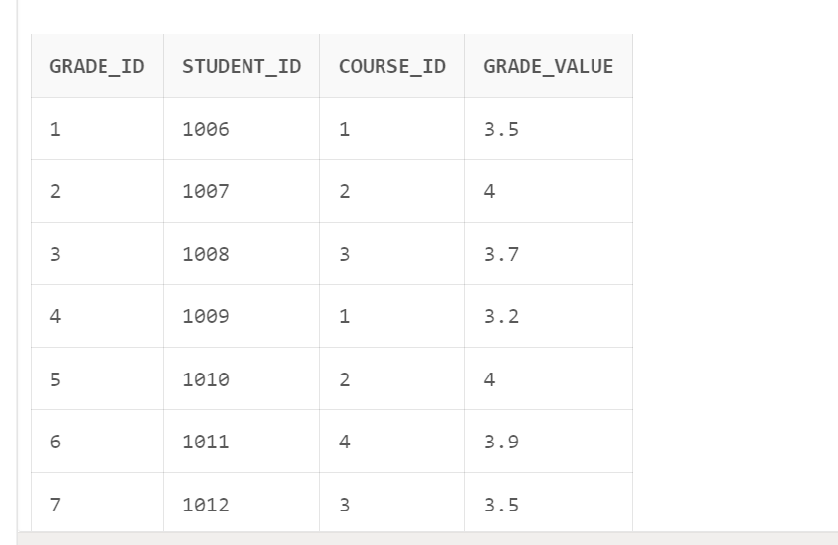

**PL/SQL Codes and Screenshots**

1.TRIGGER-

CREATE TABLE student (

student_id NUMBER(10) PRIMARY KEY,

student_name VARCHAR2(50) NOT NULL,

student_email VARCHAR2(50) NOT NULL,

student_phone VARCHAR2(20) NOT NULL,

department_id NUMBER(10) REFERENCES department(department_id)

);

CREATE OR REPLACE TRIGGER trg_student_name_capitalized

BEFORE INSERT OR UPDATE ON student

FOR EACH ROW

BEGIN

:new.student_name := INITCAP(:new.student_name);

END;

INSERT INTO student (student_id, student_name, student_email, student_phone, department_id)

VALUES (1006, 'Alice Smith', 'alice.smith@email.com', '555-1234', 101);

INSERT INTO student (student_id, student_name, student_email, student_phone, department_id)

VALUES (1007, 'Bob Johnson', 'bob.johnson@email.com', '555-5678', 102);

INSERT INTO student (student_id, student_name, student_email, student_phone, department_id)

VALUES (1008, 'Carla Ramirez', 'carla.ramirez@email.com', '555-9012', 103);

INSERT INTO student (student_id, student_name, student_email, student_phone, department_id)

VALUES (1009, 'David Lee', 'david.lee@email.com', '555-3456', 101);

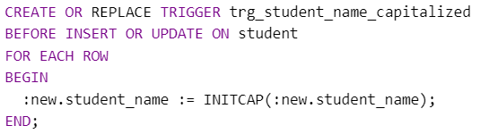

**OUTPUT-**

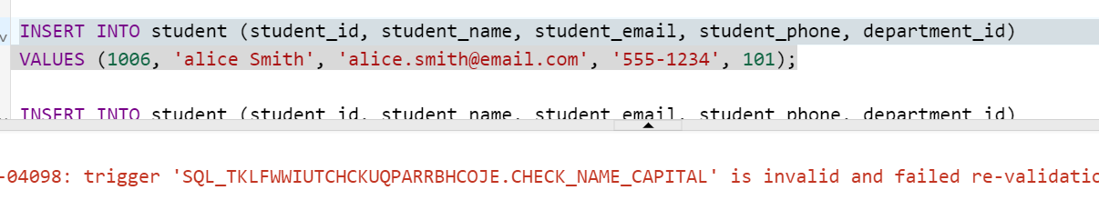

**2.PROCEDURE-**

CREATE OR REPLACE PROCEDURE get_course_grades(

course_id IN NUMBER,

grades OUT SYS_REFCURSOR

)

AS

BEGIN

OPEN grades FOR

SELECT *

FROM grade

WHERE course_id = course_id;

END;

**OUTPUT-**

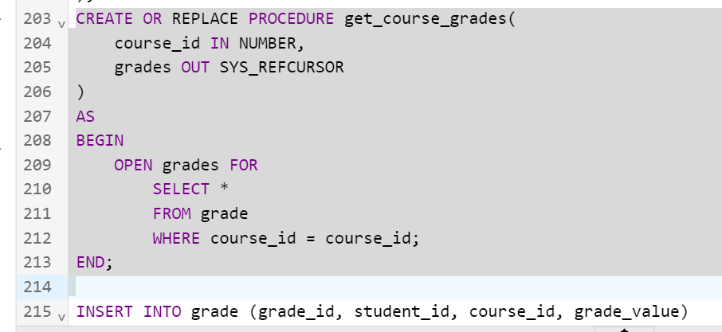

**3.EXCEPTION-**

**BEGIN**

**INSERT INTO department (department_id, department_name, department_head)**

**VALUES (106, 'Mathematics', 'Dr. William Brown');**

**EXCEPTION**

**WHEN DUP_VAL_ON_INDEX THEN**

**DBMS_OUTPUT.PUT_LINE('Error: Department ID 106 already exists.');**

**END;**

**OUTPUT-**

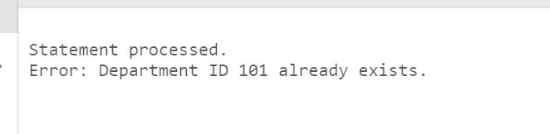

**4.CURSOR-**

**DECLARE**

**CURSOR dept_faculty_cursor IS**

**SELECT d.department_name, f.faculty_name**

**FROM department d**

**INNER JOIN faculty f ON d.department_id = f.department_id**

**ORDER BY d.department_name;**

**dept_name department.department_name%TYPE;**

**faculty_name faculty.faculty_name%TYPE;**

**BEGIN**

**OPEN dept_faculty_cursor;**

**LOOP**

**FETCH dept_faculty_cursor INTO dept_name, faculty_name;**

**EXIT WHEN dept_faculty_cursor%NOTFOUND;**

**DBMS_OUTPUT.PUT_LINE('Department: ' || dept_name || ', Faculty: ' || faculty_name);**

**END LOOP;**

**CLOSE dept_faculty_cursor;**

**END;**

**OUTPUT-**

