**Some Important C++ Program Using Recursive Function**

1. 1. Calculate x^n using Recursion - 2 -
2. 2. Sum of N Natural Numbers using Recursion - 3 -
3. 3. GCD of Two Numbers using Recursion - 4 -
4. 4. Factorial of a Number using Recursion - 6 -
5. 5. Fibonacci series using recursion and normal - 7 -
6. 6. Print 1 to N using Recursion - 9 -
7. 7. Print n to 1 using Recursion - 10 -

***֎***

***֎֎***

***֎֎֎***

***֎֎֎֎***

***֎֎֎֎֎֎***

# **Calculate x^n using Recursion**

**#include<iostream>**

**using namespace std;**

**int main()**

**{**

**int x,n;**

**long int power(int,int),result;**

**cout<<"Enter Base : ";**

**cin>>x;**

**cout<<"Enter Power : ";**

**cin>>n;**

**result = power(x,n);**

**cout<<"\n The "<<x<<"^"<<n<<" is : "<<result<<endl;**

**}**

**long int power(int x,int n){**

**if(n==0)**

**return 1;**

**else**

**return (x*power(x,n-1));**

**}**

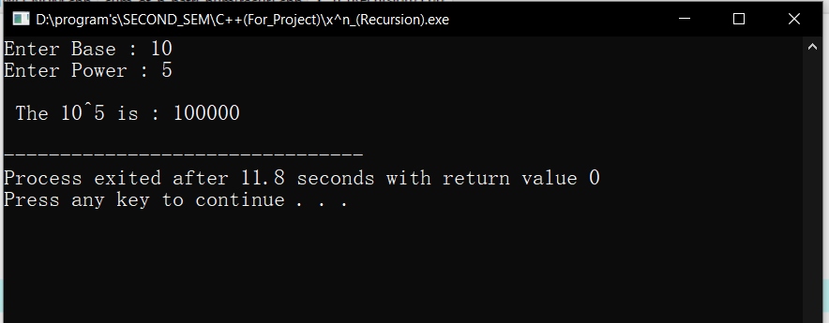

# **Sum of N Natural Numbers using Recursion**

**#include<iostream>**

**using namespace std;**

**int main(){**

**int n,sum(int);**

**cout<<"Enter N: ";**

**cin>>n;**

**cout<<"\n The Sum of Natural Number up to "<<n<<" is :"<<sum(n)<<endl;**

**}**

**int sum(int n){**

**if(n==1)**

**return 1;**

**else**

**return (n+sum(n-1));**

**}**

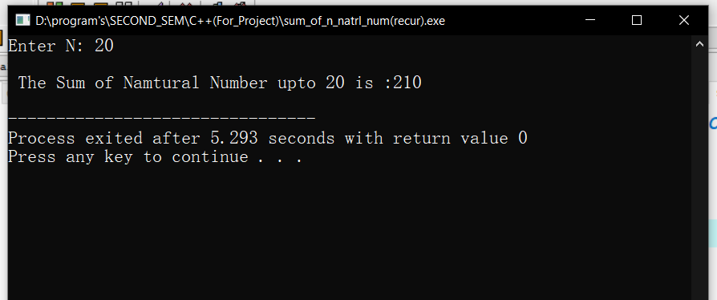

# **GCD of Two Numbers using Recursion**

**#include<iostream>**

**using namespace std;**

**int main(){**

**int a,b;**

**int GCD(int,int),result;**

**cout<<"Enter A : ";**

**cin>>a;**

**cout<<"Enter B : ";**

**cin>>b;**

**result = GCD(a,b);**

**cout<<"\n GCD of "<<a<<" and "<<b<<" is :"<<result<<endl;**

**}**

**int GCD(int a, int b){**

**if(b==0)**

**return a;**

**else**

**return (GCD(b,a%b));**

**}**

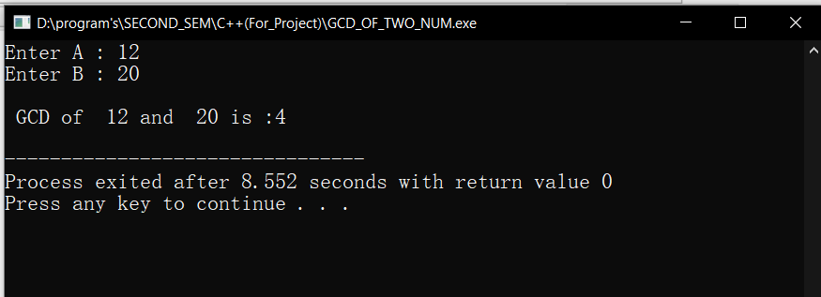

# **Factorial of a Number using Recursion**

**#include<iostream>**

**using namespace std;**

**int main(){**

**int n;**

**long int fact(int);**

**cout<<" Enter N : ";**

**cin>>n;**

**cout<<" \n The factorial of "<<n<<" is :"<<fact(n)<<endl;**

**}**

**long int fact(int n)**

**{**

**if(n==0)**

**return 1;**

**else**

**return (n*fact(n-1));**

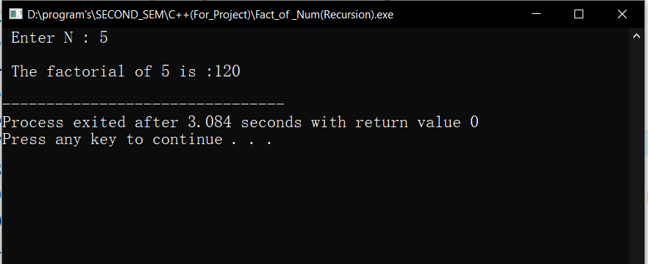**}**

# **Fibonacci series using recursion and normal**

**#include<iostream>**

**using namespace std;**

**//Using Recursion up to given term -->fibo(n) = fibo(n-1)+fibo(n-2) | tail Point-->n=0,o-->n=1,1**

**int main(){**

**int n,i=0,c=0;**

**int fibo(int);**

**system("cls");**

**cout<<"N =";cin>>n;**

**cout<<"Fibonacci Series :"<<endl;**

**for(i=1;i<=n;i++){**

**cout<<fibo(c++)<<" ";**

**}**

**return 0;**

**}**

**int fibo(int n){**

**if(n==0)**

**return 0;**

**else if (n==1)**

**return 1;**

**else**

**return (fibo(n-1)+fibo(n-2));**

**}**

**/\***

**//-------------------------------------------------------------------------------**

**//Normal up to n**

**int main(){**

**int a=0,b=1,c=0,n;**

**cout<<" N= ";cin>>n;**

**cout<<"Fibonacci Series up to N "<<n<<"are as follows : "<<endl;**

**while(c<=n){**

**cout<<c<<" ";**

**a = b;**

**b = c;**

**c = a+b;**

**}**

**}**

**\*/**

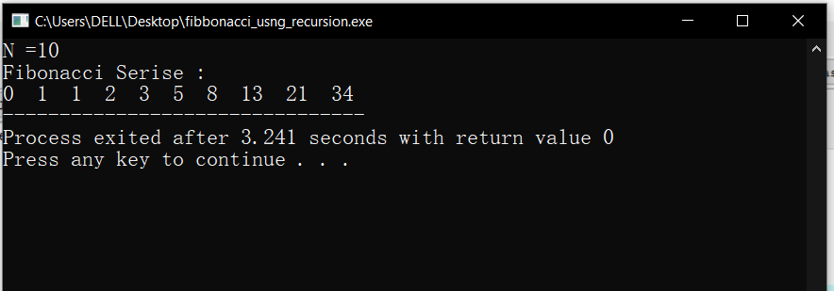

# **Print 1 to N using Recursion**

**#include<iostream>**

**using namespace std;**

**int main(){**

**int n;**

**void disp(int);**

**system("cls");**

**cout<<"N = ";cin>>n;**

**disp(n);**

**return 0;**

**}**

**void disp(int n){**

**if(n==0){**

**return;**

**}**

**else**

**disp(n-1);**

**cout<<n<<" ";**

**}**

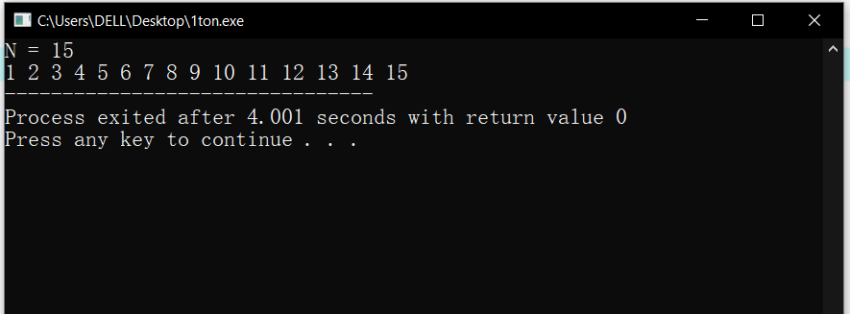

# **Print n to 1 using Recursion**

**#include<iostream>**

**using namespace std;**

**int main(){**

**int n;**

**void disp(int);**

**system("cls");**

**cout<<"N = ";cin>>n;**

**disp(n);**

**return 0;**

**}**

**void disp(int n){**

**if(n==0){**

**return;**

**}**

**else**

**cout<<n<<" ";**

**disp(n-1);**

**}**

