**Blinkit Quick Commerce Analysis – Project Report**

**1. Introduction**

This project analyses **Blinkit’s quick commerce operations** using a dataset of 8,523 records.  
The goal is to uncover key insights about **products, outlets, sales trends, and customer preferences**, and finally build an interactive **Power BI dashboard** for decision-making.

**2. Tools Used**

* **Excel** → Data cleaning and preprocessing
* **SQL** → Querying and structured data analysis
* **Python (Pandas, Matplotlib, Seaborn)** → Exploratory Data Analysis (EDA)
* **Power BI** → Dashboard visualization & storytelling
* **GitHub** → Version control and project portfolio showcase

**3. Dataset Overview**

* **Rows**: 8,523
* **Columns**: 12
* **Key Columns**:
  + Item Identifier, Item Type, Item Fat Content, Item Weight, Item Visibility
  + Outlet Identifier, Outlet Establishment Year, Outlet Size, Outlet Type, Outlet Location Type
  + Rating, Item Outlet Sales

✅ No missing values (cleaned in Excel)  
✅ No duplicates

**4. Exploratory Data Analysis (Python)**

* **Item Fat Content** → Mostly “Low Fat” & “Regular” items
* **Item Type** → Top categories: Fruits/Vegetables, Snack Foods, Household Items
* **Outlet Size** → Medium outlets dominate (65%+)
* **Outlet Type** → Supermarket Type1 is most common
* **Sales** → Highly skewed, with some items contributing much higher revenue
* **Rating** → Ranges 1–19 (average 8–9 across outlets)

📊 **Visuals created:**

* Count plots (Item Type, Fat Content)
* Sales distribution histograms
* Boxplots (Sales by Outlet Type/Size)
* Correlation heatmap

**5. Dashboard (Power BI)**

An interactive dashboard was built covering:

* **KPIs**: Total Sales, Average Rating, No. of Items, No. of Outlets
* **Sales by Outlet Type & Size**
* **Top 10 Item Types by Sales**
* **Ratings distribution**
* **Outlet establishment trend over years**

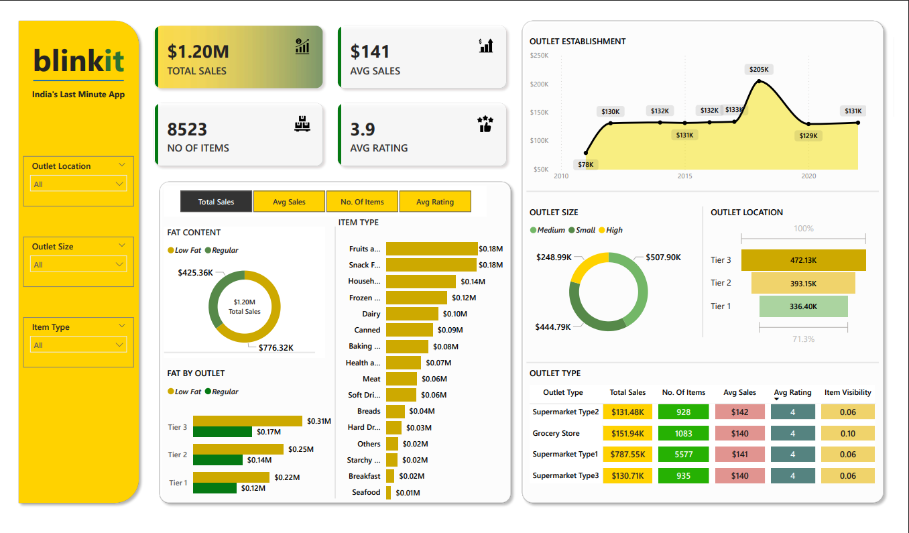

**7. Key Insights**

1. Medium-sized outlets generate the highest sales.
2. Supermarket Type1 is the largest contributor to revenue.
3. Fruits, vegetables, and snacks are top-performing categories.
4. Sales distribution is highly skewed → a few products drive most revenue.
5. Random Forest model gives strong predictive capability for sales forecasting.

**8. Conclusion**

This end-to-end project demonstrates:

* Data cleaning in **Excel**
* Querying in **SQL**
* **EDA** in Python
* Storytelling with **Power BI Dashboard**
* Documentation & Portfolio building with **GitHub**