**📊 Blinkit Quick Commerce Analysis**

**📌 Project Overview**

This project analyzes Blinkit’s sales and outlet performance to uncover business insights of sales.  
It is an **end-to-end data analytics project** using **Excel, SQL, Python (EDA), and Power BI**.

**🛠️ Tools & Technologies**

* **Excel** → Data cleaning & formatting
* **SQL** → Data querying and exploration
* **Python** → Exploratory Data Analysis (EDA)
* **Power BI** → Interactive dashboard & storytelling
* **GitHub** → Documentation & portfolio showcase

**📂 Folder Structure**

Blinkit-Quick-Commerce-Analysis/

│

├── Dataset/

│ └── Blinkit_data.csv

│

├── SQL/

│ └── Blinkit_SQL_Analysis.sql

│

├── Python/

│ └── blinkit_EDA_ML.ipynb

│

├── PowerBI/

│ └── Blinkit_Dashboard.pbix

│ └── Dashboard_Screenshot.png

│

├── Docs/

│ ├── Blinkit_Project_Report.docx # Detailed report

│ ├── Blinkit_Project_Blog.md # Blog version

│ └── README.md # Main repo readme

│

└── LICENSE (optional)

**📊 Power BI Dashboard**

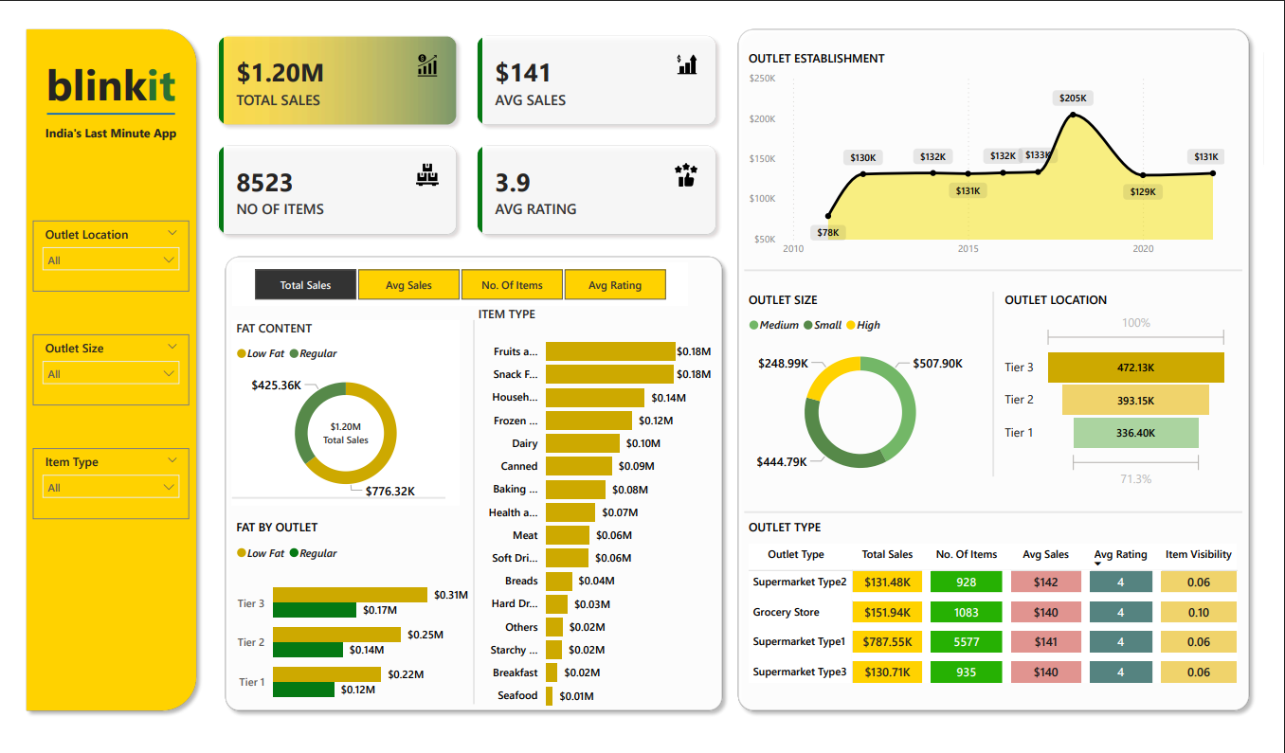

The dashboard highlights:

* Total sales & average ratings
* Sales by outlet type & size
* Top-performing item categories
* Rating distributions
* Yearly sales trends

**🔎 Key Insights**

1. **Medium-sized outlets** generate the highest revenue.
2. **Supermarket Type1** dominates in sales contribution.
3. **Fruits, Vegetables, and Snacks** lead in performance.

**✅ How to Use**

1. Clone this repo:
2. git clone https://github.com/hey-sree/Blinkit-Quick-Commerce-Analysis.git
3. Explore Dataset/, SQL/, Python/, and PowerBI/ folders.
4. Open Docs/Blinkit_Project_Report.docx for full documentation.
5. Open Docs/Blinkit_Project_Blog.md for blog-style explanation.

**🧑‍💻 Author**

**Sree Chandana**

* 💼 Aspiring Data Analyst