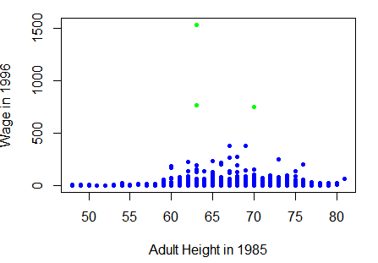

In the relationship between wage and height 85 we can see from the plot that wage has some extreme values which will be excluded before running the regression model.