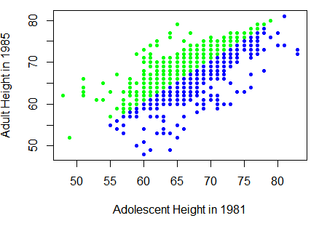

From this graph we can see there is a positive relationship between adult height and adolescent height.