**SMART-BIN:**

Ashutosh Kumar  
Department of CSE  
JECRC University  
Jaipur, India

Ayush Chauhan  
Department of CSE  
JECRC University  
Jaipur, India

Rohit Singh  
Department of CSE  
KNIT  
Sultanpur, India

*Abstract*—This electronic document is a “live” template and already defines the components of your paper [title, text, heads, etc.] in its style sheet. *\*CRITICAL: Do Not Use Symbols, Special Characters, Footnotes, or Math in Paper Title or Abstract*. (*Abstract*)

Keywords—mqtt, arduino, rasberi pi,

Abstract

In today’s scenario due to massive increase in population huge amount of waste is generated. So to ensure healthy environment, waste management is strictly needed. Earlier people regularly checks and empty the filled waste bins, after that smart bins are developed which by using some technologies predict the level of waste whenever bins gets filled an alarm is raised, but these are unable to change human tendency of throwing waste. Here we have proposed a smart waste management system using cloud computing and machine learning approach, sensors are installed in each bin which captures the garbage within certain distance, this data is sent to cloud and by using machine learning approach waste nearby garbage collector is predicted and alarm will be raised which continue till waste is not thrown in bins.

Introduction

Today’s everyone is talking about smart city and government has also launched “Swachh Bharat Abhiyan”, but people are still unware about the garbage that they are spreading everywhere. Findings from report published by United Nations is that by the end of 2025, there would be a massive increase in world population by 20% and will reach up to 8 billion and more. Due to this demand and consumption of commodities will raised, in result level of waste/garbage will also increase at similar rates. The traditional method of waste collection and decomposition requires a lot of resources due to un-equipped method and lack of technology. Report suggested that 90% of the people are suffering from COPD (Chronic Obstructive Pulmonary Disease) are due to the foul smell created by garbage and about 235 million suffer from asthma from the smell of the unpicked garbage. So its matter of concern that how we intimate the people to do not spread waste everywhere and put waste into the dustbin.

Government is focusing on method of garbage collection as well as its decompositions. There is focus on alert system for garbage collection i.e. generating alarm if the dustbin is full and alert to the local garbage collector. The main issue is that people are unaware of the garbage they are **created**, spread it everywhere.

In this paper we are focusing on waste created by people in the mall, houses, public places like hospitals, markets etc. This garbage/wastes is becoming a hazardous problem for the society, because of its non-monitoring existing system. In most of the countries, waste was either burn in bulk or usually dumped in to the open space, river etc. and in result it creates serious health issues for humans and aqua world. In the traditional mechanism, sweeper collects waste and put this into the nearest dustbin but it requires a lot of recourses.

Our proposed system is smart enough to make aware people to don’t spread the waste, it ensures that the waste must be dropped into the smart-bins. The proposed smart-bins will raise an alarm whenever someone throws waste on the floor and alarm will raised and continue till the waste will pick and dropped in to the dustbin. All the smart dustbin will have connected through the cloud so that they can alert the local waste collector in the case of overflow of the smart dustbin.

**I. LITERATURE SURVEY**

**Cloud Computing Based Smart Garbage Monitoring System**

Cloud based Smart Monitoring System

To provide a healthy environment certainly there is a need of hiring people which consistently checks and empty the garbage from traditional dustbins. But this regular checks are en-efficient because it might be possible that dustbins get filled early. So in this case an immediate action is required, but sometimes regular checks do not require. This system becomes expensive due these factors. In this paper they proposed “Smart Bin” by integrating technologies like IoT, WSN etc. and machine learning algorithms are applied on data which is collected from sensors to ensure efficient garbage monitoring.

**Architecture**

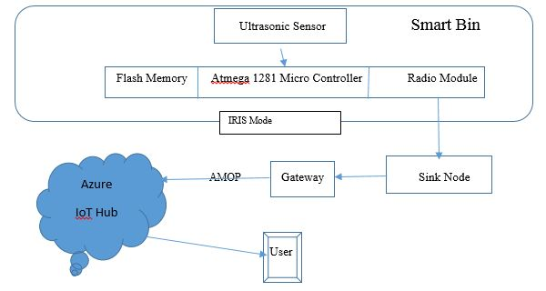

Fig.1.1: Existing System [1]

1. Sensors nodes are equipped in bins and certain range is fixed.
2. In deployment phase every bins were assigned a static geo-location
3. This constructs a network of bins and these sensor nodes collected/sensed data to the sink node.
4. The sink nodes upload data to cloud for this Mqtt protocol is used.
5. Thus machine learning algorithm are applied on this collected data to predict the garbage level.

**Smart Bin: An Intelligent Waste Alert and Prediction System Using Machine Learning Approach**

In this paper, a smart-bin using machine learning approach is created using Microsoft azure platform. Jeetendra et. al [1] proposed a network of smart bin which alert the local authorities to pick the waste from those bin which were critically filled. This system is trained by using machine learning with Microsoft azure to generate a pattern to predict the bin which usually filled frequently. This helps the local authorities to allocate funds in the areas where bins were getting filled frequently. Text and email alert system is also implemented to automatically inform the concerned authorities.

All the existing systems only checks that whether bin is full or not, if it is full an alarm is raised, but these mechanisms /algorithms are not able to create a situation where it can prevent human from doing this spilling garbage near bin.

**II. METHODOLGY**

**A. Working of Proposed System**

The block diagram below shows the working of the system in environment. The camera, ultrasonic and IR sensors are installed in the dustbin which captures the image and is then sent over cloud to recognize it’s type and information of it using the Azure function app.

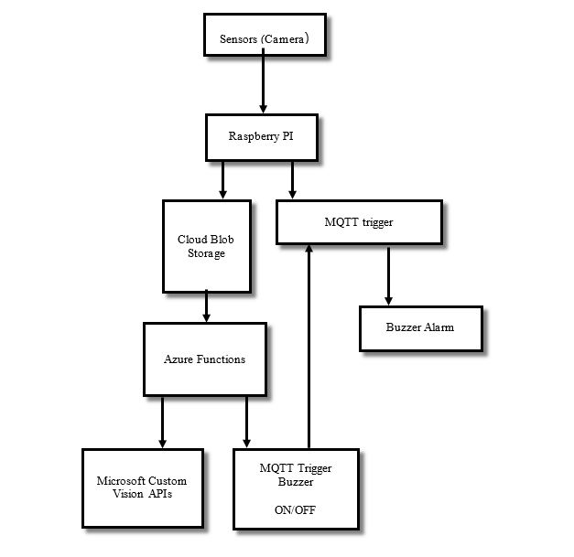

Fig.1.2 Work Flow

Azure function app then sends the captured picture to Microsoft custom vision API. The custom vision API has the trained model to recognize and predict the tags found in picture. Azure function app after receiving the response from the api then sends the MQTT trigger to turn on the buzzer. Raspberry Pi connected to MQTT broker receives the instruction to turn ON the buzzer and a Python scripts turns it off after a certain amount of time.

**B. Components Required**

1. **Software Requirements:**

* VS CODE- IDE for all purpose uses of coding like writing shell scripts and building azure function.
* Azure functions core tools - Local testing and building of azure functions.
* Microsoft Custom Vision - It is a service that trains a prediction model to recognize images from previously trained tags using machine learning.
* CloudMQTT - CloudMQTT offers a hosted MQTT brokers that can be used as an event pipeline between a service and IoT hardwares.

**2) Hardware Requirements:**

* Raspberry Pi - Raspberry Pi with Wi-Fi module: Raspberry Pi is a single board computer which runs on Linux based operating system and is best suited for IoT based devices.
* Camera Sensor
* Buzzer

**III. IMPLEMENTATION**

* *Step-1*: We will get the dataset of images clicked by humans or drones of garbage like plastic, tin, paper etc. We need upload the images and train the model giving them respective tags.
* *Step-2*: We will then need to create a azure function app by going into Microsoft Azure Portal.
* *Step 3*: We then need a MQTT broker to communicate with our raspberry PI. Signup for a MQTT broker at cloudmqttt.com or any hosted broker would work.
* *Step 4*: Create a new blob triggered function and code the logic that sends an POST api request to custom vision api we got in step-1. Then execute the MQTT topic to send whether to turn on or off buzzer according to the response we got from custom vision api.
* *Step 5*: We then need to write a python script which clicks a picture attached to our raspberry pi using opencv library.
* Step 6: Also we need a python script which subscribes to a topic subscribed by our azure function app using MQTT python library to turn off and turn on buzzer based on instruction.

**IV. RESULTS**

The output of the trained images on Microsoft Custom Vision is shown in the fig 1.3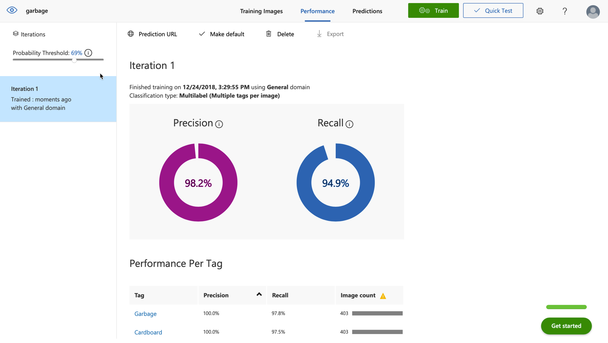

Fig.1.3 Custom Vision Precision and Recall

Figure 1.4 is the test image we use garbage clicked by our camera and Fig 1.5 below shows the processing output given by azure function which is 0.683 probability being a paper and garbage.

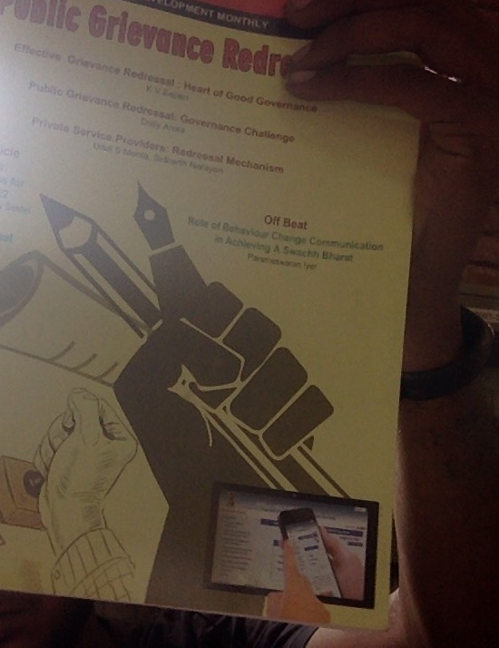

Fig.1.4 Garbage test Image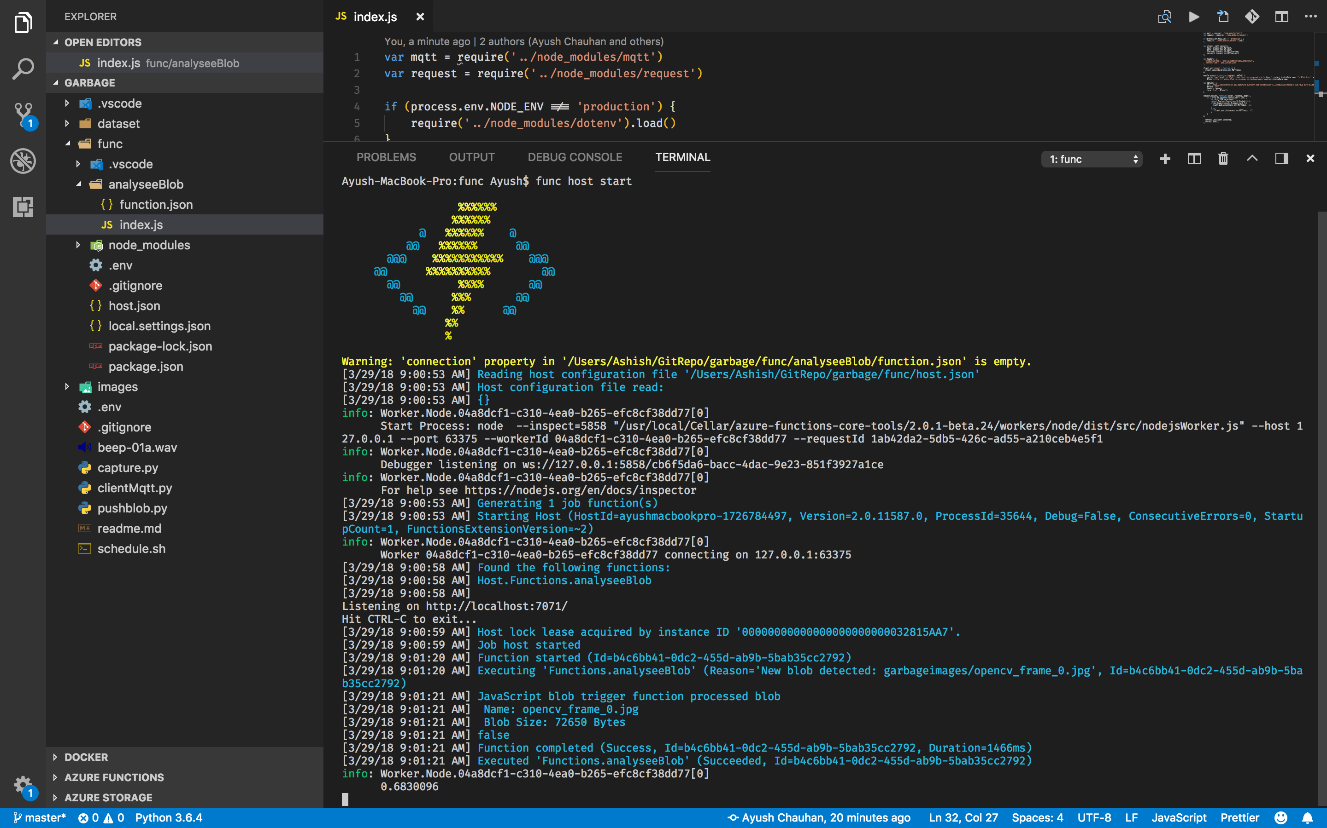

Fig.1.5 Processing Out by Azure function

**V. CONCLUSIONS AND FUTURE SCOPE**

In this paper we are focusing on waste created by people in the mall, houses, public places like hospitals, markets etc. This system is trained by using machine learning with Microsoft azure to generate a pattern to predict the bin which usually filled frequently.

The proposed smart-bin system is tested, implemented in real time and it accurately predicted the dropped garbage by using the machine learning techniques. There is no need of manual checking hence it reduces human efforts. Buzzer of this system also create awareness among the peoples which throws garbage while roaming. In future we can implement this system at large scale that will keep clean the society as well as the environment

**REFERENCES**

[1] Cyril Joe Baby et al. "Smart Bin: An Intelligent Waste Alert and Prediction System Using Machine Learning Approach" IEEE, 2017

[2] Jetendra Joshi et al."Cloud Computing Based Smart Garbage Monitoring System" ICED, 2016

[3] K. A. Monika, N. Rao, S. B. Prapulla, and G. Shobha, “Smart dustbin-an

efficient garbage monitoring system,” vol. 6, no. 6, pp. 7113–7116, 2016.

[4] K. M. Kumar, “Smart dustbin 1,” no. 5, pp. 101–104, 2015.

pp. 143–147.

[5] J. Joshi et al., “Cloud computing based smart garbage monitoring system,”

pp. 70–75, 2016.

[6] B. Singh and M. Kaur, “Smart dustbins for smart cities,” vol. 7, no. 2,

pp. 610–611, 2016.