**University of Chittagong**

Department of Computer Science and Engineering

Heart Disease Classification System

# Your name

# ID: Your ID

Department of Computer Science and Engineering

**Supervisor Supervisor name** Email: Email ID

# Introduction

Heart disease is a broad term that encompasses a wide range of heart problems. It is also referred to as cardiovascular disease, which refers to heart and blood vessel disease. Every year, many people die as a result of various types of heart disease. Smoking, high blood pressure, high cholesterol, an unhealthy diet, a lack of exercise, and obesity can all increase the risk of certain heart diseases. Coro- nary artery disease (narrow or blocked coronary arteries) is the most common type of heart disease, and it can cause chest pain, heart attacks, or stroke. Aside from that, there are various types of heart disease such as heart attack, angina, and so on.

# Main Objectives

There are, however, numerous types of heart disease. As a result, determining which types of heart disease exist is difficult. A proper treatment can help the infected patient avoid long-term compli- cations. Heart disease classification is required for this. The system’s goal is to create an expert system that can classify heart disease based on various symptoms. As a result, long-term treatment will be avoided, and costs will be reduced. The system has also created a knowledge base with details information about heart disease

# System Design

The concept behind a rules-based expert system is to represent a domain expert’s knowledge in the form of rules. It includes domain knowledge, a user interface, an inference engine, and knowledge acquisition. The following figure show the system design of our proposed method.

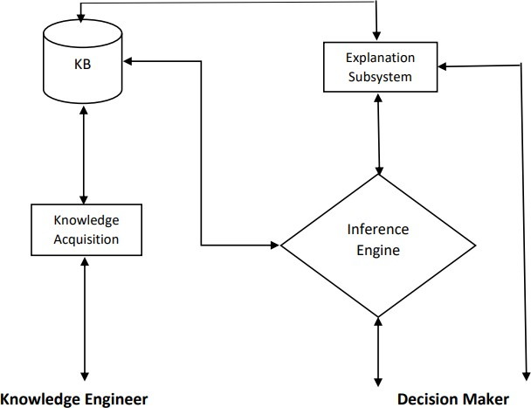

**Figure 1:** Knowledge Based Expert System Structure

# Methodology

The following figure describe how the system work and reacts to different responses ask by the user

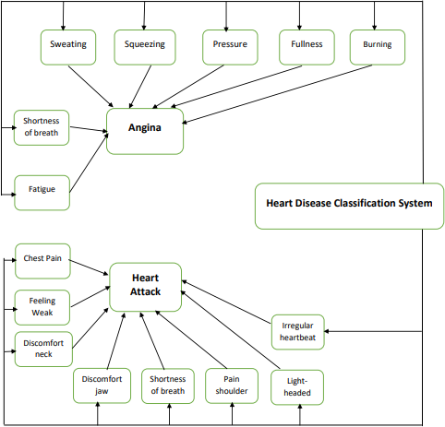

**Figure 2:** Heart Disease Classification System

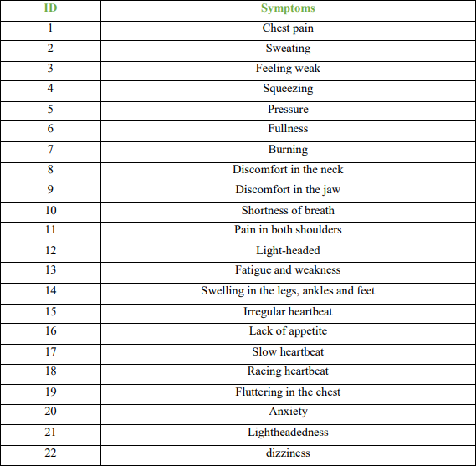

**Table 1:** Symptom of Heart Disease

# Implementation

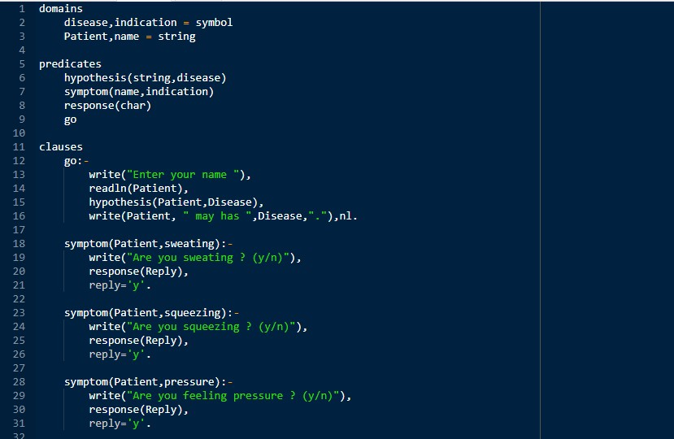

**Conclusions**

Finally, a knowledge based expert system model for heart disease classification is developed. It is not replacement of human doctor but it can help doctor to find out types of heart disease.

# Reference

1. Tsao CW, Aday AW, Almarzooq ZI, Beaton AZ, Bittencourt MS, Boehme AK, et al. Heart Disease and Stroke Statistics—2022 Update: A Report From the American Heart Association. Circulation. 2022;145(8):e153–e639.
2. Fryar CD, Chen T-C, Li X. Prevalence of uncontrolled risk factors for cardiovascular disease: United States, 1999–2010 [PDF-494K]. NCHS data brief, no. 103. Hyattsville, MD: National Center for Health Statistics; 2012. Accessed May 9, 2019.