# 2. Qualitative variable

> cats <- read.csv("C:/Users/16273/GitHub/ISEP-Documents/2309-2401/Probability/TDm3/cats.txt", sep="")

>   View(cats)

> class(cats$Sex)

[1] "character"

> unique(cats$Sex)

[1] "F" "M"

> cats$Sex <- factor(cats$Sex)

> class(cats$Sex)

[1] "factor"

> unique(cats$Sex)

[1] F M

Levels: F M

> levels(cats$Sex)

[1] "F" "M"

# Exercise 5.(1)

> table(cats$Sex)

 F  M

47 97

> relative_freq <- prop.table(table(cats$Sex))

> relative_freq

        F         M

0.3263889 0.6736111

> freq_table <- table(cats$Sex)

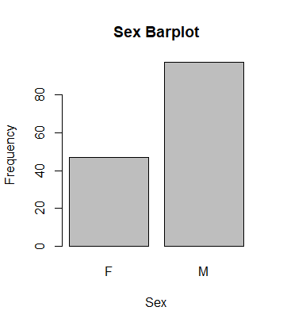

# Exercise 5.(2)

> barplot(freq_table, main = "Sex Barplot", xlab = "Sex", ylab = "Frequency")

# Exercise 5.(3)

> pie(freq_table, labels = levels(cats$Sex), main = "Sex Distribution")

# Exercise 6

# Plot the boxplots of the weight of male and female cats and interpret the result

> boxplot(Bwt ~ Sex, data = cats,

+         xlab = "Sex", ylab = "Bwt",

+         main = "boxplots of the weight of male and female cats")

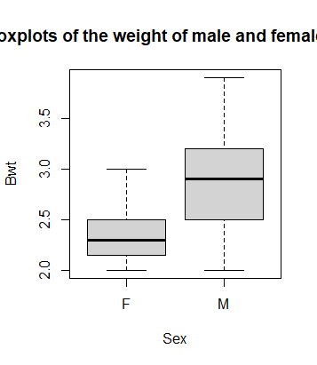

# Exercise 7

#  display the scatter plot of the variables (Bwt,Hwt)

> plot(cats$Bwt, cats$Hwt,

+      xlab = "Body Weight", ylab = "Heart Weight",

+      main = "Scatter Plot of Body Weight vs Heart Weight")

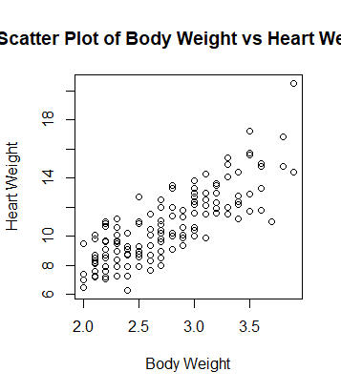

#  Calculate the sample covariance and correlation coefficient

> covariance <- cov(cats$Bwt, cats$Hwt)

> covariance

[1] 0.9501127

> correlation <- cor(cats$Bwt, cats$Hwt)

> correlation

[1] 0.8041274

# using different colors

> plot(cats$Bwt, cats$Hwt, col = ifelse(cats$Sex == "M", "blue", "red"),

+      xlab = "Body Weight", ylab = "Heart Weight",

+      main = "Scatter Plot of Body Weight vs Heart Weight by Sex")

