**IG.2407 - Signal Acquisition and Processing**

**Lab 2**

**IIR and FIR Filtering**

**G8**

**GUO Xiaofan**

<https://github.com/heyPetiteF/ISEP/tree/main/2402-2406/2-SIGNAL/LAB/LAB2>

CONTENT

Part 1: IIR filter as a noise cancelling filter. 3

1. Signal Analysis 3

2. Filter Design – IIR 4

3. Results 4

Part 2: FIR filter as moving average filter. 6

1. Signal Analysis 6

2. Filter Design – FIR 6

1) When N=1&10&100, the impulse response figures. 7

2) When N=1&10&100, the magnitude response figures. 7

3) When N=1&10&100, the phase response figures. 8

4) When N=3&11&31, the impulse response figures. 8

5) When N=3&11&31, the magnitude response figures. 9

6) When N=3&11&31, the phase response figures. 9

3. Results 9

Appendix (Code) 10

Part1 10

Part2 10

# Part 1: IIR filter as a noise cancelling filter.

## Signal Analysis

* Fourier transform an audio file.
* Plot the spectrum of an audio file.
* Use “findpeaks” function to mark two peaks.

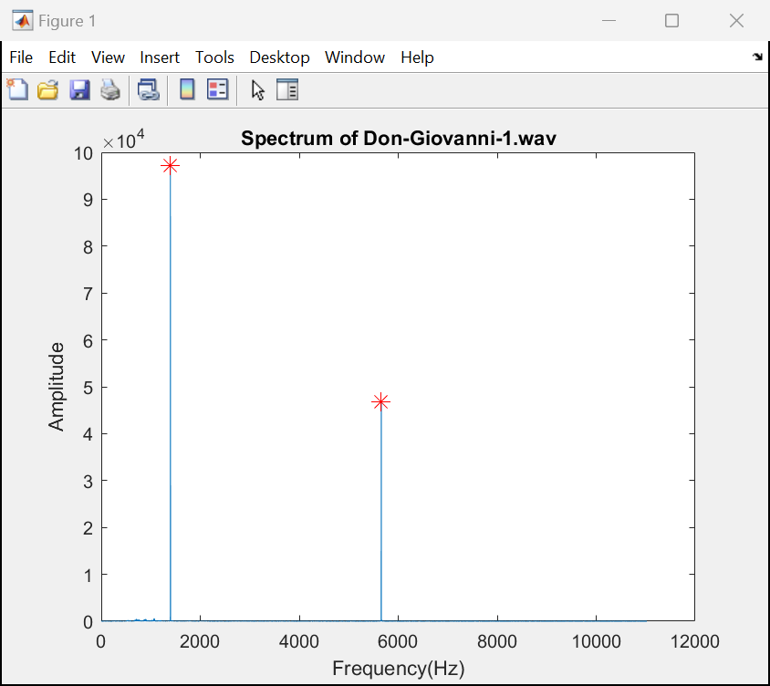

* These two peaks are which need to be removed.

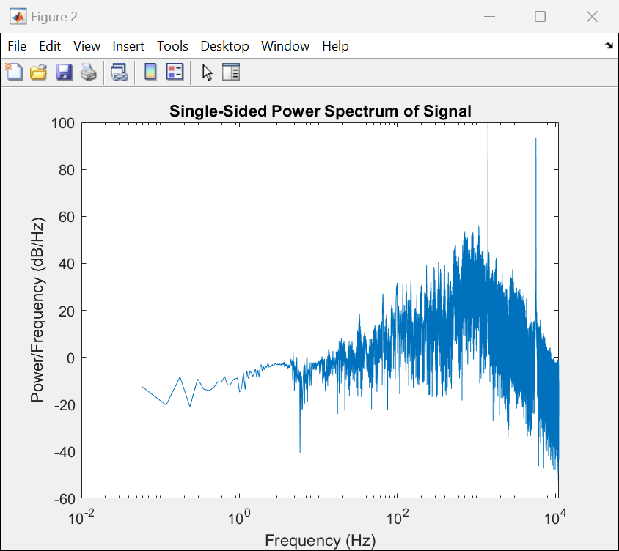

* In the single-side power spectrum image can also clearly see that there are two frequency points, which are noise points.

## Filter Design – IIR

* Use the “fdesign.notch” function to create a notch filter design object & implement it as a digital filter through the “design” function.
* **N**: the order of the filter, here is 2.
* **F0**: the filter center frequency, already obtained when marking peak before.
* **Q**: the quality factor, which is inversely proportional to the bandwidth of the filter.
* **butter**: instructs the design function to use the Butterworth method to implement filter design.
* **bn**: numerator coefficient of the filter.
* **an**: denominator coefficient of the filter.

## Results

* After filtering, can see that there are no obvious noise points through Spectrum figure:

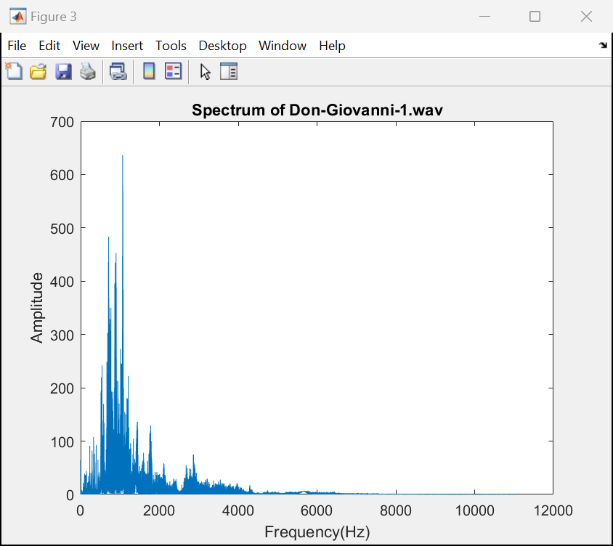

* There also no noise points in single-Sided Power Spectrum figure:

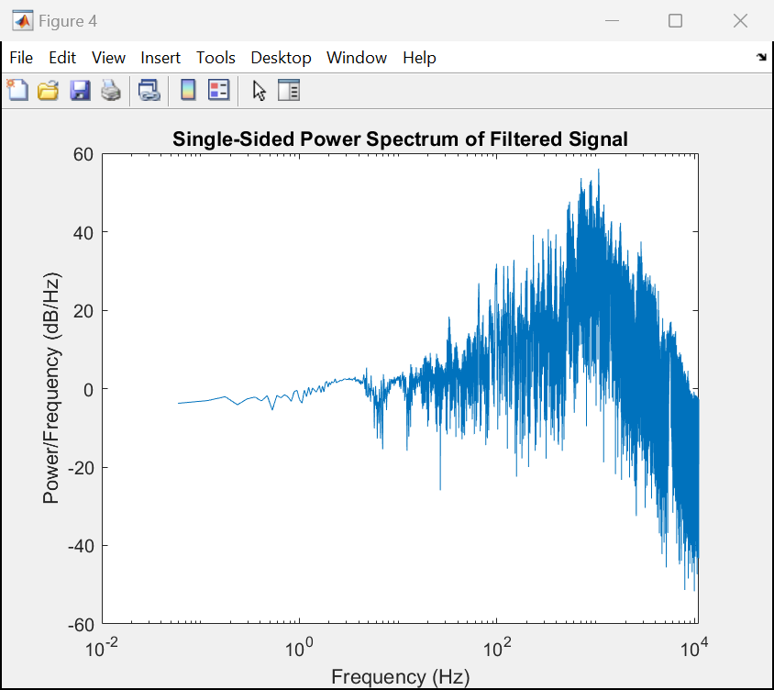

* Play the filtered audio and you can hear clear singing without harsh noise.
* Filtering successful.

# Part 2: FIR filter as moving average filter.

## Signal Analysis

* The Convolution:
* Impulse Response Function:
* **Transfer Function** (Z transform of IRF)**:**
* Frequency Response (Transfer Function on the unit circle, z = ):
* **Magnitude Response:**
* **Phase response:**

## Filter Design – FIR

* Create a quantity of length N and value 1/N as the coefficient of the FIR filter.
* Calculate and plot the impulse response using the “impz” function.
* Calculate and plot the frequency response using the “freqz” function.
* Observe changes in frequency response and impulse response by changing the value of N.

### When N=1&10&100, the impulse response figures.

* N=1: There is actually no filtering effect. The impulse response only has one sample of 1.
* N=10: The impulse response shows ten values (all 0.1), indicating that each input sample is one of the ten numbers that is averaged.
* N=100: The impulse response here is very dense, showing 100 values (all 0,01).
* As N increases, the impulse response broadens in time, the filter has a longer temporal "memory" of the input signal.

### When N=1&10&100, the magnitude response figures.

* N=1: The magnitude response is a flat line, indicating that all frequency components are passed.
* N=10: The magnitude response shows an obvious sine wave shape with large fluctuations, signal components at certain frequencies are amplified or attenuated.
* N=100: The magnitude response becomes more oscillatory, the main lobe (the main peak area) becomes narrower, and the side lobes (fluctuations) become more numerous, which means the filter becomes more selective.

### When N=1&10&100, the phase response figures.

* N=1: it is almost a constant.
* N=10: a trend in phase as a function of frequency.
* N=100: the phase response becomes very volatile.
* As N increases, the phase response becomes more complex.

### When N=3&11&31, the impulse response figures.

### When N=3&11&31, the magnitude response figures.

### When N=3&11&31, the phase response figures.

## Results

When increasing the order N of an FIR filter:

* **Narrower Bandwidth**

The main lobe of the filter's frequency response becomes narrower, enhancing frequency resolution. For broadband signals, higher-order filters can suppress adjacent unwanted frequencies more effectively.

* **Increased Phase Complexity**

The phase response becomes more erratic with frequency as N increases. This increased phase complexity can lead to signal phase distortion, especially in parts of the frequency spectrum where the phase changes rapidly.

* **Greater Latency**

A higher filter order N introduces more latency due to the need to process a greater number of historical input samples.

# Appendix (Code)

## Part1

<https://github.com/heyPetiteF/ISEP/blob/main/2402-2406/2-SIGNAL/LAB/LAB2/LAB2PART1.m>

## Part2

<https://github.com/heyPetiteF/ISEP/blob/main/2402-2406/2-SIGNAL/LAB/LAB2/LAB2PART2.m>