Hospital Indoor Localization & Behavior Analysis
USE CASE – V1.

Context (Project Background & Current Uncertainties)
Focuses on indoor localization and behavior analysis based on localization within hospital environments.
Indoor spaces, especially hospitals, are highly dynamic IoT environments where location awareness is essential. GPS is unavailable indoors, therefore a dedicated Indoor Positioning System (IPS) is required.
Behavior analysis relies on accurate position and movement data. Most medical activities involve spatial context - patient monitoring, staff dispatching, equipment allocation, and emergency responses which require real-time and room-level positioning accuracy.
Hospital radio environments are highly unstable due to:
- frequent movement of metallic medical devices
- human crowds in corridors
- door openings, bed movements, and staff traffic
These factors introduce severe multipath, fading, and RSSI fluctuations, making hospital localization more challenging than offices or malls.
The final use case has not been confirmed yet, including:

Target Subjects
- Patients?
- Healthcare staff?
- Mobile medical equipment?

Spatial Scope
- Single floor? Multi-floor?
- single building? Multi building?

Behavior Analysis Scope
- Behavior pattern recognition?
- Risk-event detection?
- Workflow analysis?
- Equipment usage behavior?

Allowed Sensors
- Not interfere with medical devices
- Not be strongly affected by medical devices
- Comply with privacy & ethics standards

Potential Application Scenarios

Patient-Related Scenarios

Patient activities
- Room → corridor → public area paths
- Activity frequency, speed, dwell points

Risk Event Detection
- Falls
- Entering restricted areas (ICU, operating room, isolation areas)

Healthcare Staff Scenarios
- Rounding paths
- Workload & crowded areas
- Process optimization

Mobile Medical Equipment Scenarios
- Mobility of hospital beds/wheelchairs/and other equipment
- Usage frequency

Sensor Categories & Comparison
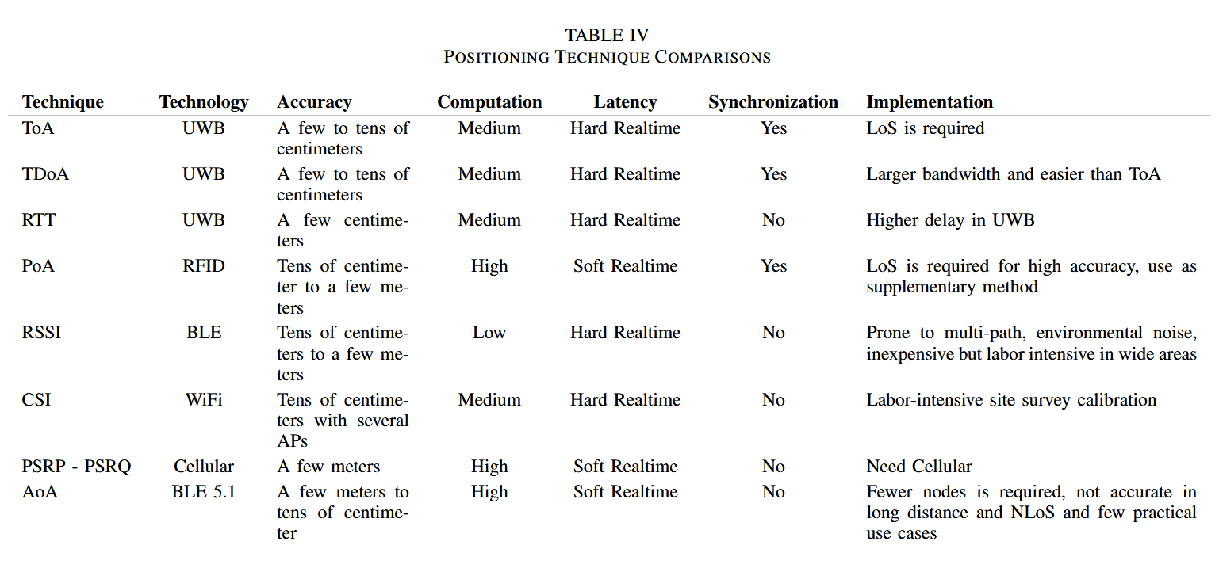

Distance-based Methods（ToA / TDoA / RTT）
- Used in UWB
- High accuracy (cm-level)
- Requires synchronization (ToA/TDoA)
- Infrastructure cost high → often used for equipment tracking

Angle-based Methods（AoA）
- Provides angle information
- Requires antenna arrays
- BLE 5.1 supports AoA
- Deployment cost high → limited use in hospitals

Fingerprinting (RSSI-based)
- Low-cost, widely used in hospitals
- No special hardwar
- Highly unstable due to multipath
- Requires offline survey → may be costly

Proximity (BLE beacon)
- Room-level localization
- Useful for geofencing (ICU alarms)
- Not accurate enough for movement trajectory

Possible Technical Directions
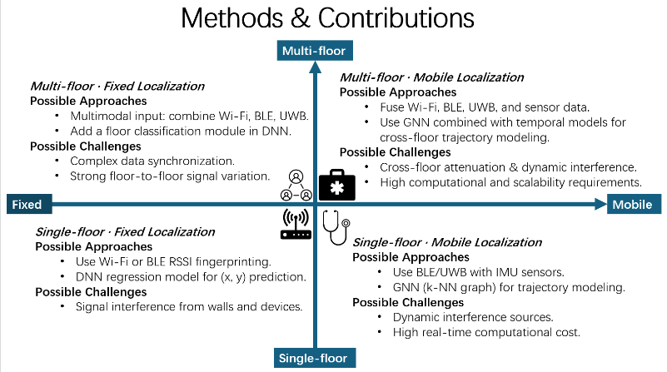

Single-floor Mobile Localization + Behavior Analysis
- BLE/UWB + IMU fusion
- RSSI-based temporal regression
- GNN (k-NN graph) trajectory modeling

Multi-floor Localization + Behavior Analysis
- Multi-modal fusion
- Spatiotemporal modeling
- Floor-transition attenuation modeling

Fusion-based Localization
- RSSI + IMU
- RSSI + proximity
- UWB + WiFi fallback
- Temporal smoothing (Kalman/particle filtering)

Data Types

Hospital provides (to be confirmed)
- Equipment movement
- Access control information
- Daily activity logs
- Building/floor identifiers
- Room/zone topology
- Floor plan constraints (walls, materials)

Data to collect (needs approval)
- Wi-Fi/BLE RSSI sequences
  - RSSI vectors
  - RSS time-series
  - Channel State Information (CSI)
  - Link quality indicators
  - Access Point metadata (SSID/BSSID, channel, floor tags)
- UWB trajectory points
- IMU 3-axis acceleration
- Behavior event labels
- Multi-AP transitions

Medical Environment Constraints
- wear devices?
- deployment requires approval
- complex radio environment
- behavior labeling need help
- multipath caused by metallic medical instruments
- human body shadowing
- signal absorption by medical liquids or equipment
- high-density AP deployment causing interference

Questions for Next Meeting

- Who are the target subjects? (equipment / staff / patients)
- What is the study area? (areas / floors / buildings)
- What level of accuracy is needed by the hospital? (room-level/bed-level)
- What anonymized data can the hospital provide?
- Real-time latency? (seconds/minutes)
- How can I obtain the devices?
- What time periods are allowed for data collection, and for how long?
- Which behaviors are most important to the hospital? Do you need visualized results?
- Is ethical/IRB approval required? How long will it take?

