Hospital Indoor Localization & Behavior Analysis
USE CASE – V2.

Medical Environments

Patient-Related
- Activity Tracking
- Movement between room → corridor → public areas
- Analysis of speed, activity frequency, and dwell points
- Risk Event Detection
  - Fall detection
  - Alerts when patients enter restricted zones (ICU or isolation rooms…)

Staff
  - Rounding path monitoring / identifying
  - Workload & crowded areas detection
  - Process optimization

Medical Equipment
- Real-Time Asset Tracking
  - Wheelchairs
  - beds…
- Usage Pattern Analysis
  - Usage frequency
  - Movement cycles

Constraints in Hospital Environments

Radio Environment Instability
- Surveyed literature emphasizes that indoor environments (especially hospitals) cause high variability in wireless signals due to obstacles and dynamic conditions.
Source: A Survey on Indoor Positioning Systems for IoT-Based Applications
- Frequent movement of beds, metallic equipment, human crowds, and door opening/closing causes multipath, fading, and severe RSSI fluctuations.

Interference from Medical Devices
- Imaging devices and electronic medical equipment generate electromagnetic emissions that may interfere with localization technologies.

Privacy and Ethical Limitations
- Sensors must comply with medical privacy standards.
- Wearable-based solutions for patients may require consent and approval.

Deployment & Operational Constraints
- Hospitals often avoid major infrastructure changes.
- low-maintenance and low-cost solutions.
- Multiple technologies (Wi-Fi, BLE, IR, ultrasound) coexist (increasing system management complexity).

Existing Localization Solutions (in Hospitals)
Wi-Fi RSSI-Based Localization | - RSSI value.  - Simple, widely available due to existing Access Points.  - Typical accuracy: 2–4 meters in real indoor conditions.  - High interference, limited accuracy.
RSSI Fingerprinting Systems | - Offline fingerprint database + online matching.  - Achieves sub-meter accuracy (≈ 60 cm under ideal conditions).  - Highly sensitive to environmental changes.  - Labor-intensive to maintain.
Bluetooth Low Energy (BLE) | - RSSI beacon sequences (requires beacon deployment)  - Low deployment cost, low power consumption.  - Works well for room-level or corridor-level localization  - Sensitive to environmental dynamics.
Ultra-Wideband (UWB) | - Uses ToF / TDoA measurements  - Provides high accuracy (cm-level).  - High cost & infrastructure requirements
IMU-Based Behavioral Monitoring | - IMU accelerometers/gyroscopes → fall detection  - Requires wearable devices

Sensors and Methods Used in Hospital Localization

Sensors

Methods
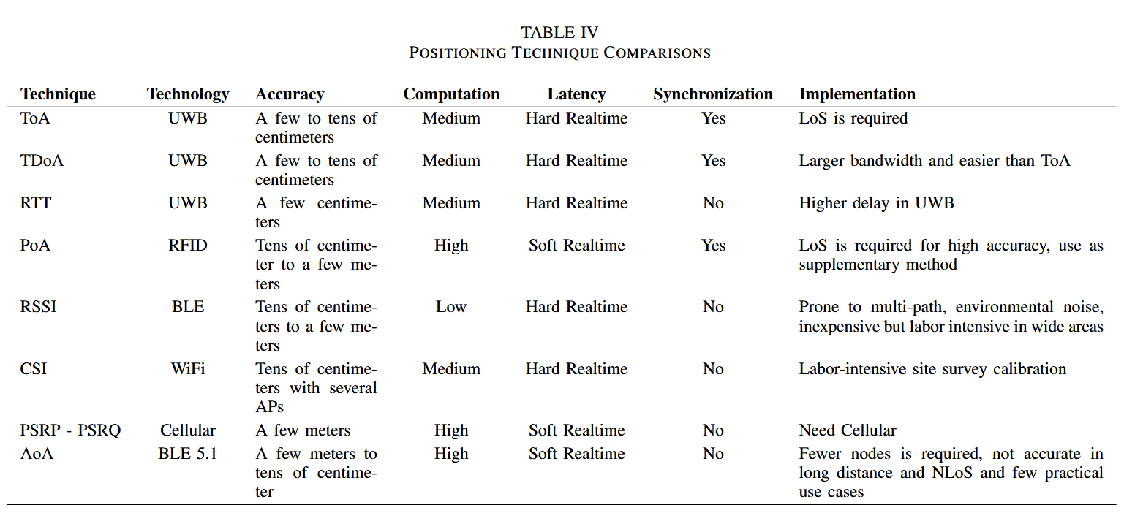
- Distance & Angle-Based Approaches
- ToA / TDoA: Used in UWB; requires synchronization.
- AoA: Supported by BLE 5.1 antenna arrays; higher deployment cost.
- RSSI Fingerprinting
- Widely used in hospitals: easy to deploy
- Common algorithms include KNN, SVM, probabilistic models, and deep learning.
- CSI-Based Localization
- Provides richer channel information
- Improving stability and accuracy.
- Tracking & Filtering Methods
- Kalman Filter, Particle Filter for smoothing trajectories.
- Widely used in real-time tracking systems: noise robustness.
- Multi-Sensor Fusion
- Combining Wi-Fi + BLE + IMU or UWB ….
- Improves robustness in dynamic hospital environments.
- Multipath, occlusions, and varying conditions…

