**Birdsonwire**

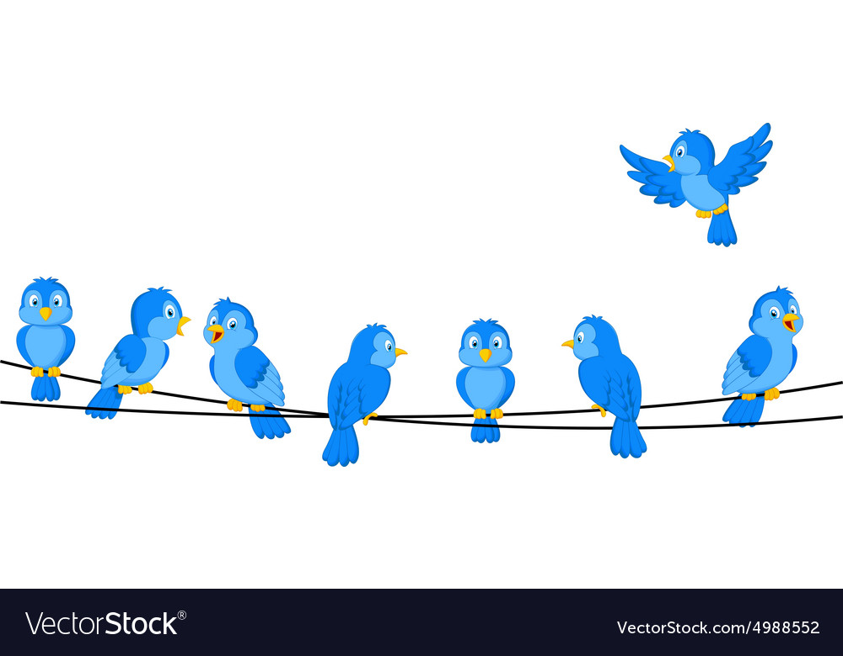

**https://www.vectorstock.com/royalty-free-vector/cartoon-blue-bird-on-wire-vector-4988552**

**cardinal**

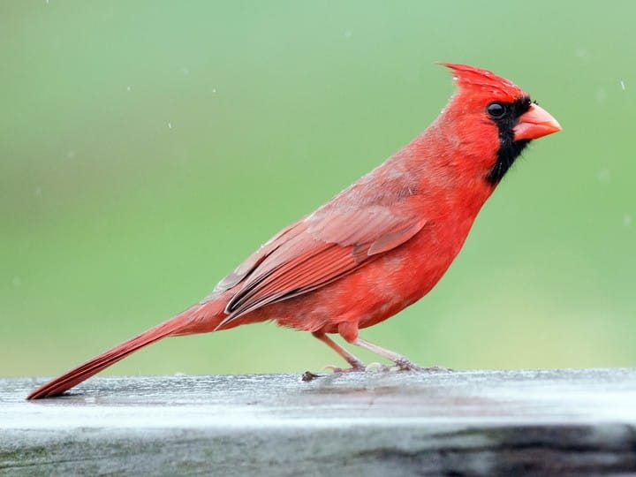

**https://www.allaboutbirds.org/guide/Northern_Cardinal/media-browser/63667361**

**bluejay**

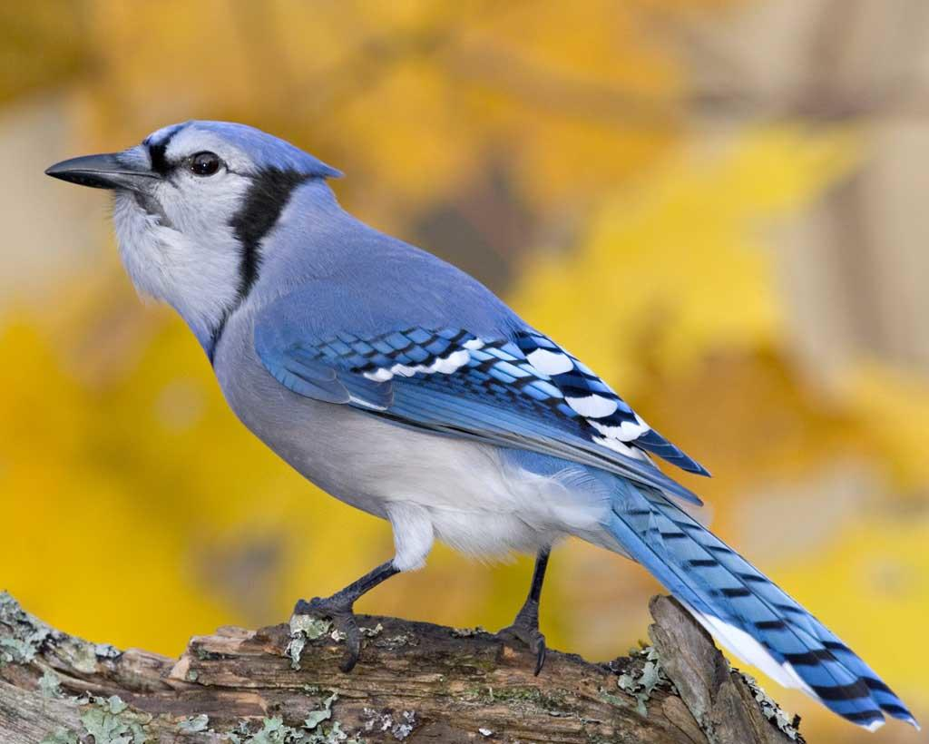

**https://www.audubon.org/field-guide/bird/blue-jay#photo1**