CC-Project — Lexical Specification & Token Reference

1. Language Overview
The name of my programming language is "Tech-Zubaan". It is inspired from Urdu language. Tech-Zubaan is designed to make programming more, accessible and intuitive for Urdu speaking communities.
The language aims to bridge the gap between natural, urdu language constructs and programming logic, treating a genetic learning experience for beginners while maintaining the power of modern programming paradigms. The syntax of this language includes the urdu based keywords and identifiers.

2. Lexical Elements

2.1 Keywords
Keyword | Meaning | Example (from your code)
yay | if (conditional) | yay (num > 3) { … }
wrna | else (alternative branch) | wrna { … }
barbar | for (loop) | barbar(rakam x = 0; x < 5; x = x + 1) { … }
dedo | return | dedo 0;
darost | boolean true | dedo darost
galat | boolean false | dedo galat
laina | input | laina(no)
likho | output/print | likho("SALAM”);
rakam | int (data type) | rakam num = 4;
lafz | char (data type) | lafz character = 'A';
ruko | break | ruko;
khali | void (data type / return type) | khali myfunc()
yan | logical OR (keyword form) | (A>B yan B>C)
aur | logical AND (keyword form) | (A>B aur B>1)
ashariya | float (data type) | ashariya val = 31.1;

2.2 Operators
Symbol / Word | Operator Name | Example (from your code)
= | assignment | rakam A = 1;
> | greater-than (relational) | A > 0
< | less-than (relational) | A < 5
+ or add | addition | A add B
- or subtract | subtraction | A subtract B
* or mul | multiplication | A mul B
/ or divide | division | A div B
! or not | logical negation | Not darost
== | equality test | A ==2
> | relational | A > 2
< | relational | A < 2

2.3 Punctuations / Delimiters
Symbol | Role | Example (from your code)
( | left parenthesis (grouping / call) | ("…")
) | right parenthesis (grouping / call) | ("…")
{ | left brace (block start) | {
} | right brace (block end) | }
, | separator in lists/arguments | rakam A = 4, B = 2;
; | terminator | Rakam A;

3. Regular Expressions
The Regular expressions are the following;
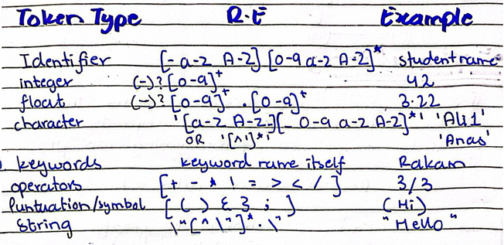

4. DFA
Identifier:
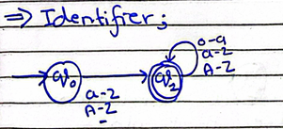
Integer:
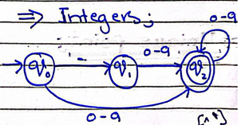
Character:
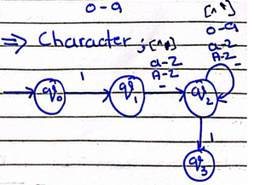
Float:
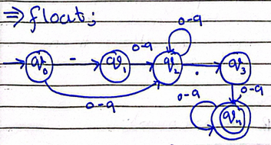
Strings:
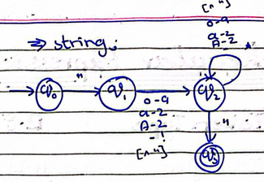
Comments (ignored but just in case):
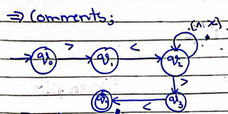

5. Explanation
The keywords are selected from the Urdu language or vocabulary that naturally maps to programming concepts like:
Dedo = return, ruko = break
Each keyword was chosen to create an intuitive, bridge between natural language thinking and computational thinking. The Vocabulary covers front complexity while their educated, under speakers immediately recognize, making easy for them to understand.

5.1 Unique Point
'Tech Zubaan' is not just a translation. It is a cognitive bridge that allows under speakers to learn programming concept in their own language which make it easier to learn. This language can allow them to implement logics and express their skills in their own language.

6. Sample Program
Rakam meraProgram()
{
rakam number = 10;
ashariya decimal = 13.2;
lafz character = 'A';
agr (number > 5) {
likho "Number is greater than 5";
} wrna {
likho "Number is small"
}
>< this is loop ><
barbar (rakam i = 0; i < 5; i = i + 1) {
agr (i == 3) {
ruko;
}
likho i;
}
>< this is return ><
dedo 0;
}

