Quarterly Report
This report summarises results for the quarter. Café prices rose 5%.

Highlights
- Revenue grew 12%
- Two new offices opened
- Customer satisfaction at 94%
Region | Q1 | Q2
North | 120 | 135
South | 98 | 110
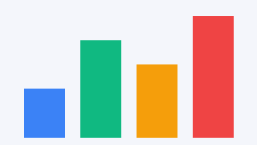
Large text paragraph.

Appendix
Second page content with bold text

