Target thematic issues

* Fighting climate change
* Advancing future of mobility

Problem statement

The current Malaysian traffic system needs an upgrade in terms of red light detection and traffic signal optimization in order to increase road safety and efficiency.

Our solution

* Streamlights, a smart traffic light program that scans all incoming cars on the road including number plates and measures real-time traffic flow. Information on red light runners is made available for government action. When roads are empty, actuated signals can be sent to prolong green light signals at other roads in order to reduce vehicle idle time.

Future features

* Red light running detection [makes travelling on roads safer](https://www.google.com/search?sxsrf=ALeKk03FhCqTda__wZ3PrWH7QbRlS2ZyKQ%3A1607433770774&ei=Kn7PX-PTLvmF4-EPleiE0A4&q=traffic+light+camera+costs+malaysia&oq=traffic+light+camera+costs+malaysia&gs_lcp=CgZwc3ktYWIQAzIFCAAQzQI6CAghEBYQHRAeOgUIIRCgAToECCEQClDbDFjLT2DAUWgDcAB4AIAB9AGIAZgWkgEGMC4yMS4xmAEAoAEBqgEHZ3dzLXdpesABAQ&sclient=psy-ab&ved=0ahUKEwjjkKC3vb7tAhX5wjgGHRU0AeoQ4dUDCA0&uact=5), essentially improving mobility.

Modules

* Detectron 2

Core aspect of product

* Able to detect and identify cars on the road
* Able to detect red light runners

Pros of product

* Cost advantage compared to conventional red light cameras
  + [Implementation costs](https://www.itskrs.its.dot.gov/its/benecost.nsf/ID/2b209ad2c5ad2ab985256db10045892b#:~:text=Implementation%20costs%20for%20automated%20red,%2467%2C000%20to%20%2480%2C000%20per%20intersection.) for automated red light camera systems range from $67,000 to $80,000 per intersection (US)
  + Current vehicle detection uses in-pavement inductive loop detectors which cost approx. $5,000 per leg
  + Product is a software which analyses footage from conventional low-cost video camera systems, reducing the need for high setup costs and manual traffic analysis.

Foreseeable obstacles of product

* Privacy concerns

Info ideas to touch on in pitch

* Appeal emotionally - “ever been stuck in a traffic jam?”
* Counts number of cars and plots against time, allowing officials to determine choke points in the traffic system
* Helps average out congestion by allowing more busy roads stay green
* Works particularly well for night time drivers when one road is busy and the other is empty

Usable statistics

* Study by professors of University of California, Riverside (UCR) <https://www.accessmagazine.org/fall-2009/traffic-congestion-greenhouse-gases/>

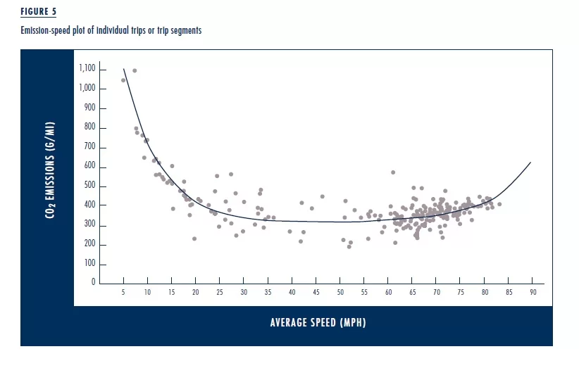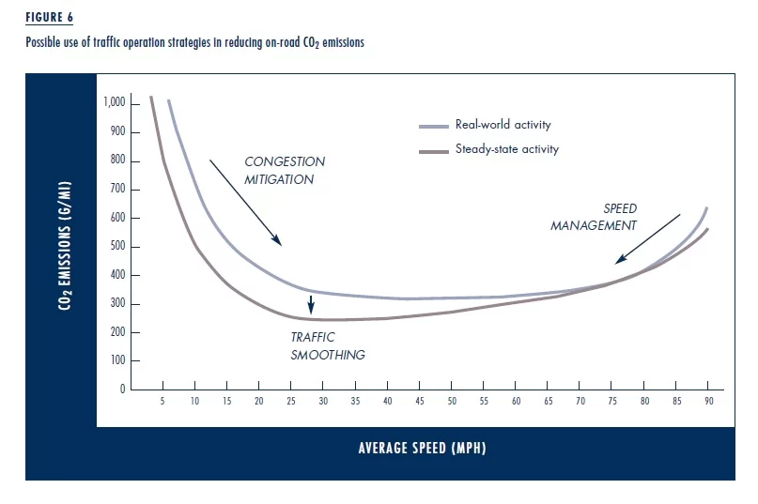

* Smart traffic lights eases congestion and ensures smoother traffic flow. This would help the problem in 2 ways. Easing congestion reduces the right side of the U-shaped graph as more people will be in a greater average speed which results in lower emissions. Smoother traffic would lower the total average of emissions.
* Idling cars are [bad for the environment](https://time.com/5502192/smart-traffic-lights-ai/), generating about 30 million tons of CO2 emissions in the U.S. annually.
* Graph of total CO2 emissions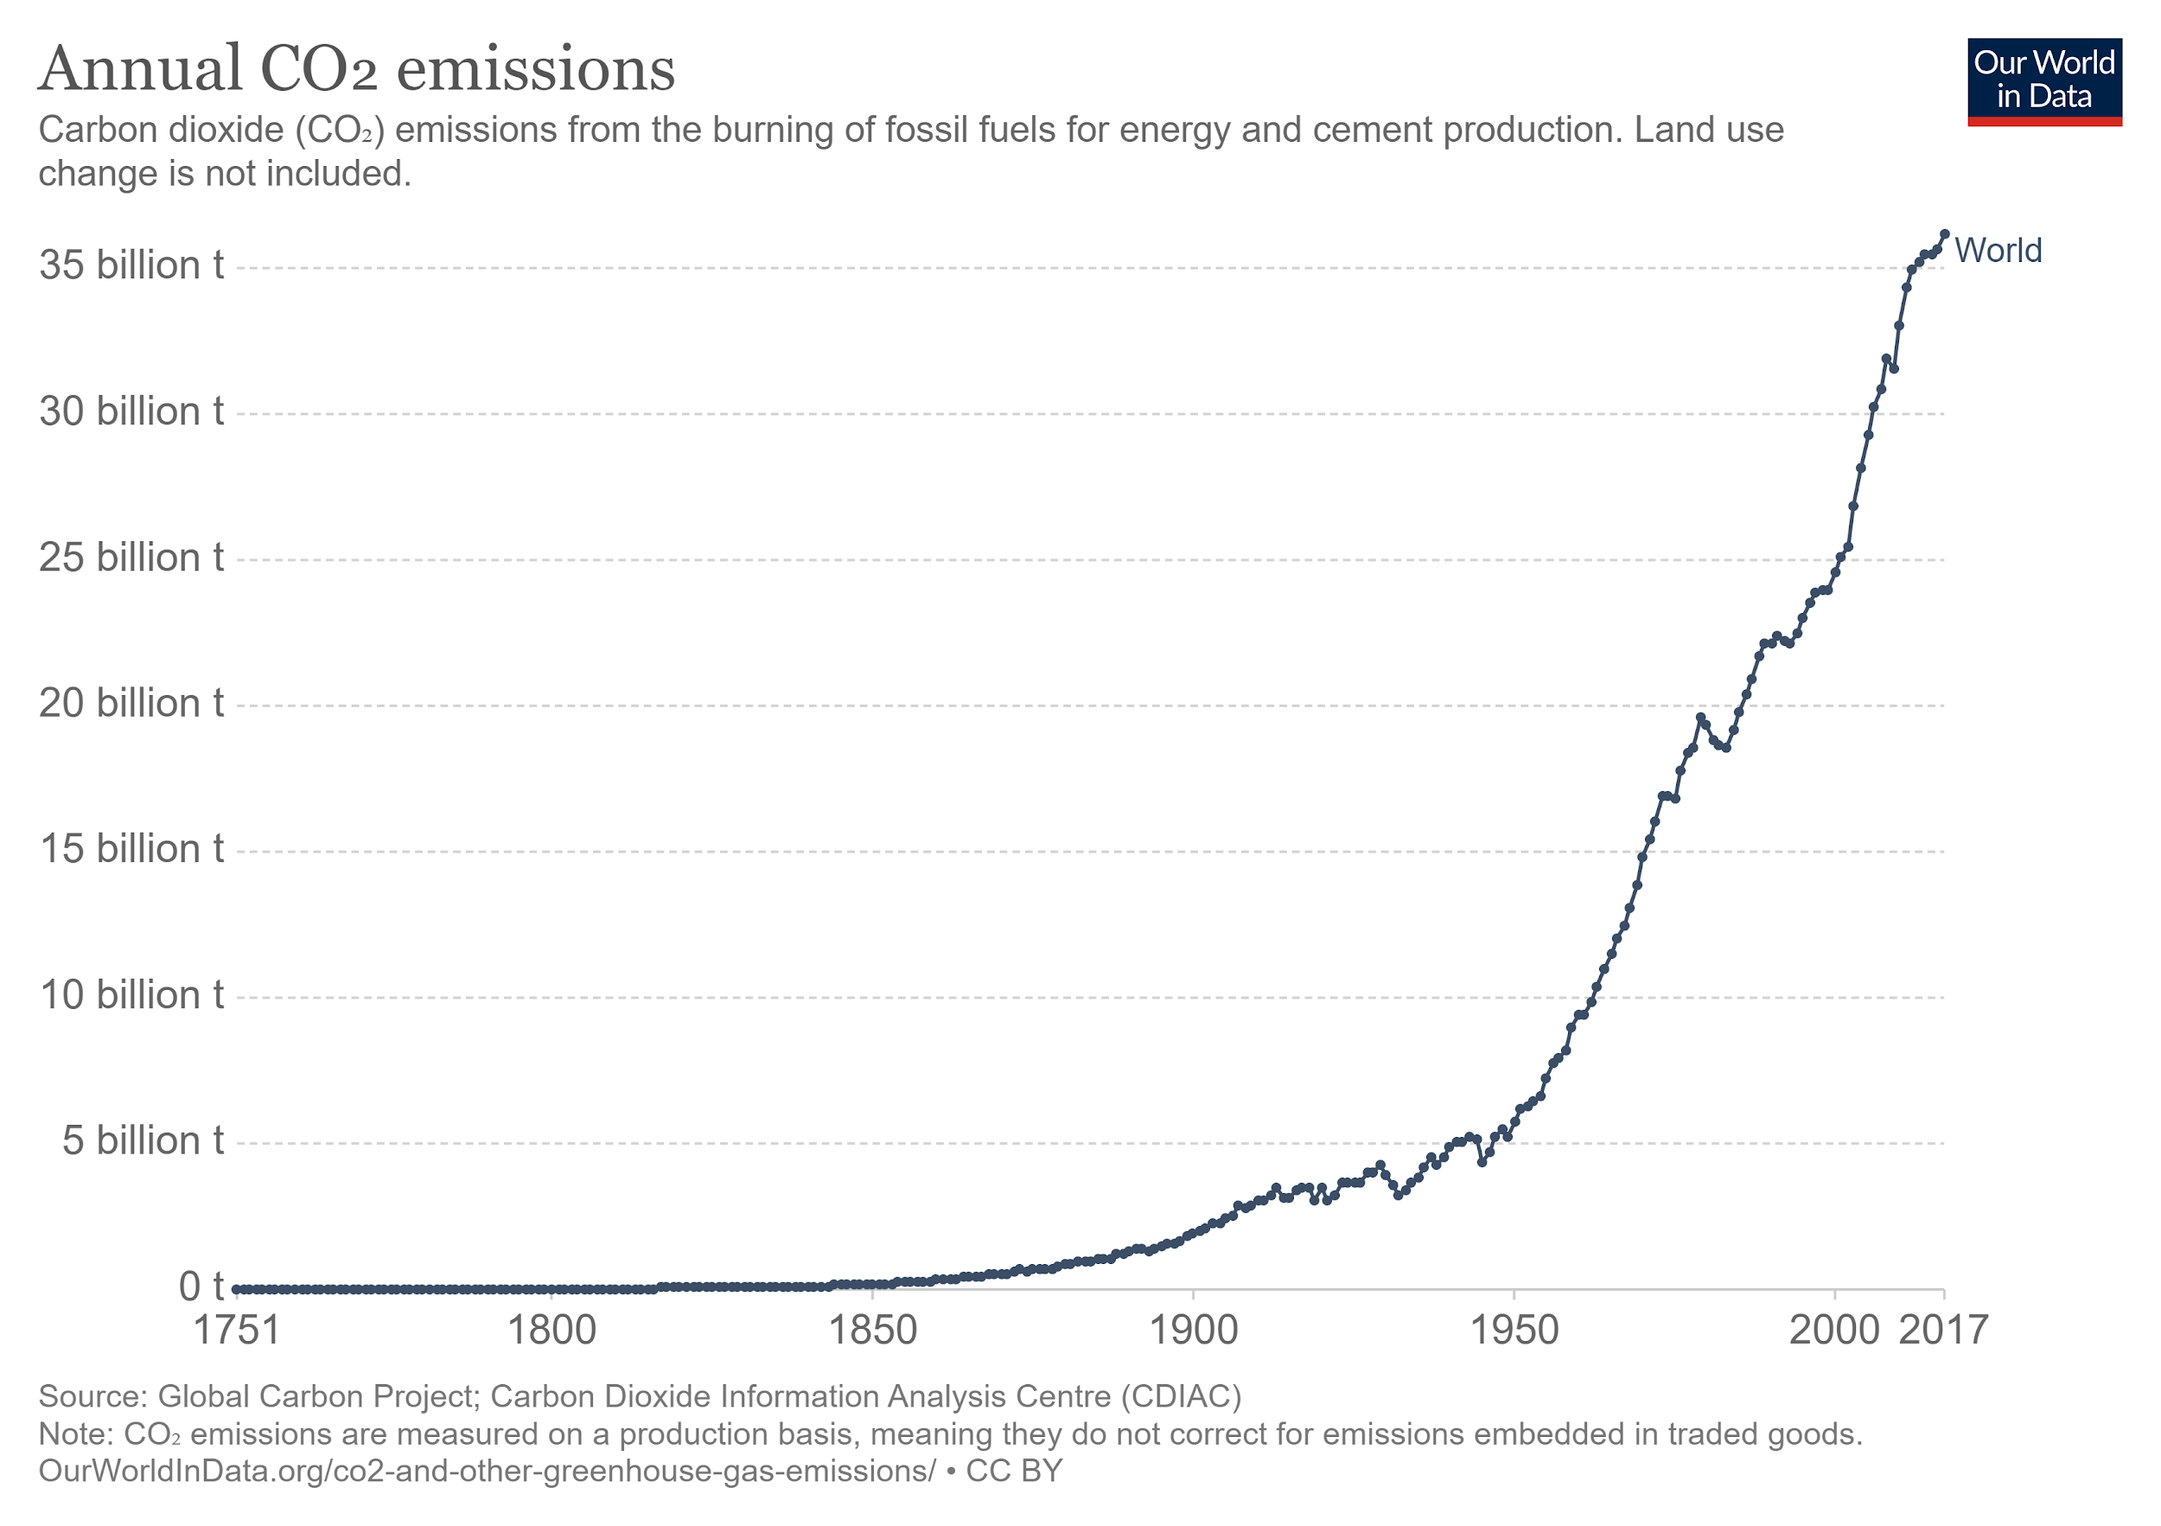

Citations

* <https://www.freethink.com/articles/smart-traffic-lights>
* <https://en.wikipedia.org/wiki/Red_light_camera>
* <https://www.google.com/search?sxsrf=ALeKk03FhCqTda__wZ3PrWH7QbRlS2ZyKQ%3A1607433770774&ei=Kn7PX-PTLvmF4-EPleiE0A4&q=traffic+light+camera+costs+malaysia&oq=traffic+light+camera+costs+malaysia&gs_lcp=CgZwc3ktYWIQAzIFCAAQzQI6CAghEBYQHRAeOgUIIRCgAToECCEQClDbDFjLT2DAUWgDcAB4AIAB9AGIAZgWkgEGMC4yMS4xmAEAoAEBqgEHZ3dzLXdpesABAQ&sclient=psy-ab&ved=0ahUKEwjjkKC3vb7tAhX5wjgGHRU0AeoQ4dUDCA0&uact=5>
* <https://nacto.org/publication/urban-street-design-guide/intersection-design-elements/traffic-signals/fixed-vs-actuated-signalization/>
* <https://www.itskrs.its.dot.gov/its/benecost.nsf/ID/2b209ad2c5ad2ab985256db10045892b#:~:text=Implementation%20costs%20for%20automated%20red,%2467%2C000%20to%20%2480%2C000%20per%20intersection>.
* <https://ourworldindata.org/co2-emissions>
* <https://ourworldindata.org/co2-emissions-from-transport>