Java - Introduction to Programming
Lecture 5

Patterns - Part 1


import java.util.*;

public class Patterns {
public static void main(String args[]) {
int n = 5;
int m = 4;
for(int i=0; i<n; i++) {
for(int j=0; j<m; j++) {
System.out.print("*");
}
System.out.println();
}
}
}



import java.util.*;

public class Patterns {
public static void main(String args[]) {
int n = 5;
int m = 4;
for(int i=0; i<n; i++) {
for(int j=0; j<m; j++) {
if(i == 0 || i == n-1 || j == 0 || j == m-1) {
System.out.print("*");
} else {
System.out.print(" ");
}
}
System.out.println();
}
}
}



import java.util.*;

public class Patterns {
public static void main(String args[]) {
int n = 4;

for(int i=1; i<=n; i++) {
for(int j=1; j<=i; j++) {
System.out.print("*");
}
System.out.println();
}
}
}



import java.util.*;

public class Patterns {
public static void main(String args[]) {
int n = 4;

for(int i=n; i>=1; i--) {
for(int j=1; j<=i; j++) {
System.out.print("*");
}
System.out.println();
}
}
}



import java.util.*;

public class Patterns {
public static void main(String args[]) {
int n = 4;

for(int i=n; i>=1; i--) {
for(int j=1; j<i; j++) {
System.out.print(" ");
}

for(int j=0; j<=n-i; j++) {
System.out.print("*");
}
System.out.println();
}
}
}

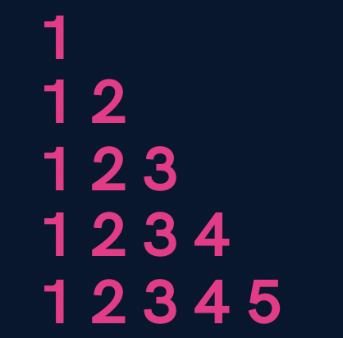

import java.util.*;

public class Patterns {
public static void main(String args[]) {
int n = 5;

for(int i=1; i<=n; i++) {
for(int j=1; j<=i; j++) {
System.out.print(j);
}
System.out.println();
}
}
}

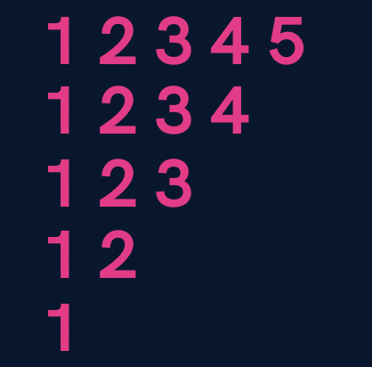

import java.util.*;

public class Patterns {
public static void main(String args[]) {
int n = 5;

for(int i=n; i>=1; i--) {
for(int j=1; j<=i; j++) {
System.out.print(j);
}
System.out.println();
}
}
}

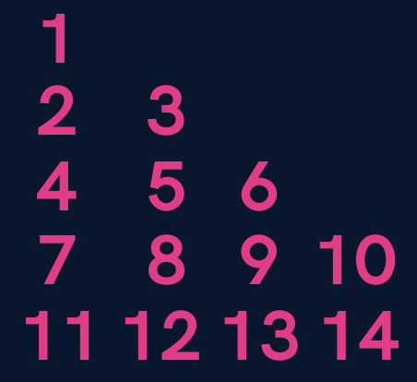

import java.util.*;

public class Patterns {
public static void main(String args[]) {
int n = 5;
int number = 1;

for(int i=1; i<=n; i++) {
for(int j=1; j<=i; j++) {
System.out.print(number+" ");
number++;
}
System.out.println();
}
}
}

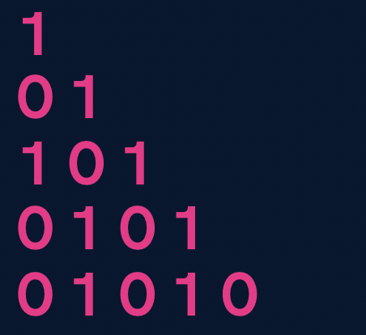

import java.util.*;

public class Patterns {
public static void main(String args[]) {
int n = 5;

for(int i=1; i<=n; i++) {
for(int j=1; j<=i; j++) {
if((i+j) % 2 == 0) {
System.out.print(1+" ");
} else {
System.out.print(0+" ");
}
}
System.out.println();
}
}
}

Homework Problems (Solutions in next Lecture’s Video)
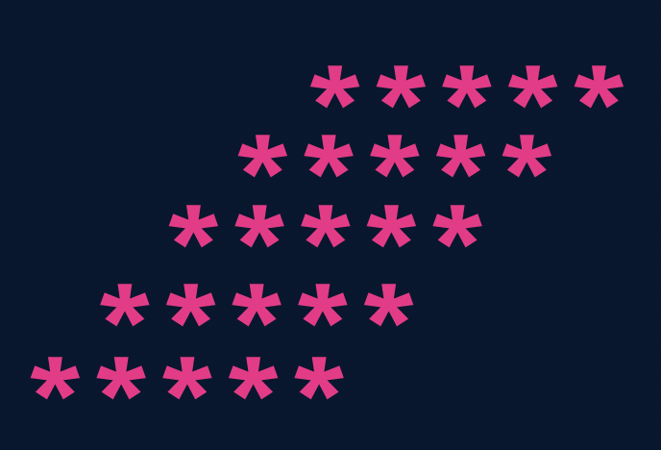
- Print a solid rhombus.

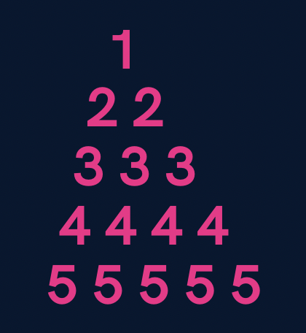
- Print a number pyramid.

- Print a palindromic number pyramid.
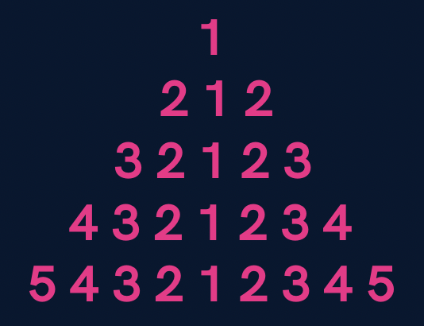

Homework Solution (Lecture 4)

- Print all even numbers till n.

- public class Solutions {
- public static void main(String args[]) {
- int n = 25;

- for(int i=1; i<=n; i++) {
- if(i % 2 == 0) {
- System.out.println(i);
- }
- }
- }
- }

3. Make a menu driven program. The user can enter 2 numbers, either 1 or 0.
If the user enters 1 then keep taking input from the user for a student’s marks(out of 100).
If they enter 0 then stop.
If he/ she scores :
Marks >=90 -> print “This is Good”
89 >= Marks >= 60 -> print “This is also Good”
59 >= Marks >= 0 -> print “This is Good as well”
Because marks don’t matter but our effort does.
(Hint : use do-while loop but think & understand why)

import java.util.*;

public class Solutions {
public static void main(String args[]) {
Scanner sc = new Scanner(System.in);
int input;

do {
int marks = sc.nextInt();
if(marks >= 90 && marks <= 100) {
System.out.println("This is Good");
} else if(marks >= 60 && marks <= 89) {
System.out.println("This is also Good");
} else if(marks >= 0 && marks <= 59) {
System.out.println("This is Good as well");
} else {
System.out.println("Invalid");
}

System.out.println("Want to continue ? (yes(1) or no(0))");
input = sc.nextInt();

} while(input == 1);
}
}

Qs. Print if a number n is prime or not (Input n from the user).
[In this problem you will learn how to check if a number is prime or not]
import java.util.*;

public class Solutions {
public static void main(String args[]) {
Scanner sc = new Scanner(System.in);
int n = sc.nextInt();

boolean isPrime = true;
for(int i=2; i<=n/2; i++) {
if(n % i == 0) {
isPrime = false;
break;
}
}

if(isPrime) {
if(n == 1) {
System.out.println("This is neither prime not composite");
} else {
System.out.println("This is a prime number");
}
} else {
System.out.println("This is not a prime number");
}
}
}

