In the name God

Vibration Project – Deadline: 1 Bahman 1401

Please consider the following model of vehicle. The properties are also mentioned in the table. Note: ks3 and cs3 are mistakenly written as ks9 and cs9 in the graph.

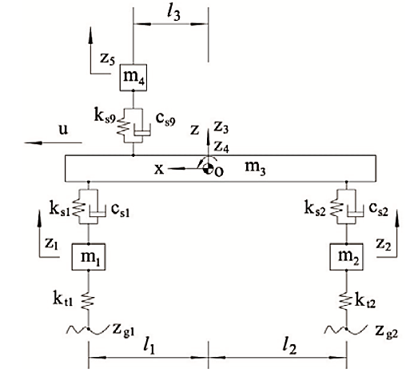

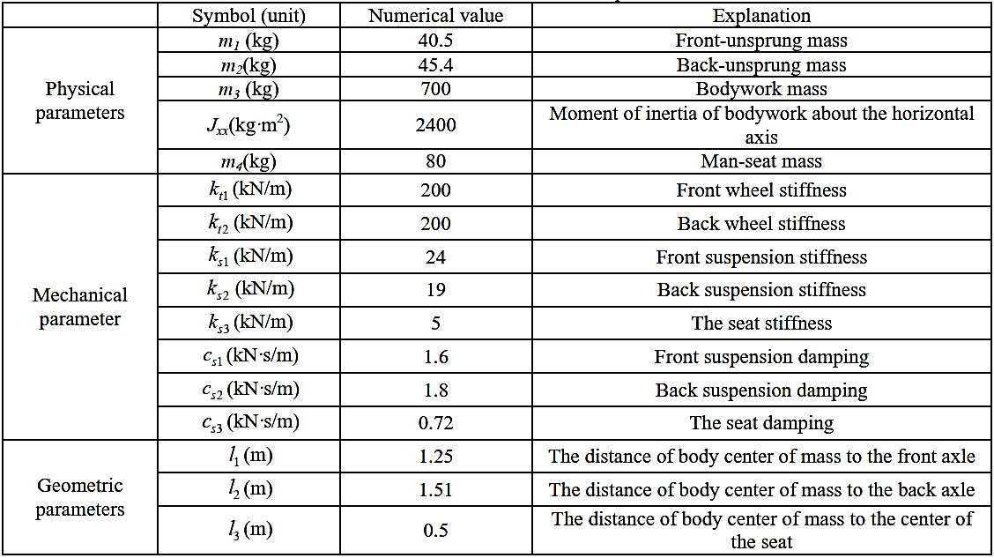

1. Please obtain the equations of motion.
2. Calculate the natural frequencies and the corresponding mode shapes. Please show the mode shapes graphically.
3. Assume that the vehicle is passing over a wavy road with the following equation:

$$y=0.01\sin{(100πx)}$$

What is the steady-state response of the passenger (displacement, velocity and acceleration).

1. Assume that the velocity of vehicle is 80 km/h and constant. It passes over a speed bump with the height and width of 30 cm and 50 cm, respectively. Please model this bump. Solve the dynamic model of the vehicle and draw the displacement, velocity and acceleration curves of the passenger for a certain time that covers after the rear wheels pass the bump as well.
2. Conduct a parameter analysis on different parameters such as the width, height of the bump, or the velocity of vehicle, and show their effect on the passenger response.