PUBLIC

How to include item pictures in
SAP Business One

Applicable Release:
SAP Business One 8.8

All Countries
English
03/ 2010

Print preview Crystal Report with item master pictures
Note: This guide is related to SAP Business One 8.8 OEC Computer demo databases.

Procedure
- Go to the demo DB: Administration->System Initialization->General Settings, under the Path tab, sets the Pictures Folder that you want to store images, such as item pictures.
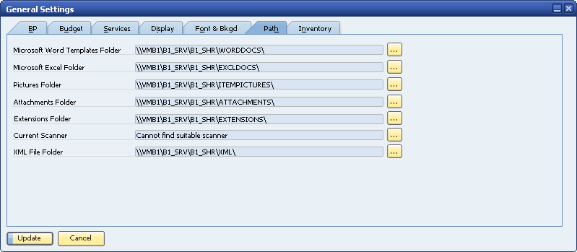

- Extract the item pictures which are provided together with this guide to the ‘Pictures Folder’ path configured in step 1.
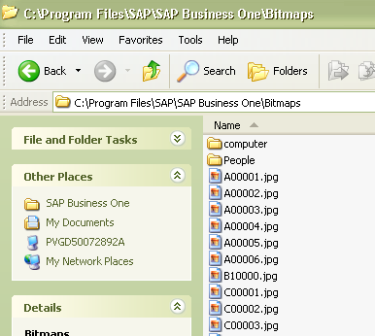
You can download the package containing the item pictures and this how-to guide on the demo database landing page: http://channel.sap.com/sbo/demodb within the SAP Business One 8.8 download center section.
- Preview item pictures in Item Master Data:
Go to the demo DB: Inventory→Item Master Data, check the existing items, like A00001, go to the ‘Remarks’ tab, there you can see the related item picture.
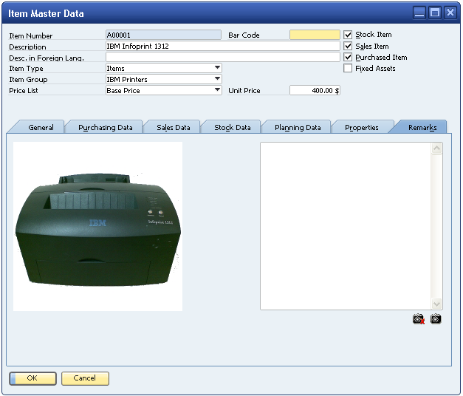

- Example on how item pictures could benefit, by using a Crystal Report Layout which includes item pictures:

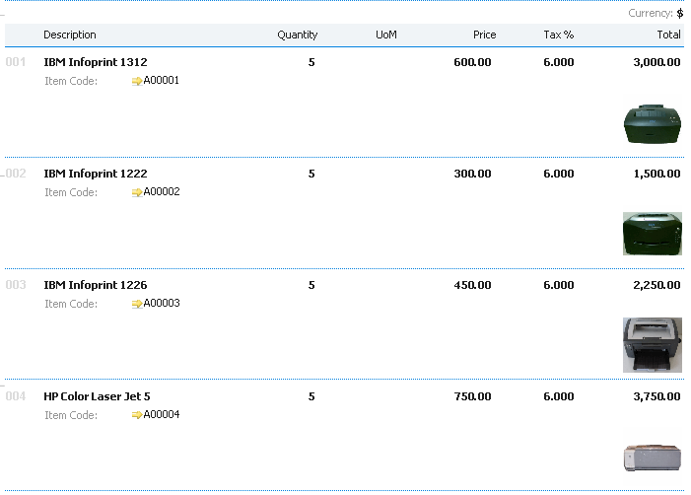

Copyrights, Trademarks, and Disclaimers
© Copyright 2010 SAP AG. All rights reserved.

The current version of the copyrights, trademarks, and disclaimers at http://service.sap.com/smb/sbocustomer/documentation is valid for this document.

