https://www.youtube.com/watch?v=Ojb9Rh0BcvA&list=PLJwvtUqYDmA664kRrHivVuXOf2cjMmTE5

https://www.coachdevops.com/2023/05/how-to-deploy-springboot-microservices_13.html

<https://www.coachdevops.com/search?q=kubeconfig>

Steps 1 : install docker , maven , Jenkins ( and setup EKS cluster also install all related Kubernetes plugins in jenkins and docker and docker-pipeline ( install all tools that fits best )

Plugins

Docker

Docker-pipeline

All Kuberentes plugins

**Eks cluster :**

eksctl create cluster --name eks2 --version 1.24 --region us-west-1 --zones=us-west-1b,us-west-1a

--nodegroup-name worker-nodes --node-type t2.medium --nodes 2 --node-min 2 --nodes-max 3

**Even if the eks is up and running install docker and setup the user**

sudo apt install docker.io -y

Step 2 : add below user

**Add Jenkins to Docker Group**sudo usermod -aG docker jenkins  
sudo systemctl daemon-reload

**Restart Docker service**

sudo systemctl start docker

sudo systemctl enable docker  
sudo systemctl restart docker

**Restart Jenkins service**

sudo service jenkins restart

steps 3 # create ECR in aws

github code : https://github.com/heydevopsbatch5/cicdhelmeks.git

**Step #4 - Create Credentials for Kubernetes Cluster**

execute the below command to get kubeconfig info, copy the entire content of the file:

sudo cat ~/.kube/config

[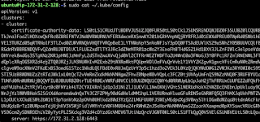](https://1.bp.blogspot.com/-ODt-1df6Ijw/Xt_hoI3aF4I/AAAAAAAACiE/CXR4j7JLUfM51GEZn2v2k3mS7Jv0qGc7QCK4BGAsYHg/s1402/kube%2Bconfig.png)

Go to Jenkins, Manage Jenkins, Click on Add Credentials, use Kubernetes configuration from drop down.

Enter ID as kubeconfig_raw and upload kubeconfig file

[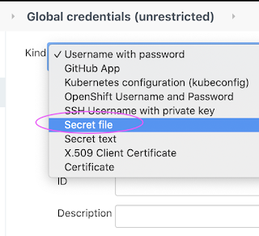](https://1.bp.blogspot.com/-VX04gi20B8E/X76hQHviluI/AAAAAAAADJ8/7gHidkJgNIUR9Y6nLa2N9le12SBMzbgNwCLcBGAsYHQ/s700/kube%2Bconfig.png)

 Click on browse

[[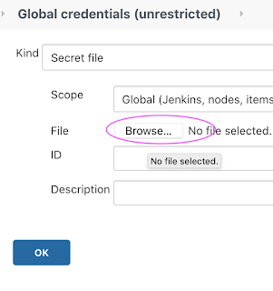](https://1.bp.blogspot.com/-WH6_xk04MoU/X76hQAwD8QI/AAAAAAAADJ4/AHT6UbnFDoApHs2welkJqEUpRNnDfNqdACLcBGAsYHQ/s726/kube%2Bconfig1.png)](https://1.bp.blogspot.com/-WH6_xk04MoU/X76hQAwD8QI/AAAAAAAADJ4/AHT6UbnFDoApHs2welkJqEUpRNnDfNqdACLcBGAsYHQ/s726/kube%2Bconfig1.png)

Upload kube config and enter id as ID kubeconfig-raw

**[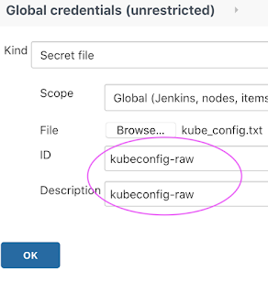](https://1.bp.blogspot.com/-Toiz7yQzPQ0/X76h1q8Gg2I/AAAAAAAADKI/E5QtlbXJ39srlqM3l_R_mowt00-643QdQCLcBGAsYHQ/s712/kube-config3.png)**

Use the below and save the same file as kubeconfig-raw then upload the file in Jenkins as secrete file

apiVersion: v1

clusters:

- cluster:

certificate-authority-data: 

server: https://B582220F1025A2EBE8EB698F2DE00EC7.gr7.us-east-1.eks.amazonaws.com

name: eks2.us-east-1.eksctl.io

contexts:

- context:

cluster: eks2.us-east-1.eksctl.io

user: i-0756e7e1fd02c360e@eks2.us-east-1.eksctl.io

name: i-0756e7e1fd02c360e@eks2.us-east-1.eksctl.io

current-context: i-0756e7e1fd02c360e@eks2.us-east-1.eksctl.io

kind: Config

preferences: {}

users:

- name: i-0756e7e1fd02c360e@eks2.us-east-1.eksctl.io

user:

exec:

apiVersion: client.authentication.k8s.io/v1beta1

args:

- eks

- get-token

- --output

- json

- --cluster-name

- eks2

- --region

- us-east-1

command: aws

env:

- name: AWS_STS_REGIONAL_ENDPOINTS

value: regional

provideClusterInfo: false

