
http://iringtools.org

SDK Guide
Version 1.02.01

Notice
This is a controlled document. Unauthorized access, copying, replication or usage for a purpose other than for which it is intended, are prohibited.
All trademarks that appear in the document have been used for identification purposes only and belong to their respective companies.

Document Release Note
Notice No.: 1.0
Customer: iRINGUserGroup
Project: iRINGTools

Document details
Name | Version no. | Description
iRINGTools SDK Guide | 1.02.01 | iRINGTools SDK Guide

Reviewers
L | Role | Organization Unit
Lee Colson | Documentation | iRINGTools
Hahn Le | Software Engineer | iRINGTools

Revision details
Action taken  (add/del/change) | Previous  page no. | New page no. | Revision description

Terms of License
Copyright (c) 2009, iringug.org
All rights reserved.
Redistribution and use in source and binary forms, with or without modification, are permitted provided that the following conditions are met:
* Redistributions of source code must retain the above copyright notice, this list of conditions and the following disclaimer.
* Redistributions in binary form must reproduce the above copyright notice, this list of conditions and the following disclaimer in the documentation and/or other materials provided with the distribution.
* Neither the name of the iringug.org nor the names of its contributors may be used to endorse or promote products derived from this software without specific prior written permission.
THIS DOCUMENT IS PROVIDED BY iringug.org ''AS IS'' AND ANY EXPRESS OR IMPLIED WARRANTIES, INCLUDING, BUT NOT LIMITED TO, THE IMPLIED WARRANTIES OF MERCHANTABILITY AND FITNESS FOR A PARTICULAR PURPOSE ARE DISCLAIMED. IN NO EVENT SHALL iringug.org BE LIABLE FOR ANY DIRECT, INDIRECT, INCIDENTAL, SPECIAL, EXEMPLARY, OR CONSEQUENTIAL DAMAGES (INCLUDING, BUT NOT LIMITED TO, PROCUREMENT OF SUBSTITUTE GOODS OR SERVICES; LOSS OF USE, DATA, OR PROFITS; OR BUSINESS INTERRUPTION) HOWEVER CAUSED AND ON ANY THEORY OF LIABILITY, WHETHER IN CONTRACT, STRICT LIABILITY, OR TORT (INCLUDING NEGLIGENCE OR OTHERWISE) ARISING IN ANY WAY OUT OF THE USE OF THIS SOFTWARE, EVEN IF ADVISED OF THE POSSIBILITY OF SUCH DAMAGE.

Document Revision List
Customer: iRINGUserGroup
Project: iRINGTools
Document Name: iRING SDK Guide

Release Notice Reference (for release)
Rev. No. | Revision date | Revision description | Page no. | Previous page no. | Action taken | Addenda/New page | Release notice reference

About this Manual

Purpose
iRINGTools is a set of free, public domain, open source (BSD 3 license) software applications and utilities that implement iRING protocols. iRINGTools provide users with production ready deployable solutions. iRINGTools also provides technology solution providers with usage patterns for the implementation of iRING protocols in their respective solutions. This SDK Guide provides step by step detail instructions for how to create and deploy a custom DataLayer with iRINGTools.

Intended Audience
Intended audience for this installation guide is iRINGUserGroup, an open online community of users, companies, and organizations that use, are considering using, or are developing or deploying iRING protocols. The iRINGUserGroup is also responsible for the management, enhancement, and maintenance of iRINGTools and iRINGSandbox.

Organization of the Manual
Information in this manual has been organized as follows:
Table 1: Organization of this Manual
Chapter | Description
Chapter 1 | This gives brief overview of iRINGTools and its components, packages involved, package dependencies, prerequisites and list of software components required for the individual package (the adaptor, the Sandbox or both) installation.
Chapter 2 | This section provides detailed instructions for the installation and configuration of each prerequisite i.e. IIS, .Net Framework 3.5 SP1, Silverlight MIME extensions, Application Extension Mapping and SQL Server.
Chapter 3 | This section describes the iRINGTools Sandbox components and provide detailed instructions on how to install and configure each component i.e. Sandbox Service, Reference Data Service, Reference Data Editor.
Chapter 4 | This section describes the iRINGTools Adapter components and provide detailed instructions on how to install and configure each component i.e. Interface Service, Adapter Service, Mapping Editor.
Chapter 5 | The final step in the installation is updating hostname in certain iRINGTools services for use with client browsers on the network

Contents
List of Abbreviations xi
1 Overview 12
1.1 Packages 12
1.2 Package Dependencies 13
1.3 Prerequisites 13
1.4 Preparing for Installation 14
1.4.1 Downloads 14
1.4.2 Internet Access 15
1.4.3 RDS-WIP Access 15
1.4.4 Sandbox Access 15
2 Installing Prerequisites 16
2.1 Internet Information Services 16
2.2 .NET Framework 3.5 SP 1 18
2.3 Validate IIS and ASP.NET 19
2.4 Silverlight MIME Extensions 24
2.5 Application Extension Mapping for SemWeb 29
2.6 SQL Server 32
3 Installation iRINGTools Sandbox 33
3.1 iRINGTools Sandbox Components 33
3.2 Localhost versus Server Hostname 34
3.3 Installing Sandbox Service 34
3.4 Creating Sandbox Storage 41
3.5 Configuring Sandbox Service 41
3.6 Testing Sandbox Service 41
3.7 Creating Virtual Directory for RefDataService 44
3.8 Configuring Reference Data Service 49
3.8.1 Creating Credential Tokens 49
3.8.2 Modify Reference Data Service Web.config 49
3.8.3 Modify Reference Data Service Repsitories.xml 53
3.9 Testing Reference Data Service 54
3.10 Creating Virtual Directory for Reference Data Editor 55
3.11 Configuring the Reference Data Editor 61
3.12 Testing Reference Data Editor 61
4 Installing iRINGTools Adapter 63
4.1 iRINGTools Adapter Components 63
4.2 Localhost versus Server Hostname 63
4.3 Creating the AdapterService Virtual Directory 64
4.4 Creating the MappingEditor Virtual Directory 69
4.5 Installing Interface Service 75
4.6 Creating iRING Storage 81
4.7 Configuring Interface Service 81
4.8 Testing Interface Service 81
4.9 Creating the Test Database 84
4.10 Configuring the AdapterService 87
4.11 Testing the AdapterService 92
4.12 Testing the Mapping Editor 95
5 Hostname Setup 97
5.1 iRINGTools Sandbox 97
5.2 iRINGTools Adapter 98

The total number of pages in this document, including the cover page, is 18.

List of Abbreviations

Acronym | Description
iRING | ISO 15926 Realtime Interoperability Network Grid
ISO | International Organization for Standardization
RDSWIP | Reference Data Service Work in Progress
SP | Service Pack
GUI | Graphical User Interface
IIS | Internet Information Services
MIME | Multipurpose Internet Mail Extensions
OLTP | Online Transaction Processing
API | Application Programming Interface
CRUD | Create, Read, Update and Delete
LAN | Local Area Network
FIPS | Federal Information Processing Standard

- Overview
iRING is a set of information interoperability and integration protocols and reference data that are compliant with the ISO 15926, Parts 7, 8, and 9 standards, which builds and depends on ISO 15926 Parts 1 through 6.
iRINGTools is a set of free, public domain, open source (BSD 3 license) software applications and utilities that implement iRING protocols. iRINGTools provide users with production ready deployable solutions. iRINGTools also provides technology solution providers with usage patterns for the implementation of iRING protocols in their respective solutions.
Besides the native NHibernate data layer, which interacts directly with a database, the iRINGAdapter is extendable with custom data layers to handle other sources of data, such as an API, Excel, CSV file, etc. This document provides step by step detail instructions for how to create and deploy a custom DataLayer with iRINGTools Adapter.
  - Adapter Framework
iRINGTools is deployed in two packages, iRINGTools Adapter and iRINGTools Sandbox. These packages are separated for deployment purposes. This allows implementers to only download and install the necessary components. The iRINGTools Adapter is used to map and transform legacy data to ISO 15926 representation. The iRINGTools Sandbox is used to host local Reference Data or extend the reference data hosted in the RDSWIP (http://rdswip.ids-adi.org/presentation/overview/index.html) for use with the iRINGTools Adapter. The iRINGTools Adapter uses reference data from configured Sandboxes as well as the RDSWIP.
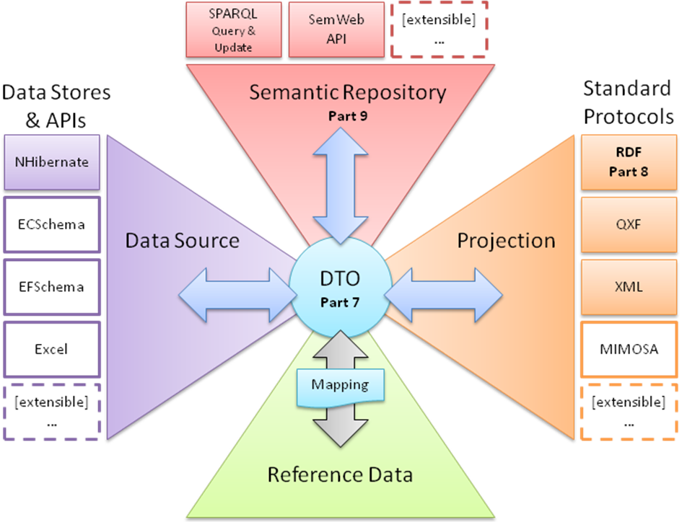
Neither package requires the other to run. You need to determine which packages will be installed and where. For test purposes, it is recommended that both packages be installed on a single machine. Virtual machines can be used to host iRINGTools, but it is not required.

  - NHibernate DataLayer
Though each package is independent of the other, the iRINGTools Adapter needs access to an iRINGTools Sandbox.
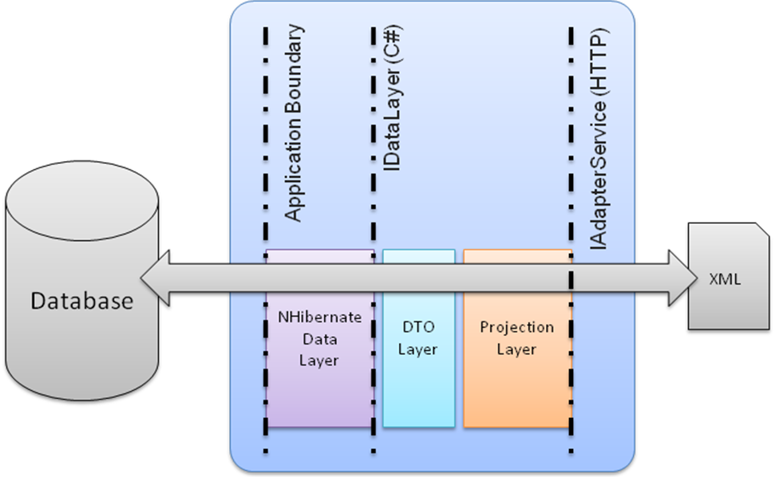
If only the iRINGTools Adapter will be deployed, then it will require internet access to connect to an existing iRINGTools Sandbox (e.g. iRING community Sandbox). If both packages will be deployed, it is assumed that the iRINGTools Adapter will use the reference data in the iRINGTools Sandbox. In this case, the iRINGTools Adapter will connect directly to the iRINGTools Sandbox being deployed (e.g. a private Sandbox). The iRINGTools Sandbox will require internet access to connect to the RDSWIP.
  - Custom DataLayer
There are several prerequisites and assumptions that are made in this guide. Some instructions are provided for setting up and configuring the prerequisites, but the instructions may not handle every case. Please see the documentation links provided in the section for each prerequisite for more information.
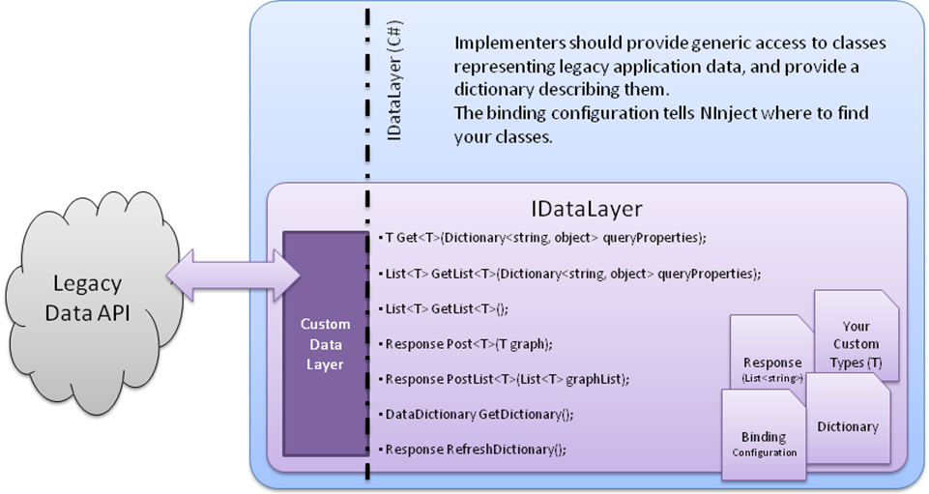
The base assumptions made are:
- The host server is running Windows Server 2003 SP2.
- You have administrative access to the host server.
- You are able to login to the graphical user interface on the host server.
- You have basic knowledge of the Windows Operating System and Windows Security.
Older and newer versions of windows are supported, but the installation and configuration may be slightly (and subtly) different for those versions. No instructions will be given on how to properly secure the operating system or the files on the host server. However, instructions will be provided on how to use the specific features of the operating system to properly install iRINGTools.
There are several essential software components required by iRINGTools. These are:
- .NET Framework 3.5 SP1
- Internet Information Services 6.0
You should understand these systems and how they work before attempting to install iRINGTools.
Finally, iRINGTools is built on top of Semantic Web, called SemWeb http://razor.occams.info/code/semweb/
Although this guide will provide the instructions necessary to install and configure the software components, you need to be aware of the technologies are being used. Below is a summary of the iRINGTools and prerequisite installations.
Software Component | Adapter | Sandbox | Remarks
iRINGTools Components 1.02.00 | X | X | Use for both adapter and sandbox
iRINGTools Adapter 1.02.00 | X |  | Use if installing adapter only
iRINGTools Sandbox 1.02.00 |  | X | Use if installing sandbox only
.NET Framework 3.5 SP 1 | X | X
Internet Information Services | X | X
SQL Server | X | X
Application Extension Mapping | X | X
Silverlight MIME Extensions | X | X
Silverlight 3.0 | X | X
  - Preparing for Installation
Before beginning the installation, you need to decide which iRINGTools packages you are installing on the server: the adapter, the sandbox or both. This determines which prerequisites and downloads are needed.
    - Downloads
Download iRINGTools Components from the iRINGTools web site: http://code.google.com/p/iring-tools/downloads/list.
Alternately, if you are installing only the adapter or sandbox then you can download one of the following:
- iRINGTools Adapter (for adapter only installations)
- iRINGTools Sandbox (for sandbox only installations)
Unzip the downloaded file to a folder on the server called iRINGWeb. (The target folder must be iRINGWeb to ensure files are properly merged.)
The following are example screenshots of the above steps:
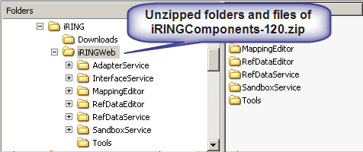
Other software packages may also be required. Installation links and instructions will be provided if and when necessary.
    - Internet Access
iRINGTools is a web-enabled system and therefore requires access to the internet to work properly. If the host server is behind a firewall, the proxy server information and valid proxy credentials will be needed later in the setup.
    - RDS-WIP Access
Access to the RDSWIP (http://rdswip.ids-adi.org/presentation/overview/index.html) is required for the iRINGTools Sandbox to generate new IDs for classes, templates and roles. An identity from ids-adi.org will be needed later in the setup.
    - Sandbox Access
If there are any existing iRINGTools Sandboxes that will be used by the iRINGTools Adapter being deployed, then the URLs for those iRINGTools Sandboxes will need to be entered into the configuration later.

- Installing Prerequisites
The

