
http://iringtools.org

Users Guide
Version 2.00.01

Terms of License
Copyright (c) 2009-2011, iringug.org
All rights reserved.
Redistribution and use in source and binary forms, with or without modification, are permitted provided that the following conditions are met:
* Redistributions of source code must retain the above copyright notice, this list of conditions and the following disclaimer.
* Redistributions in binary form must reproduce the above copyright notice, this list of conditions and the following disclaimer in the documentation and/or other materials provided with the distribution.
* Neither the name of the iringug.org nor the names of its contributors may be used to endorse or promote products derived from this software without specific prior written permission.
THIS DOCUMENT IS PROVIDED BY iringug.org ''AS IS'' AND ANY EXPRESS OR IMPLIED WARRANTIES, INCLUDING, BUT NOT LIMITED TO, THE IMPLIED WARRANTIES OF MERCHANTABILITY AND FITNESS FOR A PARTICULAR PURPOSE ARE DISCLAIMED. IN NO EVENT SHALL iringug.org BE LIABLE FOR ANY DIRECT, INDIRECT, INCIDENTAL, SPECIAL, EXEMPLARY, OR CONSEQUENTIAL DAMAGES (INCLUDING, BUT NOT LIMITED TO, PROCUREMENT OF SUBSTITUTE GOODS OR SERVICES; LOSS OF USE, DATA, OR PROFITS; OR BUSINESS INTERRUPTION) HOWEVER CAUSED AND ON ANY THEORY OF LIABILITY, WHETHER IN CONTRACT, STRICT LIABILITY, OR TORT (INCLUDING NEGLIGENCE OR OTHERWISE) ARISING IN ANY WAY OUT OF THE USE OF THIS SOFTWARE, EVEN IF ADVISED OF THE POSSIBILITY OF SUCH DAMAGE.

Contents
List of Abbreviations v
1 Overview 6
2 Reference Data Repositories 7
3 Reference Data Editor 9
3.1 Purpose 9
3.2 Reference Data Editor Layout 9
3.3 Search Reference Data 10
3.4 Reset 12
3.5 Promote 12
3.6 Add Class 13
3.7 Edit Class 13
3.8 Add Template 13
3.9 Edit Template 13
4 Application Data Dictionary 14
5 Mapping Editor 19
5.1 Mapping Editor Layout 19
5.2 Information Model 19
5.3 Open Project and Application 20
5.4 Create Graph Map 21
5.5 Mapping with Property Templates 23
5.6 Mapping with Value Lists 27
5.7 Mapping with Relationship Templates 29
6 Performing Data Exchanges 33
6.1 Later Error! Bookmark not defined.

The total number of pages in this document, including the cover page, is 35.

List of Abbreviations

Acronym | Description
iRING | ISO 15926 Realtime Interoperability Network Grid
ISO | International Organization for Standardization
RDSWIP | Reference Data Service Work in Progress
SP | Service Pack
GUI | Graphical User Interface
IIS | Internet Information Services
MIME | Multipurpose Internet Mail Extensions
OLTP | Online Transaction Processing
API | Application Programming Interface
CRUD | Create, Read, Update and Delete
LAN | Local Area Network
FIPS | Federal Information Processing Standard

- Overview
iRING is a set of information interoperability and integration protocols and reference data that are compliant with the ISO 15926, Parts 7, 8, and 9 standards, which builds and depends on ISO 15926 Parts 1 through 6.
iRINGTools is a set of free, public domain, open source (BSD 3 license) software applications and utilities that implement iRING protocols. iRINGTools provide users with production ready deployable solutions. iRINGTools also provides technology solution providers with usage patterns for the implementation of iRING protocols in their respective solutions.
This user guide provides detailed instructions for using iRINGTools Reference Data Editor and Mapping Editor.
- Reference Data Repositories
The default installation of Sandbox has three reference data repositories:
- My Private Sandbox – Development Sandbox (writable)
- ReferenceData – RDS/WIP Part 4 Reference Data Library (read-only)
- Templates – RDS/WIP Part 7 Template Library (read-only)
- TemporaryIntialsSetandProtoTemplate-Part 7 Template Library (read-only)
The repositories are defined in the Repositories.xml file located in the Services/XML folder.
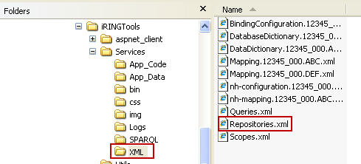

To add, change or delete repositiories, open the Repositories.xml in an XML editor and change as necessary. See example below.

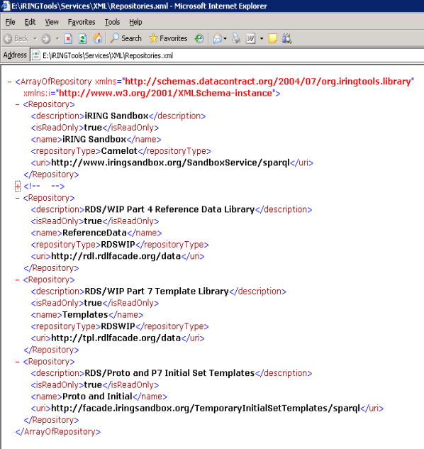
- Reference Data Editor
The following sections will provide detailed instructions for using the Reference Data Editor.
  - Purpose
The purpose of the Reference Data Editor is to search and manage reference data in connected repositories.
  - Reference Data Editor Layout
The mapping editor is arranged into four sections as shown below.
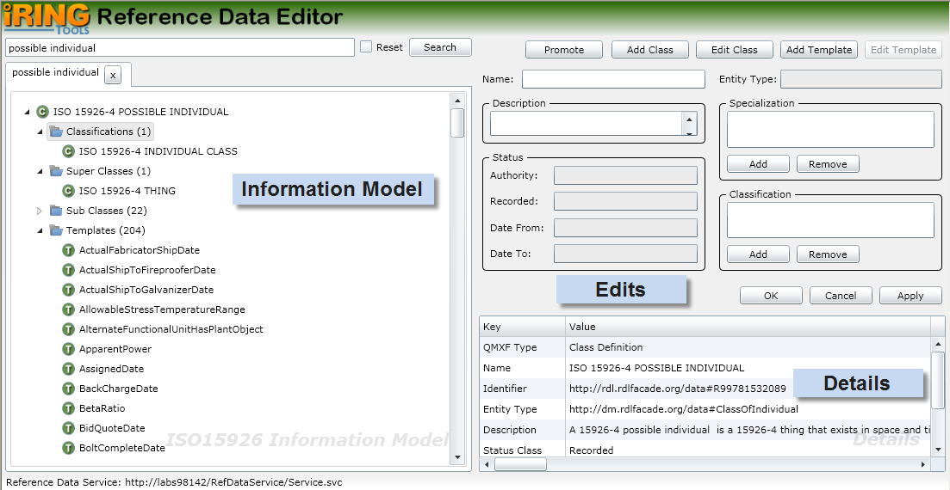
Information Model displays the search results for ISO 15926 classes and templates of connected repositories.
Edits is where you add and edit your classes and templates.
Details displays detail information about what you currently have selected. The content in the Details changes based on the last selected item from the other editor sections.

  - Search Reference Data
To search reference data, enter part or all of the class or template to search in the top left text box and then click the Search button.
Note: Only the top 100 search items displayed. If the item you want does not appear in the list, then a more explicit search needs to be done (e.g., entire name using regular expressions such as ^control valve$; the ^ means the expression starts with what follows and the $ means the expression ends with what precedes).
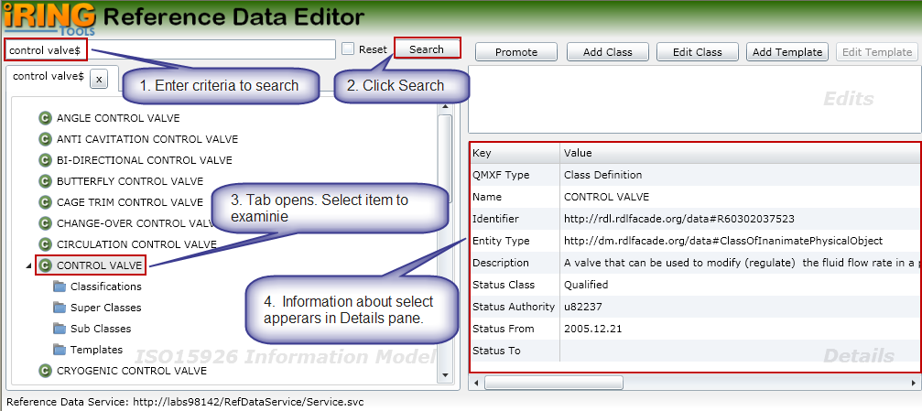
For class results, you can also examine the classifications, super classes, sub classes, and templates. The following is a brief description of each.
Classifications – The selected class is a member of classes listed in Classifications
Super Classes – The selected class is specialized from the classes listed in Super Classes
Sub Classes – The classes listed in Sub Classes are specialized from the selected class
Template – The templates listed have a role type using the selected class
To view, expand the desired class node and select the item to examine. If it contains any items, a count will appear the right and you can expand the item to view the details. In the following example, a CONTROL VALVE has 3 Classifications, 1 Super Class, 28 Sub Classes and 8 Templates.
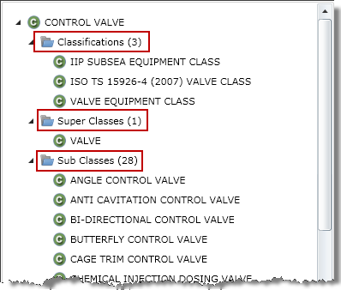
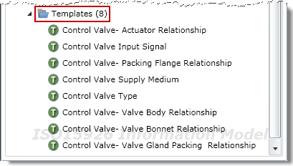
  - Reset

Reference data search items are cached to improve performance. If you know or suspect changes have been made to the reference data repositories, you can update the cache by checking the Reset box and then searching again.
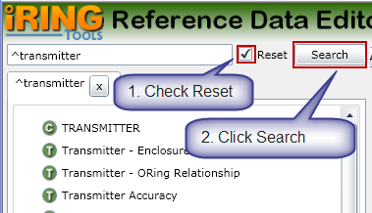
  - Promote
The Promote feature lets you open a new tab with the selected itemed as the root. This is useful when you navigate through several nested items and want the selected item to be in the root.
To promote an item, select the item and then click the Promote button. A new tab will open with that item in the root.
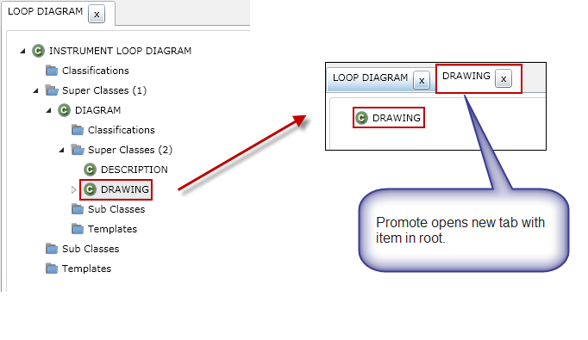
  - Add Class
To add a new class, perform the following:
- In the Reference Data Editor, click the Add Class button.
- Enter a name for the new class.
- Enter a description for the class.
- Add classes that the new class is specialized from.
- Add classifications that the new class is a member of.
- Click the OK button.
- The class will be added to the first writable repository in the reference data system.
  - Edit Class
To edit an existing class, perform the following:
- In the Reference Data Editor, search for and select the class to be edited.
- Click the Edit Class button.
- Change the Name, Description, Specialization and/or Classification as necessary.
- Click the OK button.
- The class will be updated if the repository is writable.
  - Add Template
To add a new temple, perform the following:
- In the Reference Data Editor, click the Add Template button.
- Enter a name for the new template.
- Enter a description for the template.
- Add roles as necessary in the Role Definition panel.
- Click the OK button.
- The template will be added to the first writable repository in the reference data system.
  - Edit Template
To edit an existing template, perform the following:
- In the Reference Data Editor, search for and select the template to be edited.
- Click the Edit Template button.
- Change the Name, Description, and/or Role Definitions as necessary.
- Click the OK button.
- The template will be updated if the repository is writable.

- Application Data Dictionary
The following are detailed instructions for creating an iRINGTools application data dictionary using the NHibernate data layer. Other data layers are outside the scope of this guide.
- From the iRINGTools home page, select Application Editor.
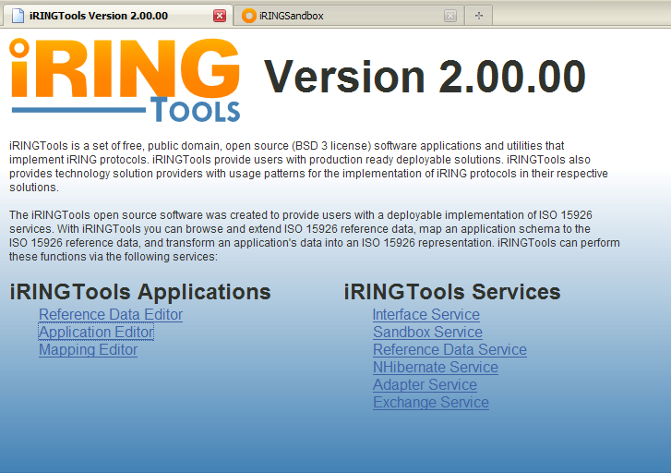
- In the Application Editor, enter the Project Name, Project Description, Application Name and Application Description, and then click the Add button.
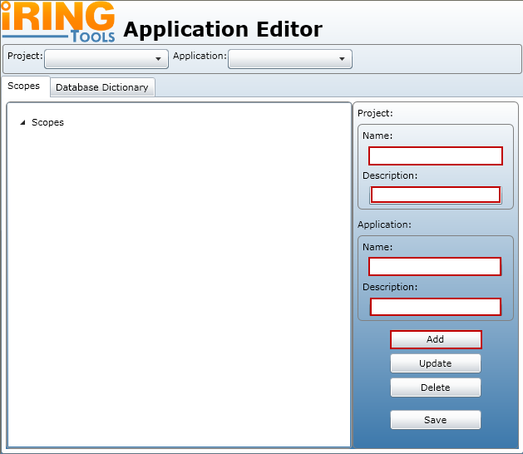
- The Scope will be created and added to the Scope configuration. The new Scope should appear under Scopes.
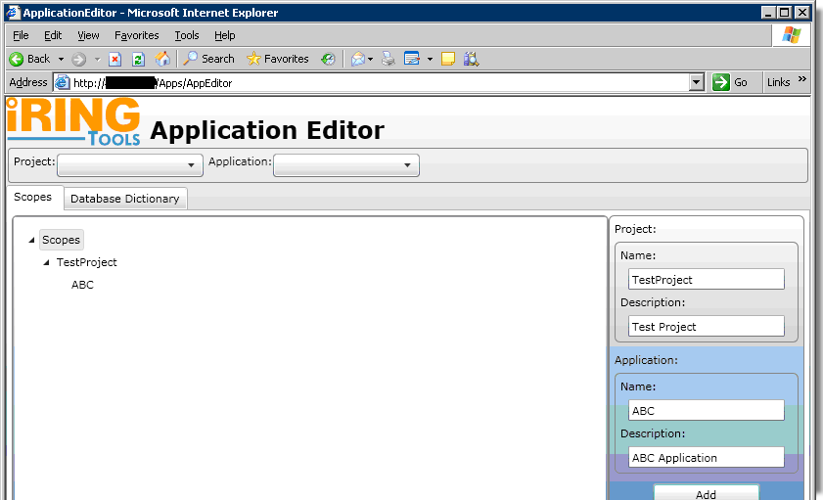
- Select the Database Dictionary tab.
- Select the Project and Application from the dropdown lists.
- Then edit the database connection information. Click the Save button, and a dialog should appear indicating the connection information was saved to the empty Database Dictionary.
- Then click the Fetch button and the available schema objects should appear under Available Database Schema Items.
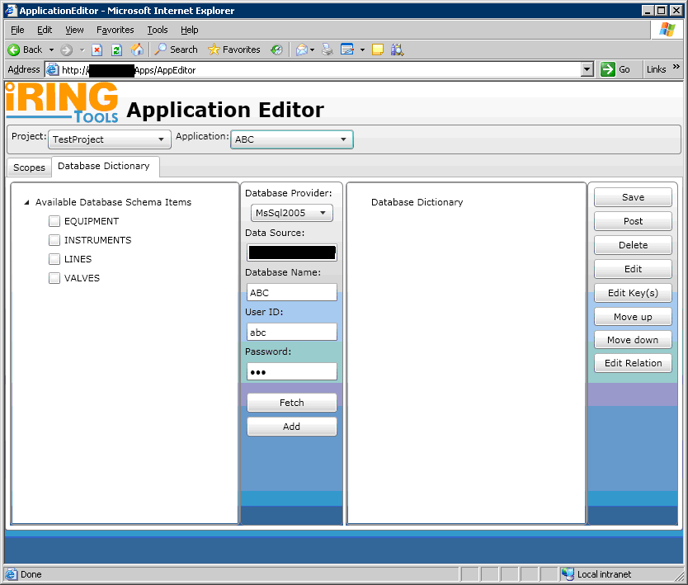
- Select the schema objects you want to add to the Database Dictionary by clicking the checkbox for each one you want, and then clicking the Add button.
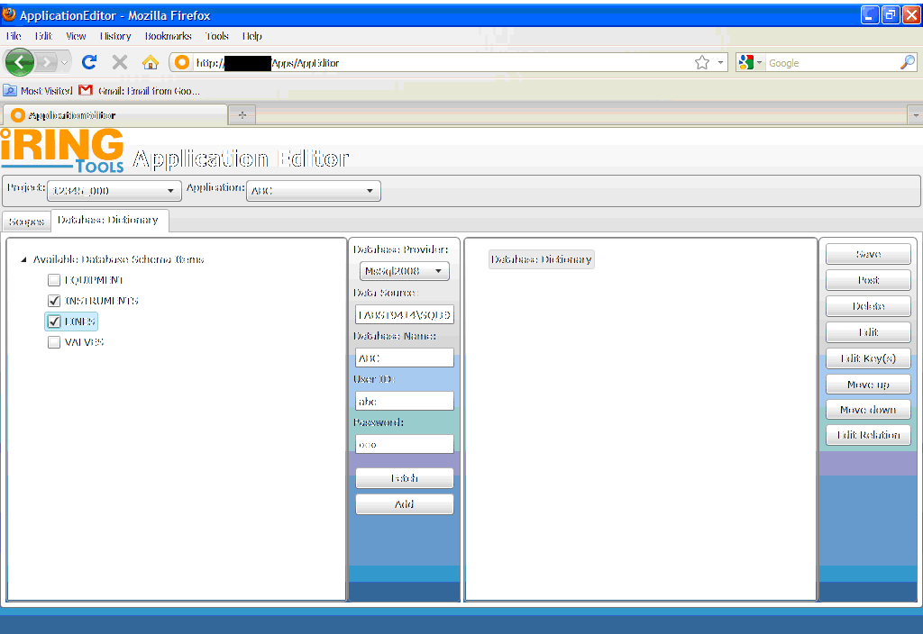
- Review the properties, keys and relationships that were found for each object. Properties may be removed, and relationships may be added. Once all desired changes have been made, click the Save button.
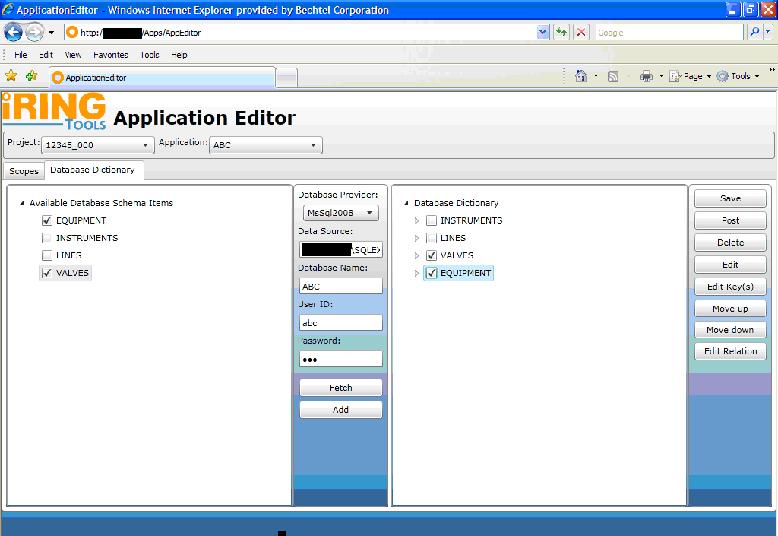
- A message will appear indicating the operation is complete. Close and then click the Post button to apply your changes to the Adapter.

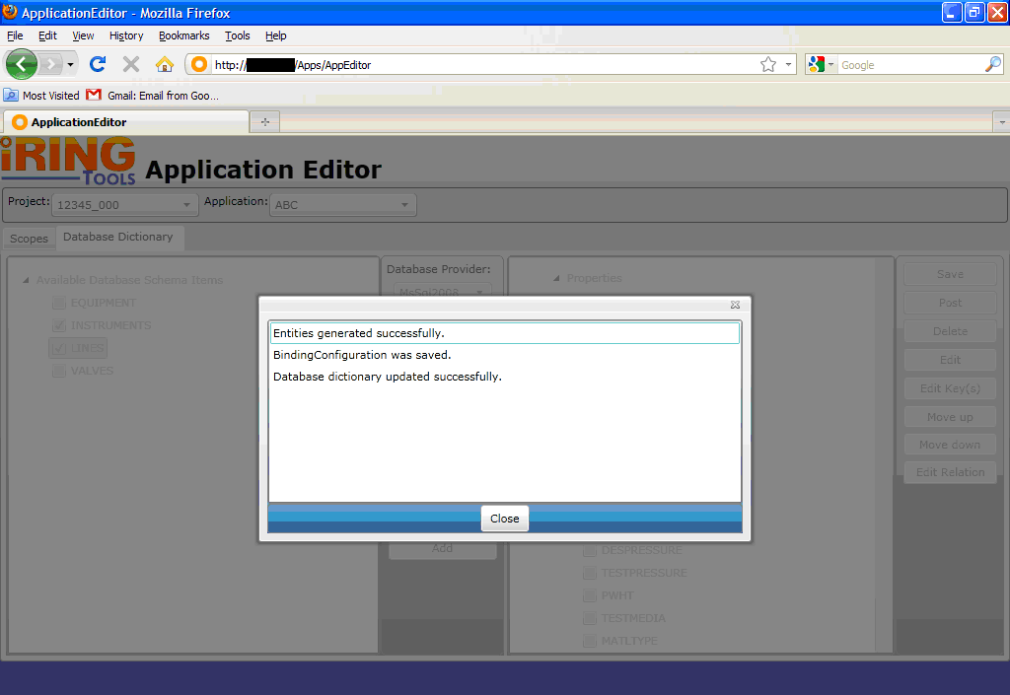

- Mapping Editor
The following sections will describe how to map application data using the iRINGTools Mapping Editor.
Note: The techniques and methodology outlined in this section are not the only way to map ISO 15926 reference data to application data, but does represent one way that is presently being used.
  - Mapping Editor Layout
The mapping editor is arranged into four sections as shown below.
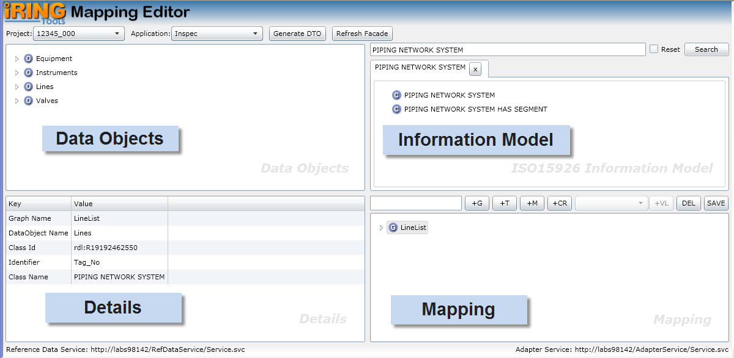
Data Objects represents the data dictionary of your application database.
Information Model is the ISO 15926 classes and templates available for you to map.
Mapping is where you build and edit you data map.
Details displays detail information about what you currently have selected. The content in the Details changes based on the last selected item from the other editor sections.
  - Information Model
The Information Model section lets you search and select ISO 15926 classes and templates to use in mapping. It operates the same as described in the Search Reference Data portion of this manual. Refer to that section for details on how to search and select ISO 15926 classes and templates.

  - Open Project and Application
Open the project and application to map by performing the following:
- Ensure the data dictionary for the application has been generated for the application per Application Data Dictionary section in this document.
- Using your browser, open the mapping editor by entering that address:
http://<hostname>/MappingEditor/Default.aspx
Where <hostname> is the name of the server hosting the iRINGTools mapping editor.
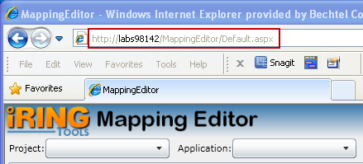
- Select the project from the Project dropdown list.
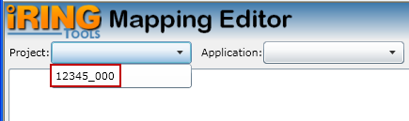
- Select the application from the Application dropdown list.
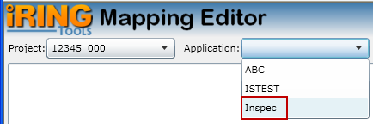
  - Create Graph Map
A graph map specifies how ISO 15926 reference data is mapped to your application database and is used in data exchanges. Create a graph map by performing the following:
Note: Prevent possible data loss by frequently saving your graph by clicking the SAVE button on the Mapping toolbar.
- Determine the class that aligns with the data map being created, search for it in the Information Model pane, and then select the result.
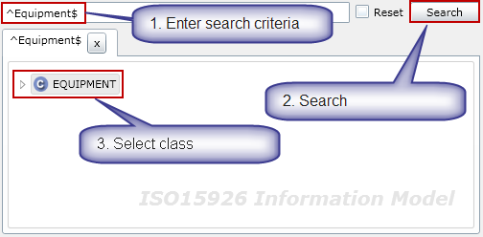
- In the Data Objects pane, select the entity (table) being mapped and its identifier (i.e., the column that uniquely identifies the table such as tag number).
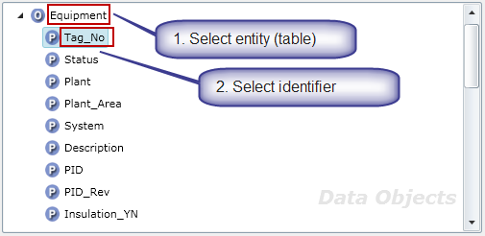
- In the Mapping pane, enter the name of the graph and create a new graph map by clicking on the +G button on the Mapping toolbar.
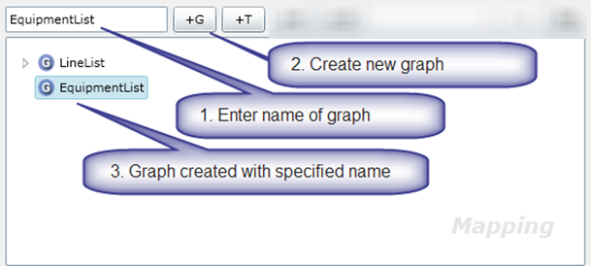
- In the Mapping pane, click on the graph name. The graph details appear in the Details pane.
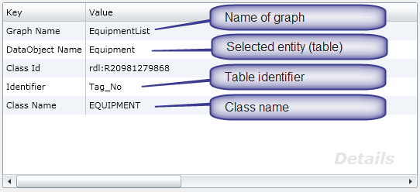
- Save the graph by clicking on the Save button on the Mapping pane toolbar.
Note: If you do not see the Save button on the toolbar, you may need to resize your browser until it appears.
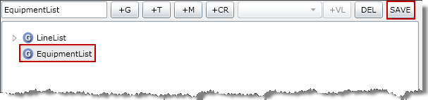
  - Mapping with Property Templates
A property template maps an ISO 15926 reference data class to your application database.
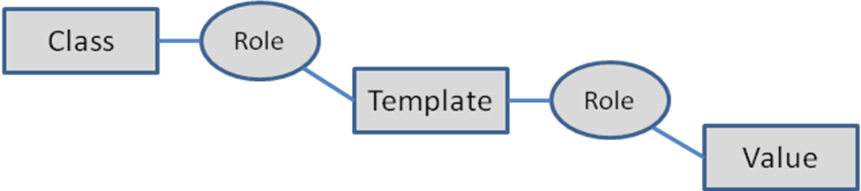
Map a property template by performing the following:
- Determine the property template that will be used, search for it in the Information Model pane, and then select the result.
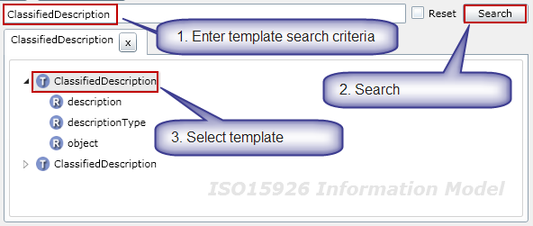
- The selected template name appears in the Mapping pane. Select the graph to map the identifier and then click the +T button on the toolbar.
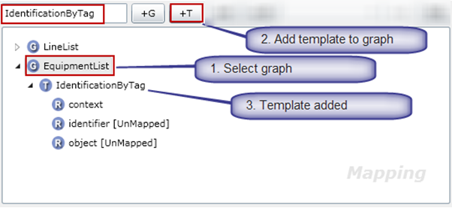
- Expand the graph to select the added template. Expand the added template to display the roles.
- Notice the role “context” is already mapped because it is a fixed role. (It is mapped because there is no [UnMapped] status next to it). The role “context”, in this case, has been specialized to the role TAG NAME. (Hence, the purpose for the template.)
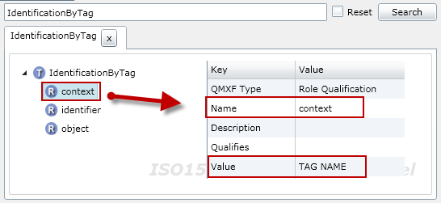
- Every template will have a processor role (which is a role pointing to the class). In this template, the role “object” is point to the class “TAGGED ITEM”. Thus, the role “object” is the processor role for the IdentificationByTag template.
- In the Mapping pane, assign the role “object” to the processor role by selecting the role “object” and then clicking the +PR button on the toolbar.
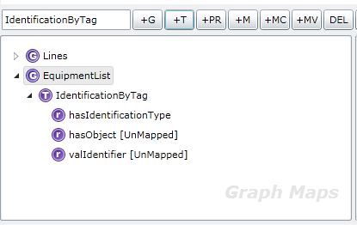
- Note the role “object” immediately disappears from the graph template role list.
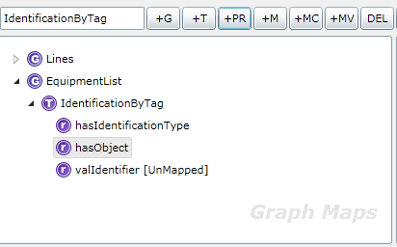
The final role “identifier” now needs to be mapped to the application entity (table) identifier column.
- In the Data Objects pane, select the entity (table) identifier column.
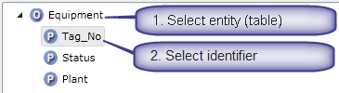
- In the Mapping pane, map the role to application by selecting the role “identifier” then clicking the +M button on the toolbar.
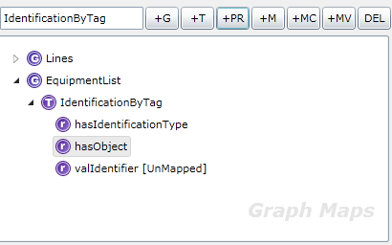
- The role identifier is now mapped because there is no [UnMapped] status next to it.
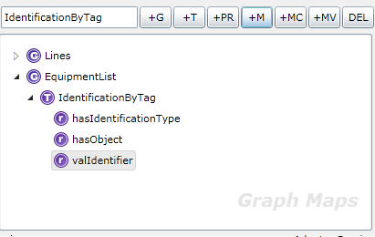
- This completes the mapping for the IdentificationByTag template. Save the graph by clicking on the Save button on the Mapping pane toolbar.
  - Mapping with Value Lists
Value Lists provide a way to set values from a predefined list. The classic example is the units of measure for various engineering parameters (e.g., pressure and temperature units). In addition to specifying the list of values, the system can be used to translate values at different endpoints. For example, one endpoint may express pressure as kPa and another may express pressure as kilopascal. Both are valid and data exchanges will properly translate the value at the endpoint. Note that value lists will not convert numerical values from one measurement system to another (e.g., 1 PSI to 6.894 kPa).
To map a value list in a graph map, perform the following:
- In Information Model pane search for valid class (e.g., Temperature) and select it.
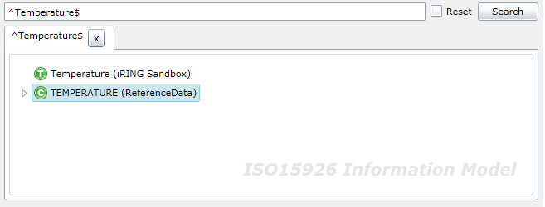
- Enter the Value List name click on +VL which will add Value list name in Value List Pane.
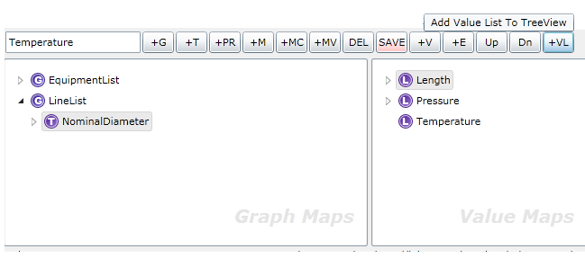
To add values to the value list, perform the following:
- In Information Model pane search for valid class (e.g., Degree Celsius) and select it.
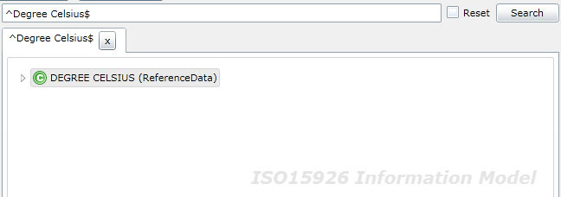
- Enter the Value name click on +V which will add Value name under Value List.
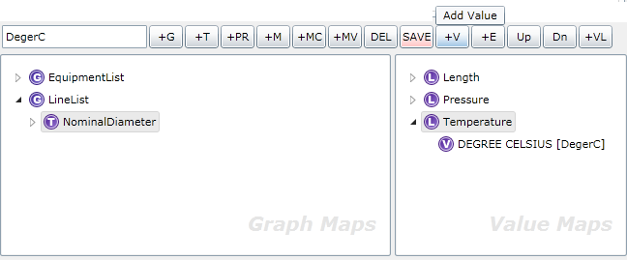
- Select the Value List pane select the desired Value List item and then in mapping pane select the role that will be assigned a Value List map.
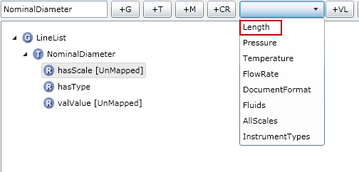
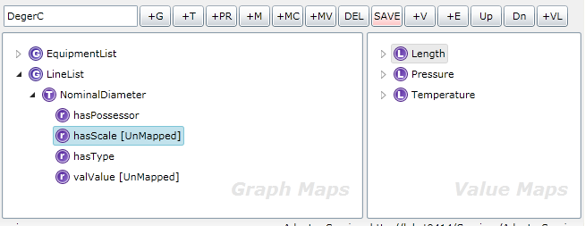
- Click the +MV button to map the specified Value List item.
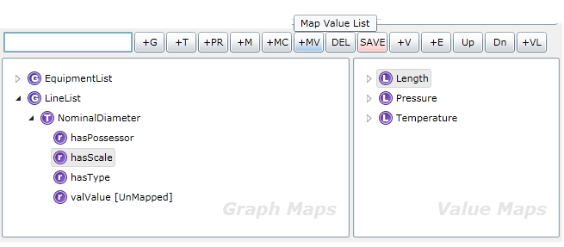
- The role identifier is now mapped because there is no [UnMapped] status next to it.
This completes the mapping for the Value List. Save the graph by clicking on the Save button on the Mapping pane toolbar
  - Mapping with Relationship Templates
Relationship templates are templates whose purpose is to relate one class to another. An example is a process line and line insulation. Each, as a class, has their own characteristics (or properties), but they are also related (i.e., a line may have insulation).
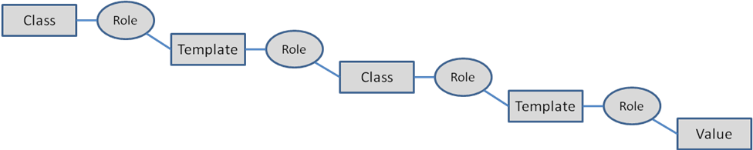
To map a relationship template, perform the following:
- In the Mapping pane, select the template role that has a class relationship.
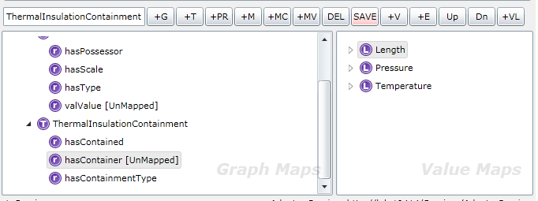
- Get the class for the role relationship by searching for the template again in the Information Model pane and select it.
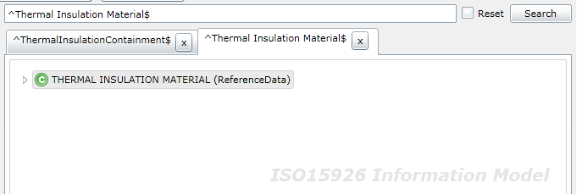
- Select the role with the relationship and finally click Map Class which will add the class under that role.
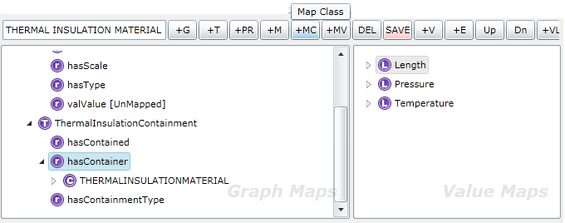
- Map additional templates to the class.
- Determine the property template that will be used, search for it in the Information Model pane, and then select the result.
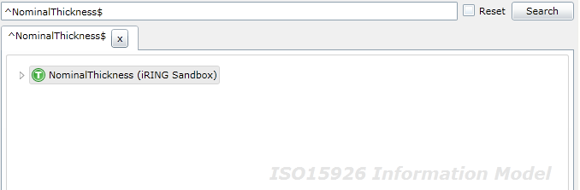
- The selected template name appears in the Mapping pane. With the class selected, click the +T button on the toolbar to map the template to the class.
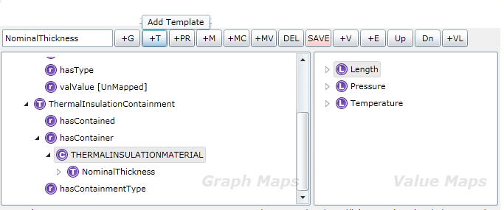
- Additional templates can now be mapped to the related class.
- Continue mapping the added template as described earlier as well as adding other templates as necessary.

- Performing Data Exchanges
The following sections will describe how to perform a data exchange using iRINGTools Façade Exchange Utility shown below. It can be found in the Utils folder.
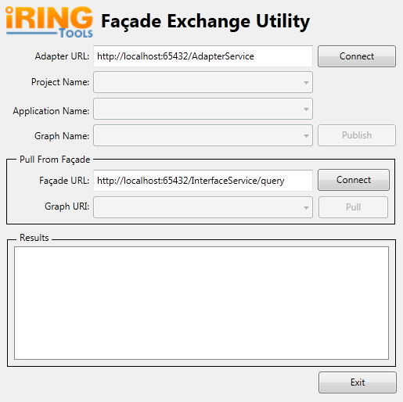
  - Connect to Adapter
Enter the URL for the iRINGTools Adapter, and click the Connect button.
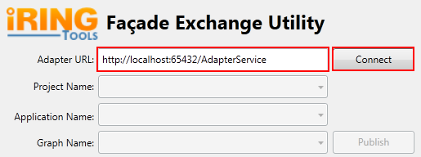
The results panel will be updated and will display the following when completed.
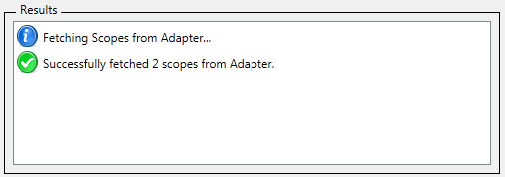
  - Publish to own Façade
Select the Project, Application, and Graph to publish and click the Publish button.
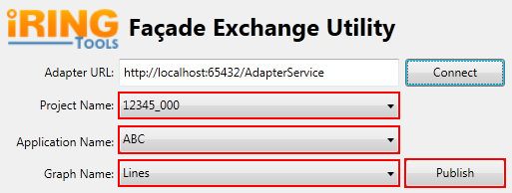
The results panel will be updated and will display the following when completed.
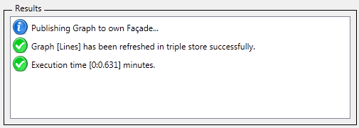
  - Connect to remote Facade
Enter the URL for the remote Façade, and click the Connect button.
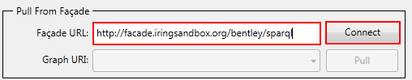
The results panel will be updated and will display the following when completed.
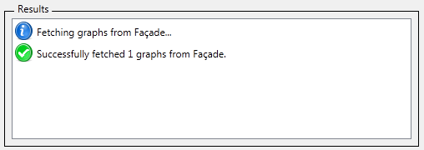
  - Pull from remote Façade
Select the Graph to pull data from, and click the Pull button.
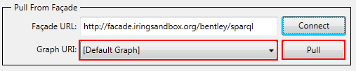
The results panel will be updated and will display the following when completed.
