
http://iringtools.org

Users Guide
Version 2. 1.00

Terms of License
Copyright (c) 2009-2011, iringug.org
All rights reserved.
Redistribution and use in source and binary forms, with or without modification, are permitted provided that the following conditions are met:
* Redistributions of source code must retain the above copyright notice, this list of conditions and the following disclaimer.
* Redistributions in binary form must reproduce the above copyright notice, this list of conditions and the following disclaimer in the documentation and/or other materials provided with the distribution.
* Neither the name of the iringug.org nor the names of its contributors may be used to endorse or promote products derived from this software without specific prior written permission.
THIS DOCUMENT IS PROVIDED BY iringug.org ''AS IS'' AND ANY EXPRESS OR IMPLIED WARRANTIES, INCLUDING, BUT NOT LIMITED TO, THE IMPLIED WARRANTIES OF MERCHANTABILITY AND FITNESS FOR A PARTICULAR PURPOSE ARE DISCLAIMED. IN NO EVENT SHALL iringug.org BE LIABLE FOR ANY DIRECT, INDIRECT, INCIDENTAL, SPECIAL, EXEMPLARY, OR CONSEQUENTIAL DAMAGES (INCLUDING, BUT NOT LIMITED TO, PROCUREMENT OF SUBSTITUTE GOODS OR SERVICES; LOSS OF USE, DATA, OR PROFITS; OR BUSINESS INTERRUPTION) HOWEVER CAUSED AND ON ANY THEORY OF LIABILITY, WHETHER IN CONTRACT, STRICT LIABILITY, OR TORT (INCLUDING NEGLIGENCE OR OTHERWISE) ARISING IN ANY WAY OUT OF THE USE OF THIS SOFTWARE, EVEN IF ADVISED OF THE POSSIBILITY OF SUCH DAMAGE.

Contents
List of Abbreviations iv
1 Overview 5
2 Reference Data Repositories 6
3 Reference Data Editor 8
3.1 Purpose 8
3.2 Reference Data Editor Layout 8
3.3 Search Reference Data 9
3.4 Reset 11
3.5 Promote 11
3.6 Add Class 12
3.7 Edit Class 12
3.8 Add Template 12
3.9 Edit Template 12
4 Application Data Dictionary 13
6 Performing Data Exchanges 22
6.1 Later Error! Bookmark not defined.

The total number of pages in this document, including the cover page, is 24.

List of Abbreviations

Acronym | Description
iRING | ISO 15926 Realtime Interoperability Network Grid
ISO | International Organization for Standardization
RDSWIP | Reference Data Service Work in Progress
SP | Service Pack
GUI | Graphical User Interface
IIS | Internet Information Services
MIME | Multipurpose Internet Mail Extensions
OLTP | Online Transaction Processing
API | Application Programming Interface
CRUD | Create, Read, Update and Delete
LAN | Local Area Network
FIPS | Federal Information Processing Standard

- Overview
iRING is a set of information interoperability and integration protocols and reference data that are compliant with the ISO 15926, Parts 7, 8, and 9 standards, which builds and depends on ISO 15926 Parts 1 through 6.
iRINGTools is a set of free, public domain, open source (BSD 3 license) software applications and utilities that implement iRING protocols. iRINGTools provide users with production ready deployable solutions. iRINGTools also provides technology solution providers with usage patterns for the implementation of iRING protocols in their respective solutions.
This user guide provides detailed instructions for using iRINGTools Reference Data Editor and Mapping Editor.
- Reference Data Repositories
The default installation of Sandbox has three reference data repositories:
- My Private Sandbox – Development Sandbox (writable)
- ReferenceData – RDS/WIP Part 4 Reference Data Library (read-only)
- Templates – RDS/WIP Part 7 Template Library (read-only)
- TemporaryIntialsSetandProtoTemplate-Part 7 Template Library (read-only)
The repositories are defined in the Repositories.xml file located in the Services/XML folder.
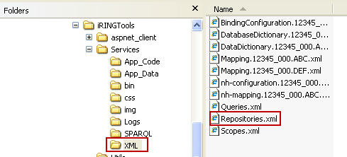

To add, change or delete repositiories, open the Repositories.xml in an XML editor and change as necessary. See example below.

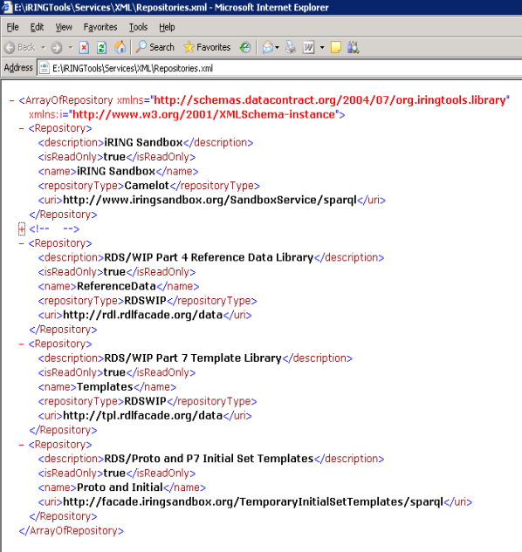
- Reference Data Editor
The following sections will provide detailed instructions for using the Reference Data Editor.
  - Purpose
The purpose of the Reference Data Editor is to search and manage reference data in connected repositories.
  - Reference Data Editor Layout
The mapping editor is arranged into four sections as shown below.
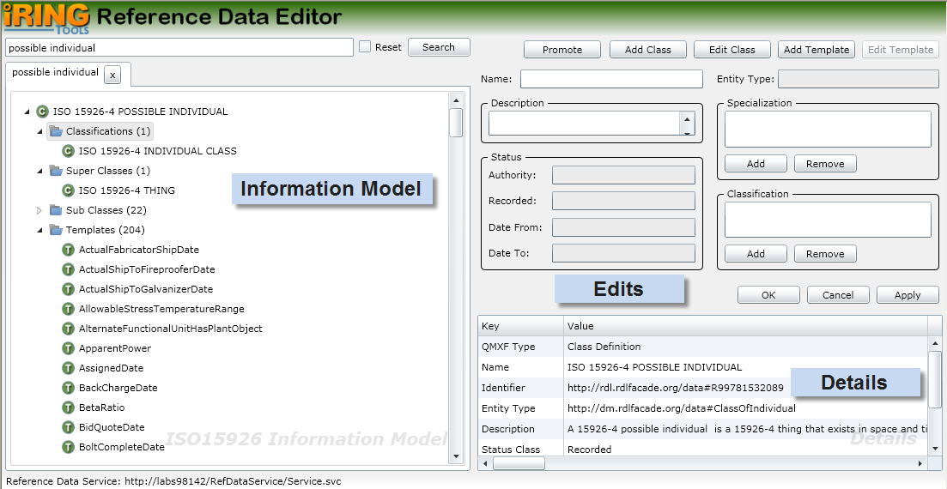
Information Model displays the search results for ISO 15926 classes and templates of connected repositories.
Edits is where you add and edit your classes and templates.
Details displays detail information about what you currently have selected. The content in the Details changes based on the last selected item from the other editor sections.

  - Search Reference Data
To search reference data, enter part or all of the class or template to search in the top left text box and then click the Search button.
Note: Only the top 100 search items displayed. If the item you want does not appear in the list, then a more explicit search needs to be done (e.g., entire name using regular expressions such as ^control valve$; the ^ means the expression starts with what follows and the $ means the expression ends with what precedes).
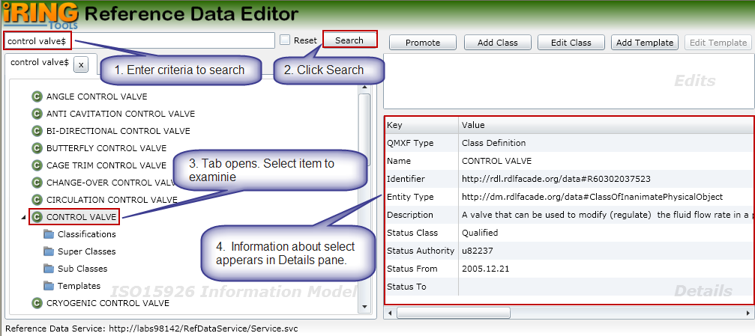
For class results, you can also examine the classifications, super classes, sub classes, and templates. The following is a brief description of each.
Classifications – The selected class is a member of classes listed in Classifications
Super Classes – The selected class is specialized from the classes listed in Super Classes
Sub Classes – The classes listed in Sub Classes are specialized from the selected class
Template – The templates listed have a role type using the selected class
To view, expand the desired class node and select the item to examine. If it contains any items, a count will appear the right and you can expand the item to view the details. In the following example, a CONTROL VALVE has 3 Classifications, 1 Super Class, 28 Sub Classes and 8 Templates.
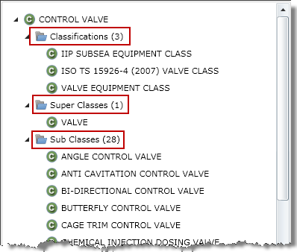
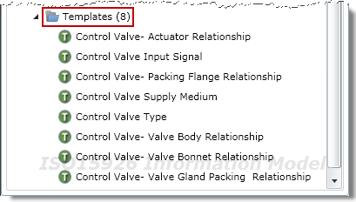
  - Reset

Reference data search items are cached to improve performance. If you know or suspect changes have been made to the reference data repositories, you can update the cache by checking the Reset box and then searching again.
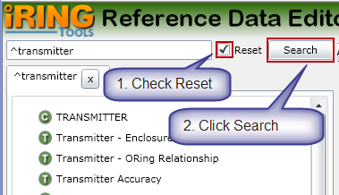
  - Promote
The Promote feature lets you open a new tab with the selected itemed as the root. This is useful when you navigate through several nested items and want the selected item to be in the root.
To promote an item, select the item and then click the Promote button. A new tab will open with that item in the root.
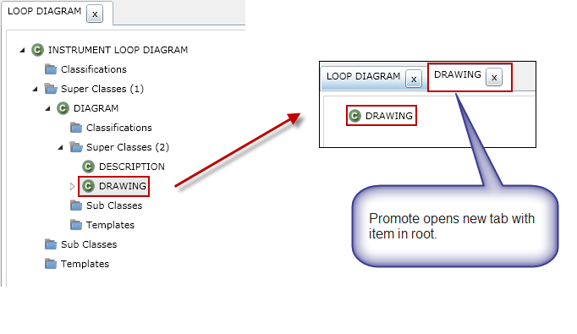
  - Add Class
To add a new class, perform the following:
- In the Reference Data Editor, click the Add Class button.
- Enter a name for the new class.
- Enter a description for the class.
- Add classes that the new class is specialized from.
- Add classifications that the new class is a member of.
- Click the OK button.
- The class will be added to the first writable repository in the reference data system.
  - Edit Class
To edit an existing class, perform the following:
- In the Reference Data Editor, search for and select the class to be edited.
- Click the Edit Class button.
- Change the Name, Description, Specialization and/or Classification as necessary.
- Click the OK button.
- The class will be updated if the repository is writable.
  - Add Template
To add a new temple, perform the following:
- In the Reference Data Editor, click the Add Template button.
- Enter a name for the new template.
- Enter a description for the template.
- Add roles as necessary in the Role Definition panel.
- Click the OK button.
- The template will be added to the first writable repository in the reference data system.
  - Edit Template
To edit an existing template, perform the following:
- In the Reference Data Editor, search for and select the template to be edited.
- Click the Edit Template button.
- Change the Name, Description, and/or Role Definitions as necessary.
- Click the OK button.
- The template will be updated if the repository is writable.

- Application Data Dictionary
The following are detailed instructions for creating an iRINGTools application data dictionary using the NHibernate data layer. Other data layers are outside the scope of this guide.
- From the iRINGTools home page, select Adapter Manager.
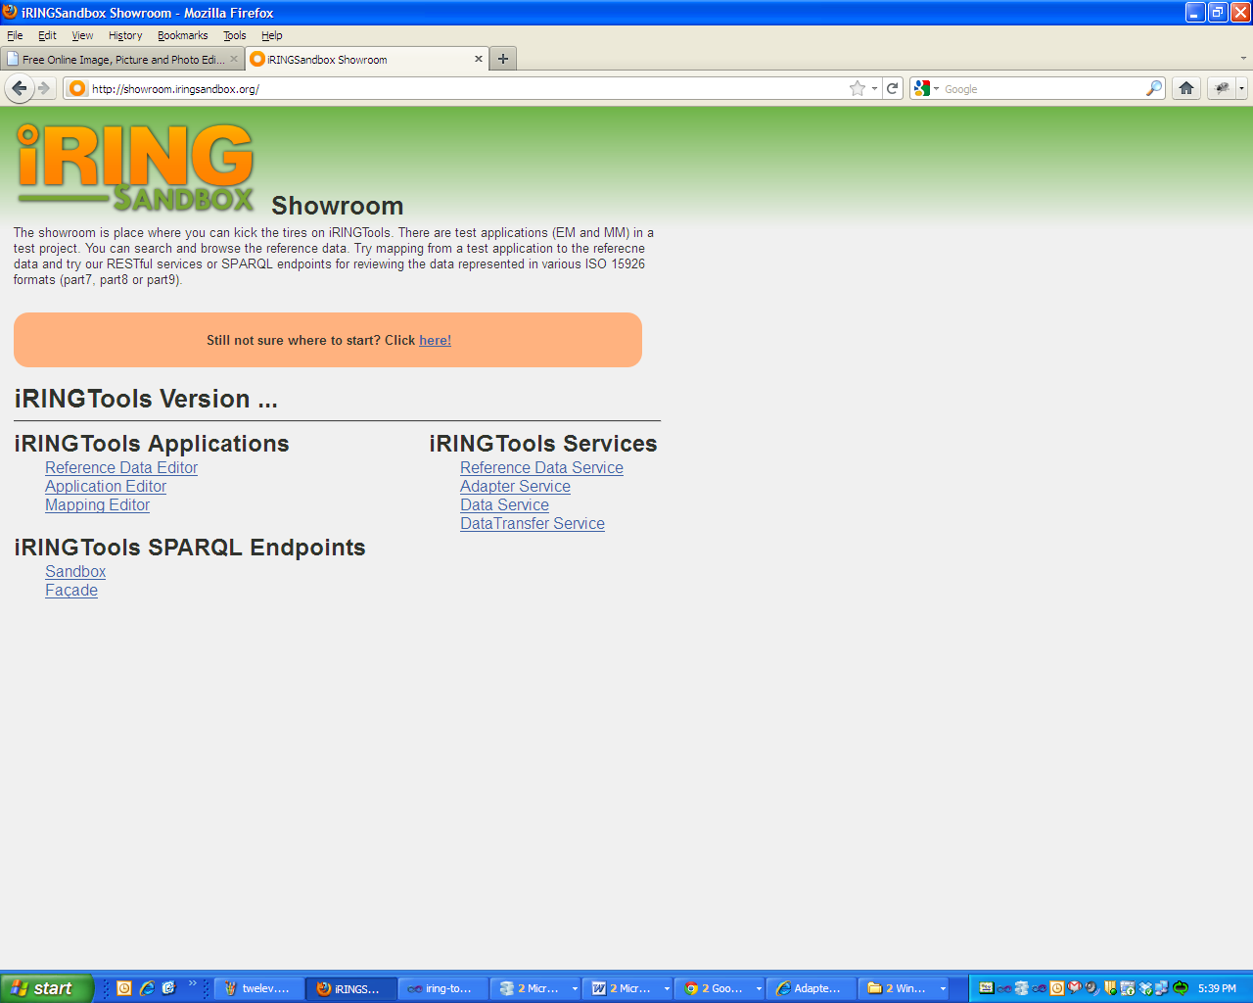
- Create Scope:-
  - In the Adapter Manager, right click on the Scopes, and select New Scopes.
  - Enter the Project Name, Project Description in the pop-up window, and then click the Ok button.
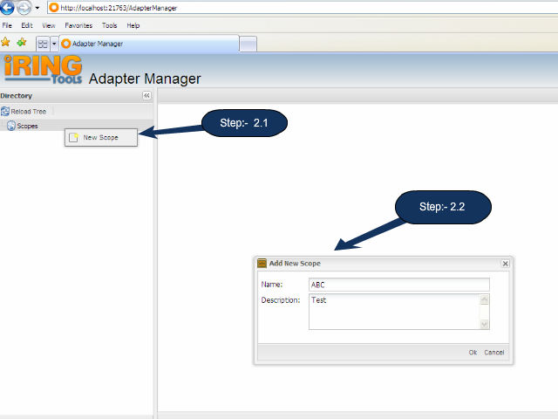
- Create Scope:-
  - In the Adapter Manager, right click on the newly created scope, and select New Application.
  - Enter the Application Name, Application Description and select appropriate datalayer from drop. In case of NHibernate datalayer select NHbernateLibaray and then click the Ok button.
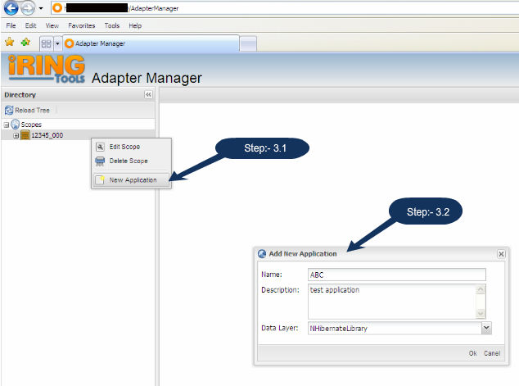
- Configure Application:-
  - Right click on the newly created Application and select Edit Configuration.
  - A new tab will open, provide the database connection information. Click the Connect button and the available schema objects should appear as multiselect option.
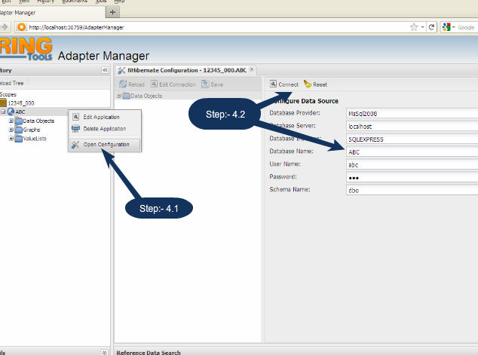
  - Click on the “Save” button. This will create DataDictionary.
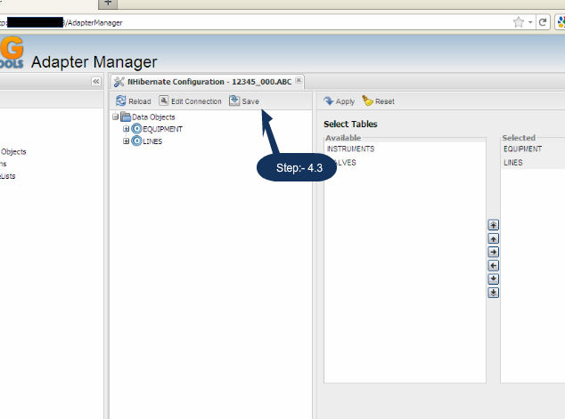
  - A message will appear indicating the operation is complete.
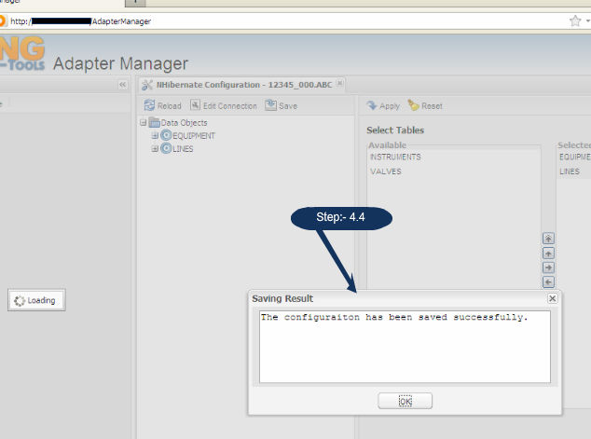

  - Select the “Properties” node form Data Objects tree, this will show a list of available properties which can be added on data dictionary. As shown in fig below
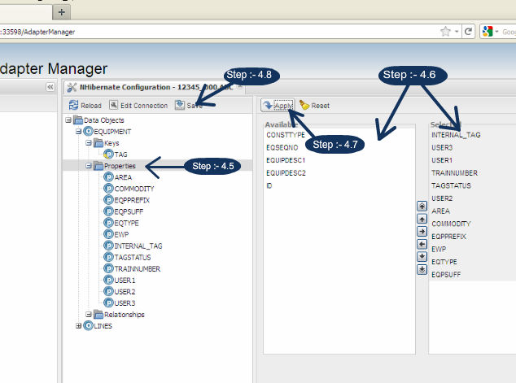
  - Create Relationship :-
    - Select the “Relationships” node form Data Objects tree.
    - Provide the inputs in the given form
    - Click on the “+Add” button given in the form.
    - For saving Relationship, click on the apply button and then Save button.
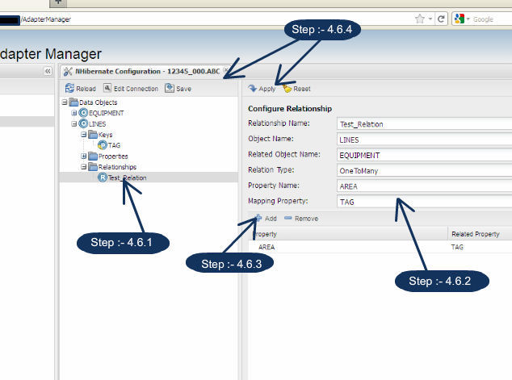
    - This will refresh the Data Objects. A message will appear indicating the operation is complete.
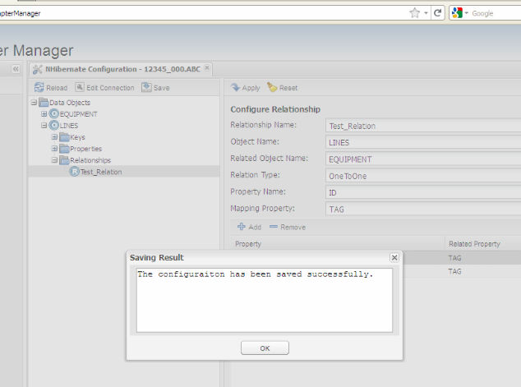
- Create Graph :-
  - Right click in one “Graphs” node in the Scope panel, and select “New GraphMap”
  - Determine the class that aligns with the data map being created, search for it in the Reference Data Search pane, and then select the result.
  - In the Data Objects tree node, select the entity (table) being mapped and its identifier (i.e., the column that uniquely identifies the table such as tag number).
  - In the Pop-Up appeared enter the name of the graph; drag the identifier and class to be mapped.
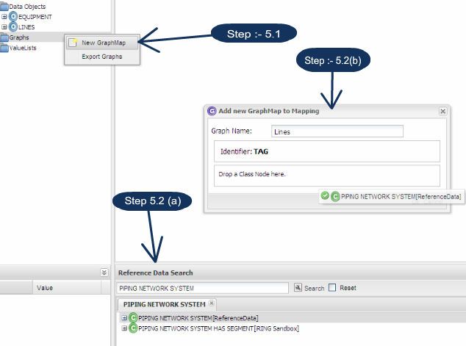
  - Mapping with Property Templates
A property template maps an ISO 15926 reference data class to your application database.
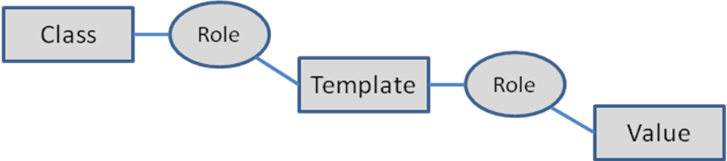
Map a property template by performing the following:
    - Right click on the newly created graph, and select “Open GraphMap”.
    - Determine the property template that will be used, search for it in the Search panel, and then select the result.
    - Drag the searched template into the graph in right pane (i.e Update Pane).
    - Every template will have a processor role (which is a role pointing to the class). In this template, the role “object” is point to the class “TAGGED ITEM”. Thus, the role “object” is the processor role for the IdentificationByTag template.
          - For mapping a role, right click on the role and map it as required.

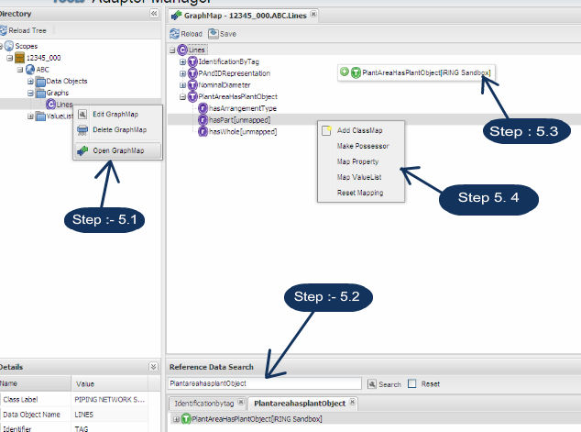

- Mapping with Value Lists:-
Value Lists provide a way to set values from a predefined list. The classic example is the units of measure for various engineering parameters (e.g., pressure and temperature units). In addition to specifying the list of values, the system can be used to translate values at different endpoints. For example, one endpoint may express pressure as kPa and another may express pressure as kilopascal. Both are valid and data exchanges will properly translate the value at the endpoint. Note that value lists will not convert numerical values from one measurement system to another (e.g., 1 PSI to 6.894 kPa).
To map a value list in a graph map, perform the following:
  - Right click in one “ValueLists” node in the Scope panel, and select “New ValueList”.
  - Provide the value list name in the pop-up appeared.
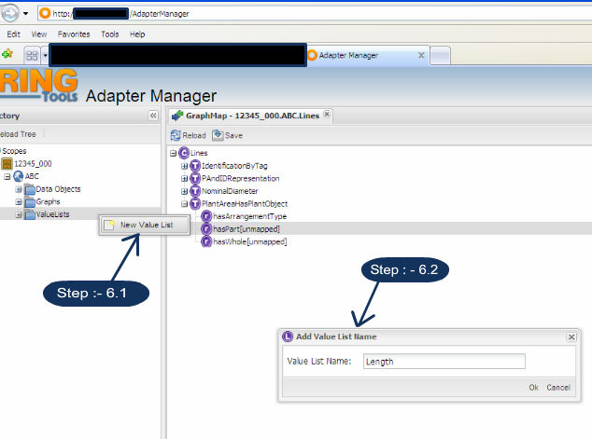
To add values to the value list, perform the following:
  - Right click on the newly created value list object, and select New Value Map.
  - In Search Panel search for valid class (e.g., Millimeter) and select it.
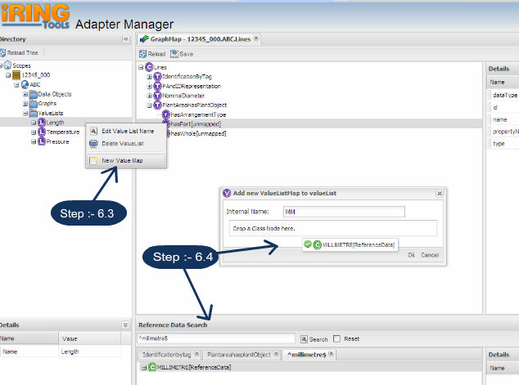
  - Right on the role to be mapped and select “Map ValueList”.
  - A pop-up will appere, in which you can drag the property node and the value list node. Then click Ok.
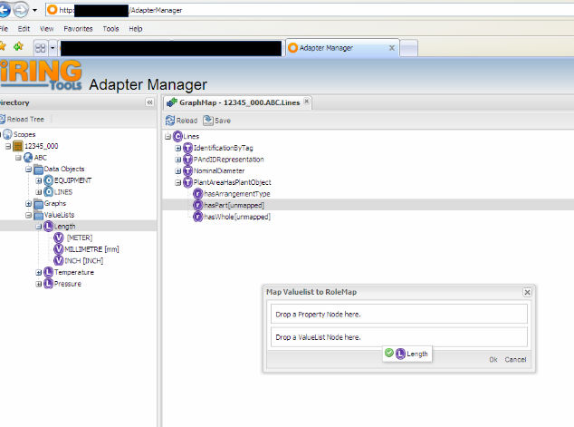

- Performing Data Exchanges
The following sections will describe how to perform a data exchange using iRINGTools Façade Exchange Utility shown below. It can be found in the Utils folder.
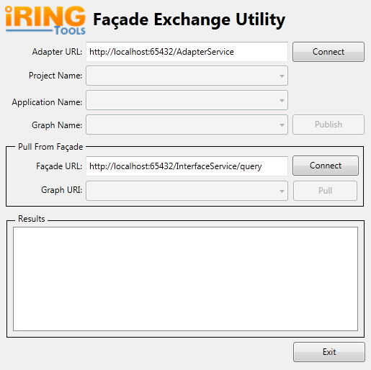
  - Connect to Adapter
Enter the URL for the iRINGTools Adapter, and click the Connect button.
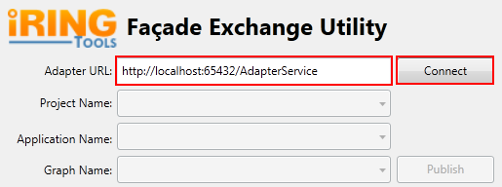
The results panel will be updated and will display the following when completed.
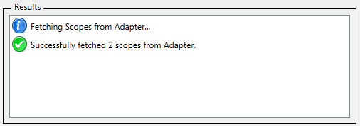
  - Publish to own Façade
Select the Project, Application, and Graph to publish and click the Publish button.
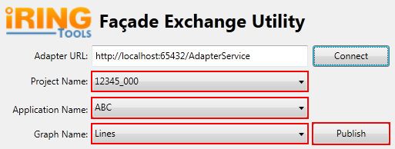
The results panel will be updated and will display the following when completed.
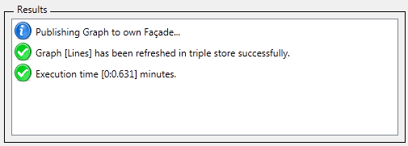
  - Connect to remote Facade
Enter the URL for the remote Façade, and click the Connect button.
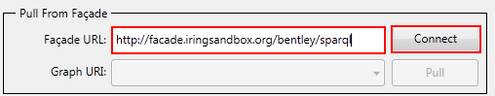
The results panel will be updated and will display the following when completed.
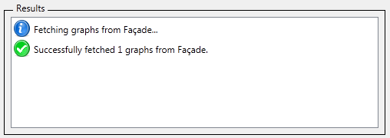
  - Pull from remote Façade
Select the Graph to pull data from, and click the Pull button.
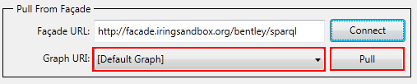
The results panel will be updated and will display the following when completed.
