
http://iringtools.org

Installation Guide
Version 2.00.00

Terms of License
Copyright (c) 2009-2010, iringug.org
All rights reserved.
Redistribution and use in source and binary forms, with or without modification, are permitted provided that the following conditions are met:
* Redistributions of source code must retain the above copyright notice, this list of conditions and the following disclaimer.
* Redistributions in binary form must reproduce the above copyright notice, this list of conditions and the following disclaimer in the documentation and/or other materials provided with the distribution.
* Neither the name of the iringug.org nor the names of its contributors may be used to endorse or promote products derived from this software without specific prior written permission.
THIS DOCUMENT IS PROVIDED BY iringug.org ''AS IS'' AND ANY EXPRESS OR IMPLIED WARRANTIES, INCLUDING, BUT NOT LIMITED TO, THE IMPLIED WARRANTIES OF MERCHANTABILITY AND FITNESS FOR A PARTICULAR PURPOSE ARE DISCLAIMED. IN NO EVENT SHALL iringug.org BE LIABLE FOR ANY DIRECT, INDIRECT, INCIDENTAL, SPECIAL, EXEMPLARY, OR CONSEQUENTIAL DAMAGES (INCLUDING, BUT NOT LIMITED TO, PROCUREMENT OF SUBSTITUTE GOODS OR SERVICES; LOSS OF USE, DATA, OR PROFITS; OR BUSINESS INTERRUPTION) HOWEVER CAUSED AND ON ANY THEORY OF LIABILITY, WHETHER IN CONTRACT, STRICT LIABILITY, OR TORT (INCLUDING NEGLIGENCE OR OTHERWISE) ARISING IN ANY WAY OUT OF THE USE OF THIS SOFTWARE, EVEN IF ADVISED OF THE POSSIBILITY OF SUCH DAMAGE.

Contents
List of Abbreviations iv
1 Overview 5
1.1 Components 5
1.2 Component Dependencies 6
1.3 Prerequisites 6
1.4 Preparing for Installation 7
1.4.1 Downloads 7
1.4.2 iRINGWeb Folder Permissions 7
1.4.3 Internet Access 10
1.4.4 RDS-WIP Access 10
1.4.5 Sandbox Access 10
2 Installing Prerequisites 11
2.1 Internet Information Services 11
2.2 .NET Framework 4.0 13
2.3 SQL Server 14
3 iRINGTools Website 15
3.1 Localhost versus Server Hostname 15
3.2 Installing Website 15
3.3 Create Virtual Directories 20
3.4 Silverlight MIME Extensions 28
3.5 Web.Config Setup 31
3.6 Creating the Test Database 32
3.7 Reset IIS 33
3.8 Final Tests 34
3.9 Hostname Setup 39

The total number of pages in this document, including the cover page is 41.
List of Abbreviations

Acronym | Description
iRING | ISO 15926 Realtime Interoperability Network Grid
ISO | International Organization for Standardization
RDSWIP | Reference Data Service Work in Progress
SP | Service Pack
GUI | Graphical User Interface
IIS | Internet Information Services
MIME | Multipurpose Internet Mail Extensions
OLTP | Online Transaction Processing
API | Application Programming Interface
CRUD | Create, Read, Update and Delete
LAN | Local Area Network
FIPS | Federal Information Processing Standard

- Overview
iRING is a set of information interoperability and integration protocols and reference data that are compliant with the ISO 15926, Parts 7, 8, and 9 standards, which builds and depends on ISO 15926 Parts 1 through 6.
iRINGTools is a set of free, public domain, open source (BSD 3 license) software applications and utilities that implement iRING protocols. iRINGTools provide users with production ready deployable solutions. iRINGTools also provides technology solution providers with usage patterns for the implementation of iRING protocols in their respective solutions.
This installation guide provides detailed instructions for the setup of iRINGTools. Once iRINGTools is setup, it will still need to be configured. Refer to the iRINGTools Users Guide for configuration.
  - Components
iRINGTools is deployed in a single package and includes both iRINGTools Services and iRINGTools Applications.

The iRINGTools Services includes RESTful web services that are hosted in IIS. These services provide the core of the functionality including reference data federation, data access, projection into various XML formats, and semantic repositories.

The iRINGTools Applications includes Silverlight applications that are also hosted in IIS. These applications enable the editing of reference data, scope, application, and mapping configuration and SPARQL query.

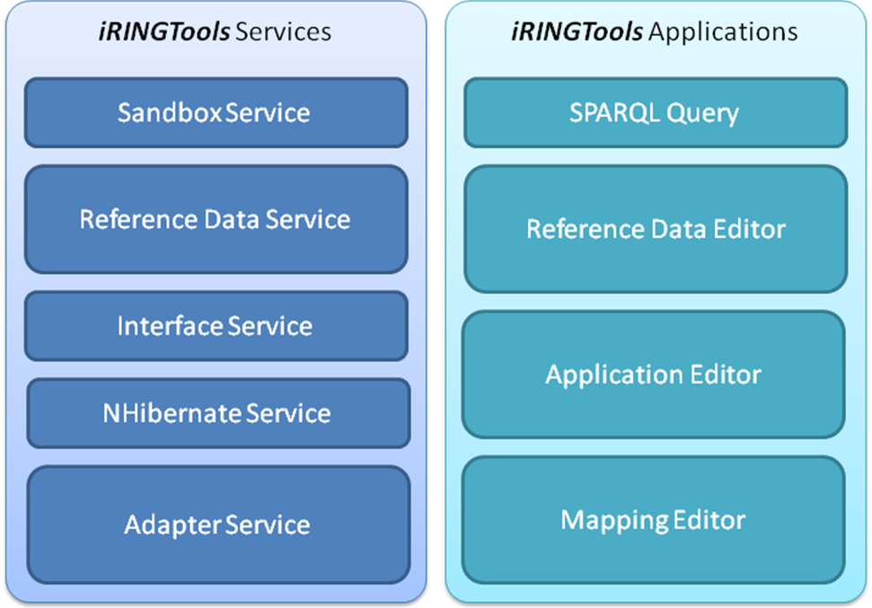
These packages work together, but do not need to be installed on the same web server. You need to determine which packages will be configured and where. It is easiest to install both packages on a single machine, but each can be installed on separate machines by deploying iRINGTools to each server and configuring accordingly. Virtual machines can also be used to host iRINGTools.
  - Component Dependencies
Though each component is independent of the other, the iRINGTools Applications needs access to an iRINGTools Services.
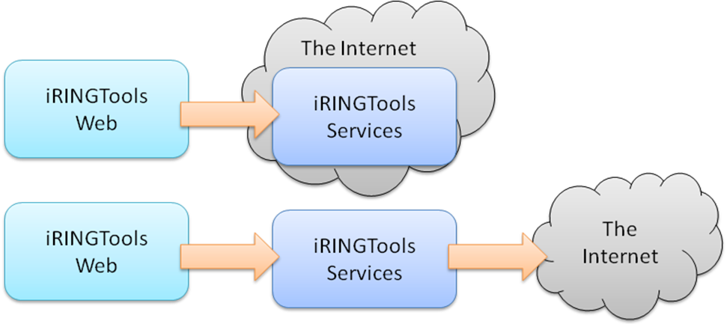
If only the iRINGTools Applications will be deployed, then it will require internet access to connect to an existing iRINGTools Services. The guide assumes that both packages will be deployed, and that the iRINGTools Applications will use the iRINGTools Services on the same machine.
  - Prerequisites
There are several prerequisites and assumptions that are made in this guide. Some instructions are provided for setting up and configuring the prerequisites, but the instructions may not handle every case. Please see the documentation links provided in the section for each prerequisite for more information.
The base assumptions made are:
- The host server is running Windows Server 2003 SP2.
- You have administrative access to the host server.
- You are able to login to the host server.
- You have basic knowledge of the Windows Operating System and Windows Security.
Older and newer versions of windows are supported, but the installation and configuration may be slightly (and subtly) different for those versions. No instructions will be given on how to properly secure the operating system or the files on the host server. However, instructions will be provided on how to use the specific features of the operating system to properly install iRINGTools.
The following software components are required for this installation:
Software Component | Remarks
iRINGTools Components | Use for both services and applications
.NET Framework 4.0
Internet Information Services | Versions 5.0, 6.0 or 7.0
SQL Server | Adapter uses only for test
Silverlight MIME Extensions
Silverlight 4.0
  - Preparing for Installation
Download the iRINGTools components and set the folder permissions.
    - Downloads
At the iRINGTools development web site http://code.google.com/p/iring-tools/downloads/list, download iRINGTools-2.0.0.zip. Unzip the downloaded file to a folder on the server called iRINGTools. (The target folder must be iRINGTools to ensure files are properly merged.)
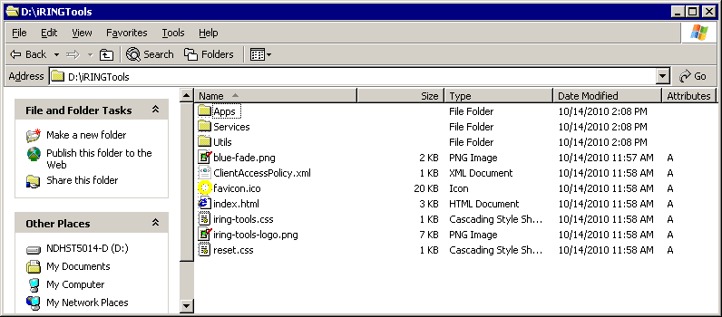
Other software packages may also be required. Installation links and instructions will be provided if and when necessary.
    - iRINGWeb Folder Permissions
File permissions are needed to by web server to open files and execute commands. Set folder permissions as follows.
- In Windows Explorer, locate the iRINGTools folder, right-click and select Sharing and Security.
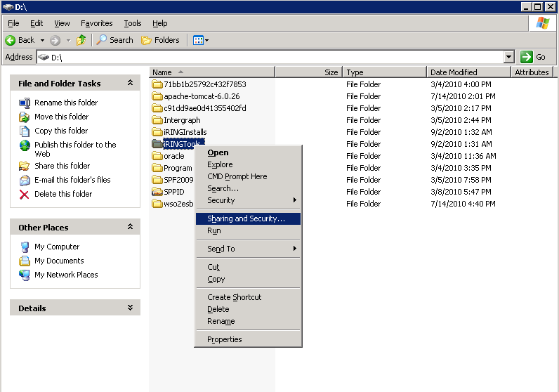
- Select the Security tab and click Add.
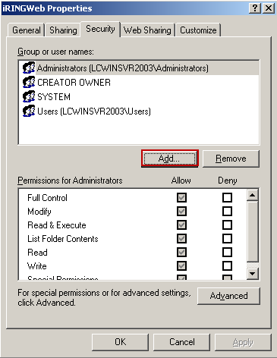
- Enter the name NETWORK SERVICE and click Okay.
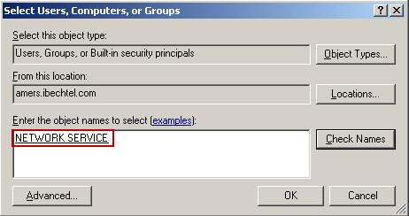
- Select NETWORK SERVICE and click Full Control. Then click the Advance button.
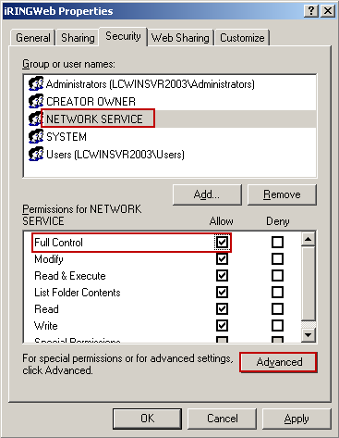
- Ensure the “Replace permission entries on all child objects with entries show here that apply to child objects” is checked.
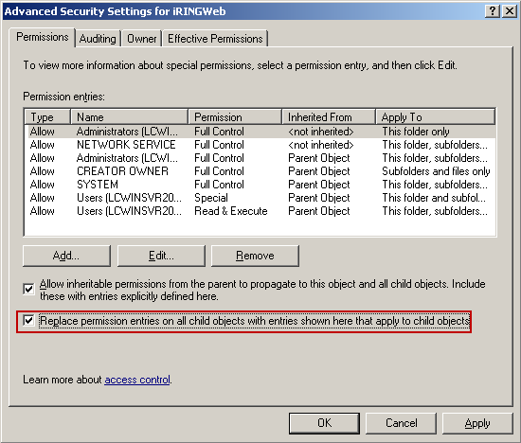
- Click the OK button to close the dialogs.
    - Internet Access
iRINGTools is a web-enabled system and therefore requires access to the internet to work properly. If the host server is behind a firewall, the proxy server information and valid proxy credentials will be needed later in the setup.
    - RDS-WIP Access
Access to the RDSWIP (http://rdswip.ids-adi.org/presentation/overview/index.html) is required for the Reference Data Service to generate new IDs for classes, templates and roles. An identity from ids-adi.org will be needed later in the setup.
    - Sandbox Access
If there are any existing Sandbox Services or other semantic repositories that will be used by the iRINGTools Services being deployed, then the URLs for those Sandbox Services will need to be entered into the configuration later.

- Installing Prerequisites
The following sections will provide detailed instructions for the installation and configuration of each prerequisite.
  - Internet Information Services
IIS (Internet Information Services) is part of the Windows Server 2003 operating system, but it is an optional component and is typically not installed by default. Perform the following steps to install or verify installation of IIS:
- From the Start menu, click Control Panel.
- Double-click Add or Remove Programs.
- Click Add/Remove Windows Components.
- In the Components list box, click Application Server.
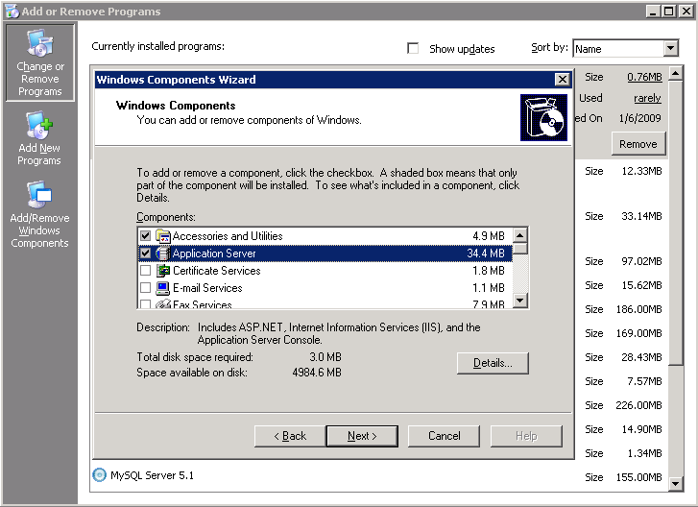
- Click Details.
- Click Internet Information Services (IIS).
- Click Details to view the list of IIS Subcomponents.
- Ensure that the Common Files (not shown), Internet Information Services Manager and World Wide Web Service are checked.
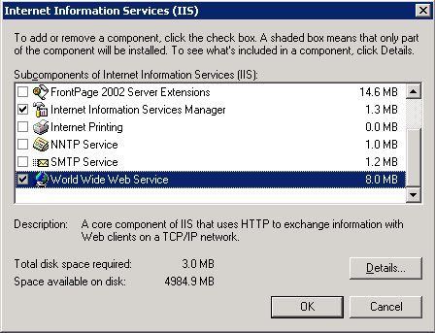
- Click World Wide Web Service.
- Click Details.
- Ensure that Active Server Pages and World Wide Web Service are checked.
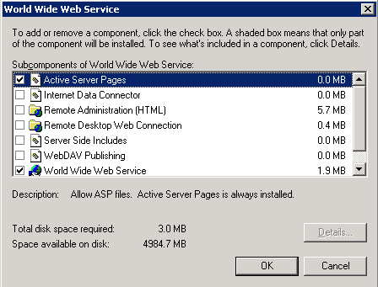
- Click OK until you are returned to the Windows Component Wizard.
- Click the Next button and complete the Windows Component Wizard.
  - .NET Framework 4.0
The .NET Framework 4.0 is used by most of the iRINGTools components.

Note: to determine if .NET Framework 4.0 is already installed, go to the WINDOWS folder and look for the folder Microsoft.NET\Framework\v4.0.30319.

To install the .NET Framework, perform the following:

- Download and install .NET Framework 4.0 from http://www.microsoft.com/net/Download.aspx.

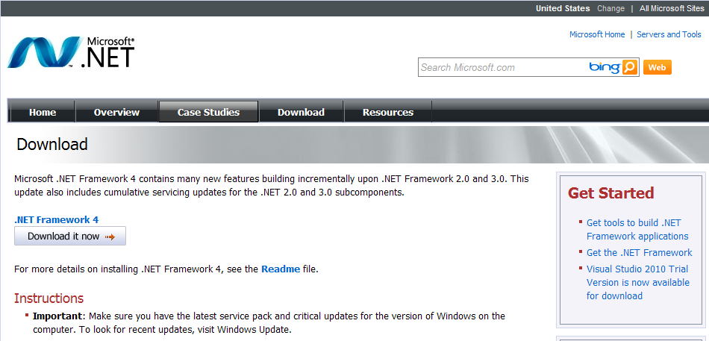

- You can verify if .NET Framework 4.0 is installed correctly by typing the following in a command prompt:
%systemroot%\Microsoft.NET\Framework\v4.0.30319\csc
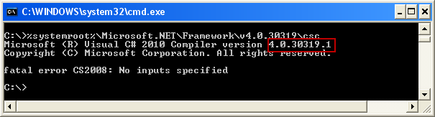
- Register IIS with .NET Framework 4.0 by executing the command aspnet_regiis.exe –r from the .NET Framework 4.0 folder.

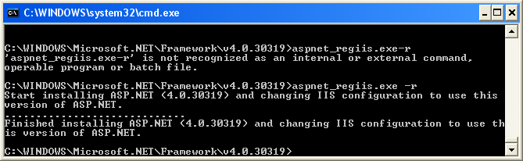
  - SQL Server
A test database is needed to test and verify the iRINGTools Services and Applications. iRINGTools supports the following SQL Server database versions.
- SQL Server 2005
- SQL Server 2008
- SQL Server Express 2008
Install these databases in accordance with the database installation instructions. Later in this document, databases will be created (using SQL Server Express 2008) for the Interface Service (for the adapter triple store and for testing purposes) and the Sandbox Service (for the sandbox triple store).
- iRINGTools Website
The following section will create and configure the iRINGTools website.
  - Localhost versus Server Hostname
The iRINGTools web.config files use localhost as the initial hostname. It is best to keep localhost as the hostname during installation to making testing easier. Instructions will be provided later in this document on where and how to change the hostname.
  - Installing Website
Create the iRINGTools website in IIS by performing the following steps.
- Start IIS Manager. One way to do this is to use Run from the Start menu. Type the command inetmgr.
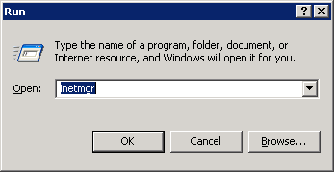
- In IIS Manager, select the Web Sites folder, right-click and select New > Web Site.
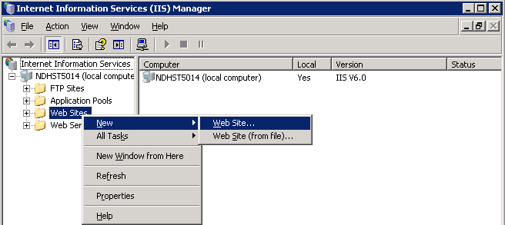

- This starts the Web Site Creation Wizard. Click the Next button.
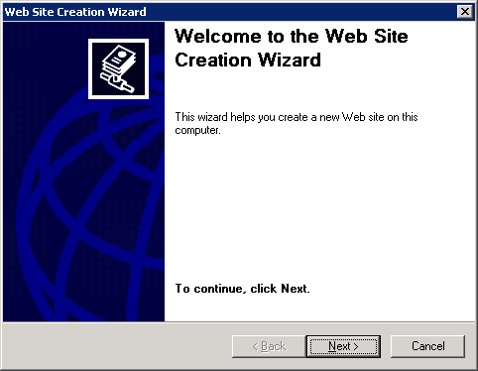
- Enter iRINGTools for the Description. Click the next button.
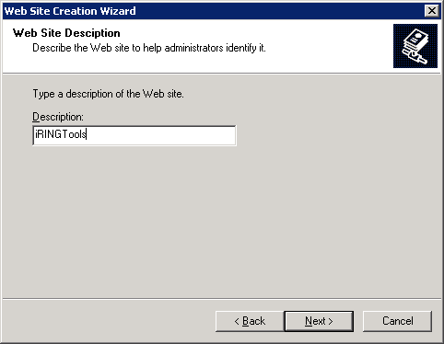
- Enter the IP address and port settings and then click the Next button.
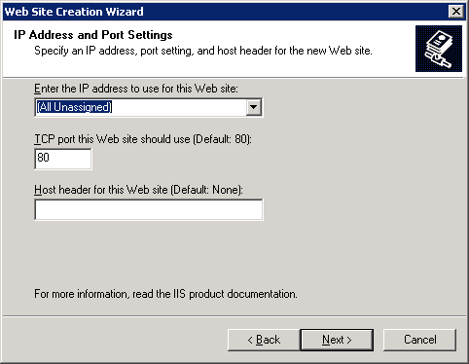
- Enter the path to the iRINGTools folder (installed earlier). Click the Next button.
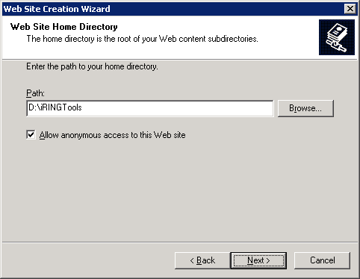
- Click Read and Run scripts for web site access permissions and then click the Next button.
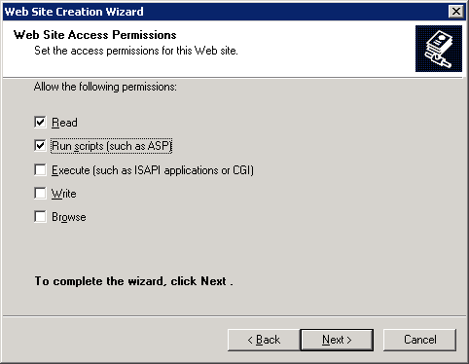
- Click the Finish button to close the wizard.
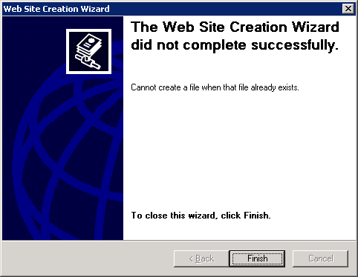
- Right-click the new website and select Properties button.
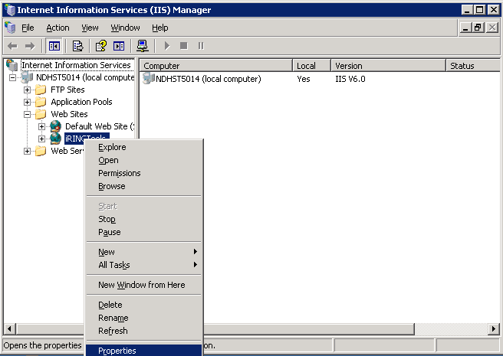
- Select the Documents tab and add index.html to the content page.
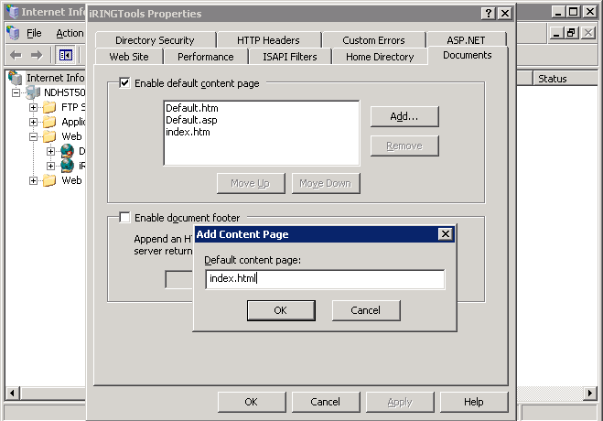
- Move index.html to the top of the list.
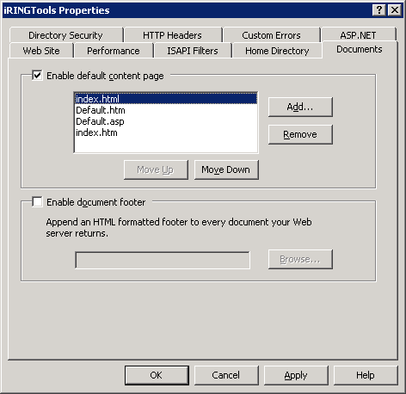
  - Create Virtual Directories
Create the virtual directories in IIS by performing the following steps.
- In IIS Manager, select the iRINGTools > Services folder, right-click and select Properties.
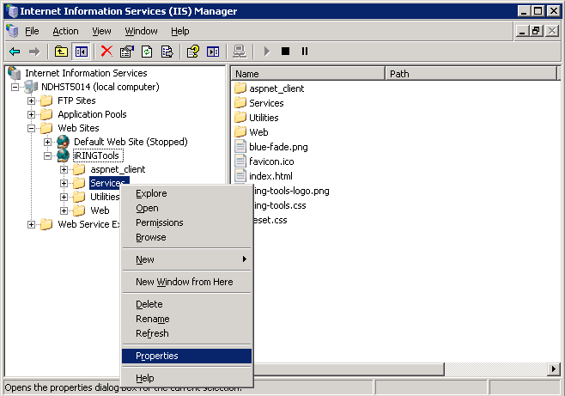
- Click the Create button.
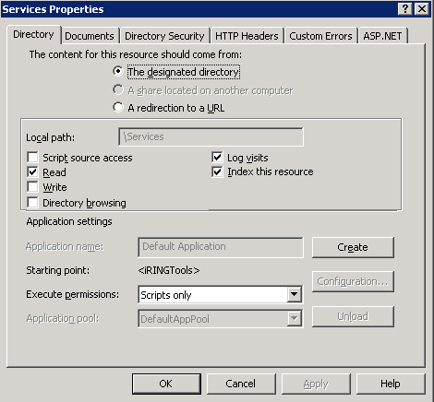
- Select the ASP.NET tab and set the ASP.NET version to 4.0.30319. Click the OK button.
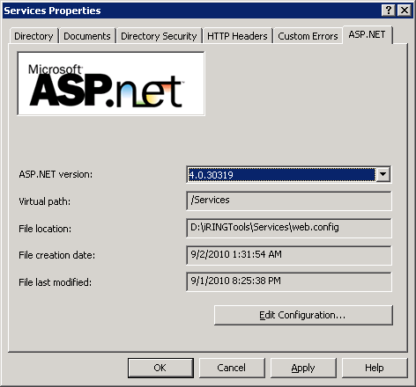
- Click the OK button to complete Services setup.
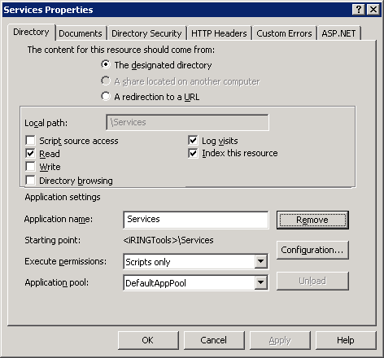
- In IIS Manager, select the iRINGTools > Apps folder, right-click and select Properties.
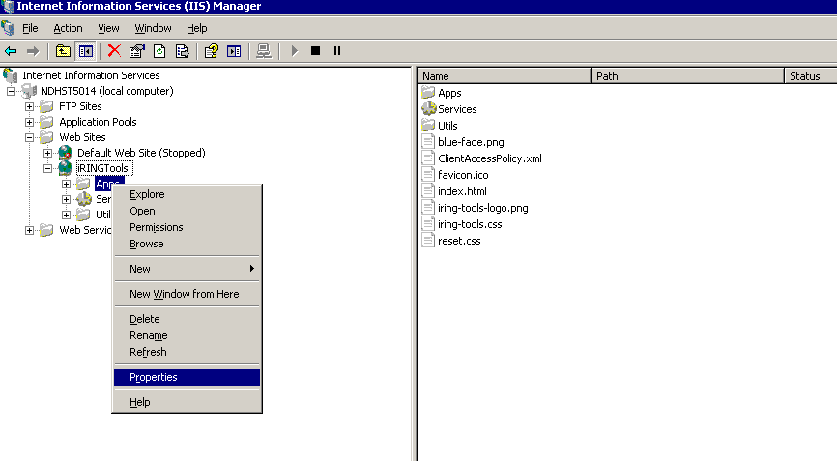
- Click the Create button.
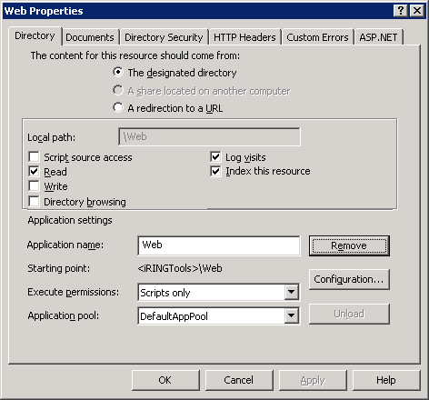
- Select the ASP.NET tab and set the ASP.NET version to 4.0.30319. Click the OK button.
- Click the OK button to complete Apps setup.
- In IIS Manager, select the iRINGTools > Utils folder, right-click and select Properties.
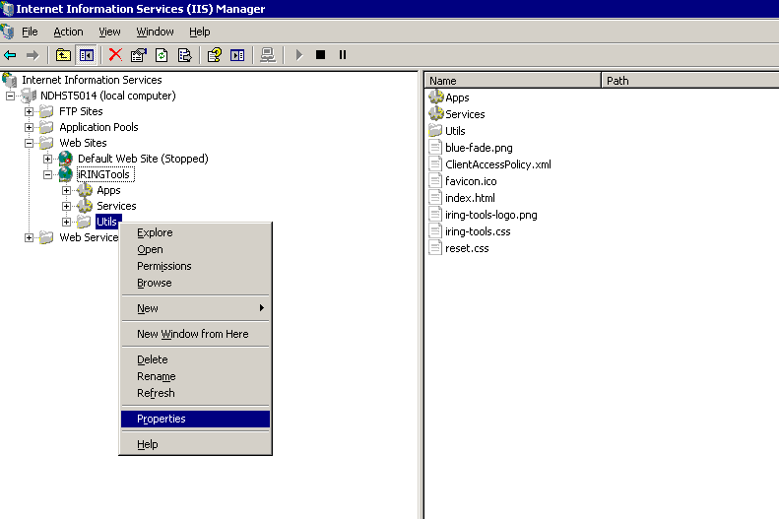
- Uncheck anonymous access & integrated windows authentication.
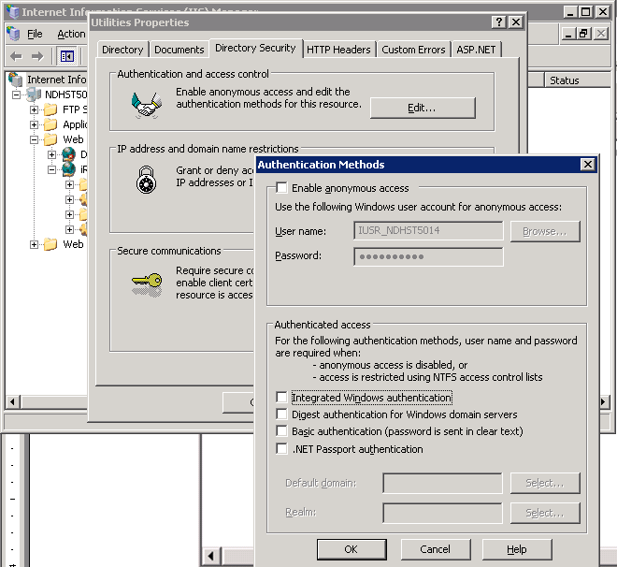
- Remove anonymous access from iRINGTools website.
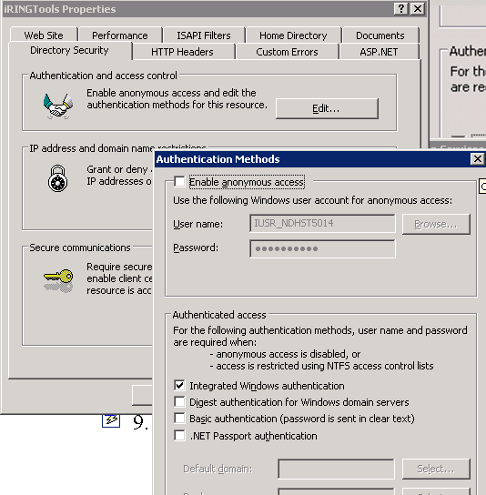
- Open the Services Properties and add aspnet_Isapi.dll to app configuration for virtual directory Services.
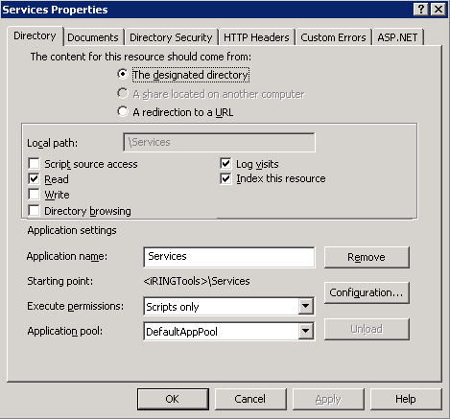
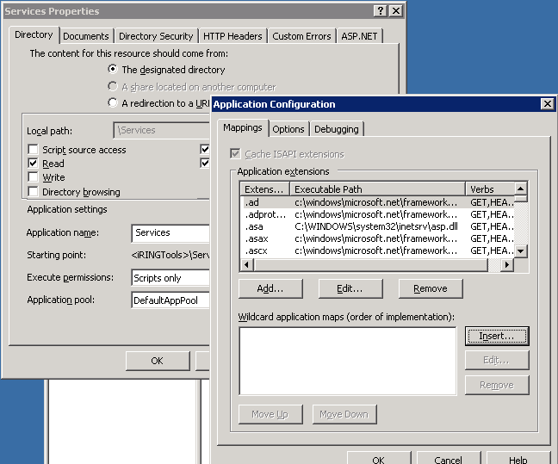
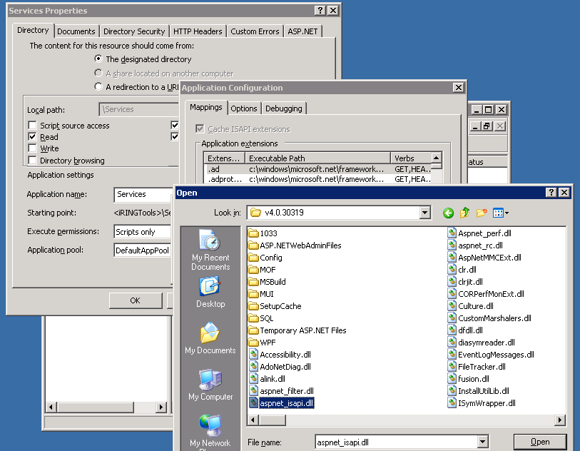
- Uncheck Verify that file exists and click the OK button.
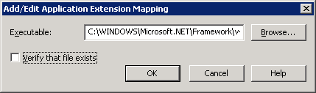
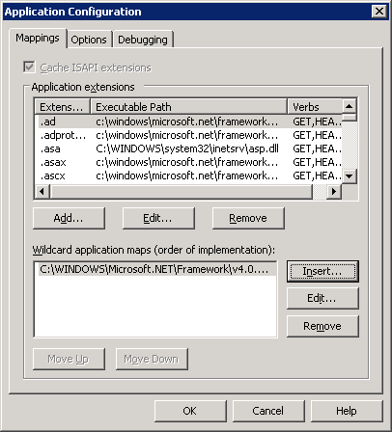
- Click OK.
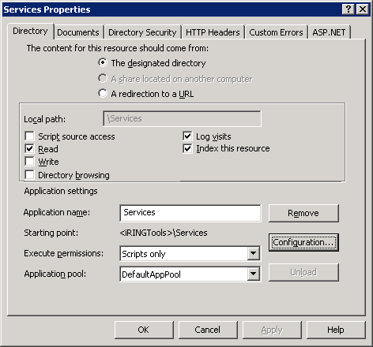
  - Silverlight MIME Extensions
iRINGTools use Silverlight for the Applications. To host Silverlight on a web server that is not IIS version 7 (e.g., IIS version 6), you will need to add the MIME types to support the correct content type interpretation by the browser. In the case of Silverlight this is the XAML content type. IIS version 7 has these MIME types already added but if they're not there this will result in errors. There are three MIME types required:
- .xaml application/xaml+xml
- .xap application/x-silverlight-app
- .xbap application/x-ms-xbap
To add (or verify) the three MIME types, perform the following steps:
- Start IIS Manager. One way to do this is to use Run from the Start menu. Type the command inetmgr.
- From the Web Sites folder, select the iRINGTools > Apps folder, right-click and select Properties.

- Select the HTTP Headers tab in the Properties window and then click on the MIME Types button.
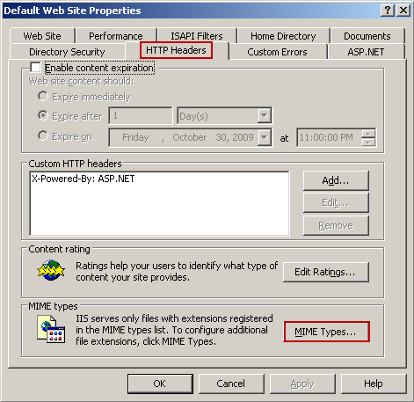
- If one or more of the three required MIME types are not listed, then click on the New button.
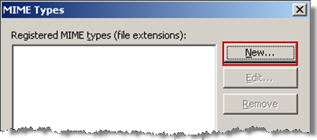
- If necessary, enter the extension and MIME type for the three types.
Extension | MIM type
.xaml | application/xaml+xml
.xap | application/x-silverlight-app
.xbap | application/x-ms-xbap
- When finished, verify the MIME types are added and then click the OK button.
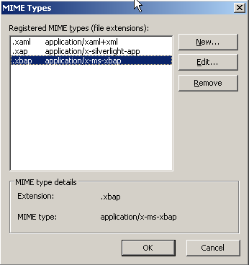
- Close the Properties window.

  - Web.Config Setup
You may need to configure the web.config file in the Services folder if:
- Your server is behind firewall (proxy credentials are needed)
- You will be generating class ids (IDS-ADI credentials are needed)
To configure, open the web.config file with an XML or text editor, and copy the necessary keys from Service Settings Defaults and Reference Data Setting Defaults to appSettings and set as necessary.
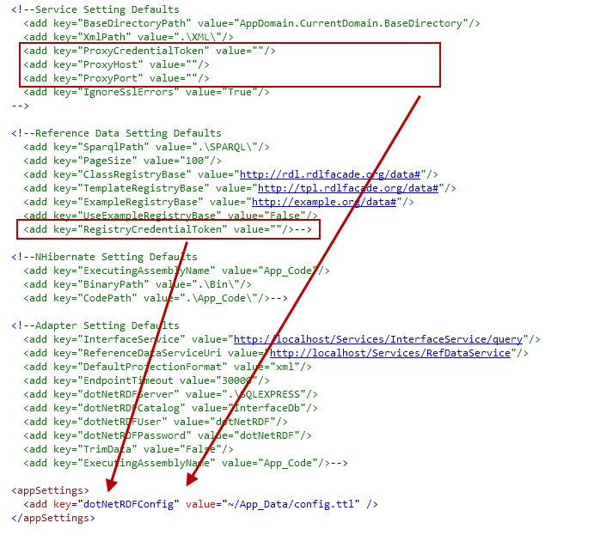
This version of iRINGTools adds a new utility for configuring the Proxy Credentials. The Proxy Configuration Tool (proxyConfig.exe), shown below, can be found in the Utils folder.
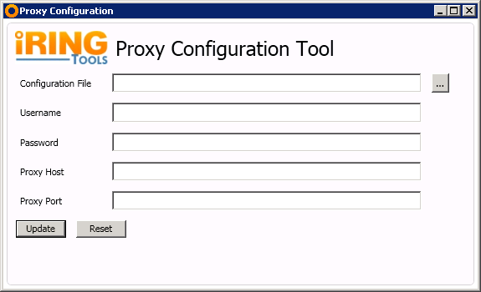
This tool will create a Token from the credentials added, and set the proxy settings in Web.confg file. The result will look similar to:
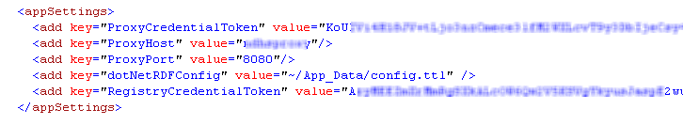
The RegistryCredentialToken is not required unless you will be adding new classes or templates in the RefDataEditor. If you need to generate this token, the EncryptCredentials utility can still be used. For additional support on how to configure these and other settings in the web.config file, contact the iRINGTools development team.
  - Creating the Test Database
Create a test database in SQL Server by performing the following steps.
- Open the folder iRINGTools\Services\App_Data.
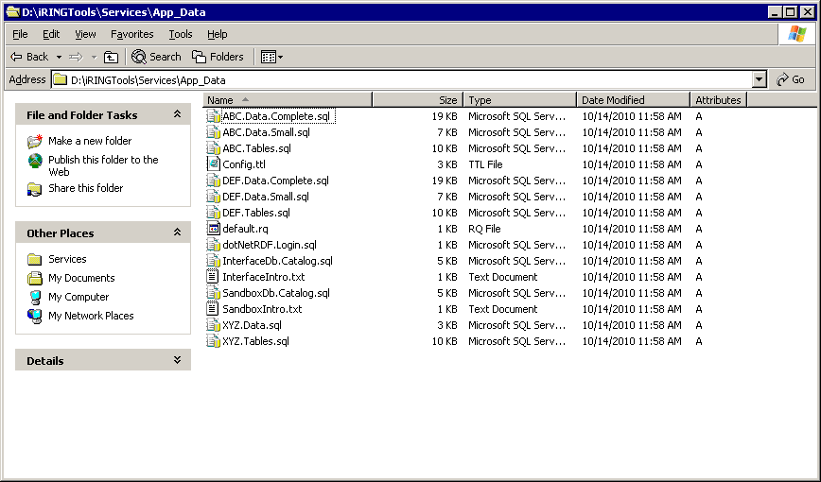
- Open Microsoft SQL Server Management Studio.
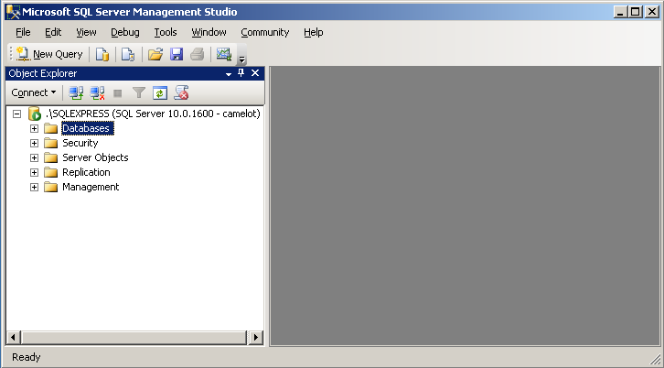
- Run the following scripts.
- dotNetRDF.Login.sql
- InterfaceDb.Catalog.sql
- SandboxDb.Catalog.sql
- ABC.Tables.sql
- ABC.Data.Complete.sql
  - Reset IIS
IIS needs reset. Execute iisreset in a command window.
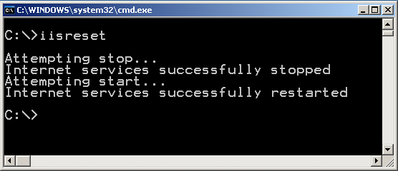
  - Final Tests
Browse to http://localhost/ and test the links in IRINGTools Applications and iRINGTools Services.
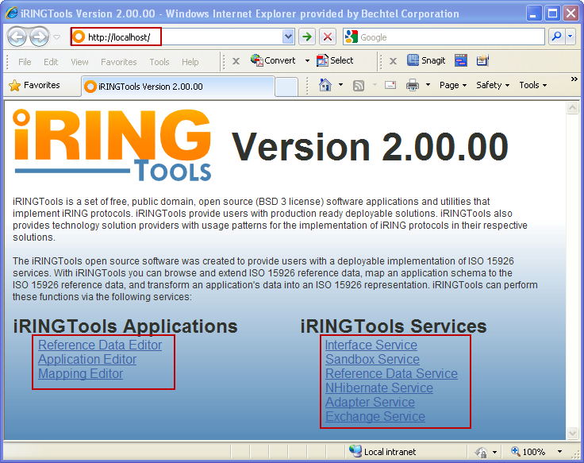
Below are sample screenshots of the applications and services.
- Reference Data Editor
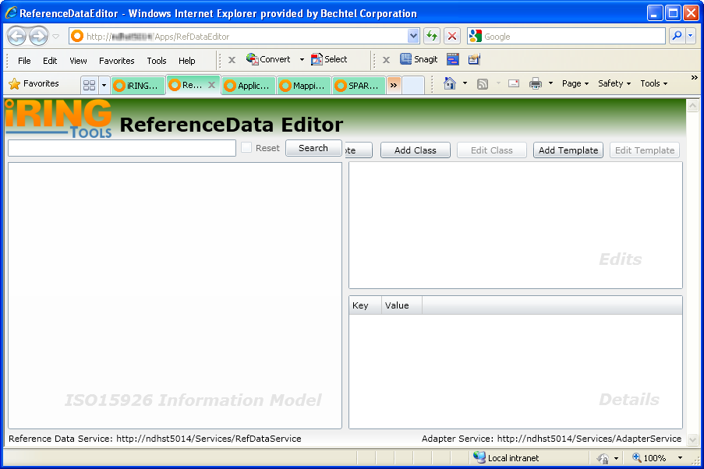
- Application Editor
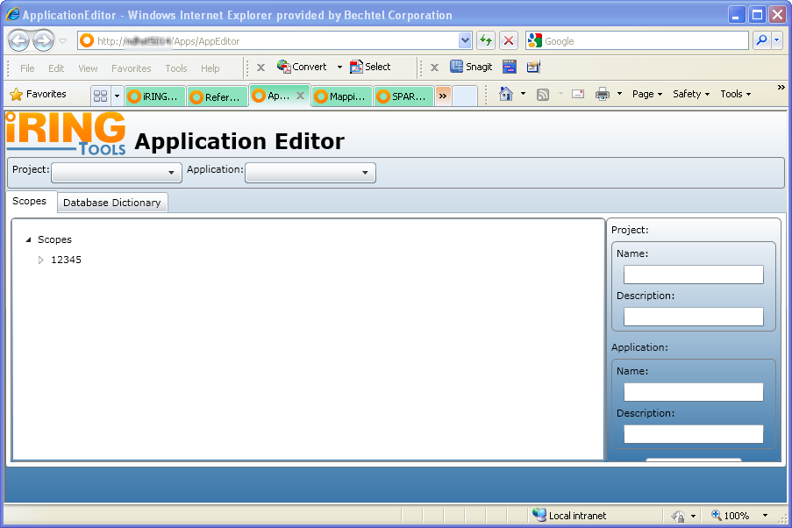
- Mapping Editor
- Interface Service
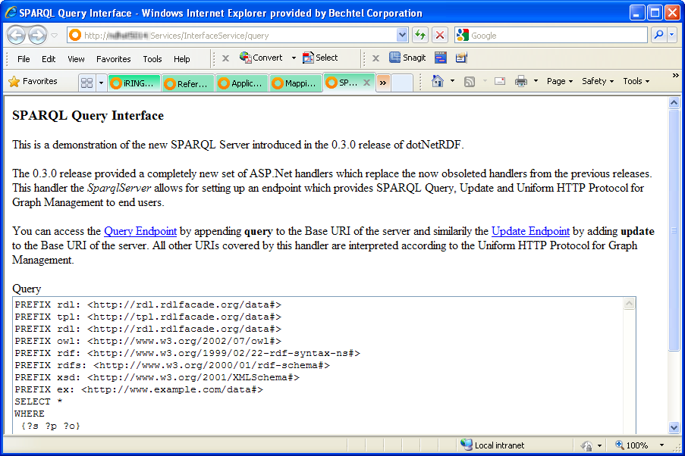
- Sandbox Service
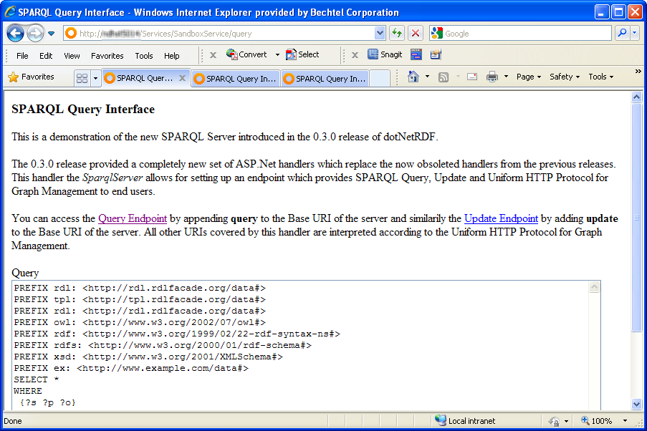
- Reference Data Service
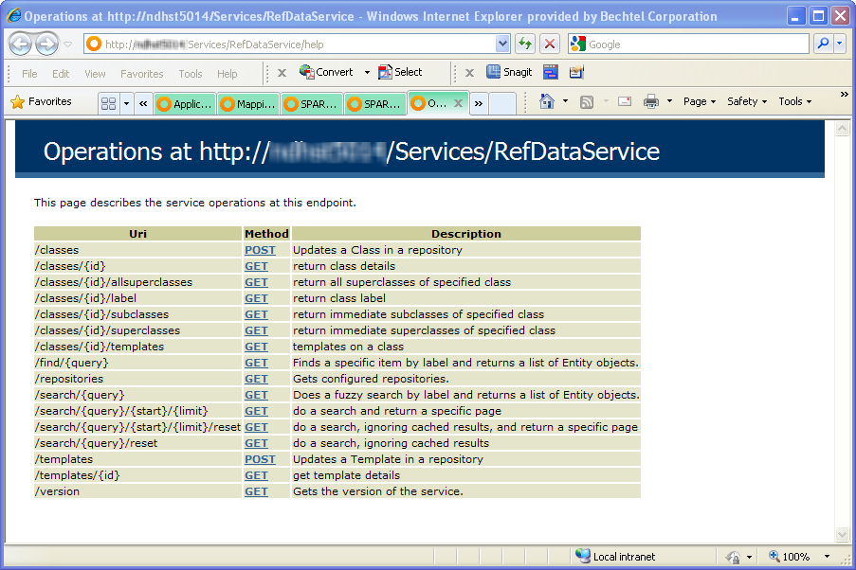
- NHibernate Service
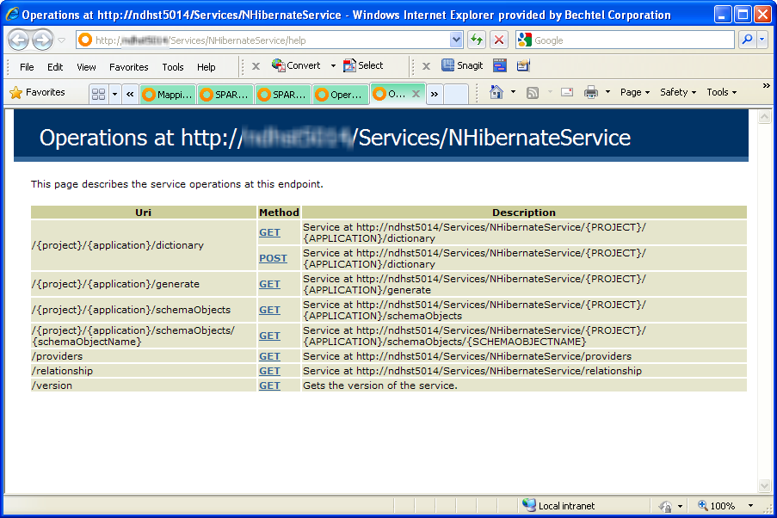
- Adapter Service
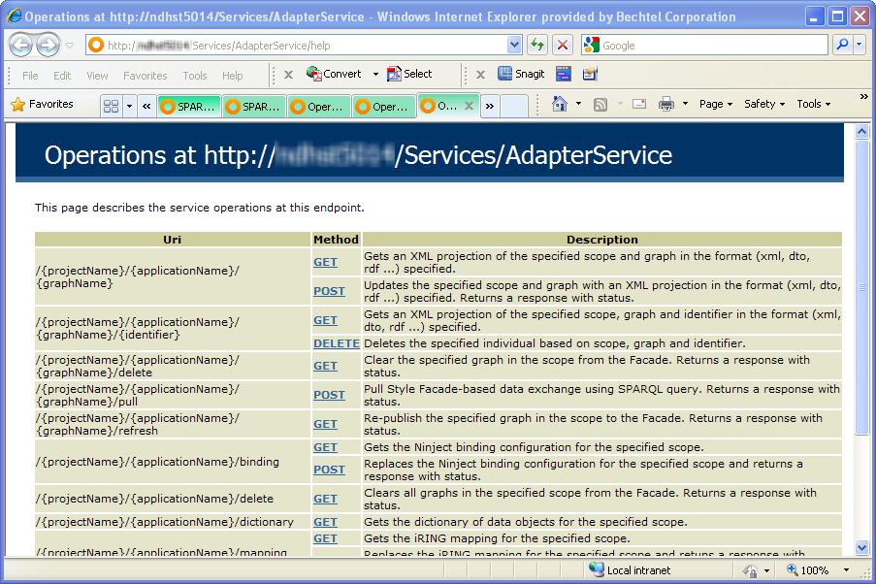
- Exchange Service
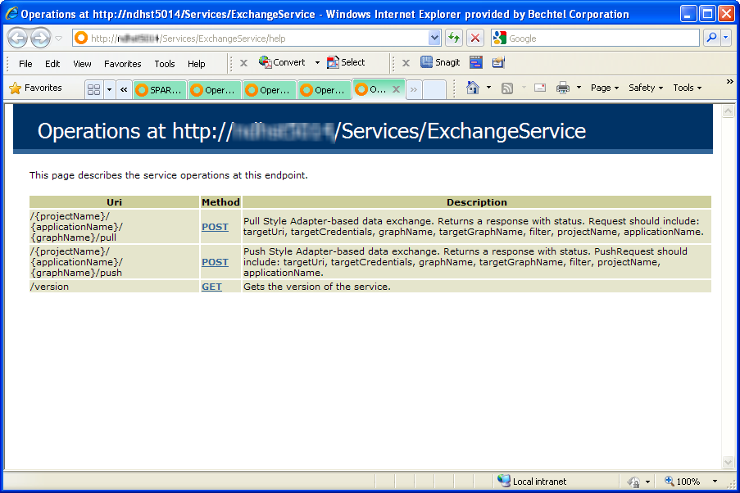
  - Hostname Setup
The final step in the installation is updating hostname in certain iRINGTools services for use with client browsers on the network.
- Open the file web.config file in Apps and Services folders in a text editor.
- Change localhost to server name.
Installation of iRINGTools is complete.

