
http://iringtools.org

SDK Guide
Version 1.02.01

Notice
This is a controlled document. Unauthorized access, copying, replication or usage for a purpose other than for which it is intended, are prohibited.
All trademarks that appear in the document have been used for identification purposes only and belong to their respective companies.

Document Release Note
Notice No.: 1.0
Customer: iRINGUserGroup
Project: iRINGTools

Document details
Name | Version no. | Description
iRINGTools SDK Guide | 1.02.01 | iRINGTools SDK Guide

Reviewers
L | Role | Organization Unit
Lee Colson | Documentation | iRINGTools
Hahn Le | Software Engineer | iRINGTools

Revision details
Action taken  (add/del/change) | Previous  page no. | New page no. | Revision description

Terms of License
Copyright (c) 2009, iringug.org
All rights reserved.
Redistribution and use in source and binary forms, with or without modification, are permitted provided that the following conditions are met:
* Redistributions of source code must retain the above copyright notice, this list of conditions and the following disclaimer.
* Redistributions in binary form must reproduce the above copyright notice, this list of conditions and the following disclaimer in the documentation and/or other materials provided with the distribution.
* Neither the name of the iringug.org nor the names of its contributors may be used to endorse or promote products derived from this software without specific prior written permission.
THIS DOCUMENT IS PROVIDED BY iringug.org ''AS IS'' AND ANY EXPRESS OR IMPLIED WARRANTIES, INCLUDING, BUT NOT LIMITED TO, THE IMPLIED WARRANTIES OF MERCHANTABILITY AND FITNESS FOR A PARTICULAR PURPOSE ARE DISCLAIMED. IN NO EVENT SHALL iringug.org BE LIABLE FOR ANY DIRECT, INDIRECT, INCIDENTAL, SPECIAL, EXEMPLARY, OR CONSEQUENTIAL DAMAGES (INCLUDING, BUT NOT LIMITED TO, PROCUREMENT OF SUBSTITUTE GOODS OR SERVICES; LOSS OF USE, DATA, OR PROFITS; OR BUSINESS INTERRUPTION) HOWEVER CAUSED AND ON ANY THEORY OF LIABILITY, WHETHER IN CONTRACT, STRICT LIABILITY, OR TORT (INCLUDING NEGLIGENCE OR OTHERWISE) ARISING IN ANY WAY OUT OF THE USE OF THIS SOFTWARE, EVEN IF ADVISED OF THE POSSIBILITY OF SUCH DAMAGE.

Document Revision List
Customer: iRINGUserGroup
Project: iRINGTools
Document Name: iRING SDK Guide

Release Notice Reference (for release)
Rev. No. | Revision date | Revision description | Page no. | Previous page no. | Action taken | Addenda/New page | Release notice reference

About this Manual

Purpose
iRINGTools is a set of free, public domain, open source (BSD 3 license) software applications and utilities that implement iRING protocols. iRINGTools provide users with production ready deployable solutions. iRINGTools also provides technology solution providers with usage patterns for the implementation of iRING protocols in their respective solutions. This SDK Guide provides step by step detail instructions for how to create and deploy a custom DataLayer with iRINGTools.

Intended Audience
Intended audience for this installation guide is iRINGUserGroup, an open online community of users, companies, and organizations that use, are considering using, or are developing or deploying iRING protocols. The iRINGUserGroup is also responsible for the management, enhancement, and maintenance of iRINGTools and iRINGSandbox.

Organization of the Manual
Information in this manual has been organized as follows:
Table 1: Organization of this Manual
Chapter | Description
Chapter 1 | This gives brief overview of iRINGTools and its components, packages involved, package dependencies, prerequisites and list of software components required for the individual package (the adaptor, the Sandbox or both) installation.
Chapter 2 | This section provides detailed instructions for the installation and configuration of each prerequisite i.e. IIS, .Net Framework 3.5 SP1, Silverlight MIME extensions, Application Extension Mapping and SQL Server.
Chapter 3 | This section describes the iRINGTools Sandbox components and provide detailed instructions on how to install and configure each component i.e. Sandbox Service, Reference Data Service, Reference Data Editor.
Chapter 4 | This section describes the iRINGTools Adapter components and provide detailed instructions on how to install and configure each component i.e. Interface Service, Adapter Service, Mapping Editor.
Chapter 5 | The final step in the installation is updating hostname in certain iRINGTools services for use with client browsers on the network

Contents
List of Abbreviations xi
1 Overview 12
1.1 Packages 12
1.2 Package Dependencies 13
1.3 Prerequisites 13
1.4 Preparing for Installation 14
1.4.1 Downloads 14
1.4.2 Internet Access 15
1.4.3 RDS-WIP Access 15
1.4.4 Sandbox Access 15
2 Installing Prerequisites 16
2.1 Internet Information Services 16
2.2 .NET Framework 3.5 SP 1 18
2.3 Validate IIS and ASP.NET 19
2.4 Silverlight MIME Extensions 24
2.5 Application Extension Mapping for SemWeb 29
2.6 SQL Server 32
3 Installation iRINGTools Sandbox 33
3.1 iRINGTools Sandbox Components 33
3.2 Localhost versus Server Hostname 34
3.3 Installing Sandbox Service 34
3.4 Creating Sandbox Storage 41
3.5 Configuring Sandbox Service 41
3.6 Testing Sandbox Service 41
3.7 Creating Virtual Directory for RefDataService 44
3.8 Configuring Reference Data Service 49
3.8.1 Creating Credential Tokens 49
3.8.2 Modify Reference Data Service Web.config 49
3.8.3 Modify Reference Data Service Repsitories.xml 53
3.9 Testing Reference Data Service 54
3.10 Creating Virtual Directory for Reference Data Editor 55
3.11 Configuring the Reference Data Editor 61
3.12 Testing Reference Data Editor 61
4 Installing iRINGTools Adapter 63
4.1 iRINGTools Adapter Components 63
4.2 Localhost versus Server Hostname 63
4.3 Creating the AdapterService Virtual Directory 64
4.4 Creating the MappingEditor Virtual Directory 69
4.5 Installing Interface Service 75
4.6 Creating iRING Storage 81
4.7 Configuring Interface Service 81
4.8 Testing Interface Service 81
4.9 Creating the Test Database 84
4.10 Configuring the AdapterService 87
4.11 Testing the AdapterService 92
4.12 Testing the Mapping Editor 95
5 Hostname Setup 97
5.1 iRINGTools Sandbox 97
5.2 iRINGTools Adapter 98

The total number of pages in this document, including the cover page, is 17.

List of Abbreviations

Acronym | Description
iRING | ISO 15926 Realtime Interoperability Network Grid
ISO | International Organization for Standardization
RDSWIP | Reference Data Service Work in Progress
SP | Service Pack
GUI | Graphical User Interface
IIS | Internet Information Services
MIME | Multipurpose Internet Mail Extensions
OLTP | Online Transaction Processing
API | Application Programming Interface
CRUD | Create, Read, Update and Delete
LAN | Local Area Network
FIPS | Federal Information Processing Standard

- Overview
iRING is a set of information interoperability and integration protocols and reference data that are compliant with the ISO 15926, Parts 7, 8, and 9 standards, which builds and depends on ISO 15926 Parts 1 through 6.
iRINGTools is a set of free, public domain, open source (BSD 3 license) software applications and utilities that implement iRING protocols. iRINGTools provide users with production ready deployable solutions. iRINGTools also provides technology solution providers with usage patterns for the implementation of iRING protocols in their respective solutions.
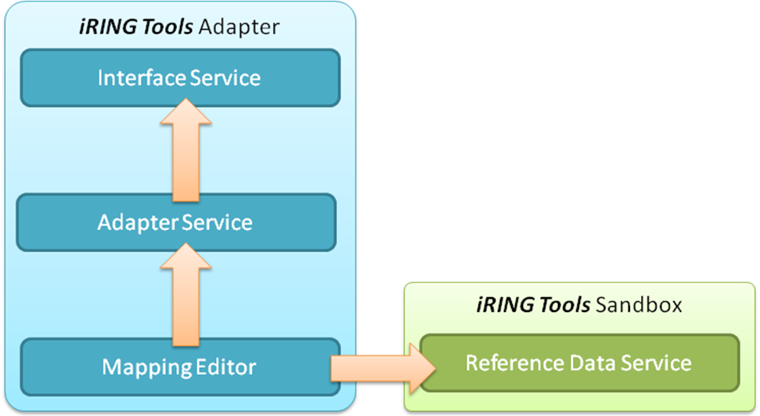
iRINGTools is deployed in two packages, iRINGTools Adapter and iRINGTools Sandbox. These packages are separated for deployment purposes. The iRINGTools Adapter is used to map and transform legacy data to ISO 15926 representations. The iRINGTools Sandbox is used to host Reference Data of local interest or draft quality for use with the iRINGTools Adapter. iRINGTools Sandbox data should be used locally only or eventually, be submitted to the IDS-ADI Core Team for addition into the RDSWIP. The iRINGTools Adapter will use reference data from configured Sandboxes, as well as the RDSWIP.
This guide focuses on the iRINGTools Adapter. The adapter is an extenisble generic web service adapter. It uses NHibernate to connect to databases for the purpose of exposing their data as a web service. Besides the native NHibernate data layer, the iRINGTools Adapter can be extended with a custom DataLayer. Custom DataLayers can handle other sources of data, such as an API, Excel, CSV file, etc. This document provides step by step detail instructions for how to create and deploy a custom DataLayer with iRINGTools Adapter.
  - Data Exchange and Data Services
The iRINGTools Adapter can produce data representations at different levels of the ISO standard. It can produce Part 7 XML, Part 8 RDF/OWL, or a Part 9 Facade. As shown below, the InterfaceService is the Facade or SPARQL endpoint. The AdapterService acts as a SPARQL client to pull data from other SPARQL endpoints. For more information about the SPARQL protocol and SPARQL query language, please see the linked W3C documents.
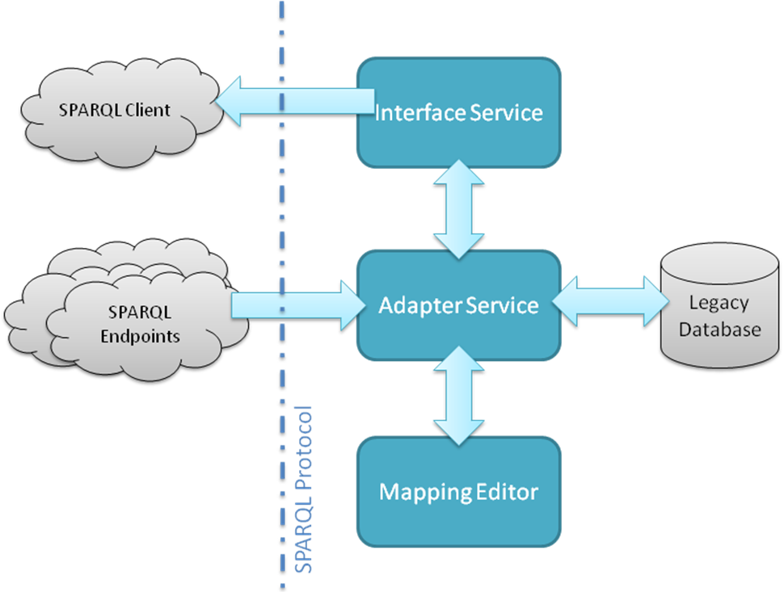
The adapter can also exchange a Part 7-based XML called a Data Transfer Object (DTO). DTO’s are exchangeable with other AdapterServices. This is not part of the ISO standard, and is not recommended for interoperability across the internet.
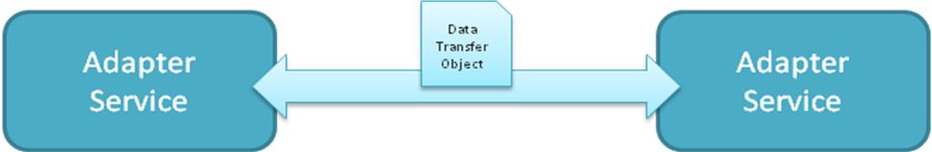

The iRINGTools Adapter can also produce a hierarchical version of the DTO for the purposes of reporting and Ajax clients. This version of the DTO is exposed over a SOAP interface for Microsoft Compatibility.
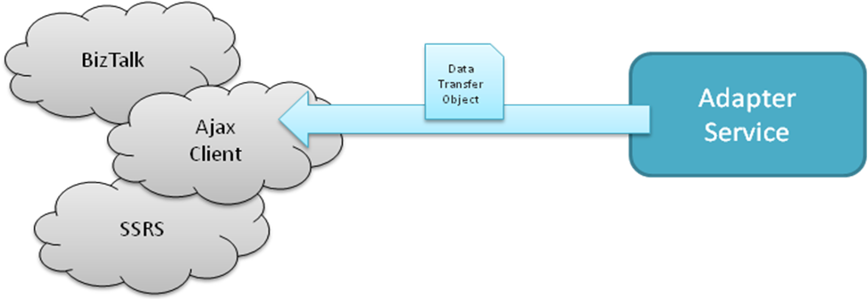
  - Adapter Framework
The iRINGTools Adapter Framework is centered around the DTO, which is based on the mapping to the ISO 15926 Reference Data. All of the functionality of the adapter deals with persisting, producing, consuming and projecting the DTO.
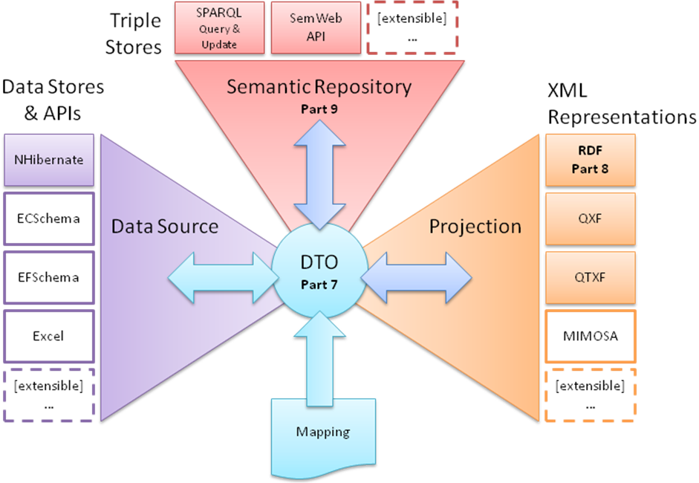
The Adapter Framework provides three primary services:

- Reading from and writing to a data source.
- Querying and writing to a semantic repository which is exposed through a Part 9 Façade.
- Projecting to and consuming different XML representations, including the Part 7-based DTO, and Part 8 RDF/OWL.
  - Dependency Injection
This framework is implemented using dependency injection. Dependency injection is a technique for supplying an external dependency (i.e. a reference) to a software component. It is a specific form of inversion of control where the concern being inverted is the process of obtaining the needed dependency. The dependency injection implementation used in iRINGTools Adapter is Ninject. For more information about Ninject, go to http://ninject.org.
  - Adapter Interfaces
The adapter framework is broken down into different layers which are separated by interfaces.
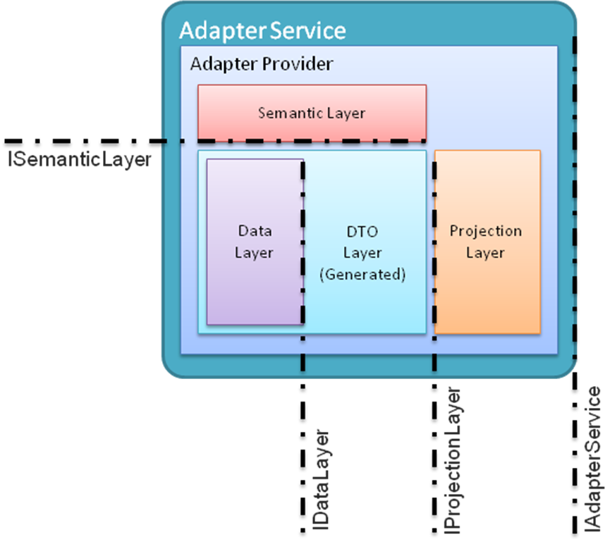
This version of the guide will focus on the IDataLayer interface. The other layers are extensible as well, and they will be documented in a later version of this guide. The IDataLayer interface consists of generic methods that must be implemented by each DataLayer. The interface is defined as follows:

// Get a data object with some filter criteria from the datalayer
T Get<T>(Dictionary<string, object> queryProperties);

// Get a list of data objects with some filter criteria from the datalayer.
IList<T> GetList<T>(Dictionary<string, object> queryProperties);

// Get all data objects from the datalayer
IList<T> GetList<T>();

// Post a data object to the datalayer
Response Post<T>(T dataObject);

// Post a list of data objects to the datalayer
Response PostList<T>(List<T> dataObjects);

// Get data dictionary from the datalayer
DataDictionary GetDictionary();
- Custom DataLayer
This section will outline the steps required to create a Custom DataLayer. Because of the use of dependency injection and generics, there are special considerations beyond the interface that must be discussed.
Implementers of a Custom DataLayer should provide generic access to classes representing application data, and provide the DataDictionary describing them. Post requests should be processed by your applications business logic, and a detailed response should be returned for each dataObject. This detailed response should include success, warnings, errors, or a detailed rejection explanation.
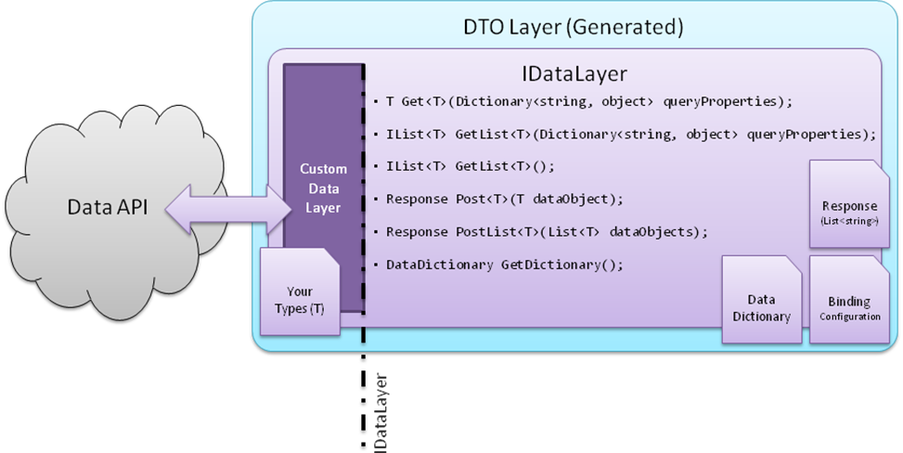
The DataDictionary is used to generate the DTOLayer, which does most of the interaction with your DataLayer.
  - Components
In order for iRINGTools Adapter to use a custom DataLayer, the custom DataLayer must have the following components. The details of each component will be described in details further in this document.
- Custom DataLayer Assembly (Entity classes and implementation of IDataLayer.cs)
- BindingConfiguration XML
- DataDictionary XML (Optional)
The DataDictionary does not have to be persisted as an XML, developers may choose to create it on the fly or get it from an API.
  - Naming Convention
iRINGAdapter supports multiple projects and applications and it uses file name convention to identify components of an application within its project scope. For a custom data layer, the naming convention is applied to the following files:
- Data Dictionary XML:
DataDictionary.<projectName>.<applicationName>.cs
- Entity classes:
Model.<projectName>.<applicationName>.cs
- Binding Configuration XML
BindingConfiguration.<projectName>.<applicationName>.cs
  - Example Implementation
This document provides an example of a custom data layer used in iRINGTools demonstrations, called CSVDataLayer, which reads comma-separated values (CSV) data from disk, turns it into standard format ( ISO15926 triples) to be exchangeable with other applications, and writes it back to disk as its original CSV format. Below is the data flow between CSVDataLayer and the iRINGAdapter.
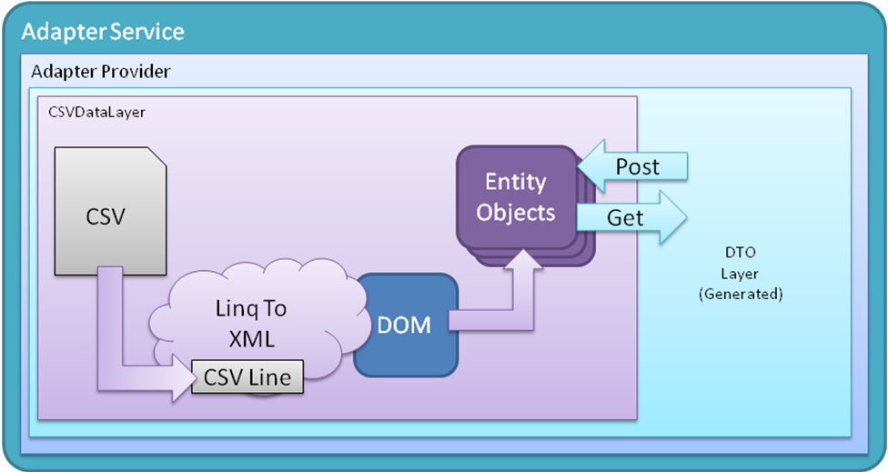
The complete CSVDataLayer source code and binary files mentioned in the document are in the Appendix section.

