
http://iringtools.org

Users Guide
Preliminary Draft
Version 1.02.00

Notice
This is a controlled document. Unauthorized access, copying, replication or usage for a purpose other than for which it is intended, are prohibited.
All trademarks that appear in the document have been used for identification purposes only and belong to their respective companies.

Document Release Note
Notice No.: 1.2
Customer: iRINGUserGroup
Project: iRINGTools

Document details
Name | Version no. | Description
iRINGTools Installation Guide | 1.02.00 | iRINGTools Users Guide

Reviewers
L | Role | Organization Unit
Lee Colson | Documentation | iRINGTools

Revision details
Action taken  (add/del/change) | Previous  page no. | New page no. | Revision description
Add | N/A | All | Initial Issue

Terms of License
Copyright (c) 2009-2010, iringug.org
All rights reserved.
Redistribution and use in source and binary forms, with or without modification, are permitted provided that the following conditions are met:
* Redistributions of source code must retain the above copyright notice, this list of conditions and the following disclaimer.
* Redistributions in binary form must reproduce the above copyright notice, this list of conditions and the following disclaimer in the documentation and/or other materials provided with the distribution.
* Neither the name of the iringug.org nor the names of its contributors may be used to endorse or promote products derived from this software without specific prior written permission.
THIS DOCUMENT IS PROVIDED BY iringug.org ''AS IS'' AND ANY EXPRESS OR IMPLIED WARRANTIES, INCLUDING, BUT NOT LIMITED TO, THE IMPLIED WARRANTIES OF MERCHANTABILITY AND FITNESS FOR A PARTICULAR PURPOSE ARE DISCLAIMED. IN NO EVENT SHALL iringug.org BE LIABLE FOR ANY DIRECT, INDIRECT, INCIDENTAL, SPECIAL, EXEMPLARY, OR CONSEQUENTIAL DAMAGES (INCLUDING, BUT NOT LIMITED TO, PROCUREMENT OF SUBSTITUTE GOODS OR SERVICES; LOSS OF USE, DATA, OR PROFITS; OR BUSINESS INTERRUPTION) HOWEVER CAUSED AND ON ANY THEORY OF LIABILITY, WHETHER IN CONTRACT, STRICT LIABILITY, OR TORT (INCLUDING NEGLIGENCE OR OTHERWISE) ARISING IN ANY WAY OUT OF THE USE OF THIS SOFTWARE, EVEN IF ADVISED OF THE POSSIBILITY OF SUCH DAMAGE.

Contents
List of Abbreviations vi
1 Overview 7
2 Reference Data Editor 8
2.1 TBD 8
3 Application Data Dictionary 9
3.1 TBD 9
4 Mapping Editor 10
4.1 Mapping Editor Layout 10
4.2 Open Project and Application 10
4.3 Create Graph Map 12
4.4 Mapping Graph Identifier 14
4.5 Mapping with Property Templates 14
4.6 Mapping with Relationship Templates 14
5 Performing Data Exchange 15
5.1 TBD 15

The total number of pages in this document, including the cover page, is 23.

List of Abbreviations

Acronym | Description
iRING | ISO 15926 Realtime Interoperability Network Grid
ISO | International Organization for Standardization
RDSWIP | Reference Data Service Work in Progress
SP | Service Pack
GUI | Graphical User Interface
IIS | Internet Information Services
MIME | Multipurpose Internet Mail Extensions
OLTP | Online Transaction Processing
API | Application Programming Interface
CRUD | Create, Read, Update and Delete
LAN | Local Area Network
FIPS | Federal Information Processing Standard

- Overview
iRING is a set of information interoperability and integration protocols and reference data that are compliant with the ISO 15926, Parts 7, 8, and 9 standards, which builds and depends on ISO 15926 Parts 1 through 6.
iRINGTools is a set of free, public domain, open source (BSD 3 license) software applications and utilities that implement iRING protocols. iRINGTools provide users with production ready deployable solutions. iRINGTools also provides technology solution providers with usage patterns for the implementation of iRING protocols in their respective solutions.
This user guide provides detailed instructions for configuring and using iRINGTools.

- Reference Data Editor
The following sections will provide detailed instructions for using the Reference Data Editor.
  - TBD
TBD

- Application Data Dictionary
The following sections will provide detailed instructions for creating an iRINGTools application data dictionary.
  - Create Data Dictionary
At present, there are two ways to create an application data dictionary:
- Create the file using an XML editor or text editor
- Using DBDictionaryUtil utility
The second method will save some typing and possibly reduce errors, but will most likely require manual editing as well.
Steps for manual creation of the application data dictionary.
- In the iRINGWeb\AdapterService\XML folder, locate the file Seed.DatabaseDictionary.xml and copy it to the same folder.
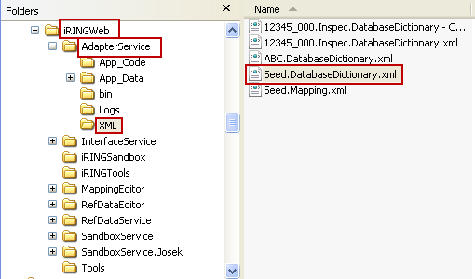
- Rename the file to <myProject>.<myApp>.DatabaseDictionary.xml
Where <myProject> is the name of the project (as specified in iRINGTools)
<myApp> is the name of the application (as specified in iRINGTools)
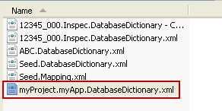
- Open the file to edit in an XML or text editor. The XML structure includes Dictionary (for the connection string and tables); tables (for the collection of tables); Table (for each table); columns (for the columns in each Table); Column (for each column in the table that is not a key); entityName (name in iRINGTools); keys (for the keys in each table); Key (for each key in the keys); lazyLoading (should not needed modifying); tableName (for the name of the database table).
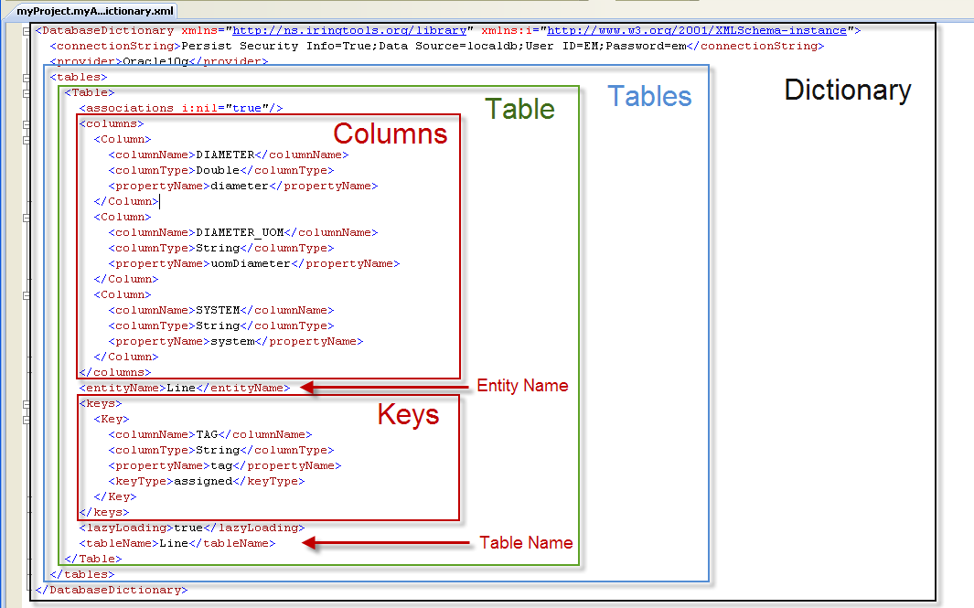
Note: When making XML edits, maintain XML syntax as provided in the seed file.
Update the connectionString for the Data Source, User ID and Password.
Change the provider
For the first table, change the entityName (must follow C# variable naming rules) and tableName.
Update the Columns
Update the Keys

- Mapping Editor
The following sections will describe how to map application data using the iRINGTools Mapping Editor.
Note: The techniques and methodology outlined in this section are not the only way to map ISO 15926 reference data to application data, but does represent one way that is presently being used.
  - Mapping Editor Layout
The mapping editor is arranged into four sections as shown below.
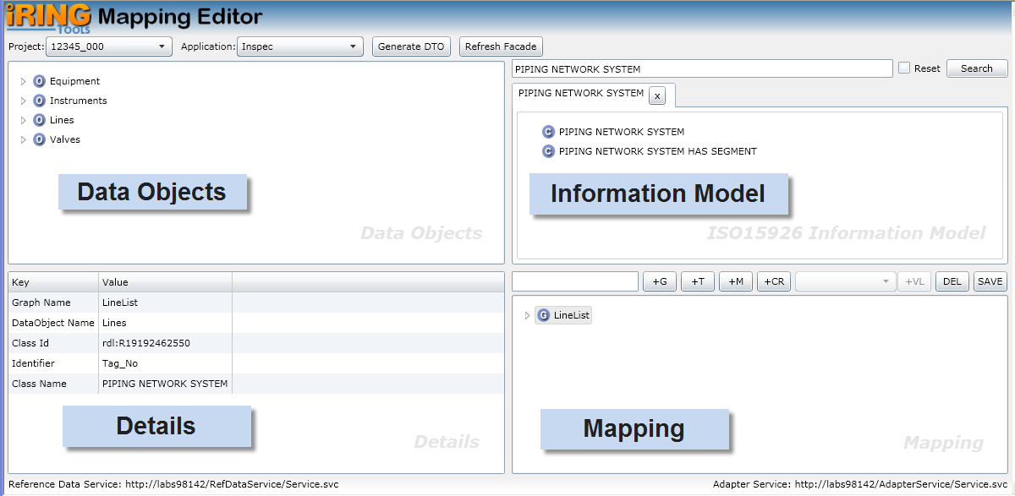
Data Objects represents the data dictionary of your application database.
Information Model is the ISO 15926 classes and templates available for you to map.
Mapping is where you build and edit you data map.
Details displays detail information about what you currently have selected. The content in the Details changes based on the last selected item from the other editor sections.
  - Open Project and Application
Open the project and application to map by performing the following:
- Ensure the data dictionary for the application has been generated for the application per Application Data Dictionary section in this document.
- Using your browser, open the mapping editor by entering that address:
http://<hostname>/MappingEditor/Default.aspx
Where <hostname> is the name of the server hosting the iRINGTools mapping editor.
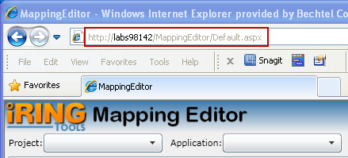
- Select the project from the Project dropdown list.
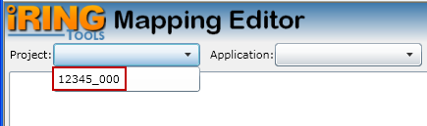
- Select the application from the Application dropdown list.
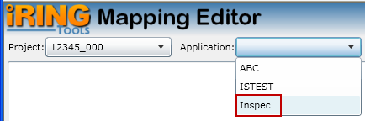
  - Create Graph Map
A graph map specifies how ISO 15926 reference data is mapped to your application database and is used in data exchanges. Create a graph map by performing the following:
Note: Prevent possible data loss by frequently saving your graph by clicking the SAVE button on the Mapping toolbar.
- Determine the class that aligns with the data map being created, search for it in the Information Model pane, and then select the result.
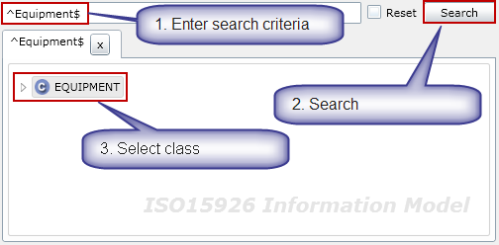
- In the Data Objects pane, select the entity (table) being mapped and its identifier (i.e., the column that uniquely identifies the table such as tag number).
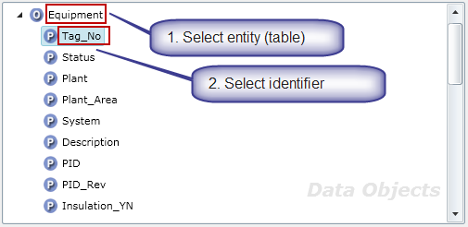
- In the Mapping pane, enter the name of the graph and create a new graph map by clicking on the +G button on the Mapping toolbar.
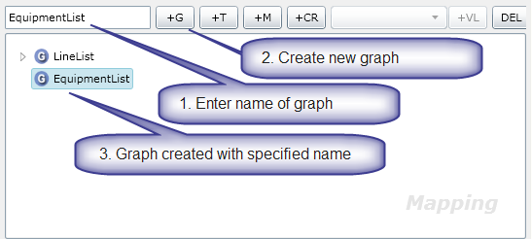
- In the Mapping pane, click on the graph name. The graph details appear in the Details pane.
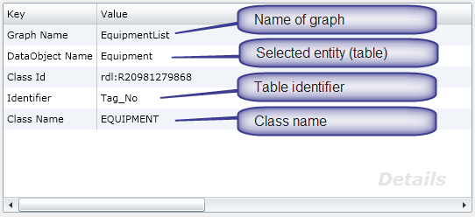
- Save the graph by clicking on the Save button on the Mapping pane toolbar.
Note: If you do not see the Save button on the toolbar, you may need to resize your browser until it appears.
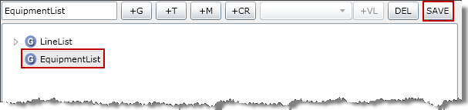
  - Mapping Graph Identifier
To successfully exchange data with your application database, the identifier for the entity (table) needs to be mapped. This is the same identifier defined when creating the graph map, but now needs to be explicitly mapped in the graph – typically using a template. Map an identifier by performing the following:
- Determine the template that will be used to map the identifier, search for it in the Information Model pane, and then select the result.
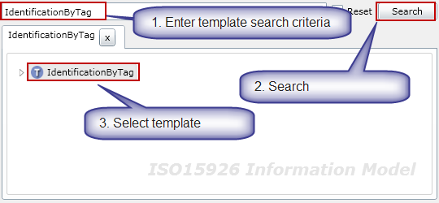
- The selected template name appears in the Mapping pane. Select the graph to map the identifier and then click the +T button on the toolbar.
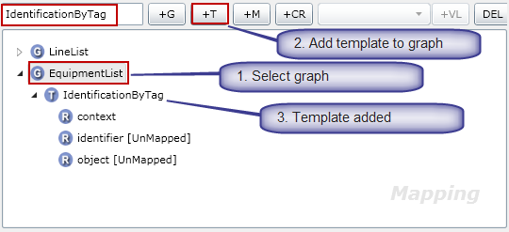
- Expand the graph to select the added template. Expand the added template to display the roles.
- Notice the role “context” is already mapped because it is a fixed role. (It is mapped because there is no [UnMapped] status next to it). The role “context”, in this case, has been specialized to the role TAG NAME. (Hence, the purpose for the template.)
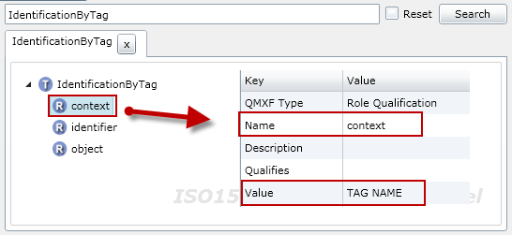
- Every template will have a class role (which is a role pointing to the class). In this template, the role “object” is point to the class “TAGGED ITEM”. Thus, the role “object” is the class role for the IdentificationByTag template.
- In the Mapping pane, assign the role “object” to the class role by selecting the role “object” and then clicking the +CR button on the toolbar.
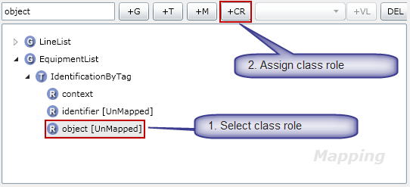
- Note the role “object” immediately disappears from the graph template role list.
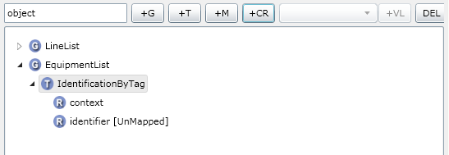
The final role “identifier” now needs to be mapped to the application entity (table) identifier column.
- In the Data Objects pane, select the entity (table) identifier column.
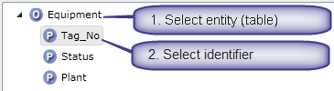
- In the Mapping pane, map the role to application by selecting the role “identifier” then clicking the +M button on the toolbar.
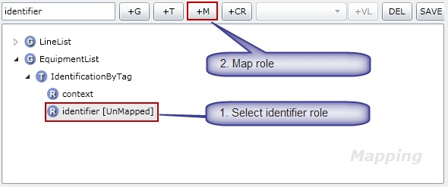
- The role identifier is now mapped because there is no [UnMapped] status next to it.
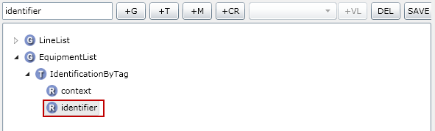
- This completes the mapping for the IdentificationByTag template. Save the graph by clicking on the Save button on the Mapping pane toolbar.

  - Mapping with Property Templates
A property template maps an ISO 15926 reference data class to your application database. Map a property template by performing the following:
- Determine the property template that will be used, search for it in the Information Model pane, and then select the result.
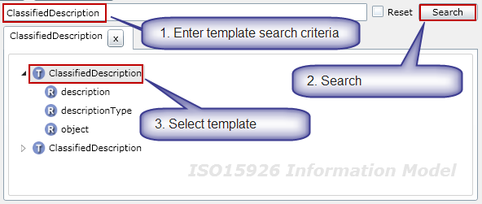
- The selected template name appears in the Mapping pane. Select the graph to map the identifier and then click the +T button on the toolbar.
- Expand the graph to select the added template. Expand the added template to display the roles.
- Notice the role “context” is already mapped because it is a fixed role. (It is mapped because there is no [UnMapped] status next to it). The role “context”, in this case, has been specialized to the role TAG NAME. (Hence, the purpose for the template.)
- Every template will have a class role (which is a role pointing to the class). In this template, the role “object” is point to the class “TAGGED ITEM”. Thus, the role “object” is the class role for the IdentificationByTag template.
- In the Mapping pane, assign the role “object” to the class role by selecting the role “object” and then clicking the +CR button on the toolbar.
- Note the role “object” immediately disappears from the graph template role list.
The final role “identifier” now needs to be mapped to the application entity (table) identifier column.
- In the Data Objects pane, select the entity (table) identifier column.
- In the Mapping pane, map the role to application by selecting the role “identifier” then clicking the +M button on the toolbar.
- The role identifier is now mapped because there is no [UnMapped] status next to it.
- This completes the mapping for the IdentificationByTag template. Save the graph by clicking on the Save button on the Mapping pane toolbar.

  - Mapping with Relationship Templates
A graph map specifies how ISO 15926 reference data is mapped to your application database and is used in data exchanges. Create a graph map by performing the following:
Note: Prevent possible data loss by frequently saving your graph by clicking the SAVE button on the Mapping toolbar.

- Performing Data Exchange
The following sections will describe how to perform a data exchange using iRINGTools.
  - TBD
TBD

