
http://iringtools.org

SDK Guide
Version 2.00.01

Notice
This is a controlled document. Unauthorized access, copying, replication or usage for a purpose other than for which it is intended, are prohibited.
All trademarks that appear in the document have been used for identification purposes only and belong to their respective companies.

Document Release Note

Document Details
Name | Version no. | Description
iRINGTools SDK Guide | 2.00.01 | iRINGTools SDK Guide

Reviewers
Name | Role | Organization Unit
Lee Colson | Documentation | iRINGTools
Rob DeCarlo | Software Engineer | iRINGTools

Terms of License
Copyright (c) 2011, iringug.org
All rights reserved.
Redistribution and use in source and binary forms, with or without modification, are permitted provided that the following conditions are met:
* Redistributions of source code must retain the above copyright notice, this list of conditions and the following disclaimer.
* Redistributions in binary form must reproduce the above copyright notice, this list of conditions and the following disclaimer in the documentation and/or other materials provided with the distribution.
* Neither the name of the iringug.org nor the names of its contributors may be used to endorse or promote products derived from this software without specific prior written permission.
THIS DOCUMENT IS PROVIDED BY iringug.org ''AS IS'' AND ANY EXPRESS OR IMPLIED WARRANTIES, INCLUDING, BUT NOT LIMITED TO, THE IMPLIED WARRANTIES OF MERCHANTABILITY AND FITNESS FOR A PARTICULAR PURPOSE ARE DISCLAIMED. IN NO EVENT SHALL iringug.org BE LIABLE FOR ANY DIRECT, INDIRECT, INCIDENTAL, SPECIAL, EXEMPLARY, OR CONSEQUENTIAL DAMAGES (INCLUDING, BUT NOT LIMITED TO, PROCUREMENT OF SUBSTITUTE GOODS OR SERVICES; LOSS OF USE, DATA, OR PROFITS; OR BUSINESS INTERRUPTION) HOWEVER CAUSED AND ON ANY THEORY OF LIABILITY, WHETHER IN CONTRACT, STRICT LIABILITY, OR TORT (INCLUDING NEGLIGENCE OR OTHERWISE) ARISING IN ANY WAY OUT OF THE USE OF THIS SOFTWARE, EVEN IF ADVISED OF THE POSSIBILITY OF SUCH DAMAGE.

Contents
List of Abbreviations vi
1 Overview 7
1.1 Data Exchange and Data Services 8
1.2 Adapter Framework 10
1.3 Adapter Layers 11
2 Custom DataLayer 12
2.1 Creating project 13
2.2 IDataObject 13
2.3 IDataLayer 14
2.3.1 Framework Hooks 15
2.3.2 GetDataDictionary Method 17
2.3.3 Create Method 18
2.3.4 Get, Post, and Delete Methods 18
2.4 Deploying the Custom DataLayer 19
3 Example Implementation 20
The total number of pages in this document, including the cover page, is 21.

List of Abbreviations

Acronym | Description
iRING | ISO 15926 Realtime Interoperability Network Grid
ISO | International Organization for Standardization
RDSWIP | Reference Data Service Work in Progress
SP | Service Pack
GUI | Graphical User Interface
IIS | Internet Information Services
MIME | Multipurpose Internet Mail Extensions
OLTP | Online Transaction Processing
API | Application Programming Interface
CRUD | Create, Read, Update and Delete
LAN | Local Area Network
FIPS | Federal Information Processing Standard

- Overview
iRING is a set of information interoperability and integration protocols and reference data that are compliant with the ISO 15926, Parts 7, 8, and 9 standards, which builds and depends on ISO 15926 Parts 1 through 6.

iRINGTools is a set of free, public domain, open source (BSD 3 license) software applications, services and utilities that implement iRING protocols. iRINGTools provide users with production ready deployable solutions. iRINGTools also provides technology solution providers with usage patterns for the implementation of iRING protocols in their respective solutions.

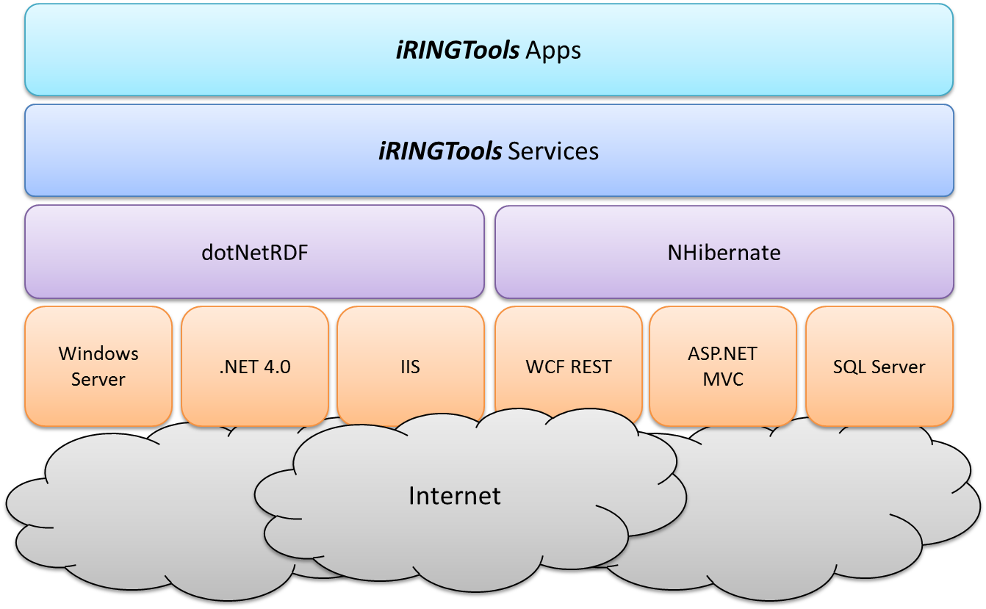

iRINGTools is deployed in two packages, iRINGTools Services and iRINGTools Apps. The iRINGTools Services are the core of the system. The iRINGTools Apps are used for mapping, configuration, and reference data management. The iRINGTools Services also support the apps, providing all information they need. The two packages are intended to be deployed into a Microsoft Windows Server 2003 running .NET 4.0 and IIS 6.0, although later versions of each are supported. The iRINGTools Apps use ASP.NET MVC, and the iRINGTools Services use WCF REST. The Services use dotNetRDF and NHibernate to handle semantic repository and relational database functionality, respectively. NHibernate and dotNetRDF both support many databases, but our sample configuration uses Microsoft SQL Server 2005 Express or later.

This guide focuses on the iRINGTools Adapter. The adapter is an extenisble generic web service adapter. It uses NHibernate to connect to databases for the purpose of exposing their data as a web service. Besides the default NHibernate DataLayer, the iRINGTools Adapter can be extended with a custom DataLayer. Custom DataLayers can handle other sources of data, such as an API, Excel, CSV file, etc. This document provides step by step detailed instructions for how to create and deploy a custom DataLayer with iRINGTools Adapter.

  - Data Exchange and Data Services
The iRINGTools Adapter can produce data projections at different levels of the ISO standard. It can produce Part 7 XML, Part 7 Data Transfer Object (DTO), Part 8 RDF/OWL, or a Part 9 Facade. The raw DataObjects are also exposed for very simple consumption needs. The purpose of exposing data in these various formats is to accommodate consumers with different needs. For the purposes of data exchange the adapter uses DTO or RDF/OWL. For general data consumption, any of the projections can be used, but the Part 7 XML is specifically optimized for this purpose. Overall, metadata is available for all levels of projection, and each format provides a uniform way of dealing with the data from various data providers.

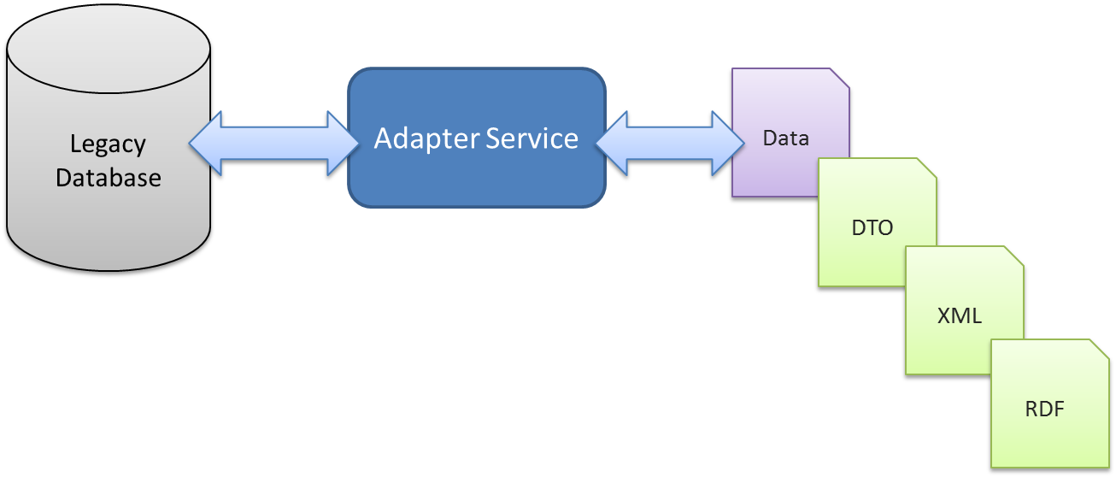

For full ISO 15926 compliance, the adapter uses RDF/OWL and SPARQL as the protocol for data exchange. In this scenario, the adapter uses pull based data exchange. This means that when the adapter receives a pull request, it can pull data from other endpoints. As shown below, the Façade Service is the SPARQL endpoint the adapter publishes to, and the SPARQL client to pull data from other SPARQL endpoints. For more information about the SPARQL protocol and SPARQL query language, please see the linked W3C documents.
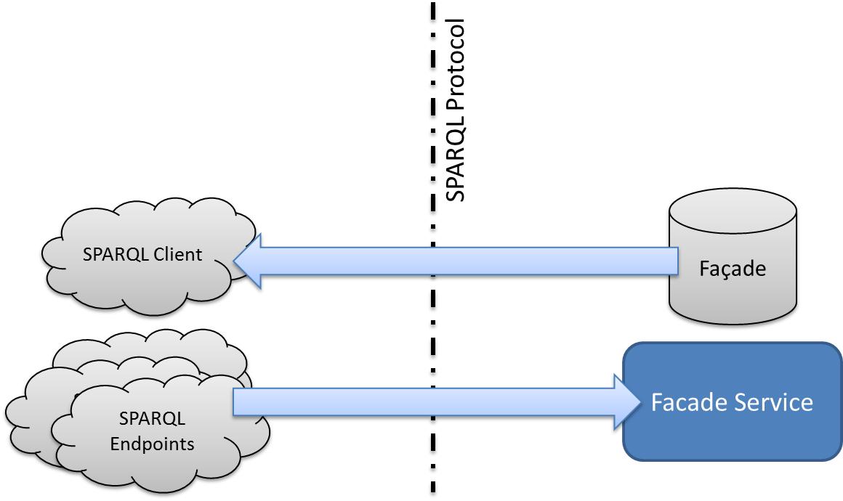

The adapter can also exchange a Part 7 Data Transfer Object (DTO). The DTO is a generic object that describes the data using Part 7 Templates. The adapter uses the HTTP protocol to enable RESTful access to the DTO’s. DTO’s are only intended to be exchanged with other iRING endpoints that support the Data Transfer (DXFR) interface. This is not part of the ISO standard, and is not recommended for interoperability across companies. However, RESTful access to the DTO’s is designed for testing and debugging purposes. It is also designed to be the easiest and fastest means of data exchange between two endpoints using Part 7 templates.

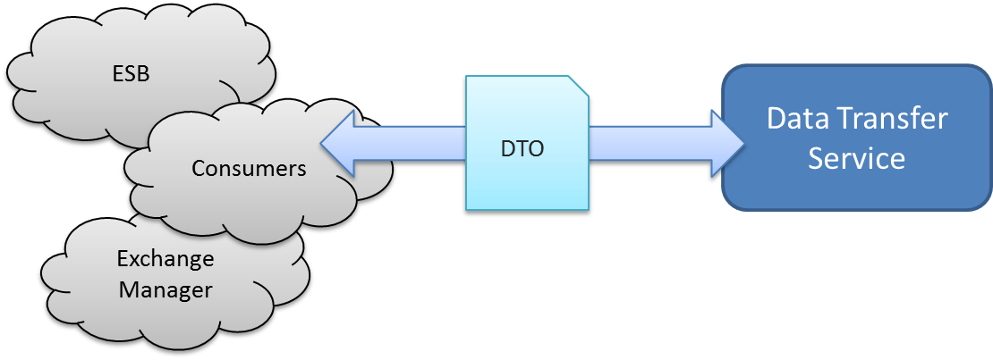

For general data consumption, the Adapter provides a data service. This service can project any of the data representations. However, for consuming Part 7 in widgets, MVC’s, or reporting, a Part 7 XML is available. It is optimized for communicating relationships via simple non-generic XML. This XML has a dynamic schema, and is hierarchical. The relationships are communicated through the hierarchy.

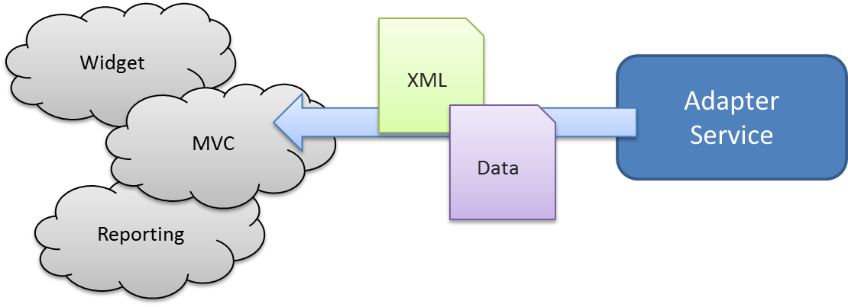

The raw DataObjects are also available for simple data structures. However, the Dictionary resource provides metadata about these objects. Also, the uniform structure allows consumers to easily deal with data from various data providers.

In future releases, the data service will provide JSON as well, and will specifically target the Sencha UI framework.

  - Adapter Framework
The iRINGTools Adapter is a generic and extensible service. The collection of interfaces and classes used by developers to extend the service is referred to as the Adapter Framework. The framework is centered around the data object, which is provided by the DataLayer. All of the functionality of the adapter deals with facilitating the persistence, production, consumption and projection of DataObjects. Projected objects are then exposed over multiple data APIs. Over time, new APIs can be exposed, and existing DataLayers will not need to change.

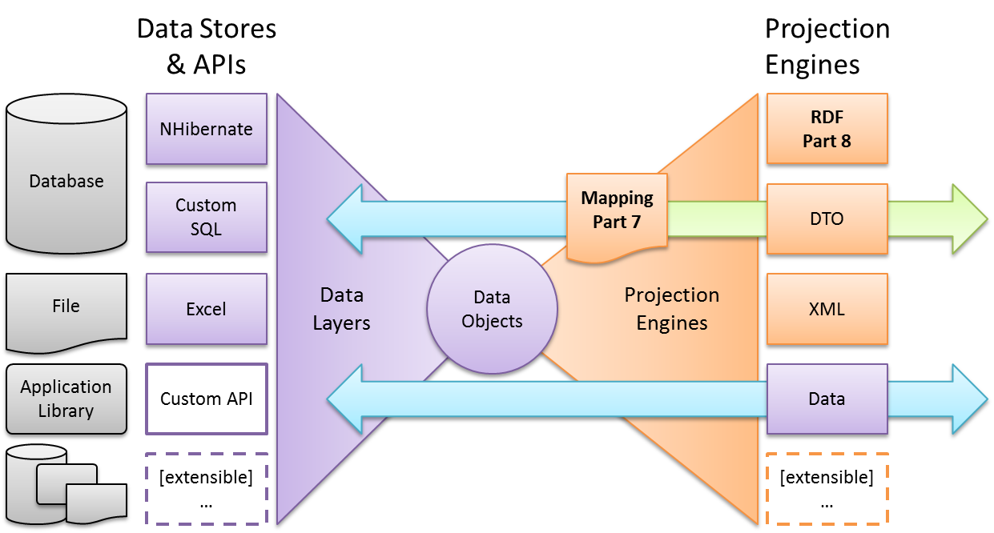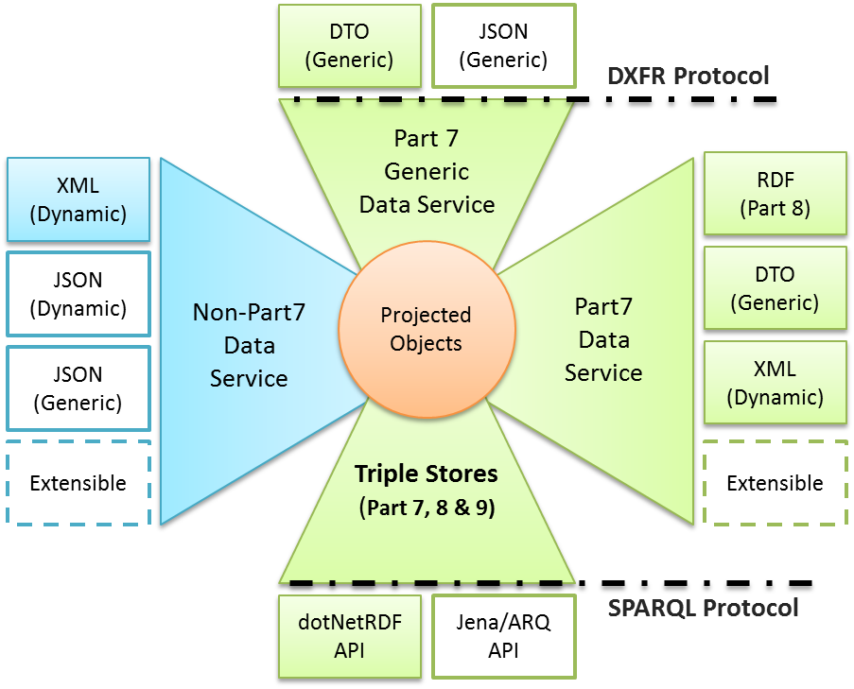

The Adapter Framework provides three primary services to a DataLayer:
- Scope and Identity
- Multiple Data APIs
- Querying and writing to a semantic repository.
  - Adapter Layers
The Adapter Framework is broken down into different layers which are separated by interfaces. Each layer has a defined set of functionality that it provides to the adapter.

This version of the guide will focus on the IDataLayer interface. The other layers are extensible as well, and they will be documented in later versions of this guide. The IDataLayer interface consists of methods that must be implemented by each DataLayer. Through this interface, the Projection Layer will project your DataObjects based on your DataDictionary and the iRING mapping. The Projection Layer also uses this interface to create, post, and delete your DataObjects through your business logic.

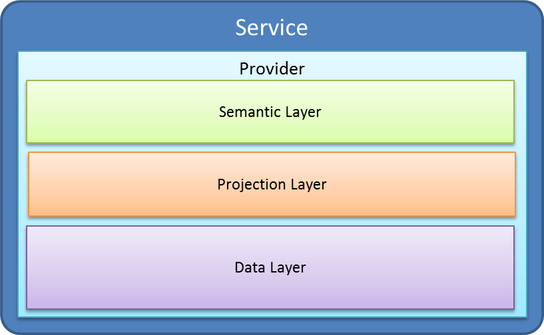

This requires you to wrap your custom types in new classes that implement the IDataObject interface. In this way, the Projection Layer is abstracted from knowing anything about your custom types. The Projection Layer will simply use the DataDictionary you provide to interact with your objects through the interfaces.

- Custom DataLayer
This section will outline the steps required to create a Custom DataLayer. Creating a Custom DataLayer involves C# development and XML configuration. The process will require the installation of the iRINGTools Services and Apps. A Custom DataLayer consists of a .NET Assembly which contains a class that implements IDataLayer.

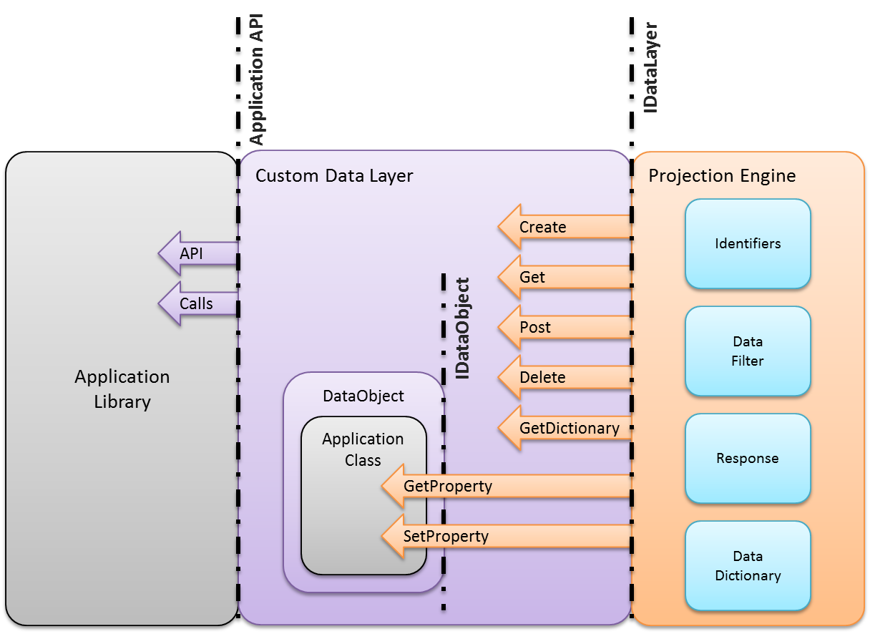

This interface has four primary methods for Create, Get, Post and Delete. These methods work with DataObjects that implement IDataObject. The interface also has a GetDictionary method that enables the Projection Layer to get metadata about your entities. Included in the installation of the iRINGTools Adapter, are libraries that should be reference by your Custom DataLayer. These libraries provide the interfaces, and all of the classes used in them. The following sections will provide all of the details.

The steps for creating an implementation of IDataLayer are as follows:
- Create a C# ClassLibrary Project.
- Wrap your Entities with DataObjects that implement IDataObject.
- Create a class that implements IDataLayer.
- Deploy your Custom DataLayer into the iRINGTools Adapter.

This section will guide you through each of these steps, using the sample included in the SDK.

  - Creating project
Create a new project of type C# ClassLibrary. Then, add a reference to the iRINGLibrary.dll and UtilityLibrary.dll from the Tools folder in the iRINGTools_Adapter.zip.

The Utility Library is only required if any of the utility methods are to be used. It is probably best to add it now, and decide later whether or not to use the library.

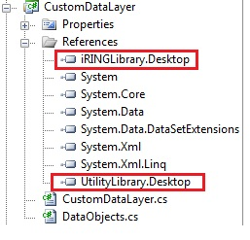

  - IDataObject
The IDataObject interface is how the adapter’s Projection Layer interacts with your entities. Developers do not need to modify their application entities in order to implement the interface. It is recommended to wrap application entities with another class that implements the interface. Below is a listing of how this can be done.
public class Equipment
{
public string Tag { get; set; }
public string PumpType { get; set; }
public string PumpDriverType { get; set; }
public Double DesignTemp { get; set; }
public Double DesignPressure { get; set; }
public Double Capacity { get; set; }
public Double SpecificGravity { get; set; }
public Double DifferentialPressure { get; set; }
}

public class EquipmentDataObject : Equipment, IDataObject
{
public object GetPropertyValue(string propertyName){...}

public void SetPropertyValue(string propertyName, object value){...}
}

Below is a class diagram that shows the listing above.

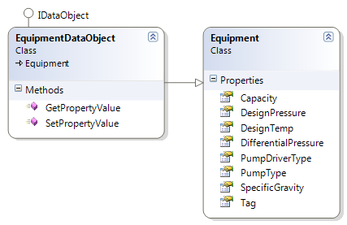

The interface allows the Projection Layer to delegate the interaction with your entities to your DataLayer. Specifically, the Projection Layer uses GetPropertyValue and SetPropertyValue to access the entity properties. In this way, your implementations of IDataObject do not necessarily need to physically wrap your Entities, but just logically wrap them. This enables the flexibility to build a DataLayer around all sorts of data structures (e.g. concrete, generic, dynamic, persisted, file-based, etc).

  - IDataLayer
A Custom DataLayer implements the IDataLayer interface. This section will describe the steps involved in implementing this interface. Each method, and how it is used by the DTO Layer to interact with your Entities, will be explained.

To create a class that properly implements IDataLayer, the following overall steps are recommended.
- Create Framework Hooks.
- Implement GetDataDictionary.
- Implement Create.
- Implement Get, Post and Delete Operations.
The listing below shows the definition of the IDataLayer interface.
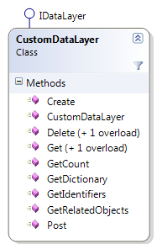
public class CustomDataLayer : IDataLayer
{
public IList<IDataObject> Create(
string objectType,
IList<string> identifiers) {...}

[Inject]
public CustomDataLayer(
AdapterSettings settings) {...}

public Response Delete(
string objectType,
IList<string> identifiers) {...}

public Response Delete(
string objectType,
DataFilter filter) {...}

public IList<IDataObject> Get(
string objectType,
DataFilter filter,
int pageSize,
int pageNumber) {...}

public IList<IDataObject> Get(
string objectType,
IList<string> identifiers) {...}

public DataDictionary GetDictionary(){...}

public IList<string> GetCount(
string objectType,
DataFilter filter) {...}

public IList<string> GetIdentifiers(
string objectType,
DataFilter filter) {...}

public IList<IDataObject> GetRelatedObjects(
IDataObject dataObject,
string relatedObjectType) {...}

public Response Post(
IList<IDataObject> dataObjects) {...}
}

    - Framework Hooks

For the Custom DataLayer to be used by the Adapter Framework, certain hooks need to be added to the constructor. Ninject (http://www.ninject.org/) is used to inject dependencies into the constructor of the Custom DataLayer. This is called constructor injection. It is done, by placing the Inject attribute on the constructor. In this way, Ninject will ensure that all of the arguments on the constructor are created before calling the constructor.

There are other types of objects that may be available from the dependency injection container, but the AdapterSettings is the most useful. The AdapterSettings are used in the provided sample. This parameter enables the Custom DataLayer to get the XML path and scope information that is specified by the adapter requests. It also provides identity information for authorization, which should be done by the DataLayer. Below is a table of some of the settings that may be useful.

BaseDirectoryPath | The path of the root of the running IIS Application. If you add a folder, you could use this to get your bearing.
XmlPath | The path where the iRINGTools Services store all of their XML files.
UserName | The identity of the calling user, from Windows Authentication.
KeyRing | The resulting collection of assertions from a Shared Token Service.
ProjectName | The part of the URI that specifies which project is requested.
ApplicationName | The part of the URI that specifies which application is requested.
Scope | The concatenation (with a “.”) of the ProjectName and ApplicationName.

In addition to these settings, anything placed in the {XmlPath}\{Scope}.config file will be loaded and made available. Keep in mind that your settings will be ignored if they conflict with the adapter’s settings.

    - GetDataDictionary Method
The DataDictionary provides metadata which is used by the Projection Layer, which does all of the interaction with the DataLayer. It is a class that defines DataObjects to be exposed to the adapter and ultimately exchanged with other applications.

It is recommended that it be created programmatically. To create a DataDictionary programmatically, you need to create an instance of DataDictionary with DataObjects and optionally data relationships. The tests will write your DataDictionary to XML, so that you can review it. The listing below shows a GetDictionary implementation that does this.
// Create a DataDictionary instance
DataDictionary dataDictionary = new DataDictionary()
{
dataObjects = new List<DataObject>()
{
new DataObject()
{
keyDelimeter = "",
keyProperties = new List<KeyProperty>()
{
new KeyProperty()
{
dataLength = 50,
dataType = DataType.String,
propertyName = "Tag",
isNullable = false,
keyType = KeyType.assigned,
},
},
dataProperties = new List<DataProperty>()
{
new DataProperty()
{
dataLength = 255,
dataType = DataType.String,
propertyName = "PumpType",
isNullable = true,
},
...
new DataProperty()
{
dataLength = 16,
dataType = DataType.Double,
propertyName = "DifferentialPressure",
isNullable = true,
},
},
objectName = "Equipment",
}
}
};

return dataDictionary;

The identifiers argument used in the interface is a list of identifiers. Each identifier is a concatenation of the key properties specified in the DataDictionary. The keyDelimiter is used to perform this concatenation. It is important to note that each data object must have at least one KeyProperty for the iRINGTools Adapter to identify each individual data object. However, it is best to use a single identifier whenever possible, like a number. This identifier will only be used on the direct DataObject projection.

    - Create Method
The create method is used by the DTO Layer to get empty instances of DataObjects to fill with data and post back to the custom DataLayer. The create method should create empty (except for the identifiers) instances of DataObjects, and return an IList<IDataObject>, which is a list of instances with the specified identifiers. Changes to your internal system, the application of business rules and authorization should not be done in this method. The DataLayer is simply creating an instance of the Data Object on behalf of the Projection Layer.

    - Get, Post, and Delete Methods
The Get, Post and Delete methods are the core of the interface. They should apply business logic, perform authorization, and modify the internal system, if appropriate. The details of what should be done in each method is described below.

Get Methods
The Get method should provide data to the Projection Layer for projecting into the various formats. It returns a list of IDataObjects.

There are two overloads of this method. One that takes the objectType and filter (a pagesize and a startIndex can also be specified here). Another that takes the objectType and list of identifiers. The Filter is a structured filter definition that can be used to create whatever filtering logic or syntax is required by your application. The iRINGTools Utility Library provides a method for converting this into a SQL WHERE clause if that is desired. The sample shows how to use a similar utility to form LinqExpressions.

To return a list of DataObjects, data needs to be fetched from the application and marshalling can be done to marshal application’s specific datatypes into IDataObjects.

The GetCount and GetIdentifiers are similar, but should provide either a simple count or a list of identifiers (strings), respectively. These are used by the adapter to facilitate different web APIs.

The GetRelatedObjects method should provide data to the Projection Layer for projecting into the various formats. It returns a list of IDataObjects of the specifies relatedObjectType that are related to a provided dataObject .

This puts the DataLayer in control of how these two DataObjects are related and how to join them. The Projections Layer uses the relationships specified in the DataLayer to know when to call this method.

Post Method
Post requests should receive data from the Projection Layer, and a detailed response should be returned for each IDataObject. This detailed response should include success, warnings, errors, or a detailed rejection explanation.

The data received needs to be inspected to determine if it is an add or change operation and the marshalling may be required to marshal DataObjects into application’s specific datatypes.

Delete Method
Delete method should delete DataObjects after verifying that it exists based on objectType and filter or based on the objectType and list of identifiers. A detailed response should be returned for each IDataObject. This detailed response should include success, warnings, errors, or a detailed rejection explanation.

  - Deploying the Custom DataLayer
Once you build the Custom dataLayer, the next step is the scope configuration. Please see the User Guide for instructions on how to add a scope. Once this configuration is done, the next step is to hook its DLL into the iRINGTools Adapter. In order for iRINGTools Adapter to use a custom DataLayer, the custom DataLayer must be bound to the IDataLayer interface. The details of how to do this will be described in detail below.

Binding configuration XML is located at {XmlPath}\BindingConfiguration.{Scope}.xml. It contains one binding for DataLayer. This specifies which implementation of the DataLayer should be used for an application. It is loaded by the Framework once per WCF service request and stored in Ninject session so that any reference to the DataLayer will get resolved dynamically at runtime.

In CSVDataLayer, the binding configuration XML is as follows. Note that the second part after the comma in the Interface and Implementation definition are assembly names.
<?xml version="1.0" encoding="utf-8"?>
<module name="12345_000.CSV">
<bind name="DataLayer"
service="org.iringtools.library.IDataLayer, iRINGLibrary"
to="iRINGTools.SDK.CSVDataLayer.CustomDataLayer, CSVDataLayer" />
</module>

The BindingConfiguration is the last step in setting up your DataLayer. The AdapterService should now respond to requests for your data. The data service can be used to directly test your data layer without any mapping. However, it is read only, you will need to perform some mapping to test Post and Delete functionality.
- Example Implementation
This document provides an example of a custom DataLayer used in iRINGTools demonstrations, called CSVDataLayer, which reads comma-separated values (CSV) data from disk, turns it into DataObjects, and writes it back to disk as its original CSV format. The complete CSVDataLayer source code and binary files mentioned in the document are available in the SDK package as a zip file.

Unzip the iRINGTools-SDK-2.0.1.zip.
Open iring-tools-sdk.sln in VisualStudio 2008 or later.

The following components will be present in the project for your reference:

- CSVDataLayer.cs that implements IDataLayer interface.
- DataObjects.cs that has the Equipment entity and EquipmentDataObject that wraps the Equipment entity and implements IDataObject interface.
- Equipment.12345_000.API.xml that contains the order of attributes of the csv file.
- 12345_000.API\Equipment folder that contains the sample csv files.

