I intend to start up a cloud computing service. The business has several aspects to it in terms of both costs and revenue streams.
The product:
My firm will offer clients both web storage and computing power on demand in a very easily maintainable and scalable manner. In essence a consumer will rent a set amount of storage space and a virtual machine running on a more powerful server which manages access to this data as well as providing a platform for a web infrastructure.

What the consumer will be buying into is a secure, convenient and cost efficient service to store their information and run their online operations with ease. My firm will provide a web interface to for the clients to access all of their data and manage their systems remotely as well as in-house technical support to provide assistance with more complicated tasks and emergencies.
The beauty in this business is that it is designed to be scaled easily. If a client simply wants to rent some storage space then all that needs to be done is to assign them an area on our network file store and assign them security credentials to access it using a VPN, we can provide them limited access to our own network or we can allow them to bridge across their own VPN although this might take some initial configuration, so that their data is transferred into and out of our storage space securely. If a client wants to rent more or less space from us we need simply alter the assigned amount of space they are allowed on our network.

The second part service we are providing is a little more complex, the client will be renting a virtual machine, running on our hardware, to run their own operations on. This has several advantages for the client, mainly scalability and cost as buying their own machine may be more expensive as well as upgrading the server taking only moments as it has no physical limitations other than the very large machine it is running on, as before to increase the power of the server we simply alter the amount assigned to them, this can even be done without the need for the server to be taken offline.

Training will be provided for the web interface at a cost.

Set Up costs:
To initially start the business I will need to invest in:
- Hardware: this business will obviously need some fairly hefty hardware. Initially a couple of top end servers will suffice for both sides of the business as they will provide enough CPU power to run a several virtual machines concurrently each of which can be rented out to the end user this will require a technician to ensure maintenance and proper installation, Ram will also need to be purchased to ensure top end performance.
- Virtualization software: My preferred choice of virtualiszation software would be Red Hat’s KVM. This has the advantage of being free to use with the option of paid consultancy from Red Hat themselves. I will also need to hire a System administrator with a familiarity of KVM to maintain the services provided and purchase support from Red Hat if its ever needed.
- A Website and Domain name: The advantage of being a web hosting firm is that I’ll be able to host my own domain. This will also require a small web team of two developers to build and maintain.
- Premises and storage: Initially I’m the business is not going to need a lot of space but if it is going to succeed it’ll need to be able to expand rapidly therefore I have decided that co-location would be, at least initially, the most sensible decision for the new company. This means that I’ll be renting space in another firms data-centre whilst still providing my own hardware.
- Bandwidth and IP addresses: Because I’m co-locating the data-centre I’ll be using will already have bandwidth setup and normal pricing is around £20 per terabyte used. I’ll need to purchase a few static IP addresses as these are not guaranteed with the data centre
- Insurance: One of the advantages of co-location is that I will be guaranteed uptime and fail-safe measures from power outages will also already be in place. I can guarantee my clients the same percentage uptime as the data centre that I’m co-locating with can which is around 99.7%. Any downtime beyond this amount I will charge to my co-locator on behalf of my clients.
- Customer facing staff: I'm going to hire a Marketing person to help bring in clients as well as take calls initially until the firm has grown in size enough to warrant a permanent secretary.
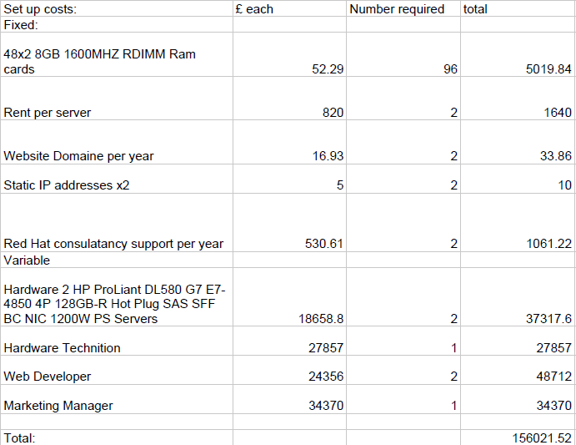
Obviously the number of staff will grow as the number of servers grows which in turn grows proportionally to the demand from clients.

Market Size and Pricing:
http://www.hostcount.com/stats.htm
The market size of the web hosting industry is large with over 50,000 firms and an estimated 62 million clients world wide. The majority of these firms are very small with 60% having a client base of less than 100 each whist the larger firms have over 350,000 clients each. Obviously I'd like to have more than 100 clients paying my firm to host content however There is no way for me to compete on price with the larger firms which sell web hosting for as little as £3.32 with 2 months free. [http://digitalocean.com ] Therefore a more sound strategy is to compete on service. This is where having a nice web interface will pay off. The vast majority of web hosting firms will simply provide the end user with only terminal, I know this from past experience, this is fine as long as your client knows how to use a computer with only a terminal interface which the vast majority of people can't do. The web interface my firm will be developing will enable users to have all the power of a terminal but designed in such a way that a layman could effectively use it. I also want to host training days for clients, at a cost, so that staff can learn how to use the system, this also helps us by getting active feedback. The superior service I'm providing to my clients will allow my to charge a higer price which will really help in the initial few months when the number of clients will low.
My price point for one server with 1.6 GHz cpu, 1GB of RAM and 50GB hard-drive will be £30 a month.

