Assignment1:

Import the legacy data from different sources such as (Excel, SQL Server, Oracle etc.) and load in the target system. (You can download sample databases such as Adventure works, Northwind, foodmart etc.)

Procedure:

For Windows

S1) Download Power BI Desktop from Microsoft store

S2) Download the excel file from the repo link:

OR

https://www.excel-easy.com/examples/excel-files/northwind.xlsx

S3) Open Power BI Desktop

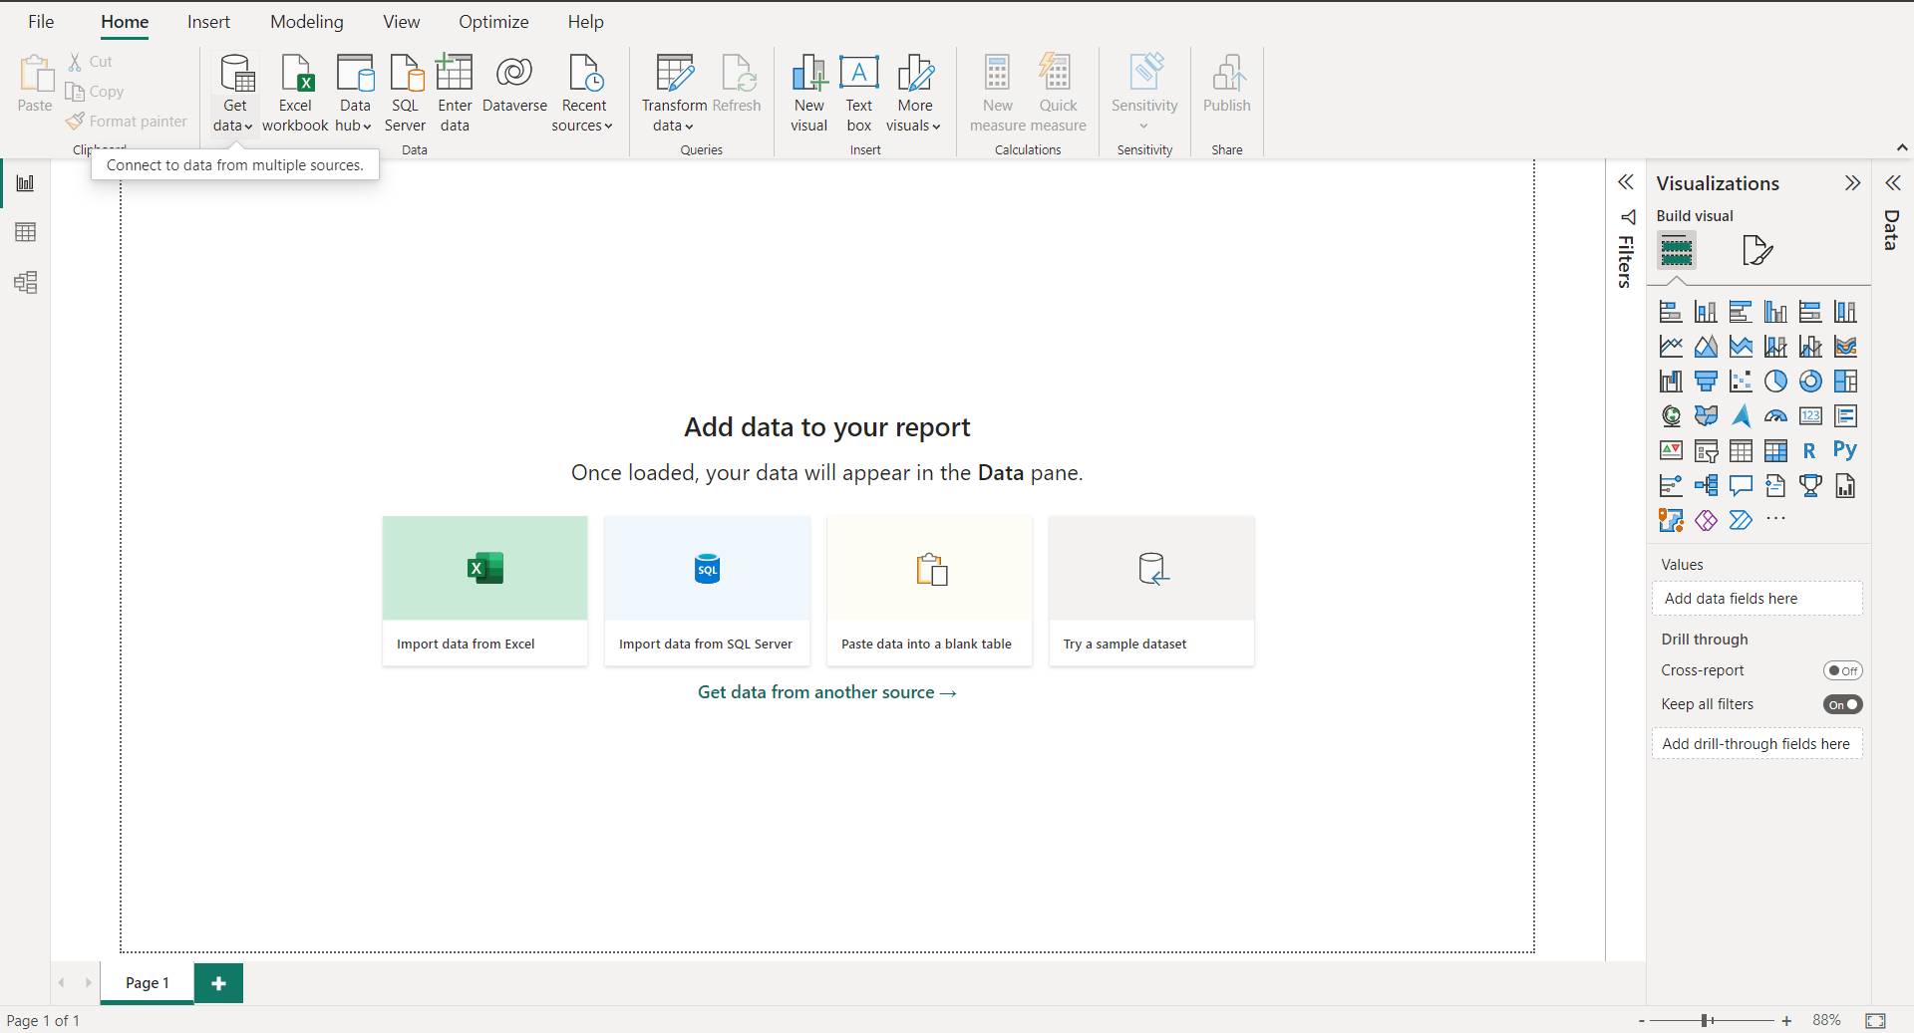

S4) Click on get data following list will be displayed -> select Excel

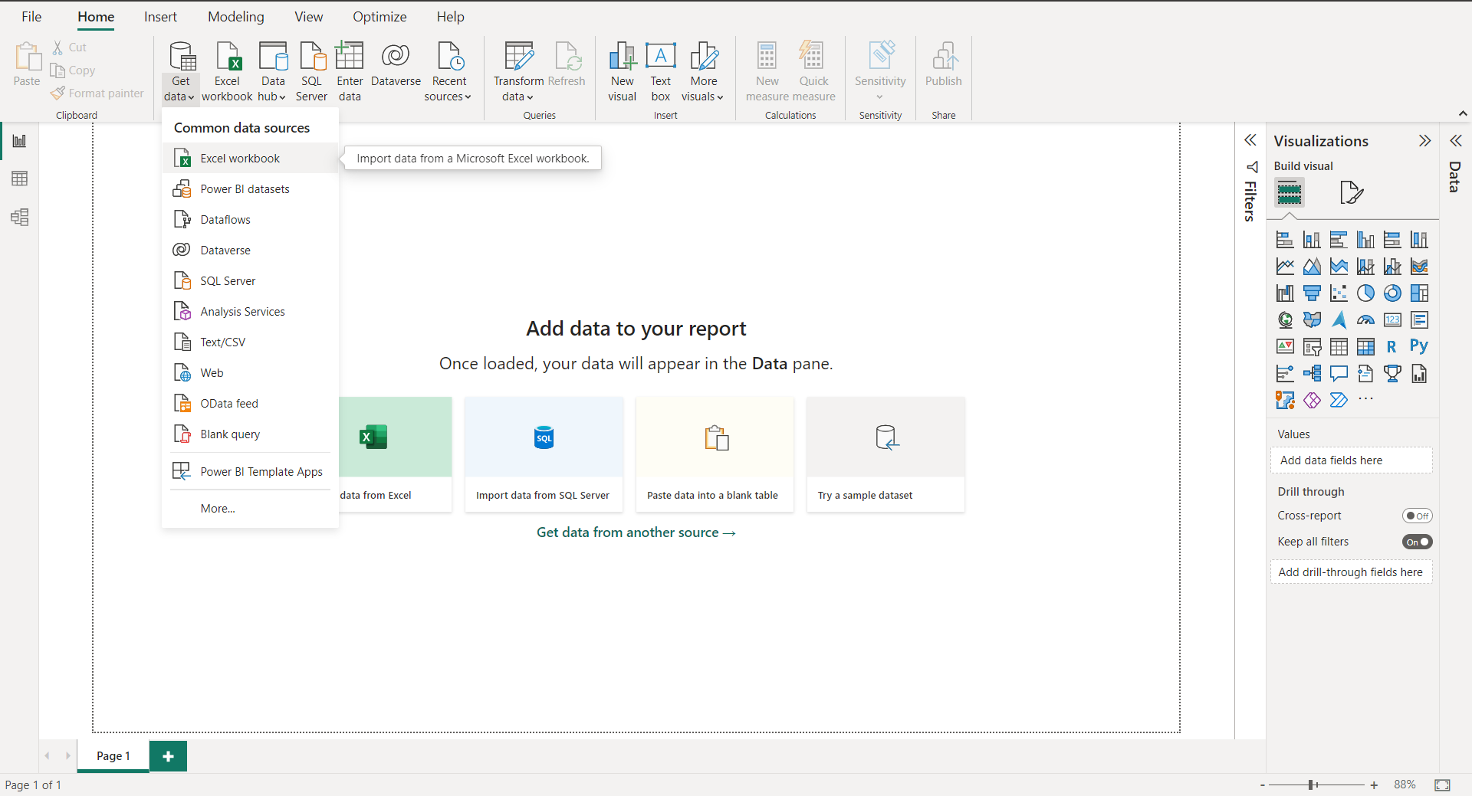

S5) Select required file and click on open, Navigator screen appears

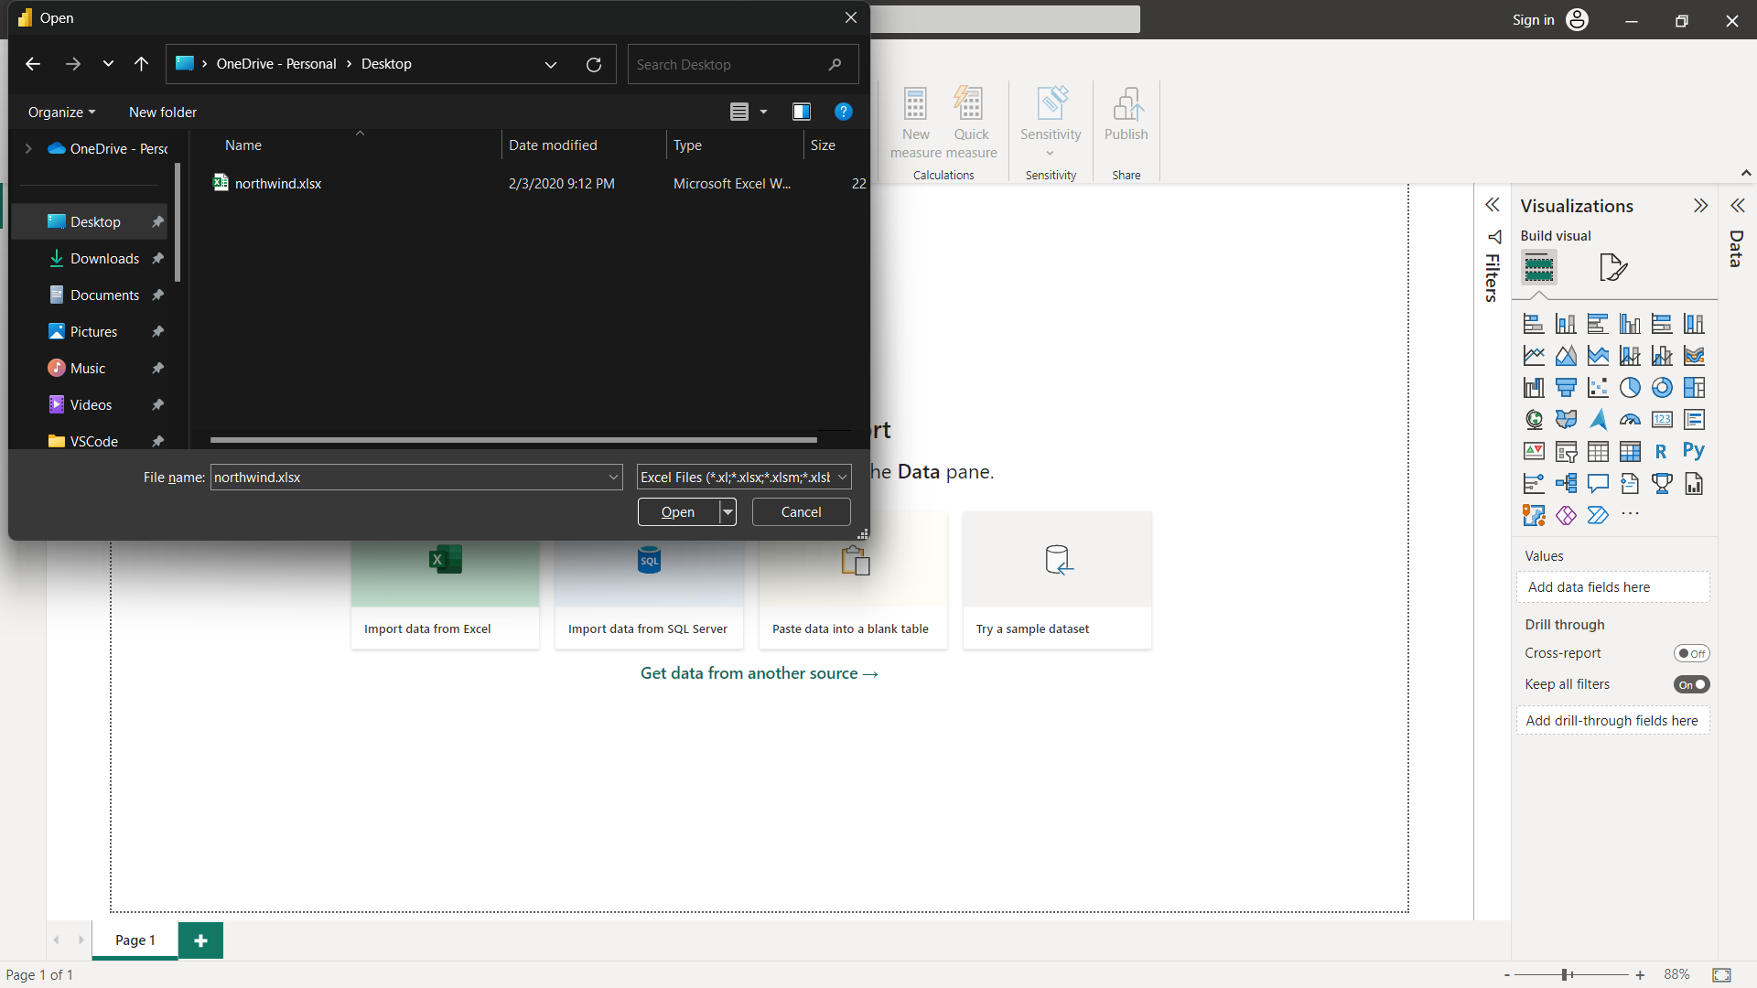

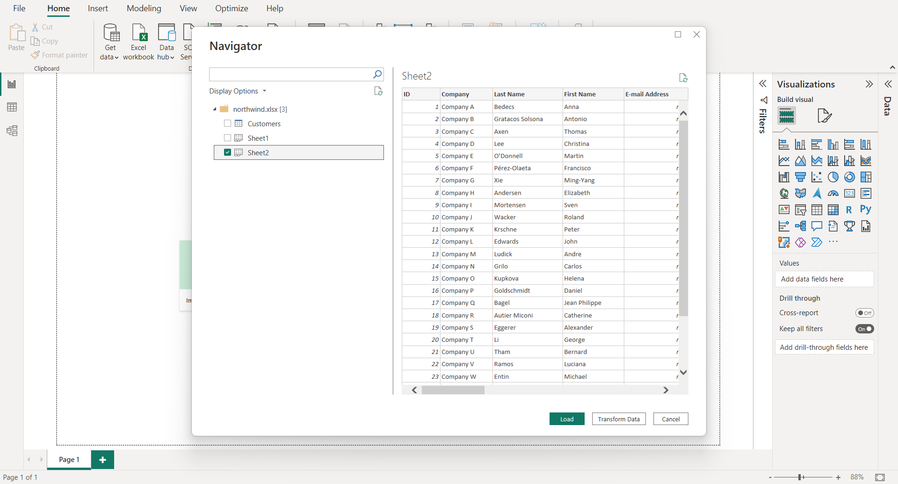

Click on Load…

S6) Power Query editor appears

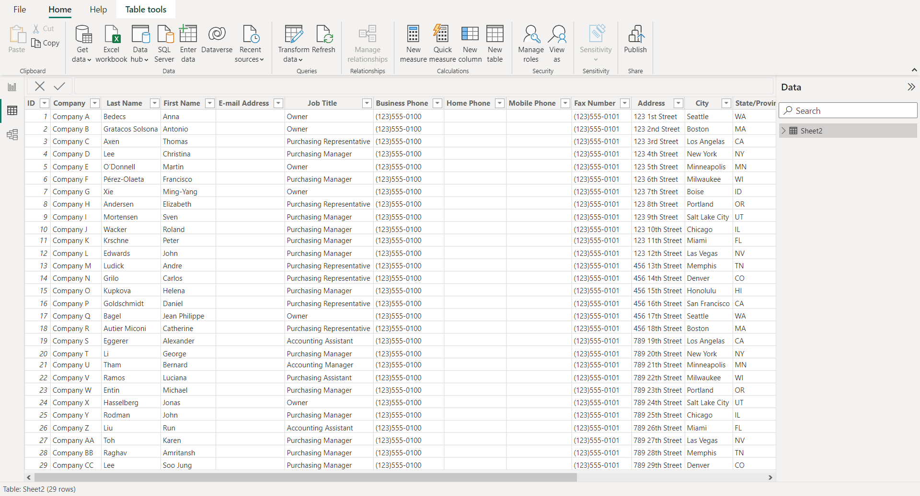

S7) Again, go to Get Data and select OData Feed.

Enter the following link in the URL field:

https://services.odata.org/V3/Northwind/Northwind.svc/

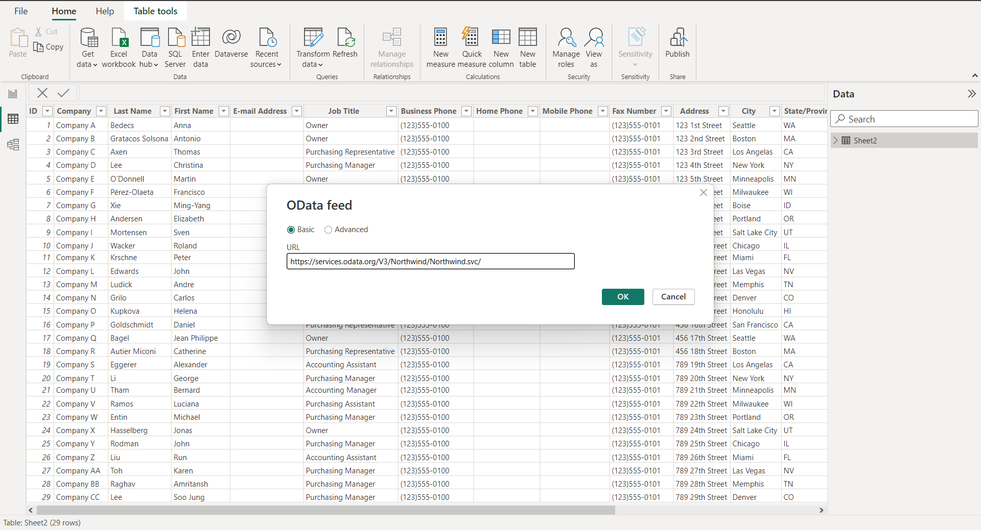

S8) Select Orders table

And click on edit

Note: If you just want to see preview you just can click on the table name without clicking on checkbox.

Click on the edit to view table.

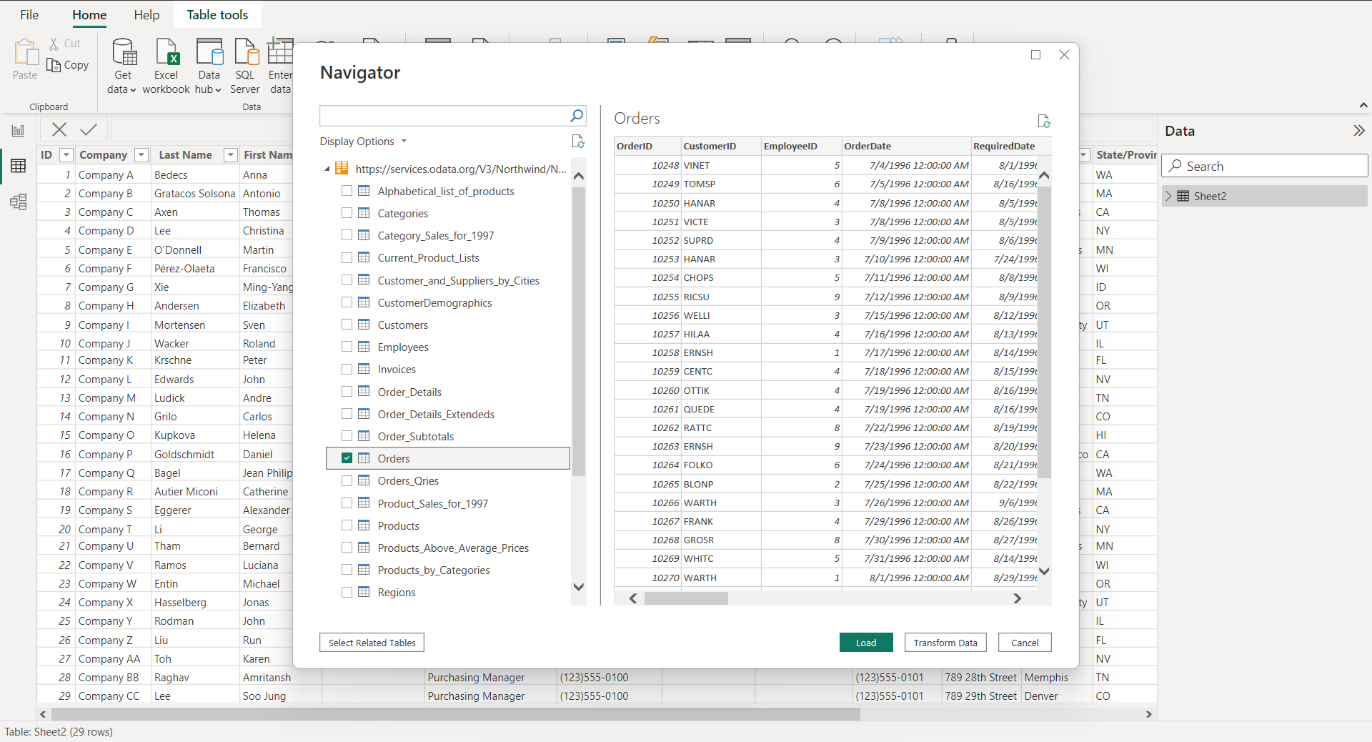

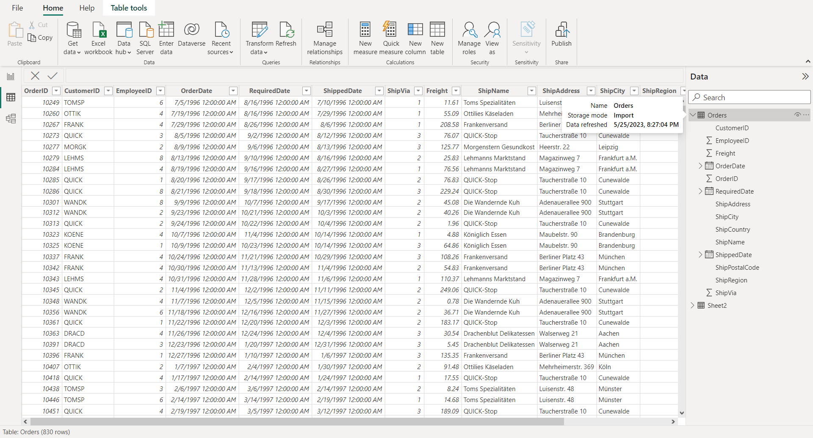

**Conclusion:** In this way we import the Legacy datasets using the Power BI Tool.