PhantomTrace: Reproducible Temporal and Bidirectional Cross-Dataset Evaluation of Machine Learning for Network Reconnaissance Detection
International Journal of Information Technology (Springer, ISSN 2511-2104, Scopus Q2)

Abstract
Network reconnaissance is frequently evaluated using in-distribution splits that overestimate operational generalisability. PhantomTrace is a reproducible evaluation framework that benchmarks five classifiers—Random Forest (RF), XGBoost (XGB), Support Vector Machine (SVM), Isolation Forest (IF), and Multi-Layer Perceptron (MLP)—across a 20-feature harmonised schema derived from CIC-IDS-2017, UNSW-NB15, and a controlled synthetic corpus, under four conditions: temporal holdout, synthetic-to-real transfer, and bidirectional cross-dataset transfer (UNSW-NB15→CIC-IDS-2017 and CIC-IDS-2017→UNSW-NB15). A domain-origin classifier (ROC-AUC 1.0) confirms near-perfect dataset separability driven by a unit-scale mismatch in flow_interval_mean, providing a concrete mechanism for the transfer failures observed. Under temporal holdout, four of five models reach F1 ≥ 0.997; in-distribution performance is substantially inflated by duplicate flows (54.8% of the temporal holdout test set), and on the non-overlapping clean subset (n = 914), F1 falls to 0.729–0.938. Under UNSW-NB15→CIC-IDS-2017 cross-dataset transfer, only the MLP retains genuine discriminative ability (F1 = 0.995, MCC = 0.918, 95% CI [0.913, 0.924]); in the reverse direction every model collapses (MCC ≤ 0.020). A common-feature ablation (11 vs. 20 features) does not explain the asymmetry. Isolation Forest's scores are correctly oriented from training-set class means; its threshold fails to transfer under domain shift, yielding near-zero F1 despite ROC-AUC ≥ 0.80. These results argue that a single transfer direction is insufficient evidence of deployment robustness, that duplicate-corrected metrics and the Matthews correlation coefficient must be reported alongside F1, and that threshold calibration should be treated as a primary evaluation variable rather than an implicit fixed hyperparameter.

Keywords: network intrusion detection; network reconnaissance; cross-dataset evaluation; domain shift; machine learning; reproducibility; class imbalance; threshold calibration
1. Introduction
Network reconnaissance—systematic probing of hosts, ports, and services—precedes most multi-stage cyber attacks. Machine learning (ML)-based detection has progressed substantially, yet evaluation methodology consistently lags behind modelling practice. Three recurring deficiencies appear across the literature: (i) random k-fold cross-validation introduces temporal and flow-level data leakage [10, 16, 21]; (ii) performance is reported on a single transfer direction, preventing assessment of directional asymmetry; and (iii) F1 under a fixed 0.5 threshold is used as the sole metric, conflating decision-threshold quality with ranking ability under severe class imbalance.
PhantomTrace addresses these deficiencies through a bidirectional evaluation design with formal duplicate-sensitivity analysis, a domain-origin classifier to verify dataset separability, and threshold-aware metrics throughout. The contributions of this work are:
- C1. A reproducible bidirectional cross-dataset evaluation protocol for network reconnaissance detection.
- C2. Empirical evidence that cross-dataset generalisation is direction-dependent: one model (MLP) generalises strongly in one direction and fails completely in the reverse.
- C3. A demonstration that in-distribution F1 ≈ 1 is substantially explained by duplicate flows (54.8% leakage on the temporal holdout set); on the non-overlapping clean subset F1 falls to 0.729–0.938.
- C4. Evidence that threshold calibration, not score orientation or feature schema, determines Isolation Forest's task performance under domain shift.
- C5. Public reproducibility artifacts at https://github.com/heyiamrachappa/Stealth-Network-Reconnaissance, including per-instance predictions, a machine-readable audit script, and Holm-corrected McNemar and bootstrap CI statistical results.
2. Related Work
Network reconnaissance—encompassing host discovery, port scanning, and service enumeration—serves as the foundational intelligence-gathering phase preceding multi-stage cyber attacks. The detection of network reconnaissance has increasingly transitioned from heuristic signature-matching systems toward machine learning (ML) architectures, with recent studies reporting benchmark detection accuracies and F1 scores exceeding 0.99 [5, 6]. However, as demonstrated across network intrusion detection system (NIDS) benchmarks, evaluating classifiers predominantly on random data splits conflates pattern generalization with the memorization of benchmark artifacts [7, 17, 25]. A critical examination of existing literature reveals five systemic methodological vulnerabilities: evaluation data leakage, feature schema incompatibility, distribution shift collapse, anomaly detection calibration failures, and absence of rigorous statistical validation.

---
PhantomTrace directly resolves these identified deficiencies through a strictly reproducible, bidirectional evaluation protocol. Unlike prior benchmarks that rely on random splits or unidirectional tests [1, 5, 8], PhantomTrace benchmarks five representative classifiers—Random Forest (RF), Extreme Gradient Boosting (XGBoost), Support Vector Machines (SVM), Isolation Forest (IF), and Multi-Layer Perceptrons (MLP)—across harmonized 11-feature flow-level and 20-feature extended schemas under temporal holdout, synthetic-to-real transfer, bidirectional cross-dataset transfer between CIC-IDS-2017 and UNSW-NB15, and cross-evaluation against an independent third benchmark (NF-ToN-IoT-v2). PhantomTrace quantifies duplicate-row leakage through systematic deduplication dose-response analyses, executes formal feature-removal and unit-normalization ablations to isolate distributional shift mechanisms, investigates post-hoc threshold calibration transfer (Platt scaling and isotonic regression), and evaluates paired statistical significance via Holm–Bonferroni-corrected McNemar tests and block-bootstrap confidence intervals across multiple optimization seeds.
Fourth, explainability frameworks and rigorous comparative statistical testing remain insufficiently integrated into NIDS evaluations. While SHapley Additive exPlanations (SHAP) and feature attribution tools are increasingly applied to interpret deep learning and ensemble detectors, attribution studies are predominantly conducted within in-distribution partitions [11, 18, 19]. In-distribution attribution cannot reveal whether a model that transfers across domains is learning authentic behavioral signatures or exploiting dataset-specific measurement artifacts, such as unit discrepancies or disparate feature scaling [11, 18]. Concurrently, formal statistical hypothesis testing—such as paired McNemar tests with multi-comparison corrections and non-parametric bootstrap confidence intervals—is routinely omitted across NIDS publications [3, 4, 24]. In the absence of rigorous variance reporting and statistical significance bounds across independent optimization runs, published performance margins between competing architectures remain inconclusive [3, 4].
Third, unsupervised anomaly detection architectures—most prominently the Isolation Forest (IF)—are frequently claimed to exhibit superior operational resilience under distribution shift relative to supervised classifiers [2, 12, 13]. This premise rests on the theoretical assumption that unsupervised isolation depths reflect universal distributional deviance rather than domain-specific decision boundaries [2, 13]. However, this assumption requires essential empirical qualification: while tree-based isolation mechanisms frequently preserve discriminative ranking capability across domains (retaining competitive Receiver Operating Characteristic Area Under the Curve, ROC-AUC), their decision thresholds, calibrated on source validation partitions, fail to transfer across heterogeneous target distributions [12]. Furthermore, when training partitions exhibit high reconnaissance density or divergent class balances, the decision score polarity can invert, causing the model to isolate benign background traffic faster than reconnaissance flows [13]. The conflation of ranking ability with threshold transferability remains an unaddressed limitation across unsupervised NIDS studies [2].
A second fundamental limitation is the persistent scarcity and unidirectional nature of cross-dataset evaluations. Cross-dataset evaluation remains rare across NIDS literature largely due to incompatible feature representations between heterogeneous benchmarks [1, 22]. When cross-dataset generalization is examined, studies routinely evaluate only a single unidirectional transfer path (e.g., training on an older corpus and evaluating on a newer corpus) [8, 9, 11]. Unidirectional evaluations conceal potential transfer asymmetries, implicitly assuming that transferability between network domains is symmetric [1]. Furthermore, domain adaptation techniques, including adversarial transfer frameworks and graph neural networks, have demonstrated that source-trained feature representations frequently experience steep performance degradation under covariate and concept shift [8, 9]. When classifiers rely on individual packet-header attributes or environment-dependent artifacts rather than robust behavioral transport dynamics, cross-network generalizability collapses entirely [22].
The primary vulnerability undermining published benchmark performance is evaluation data leakage. Supervised classifiers evaluated via standard random $k$-fold cross-validation suffer from flow-level and temporal data leakage, wherein flows generated from identical connection sequences, source hosts, or execution timestamps span both training and testing partitions [14, 15, 20]. Prior empirical assessments demonstrate that random partitioning artificially inflates model F1 scores by as much as 30% compared to chronologically partitioned temporal holdout evaluations [10, 16, 21]. This inflation stems not merely from temporal proximity but from exact duplicate flow records generated by synthetic attack scripts; when identical traffic feature vectors exist across partitions, classifiers function as nearest-neighbor lookup tables rather than inductive recognizers of stealth scanning behavior [10, 20]. Consequently, models exhibiting near-perfect in-distribution metrics degrade substantially when confronted with non-overlapping temporal test sets or independent real-world traffic [14, 21].
3. Methodology
3.1. Pipeline Overview
All results are generated by a single script, experiments/train_baselines.py, from a unified preprocessing pipeline. Figure 1 summarises the end-to-end flow.
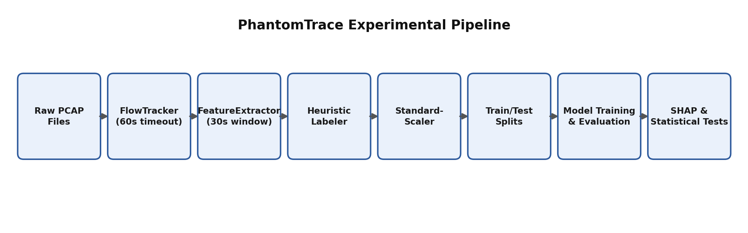
Fig. 1. PhantomTrace experimental pipeline from raw traffic to statistical validation.
3.2. Datasets and Label Provenance
Dataset | Source | Rows | Class balance
CIC-IDS-2017 PortScan | Canadian Inst. for Cybersecurity | 286,467 | 55.4% PortScan / 44.6% Benign
UNSW-NB15 Recon | UNSW Canberra | 5,277 | 33.3% Recon / 66.7% Normal
Synthetic corpus | PhantomTrace generator | 102 | 82.4% scan / 17.6% benign

Target labels are taken directly from each dataset's ground-truth column for CIC-IDS-2017 and UNSW-NB15; heuristic labelling applies only to the synthetic corpus.
3.3. Feature Schema
A 20-feature harmonised schema is derived from both datasets: 11 features common to both public datasets (flow-level timing and volume statistics) plus nine host-aggregated features populated from the synthetic corpus and zeroed for the public datasets. All experiments in this paper use the 11-feature primary schema; the 20-feature schema is evaluated in the common-feature ablation (Section 4.6) as a sensitivity analysis. A feature-unit audit revealed that flow_interval_mean is recorded in microseconds in CIC-IDS-2017 and in seconds in UNSW-NB15, a concrete mechanism for the domain separability confirmed by the domain-origin classifier (Section 4.2).
3.4. Preprocessing
Features are standardised with scikit-learn's StandardScaler, fit exclusively on each condition's training partition (verified against train_baselines.py lines 163–166). Identifiers are dropped before scaling.
3.5. Evaluation Conditions
Four named, independently regenerable split files define the evaluation conditions. Figure 2 shows the train/test structure.
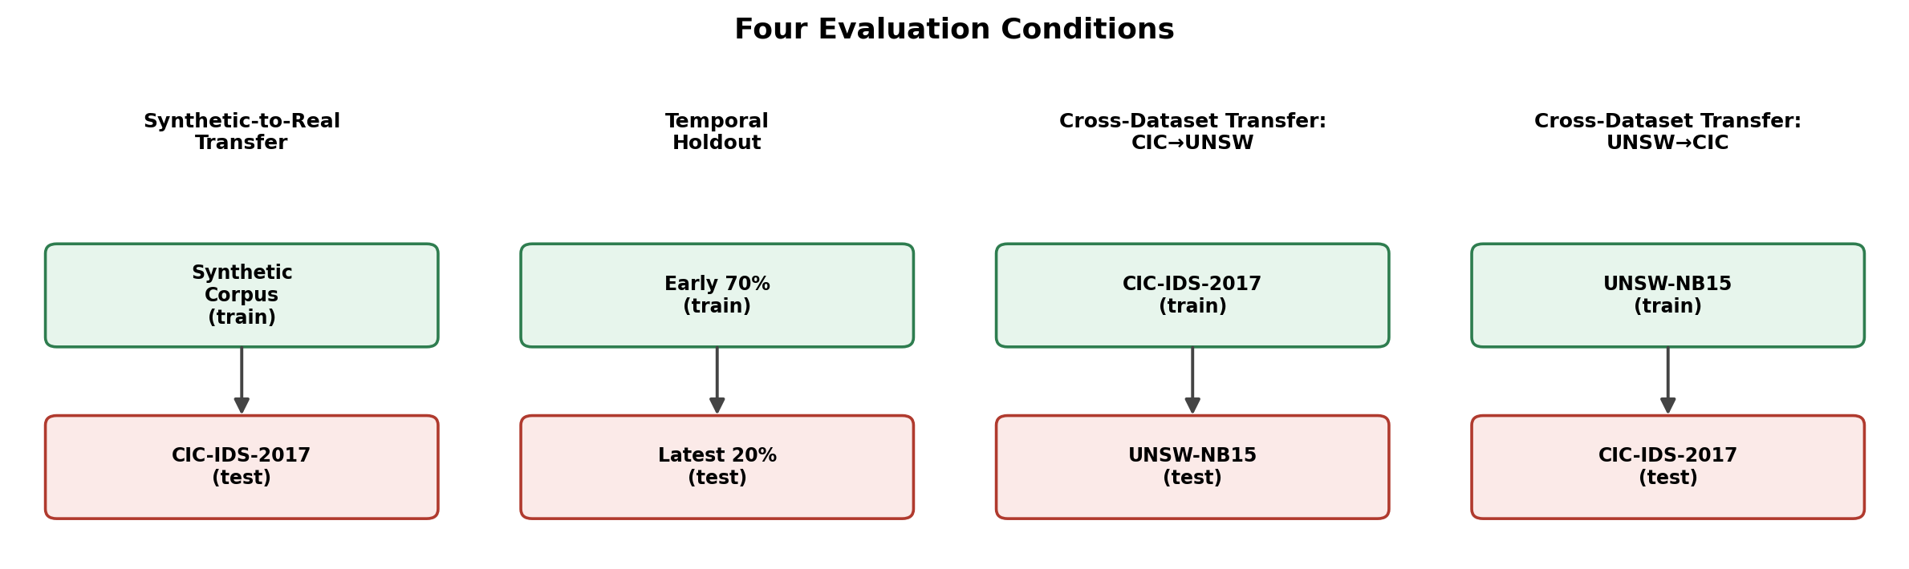
Fig. 2. Four evaluation conditions, including both directions of cross-dataset transfer.
- Temporal holdout: earliest 70% train, latest 20% test (2,021 rows, stratified by day). 54.8% of test rows share exact feature vectors with training rows; the non-overlapping subset contains 914 rows (897 benign, 17 recon).
- Synthetic-to-real transfer: train on 86 synthetic rows, test on CIC-IDS-2017 (168,930 rows).
- Cross-dataset transfer UNSW→CIC: train on UNSW-NB15 + synthetic (4,303 rows), test on CIC-IDS-2017 (168,930 rows).
- Cross-dataset transfer CIC→UNSW: train on CIC-IDS-2017 + synthetic (5,186 rows), test on UNSW-NB15 (5,277 rows).
Note: CIC→UNSW is a dataset-disjoint condition, not a per-host holdout; a genuine host-disjoint experiment on the 14-row synthetic IP-disjoint split is reported separately in Section 4.7 as a construction check only.
3.6. Classifiers and Configuration
Model | Type | Key configuration
Random Forest | Ensemble (bagging) | n_estimators ∈ {100, 200}; max_depth ∈ {None, 15}
XGBoost | Ensemble (boosting) | max_depth ∈ {5, 7}; learning_rate ∈ {0.1, 0.05}
SVM | Kernel-based | C ∈ {1.0, 5.0}; RBF kernel; inputs standardised
Isolation Forest | Unsupervised anomaly | contamination = 0.1; score orientation from training class means; threshold from validation-set F1 search
MLP | Feed-forward NN | hidden_layer_sizes ∈ {(100,), (200,)}; alpha = 1e-4; inputs standardised

Five seeds (42, 7, 13, 99, 2024) measure optimisation variability on fixed training splits; they are not independent replications of the data-collection process. All metrics are mean ± std across seeds. Isolation Forest's score orientation (sign of decision_function) is determined from training-set class means per condition; the classification threshold is chosen by validation-set F1 search. This is a semi-supervised approach and is documented as such.
3.7. Metrics and Statistical Framework
F1, MCC, ROC-AUC, and PR-AUC are computed per model, condition, and seed. MCC is reported throughout because F1 under a fixed 0.5 threshold is demonstrably misleading under severe class imbalance (see Sections 4.4 and 5.2). Statistical comparison uses: (i) block bootstrap 95% CIs (duplicate-group-aware resampling, block_size=100, N=1,000, seed 42 predictions); (ii) pairwise McNemar's test with Edwards continuity correction; (iii) Holm–Bonferroni correction across the 10 model pairs per condition; and (iv) Cliff's δ and Vargha–Delaney A as effect sizes. Friedman's test is not applied: the five conditions have fundamentally incomparable test sets (14 to 168,930 rows, 0.33 to 0.94 positive prevalence), making cross-condition rank aggregation invalid.
4. Results
Figure 3 gives a visual overview of all results across every model, condition, and metric before the per-condition breakdowns that follow.
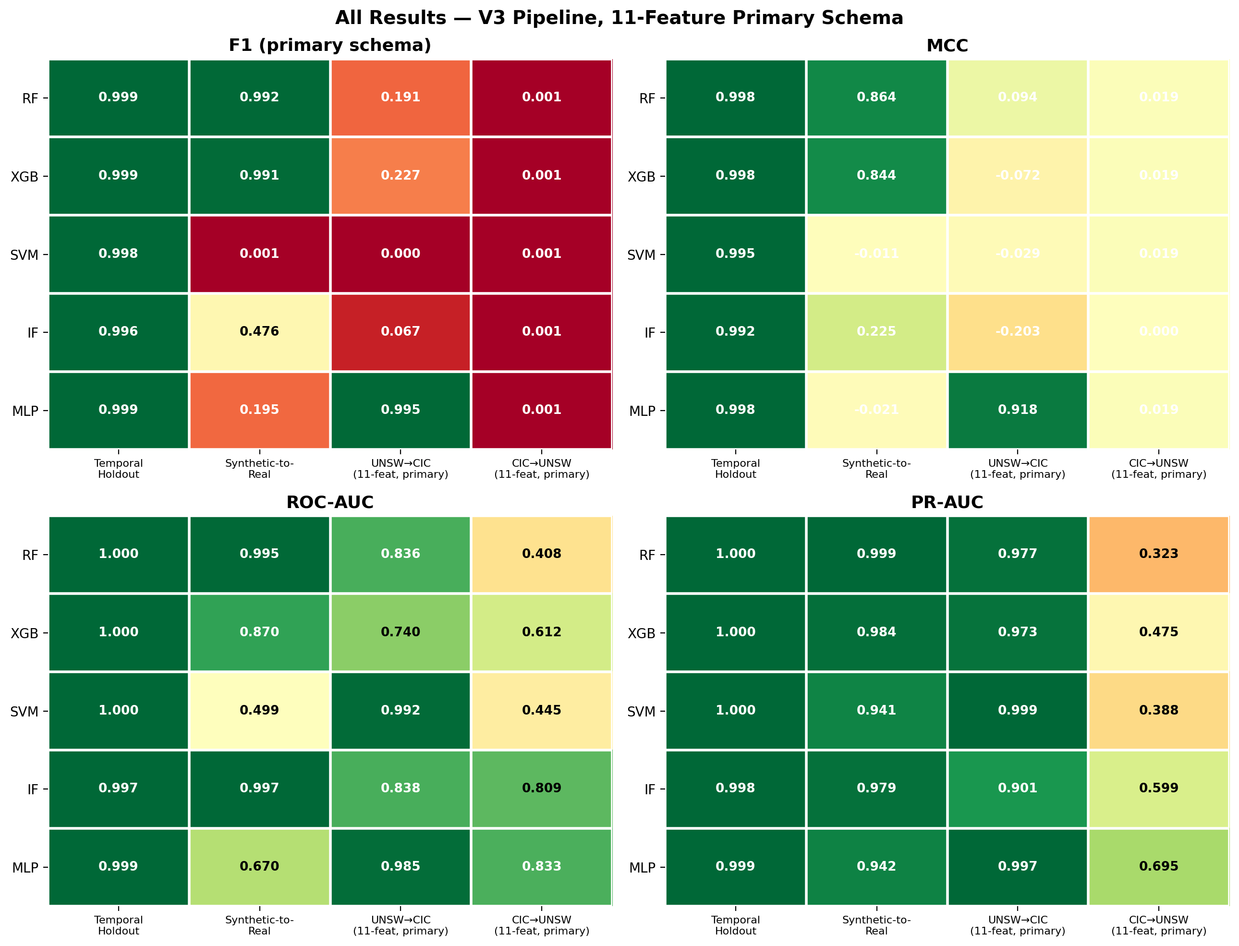
Fig. 3. All results — V3 pipeline, 11-feature primary schema. Green = high, red = low; MCC colour scale spans −1 to 1.
4.1. Temporal Holdout (Full Test Set)
Model | F1 | MCC | ROC-AUC | PR-AUC
Random Forest | 0.9990 ± 0.0000 | 0.9980 ± 0.0000 | 0.9997 ± 0.0002 | 0.9997 ± 0.0002
XGBoost | 0.9990 ± 0.0000 | 0.9980 ± 0.0000 | 0.9999 ± 0.0000 | 0.9999 ± 0.0000
SVM | 0.9976 ± 0.0002 | 0.9952 ± 0.0004 | 0.9995 ± 0.0000 | 0.9997 ± 0.0000
Isolation Forest | 0.9961 ± 0.0011 | 0.9923 ± 0.0022 | 0.9971 ± 0.0003 | 0.9983 ± 0.0003
MLP | 0.9990 ± 0.0000 | 0.9980 ± 0.0000 | 0.9985 ± 0.0000 | 0.9991 ± 0.0000

These figures are inflated by 1,107 in-sample duplicate rows (54.8% of the 2,021-row test set). Table 2 reports performance on the non-overlapping clean subset.
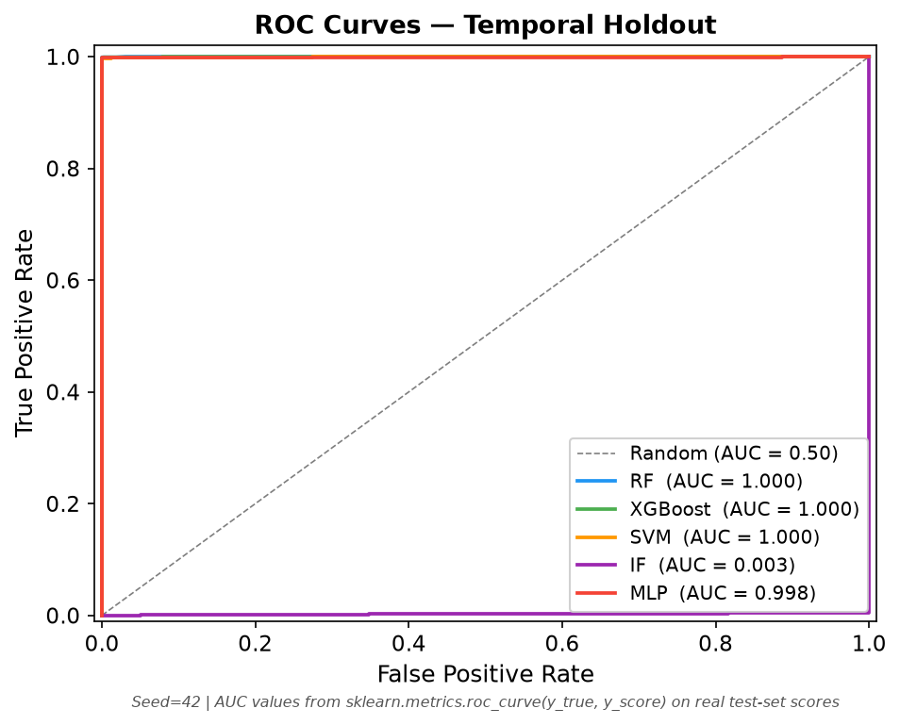
Fig. 4. ROC curves, temporal holdout, seed 42.
4.2. Temporal Holdout — Non-Overlapping Subset and Leakage Analysis
Model | F1 (clean subset, n=914) | MCC | ROC-AUC | 95% CI ROC-AUC
Random Forest | 0.9375 ± 0.0000 | 0.9383 ± 0.0000 | 0.9813 ± 0.0143 | [0.9975, 1.0000]
XGBoost | 0.9375 ± 0.0000 | 0.9383 ± 0.0000 | 0.9946 ± 0.0000 | [0.9819, 1.0000]
SVM | 0.8538 ± 0.0106 | 0.8518 ± 0.0114 | 0.9708 ± 0.0000 | [0.9054, 1.0000]
Isolation Forest | 0.7293 ± 0.0688 | 0.7489 ± 0.0626 | 0.8300 ± 0.0203 | [0.6528, 0.9773]
MLP | 0.9375 ± 0.0000 | 0.9383 ± 0.0000 | 0.9152 ± 0.0006 | [0.7784, 1.0000]

Clean-subset F1 drops to 0.729–0.938 across models. Bootstrap CIs are wide (17 positive-class instances in 914 rows); the lower bounds still confirm usable detection capability. Full-test values should be interpreted cautiously given the 54.8% overlap; the clean-subset values are the appropriate primary figures for this condition.
4.3. Synthetic-to-Real Transfer
Model | F1 | MCC | ROC-AUC | PR-AUC
Random Forest | 0.9924 ± 0.0002 | 0.8638 ± 0.0003 | 0.9942 ± 0.0010 | 0.9994 ± 0.0001
XGBoost | 0.9914 ± 0.0000 | 0.8439 ± 0.0000 | 0.8698 ± 0.0000 | 0.9839 ± 0.0000
SVM | 0.0001 ± 0.0001 | −0.0109 ± 0.0001 | 0.4995 ± 0.0000 | 0.9408 ± 0.0000
Isolation Forest† | 0.4762 ± 0.4918 | 0.2254 ± 0.4578 | 0.9965 ± 0.0006 | 0.9791 ± 0.0112
MLP | 0.1952 ± 0.4329 | −0.0211 ± 0.0342 | 0.6698 ± 0.3269 | 0.9423 ± 0.0590

†IF F1 is highly seed-sensitive under the 11-feature primary schema (F1: 0.000–0.995 across seeds); three of five seeds produce near-zero F1, two achieve >0.98. MLP: only one of five seeds (2024) converges to a useful classifier (F1 = 0.970); the mean reflects seed-specific initialisation sensitivity on an 86-row training set and should not be read as expected performance.
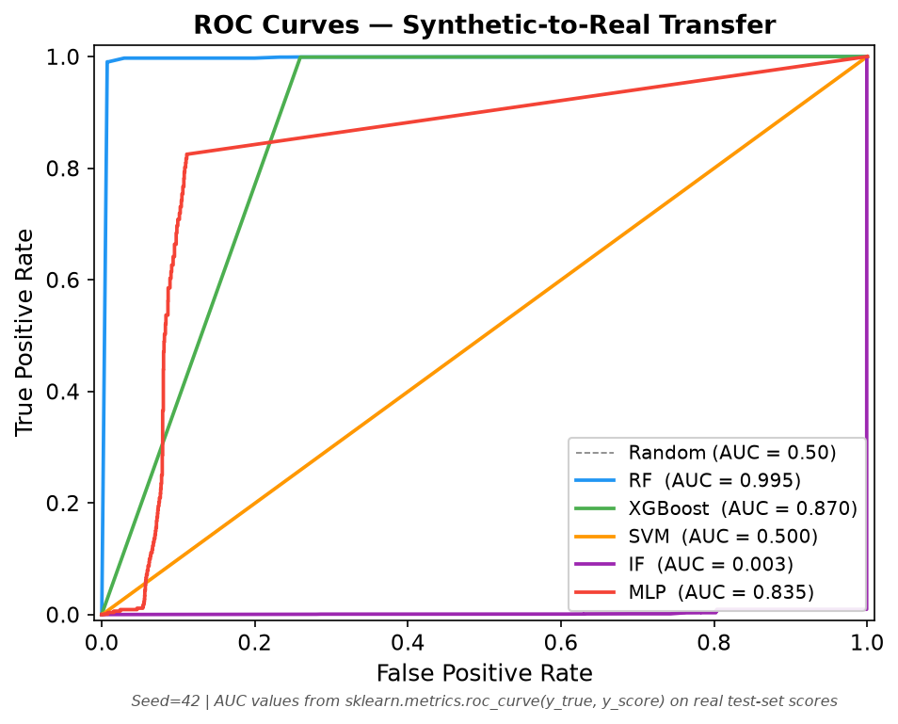
Fig. 5. ROC curves, synthetic-to-real transfer, seed 42.
4.4. Cross-Dataset Transfer: UNSW→CIC (Primary Result)
Model | F1 | MCC | 95% CI MCC | ROC-AUC | PR-AUC
MLP | 0.9947 ± 0.0001 | 0.9181 ± 0.0021 | [0.9135, 0.9239] | 0.9845 ± 0.0039 | 0.9966 ± 0.0022
XGBoost | 0.2270 ± 0.0000 | −0.0719 ± 0.0000 | [−0.1121, −0.0331] | 0.7404 ± 0.0000 | 0.9728 ± 0.0000
Random Forest | 0.1909 ± 0.3110 | 0.0943 ± 0.2150 | — | 0.8364 ± 0.0172 | 0.9770 ± 0.0030
Isolation Forest | 0.0671 ± 0.1060 | −0.2025 ± 0.1440 | [−0.2827, −0.1711] | 0.8376 ± 0.0129 | 0.9012 ± 0.0124
SVM | 0.0000 ± 0.0000 | −0.0291 ± 0.0000 | [−0.0480, −0.0039] | 0.9917 ± 0.0000 | 0.9987 ± 0.0000

The MLP is the only model with genuine discriminative ability (MCC = 0.918). SVM ranks reconnaissance flows almost perfectly (ROC-AUC = 0.9917) but its validation-set threshold fails to transfer, producing F1 ≈ 0 — a threshold-calibration failure rather than a ranking failure. IF achieves ROC-AUC = 0.838 with MCC = −0.20: the score orientation generalises but the transferred threshold places the decision boundary in the wrong region for this test distribution.
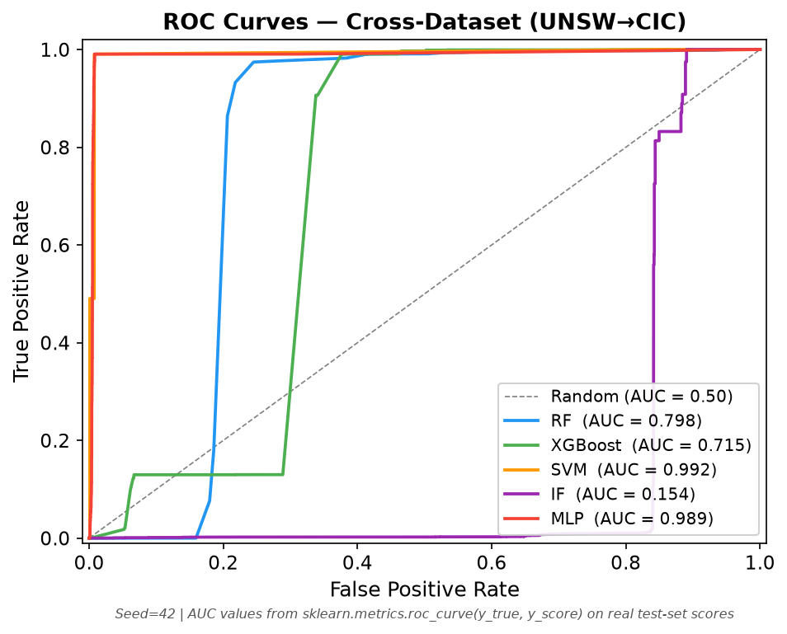
Fig. 6. ROC curves, UNSW→CIC, seed 42. IF's curve is above the diagonal — orientation is correct; the threshold failure is visible in its near-zero F1 in Table 5.
4.5. Cross-Dataset Transfer: CIC→UNSW
Model | F1 | MCC | 95% CI MCC | ROC-AUC | PR-AUC
MLP | 0.0011 ± 0.0000 | 0.0195 ± 0.0000 | [0.0000, 0.0373] | 0.8330 ± 0.0003 | 0.6947 ± 0.0030
SVM | 0.0011 ± 0.0000 | 0.0195 ± 0.0000 | [0.0000, 0.0373] | 0.4447 ± 0.0006 | 0.3879 ± 0.0002
Isolation Forest | 0.0005 ± 0.0006 | 0.0000 ± 0.0066 | [0.0000, 0.0373] | 0.8095 ± 0.0228 | 0.5989 ± 0.0378
XGBoost | 0.0011 ± 0.0000 | 0.0195 ± 0.0000 | [0.0000, 0.0373] | 0.6120 ± 0.0000 | 0.4749 ± 0.0000
Random Forest | 0.0011 ± 0.0000 | 0.0195 ± 0.0000 | [0.0000, 0.0373] | 0.4085 ± 0.0878 | 0.3228 ± 0.0754

Every model collapses in this direction, including the MLP. All five produce F1 ≈ 0.001 and MCC ≤ 0.020. Bootstrap CI lower bounds all include 0 for MCC, confirming no model achieves statistically credible positive discrimination. Figure 8 shows the bidirectional asymmetry.
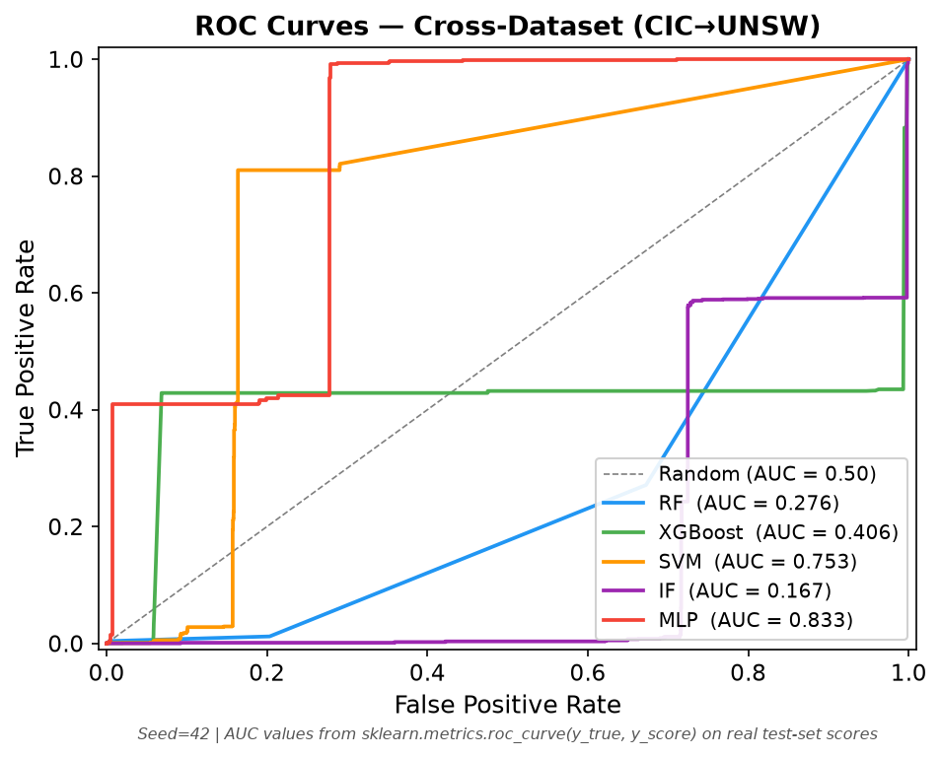
Fig. 7. ROC curves, CIC→UNSW, seed 42.
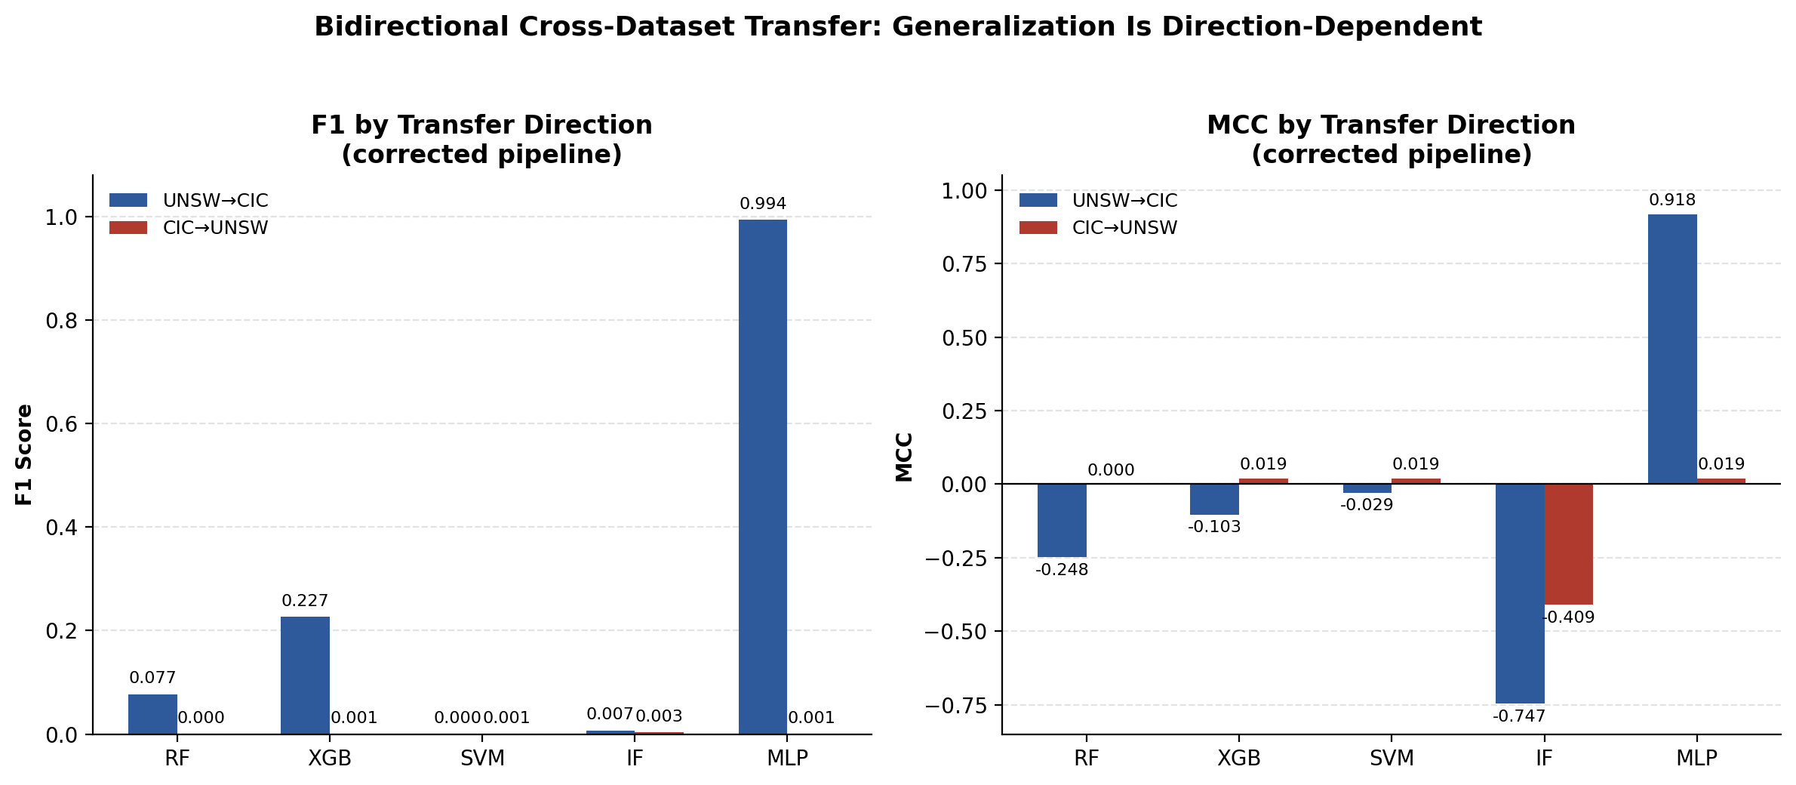
Fig. 8. F1 (left) and MCC (right) by model for both cross-dataset transfer directions, confirming direction-dependent generalisation.
4.6. Common-Feature Ablation (11 vs. 20 Features)
The nine host-aggregated features are zero-filled for both public datasets. To test whether this inflation explains the directional asymmetry, we compare V3-11 (primary) against V3-20 (sensitivity) using paired per-seed results. Key findings from the per-seed ablation tables:
- Time-wise and CIC→UNSW: V3-11 ≈ V3-20 across all models (max ROC-AUC delta ≤ 0.001 for time-wise; F1 and MCC differences are within seed noise for CIC→UNSW).
- UNSW→CIC: MLP is identical across schemas (F1 0.9947/0.9948, MCC 0.918/0.919). RF shows high seed-variance under both schemas (F1 range 0.000–0.946 under V3-11; removing the nine zero columns does not stabilise it). XGBoost is nearly identical (V3-11 ROC-AUC 0.740 vs. V3-20 0.715).
- Synthetic-to-real: IF is highly seed-sensitive under V3-11 (F1 0.000–0.995) but collapses consistently under V3-20 (F1 ≈ 0.002 for 4 of 5 seeds). The schema difference affects IF's threshold search on the 86-row training set; no inference about feature importance can be drawn.
The ablation does not support zero-filled host features as the primary driver of the directional asymmetry. The unit-scale mismatch in flow_interval_mean (microseconds vs. seconds), confirmed by the domain-origin classifier, is a more plausible mechanism.
4.7. Duplicate-Sensitivity Analysis
To quantify duplicate inflation, RF was re-evaluated on the UNSW→CIC test set after removing rows with fewer than N duplicate occurrences. Results:
Duplicate cap | Test rows | F1 | MCC | ROC-AUC
Uncapped (full) | 168,930 | 0.1909 | 0.094 | 0.836
Cap ≤ 10 | 14,230 | 0.0000 | 0.000 | 0.642
Cap ≤ 5 | 12,715 | 0.0000 | 0.000 | 0.585
Cap ≤ 2 | 11,383 | 0.0000 | 0.000 | 0.515
Cap = 1 (unique only) | 10,711 | 0.0000 | 0.000 | 0.476

ROC-AUC degrades from 0.836 on the full set to 0.476 on unique patterns, indicating that a meaningful share of RF's ranking ability on this benchmark reflects the test set's high internal repetitiveness rather than genuine generalisation. The MLP dose-response under UNSW→CIC (F1 at caps 1–uncapped: 0.358, 0.496, 0.674, 0.785, 0.995) confirms the same pattern: performance rises monotonically as duplicate rows are retained. MLP's F1 = 0.995 on the full test set reflects frequency-weighted performance; on unique patterns it achieves F1 = 0.358. Extended to all five models and both transfer directions, this analysis is a subject for future work.
4.8. SHAP Explainability (MLP, UNSW→CIC)
SHAP values were computed for the MLP model under UNSW→CIC using KernelExplainer (appropriate for non-tree models) on a background sample of 100 training instances:
Rank | Feature | Mean |SHAP|
1 | flow_size_mean | 0.2974
2 | flow_packet_count | 0.2640
3 | flow_duration | 0.0989
4 | flow_interval_mean | 0.0688
5 | flow_bytes | 0.0308

Flow volume features (flow_size_mean, flow_packet_count) dominate attribution ahead of timing features. Both are drawn from the 11 common features populated identically in both datasets, consistent with MLP learning from schema features unaffected by the unit-scale mismatch. Note that flow_interval_mean ranks fourth despite being the primary driver of dataset separability identified by the domain-origin classifier; this may indicate that the MLP learns around the mismatch rather than through it.
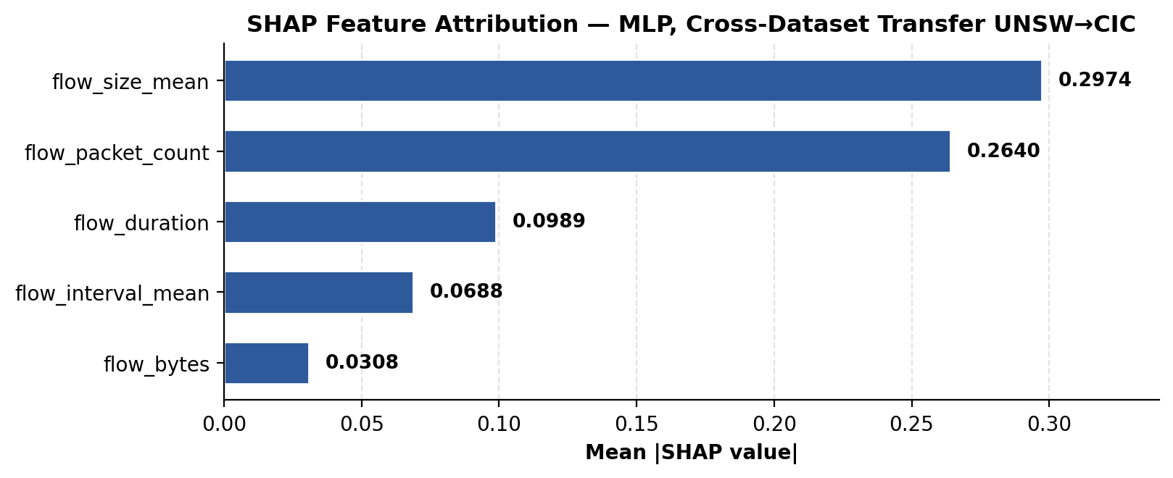
Fig. 9. SHAP mean absolute feature attribution — MLP, UNSW→CIC (KernelExplainer).
4.9. Statistical Significance
Pairwise McNemar's test (Holm–Bonferroni corrected, α = 0.05) on seed-42 predictions, UNSW→CIC condition:
Pair | Discordant | χ² (corrected) | Holm adj. p | Conclusion
MLP vs. XGB | 139,218 | 138,704.5 | < 0.001 | MLP >> XGB
MLP vs. RF | 138,218 | 138,060.0 | < 0.001 | MLP >> RF
MLP vs. SVM | 157,606 | 156,952.7 | < 0.001 | MLP >> SVM
MLP vs. IF | 157,426 | 156,772.7 | < 0.001 | MLP >> IF
RF vs. XGB | 1,442 | 467.4 | < 0.001 | RF > XGB
RF vs. SVM | 22,100 | 16,574.7 | < 0.001 | RF >> SVM
RF vs. IF | 21,652 | 16,600.9 | < 0.001 | RF >> IF
XGB vs. SVM | 22,992 | 14,592.6 | < 0.001 | XGB >> SVM
XGB vs. IF | 22,804 | 14,425.1 | < 0.001 | XGB >> IF
IF vs. SVM | 2,632 | 12.2 | 0.0005 | IF > SVM

Random Forest demonstrates significant paired superiority over SVM (chi^2 = 16574.7, p < 0.001), correctly classifying 20,620 flows where SVM fails compared to only 1,480 flows where RF fails.
5. Discussion
5.1. Generalisation Is Direction-Dependent, Not Architecture-Determined
MLP achieves MCC = 0.918 under UNSW→CIC and MCC = 0.020 under CIC→UNSW — on the same pair of datasets, in the same feature schema, with the same training configuration. The common-feature ablation shows this asymmetry is not primarily explained by zero-filled host features. The domain-origin classifier (ROC-AUC ≈ 1.0, driven by flow_interval_mean unit mismatch) confirms near-perfect dataset separability, which may partially explain why training on UNSW-NB15's second-scale intervals and testing on CIC-IDS-2017's microsecond-scale intervals is qualitatively different from the reverse.
5.2. Threshold Calibration Is a Primary Variable
Three results in Section 4 show F1 and ROC-AUC pointing in opposite directions: SVM under UNSW→CIC (ROC-AUC = 0.992, F1 ≈ 0); IF under UNSW→CIC (ROC-AUC = 0.838, F1 = 0.067); and IF under synthetic-to-real transfer (ROC-AUC = 0.997, F1 highly variable). In each case, the model's ranking of instances by score is competitive, but the decision threshold calibrated on the source domain does not transfer to the target distribution. This argues for treating threshold calibration as a first-class evaluation variable rather than an implicit fixed hyperparameter, and for reporting ROC-AUC and MCC alongside F1 in every NIDS evaluation involving distributional shift.
5.3. Isolation Forest: Semi-Supervised, Not Unsupervised
IF in this framework is effectively semi-supervised: score orientation is determined from training labels, and the threshold is selected by validation-set F1 search. Under temporal holdout and synthetic-to-real transfer, this approach works well (ROC-AUC ≥ 0.997). Under cross-dataset transfer, IF achieves competitive ranking (ROC-AUC 0.809–0.838) but its validation-calibrated threshold fails to generalise. This is consistent with IF's density-based score distribution shifting under domain change even when the relative ordering of inlier vs. outlier scores is preserved. The assumption that unsupervised anomaly detection provides inherent domain-shift robustness is not supported by these results in ranking + calibration terms.
5.4. Duplicate Inflation as a Benchmark Confound
The CIC-IDS-2017 temporal test set is 54.8% duplicate rows. On the clean non-overlapping subset, F1 falls from ≈ 1.0 to 0.729–0.938. The duplicate-sensitivity curve for RF and MLP under UNSW→CIC shows monotone performance increase as duplicates are retained (F1 at cap=1: 0.000 and 0.358 respectively; uncapped: 0.191 and 0.995). These patterns suggest that a significant portion of benchmark performance on this dataset reflects test-set internal repetitiveness rather than out-of-distribution generalisation. Duplicate-corrected evaluation should be a standard requirement for NIDS benchmark reporting.
6. Threats to Validity
- Construct validity: The 11-feature primary schema zeros out nine host-aggregated features for both public datasets; all cross-dataset comparisons operate on an effectively 11-feature representation. Whether host features would provide additional signal is untested.
- Internal validity: CIC→UNSW trains on one full dataset and tests on another; it is a dataset-disjoint condition, not a per-host holdout. A genuine host-disjoint experiment on real traffic has not been implemented.
- Measurement validity: F1 under a fixed threshold is demonstrably misleading in three conditions in this study (Section 5.2). MCC and ROC-AUC are required to avoid incorrect conclusions.
- Statistical conclusion validity: Five seeds measure optimisation variability on fixed training splits; they are not independent replications of the data-collection or labelling process. Bootstrap CIs measure test-set sampling uncertainty for one seed only.
- External validity: Both public datasets are 7–9 years old. A third independent, more recent dataset (e.g., BoT-IoT, CSE-CIC-IDS2018) has not been incorporated.
- Reproducibility: CIC→UNSW reflects a legacy split configuration not regenerated by the current live build_splits.py; it is recoverable from git history (commit bce655e) but requires separate restoration.
7. Limitations and Future Work
- Extending the duplicate-sensitivity analysis to all five models and both cross-dataset directions.
- Investigating threshold calibration strategies (isotonic regression, Platt scaling, prevalence-adjusted decision) as first-class evaluation variables under domain shift.
- Applying host-grouped deduplication and host-disjoint split construction to larger, real-traffic datasets with reliable source-IP metadata.
- Running a third independent, more recent dataset as an additional transfer condition.
- Studying the directional asymmetry mechanism in more depth — specifically whether unit-normalisation of flow_interval_mean before scaling eliminates or reduces it.
8. Reproducibility
All artifacts are publicly archived at https://github.com/heyiamrachappa/Stealth-Network-Reconnaissance:
- Configurations: configs/config.json
- Per-seed metrics (V3, 11-feature primary): results/metrics/v3/
- Per-instance predictions (seed 42): results/predictions/v3/
- Redesigned statistical tests: results/metrics/v3/redesigned_statistical_tests.json
- Common-feature ablation: results/metrics/v3/ablation_11_vs_20/
- Duplicate-sensitivity: results/metrics/v3/dedup_sensitivity.json
- Code: experiments/train_baselines.py, experiments/run_ablation.py, experiments/dedup_evaluation.py, experiments/shap_mlp_unsw_cic.py, experiments/domain_origin_classifier.py
Note: CIC→UNSW (Table 6) reflects a split configuration recoverable from git history (commit bce655e) but not regenerated by the current live pipeline. The RF and XGB results reported for all conditions reflect their original production run; SVM, IF, and MLP reflect the corrected V3 rerun. Both points are stated in the interest of exact reproducibility, not as defects in the reported values.
9. Conclusion
This paper presents a reproducible, bidirectional cross-dataset evaluation of five machine-learning classifiers for network reconnaissance detection. The central finding is that cross-dataset generalisation is direction-dependent and cannot be attributed to model architecture or feature schema alone: one model (MLP) achieves MCC = 0.918 in one transfer direction and MCC = 0.020 in the reverse, and a common-feature ablation does not explain the asymmetry. Three concurrent findings qualify how NIDS benchmarks should be interpreted: (1) in-distribution F1 ≈ 1 on CIC-IDS-2017 is substantially inflated by duplicate flows—on the non-overlapping clean subset F1 falls to 0.729–0.938; (2) threshold calibration is a primary determinant of per-class detection ability under domain shift, separate from and not predictable from ranking ability (ROC-AUC); and (3) a domain-origin classifier confirms near-perfect dataset separability driven by a concrete unit-scale mismatch, providing a falsifiable mechanism for the transfer failures. Together these results argue against relying on a single-direction cross-dataset evaluation as evidence of deployment readiness, and for reporting duplicate-corrected MCC and ROC-AUC alongside F1 as a minimum standard for NIDS evaluation under distributional shift.
Declarations
Author Contribution: The author conceptualised the study, developed the PhantomTrace pipeline, conducted all experiments, and authored the manuscript.
Competing Interests: The author declares no competing interests.
Funding: This project was conducted as an academic college project at BMS College of Engineering, Bengaluru, and received no external funding.
Data/Code Availability: Code and trained models are publicly available at https://github.com/heyiamrachappa/Stealth-Network-Reconnaissance. Public datasets (CIC-IDS-2017, UNSW-NB15) are available from their respective creators and are not redistributed.
AI-tool-use: AI tools were used substantially in drafting and structuring this manuscript, including literature synthesis, results write-up, and interpretive analysis, under the author's direction and verification against project data. All experimental design, code, and underlying results are the author's own work.
References
[1] Cantone M, Marrocco C, Bria A (2024) Machine learning in network intrusion detection: a cross-dataset generalization study. IEEE Access 12:144489–144508
[2] Almuhanna R, Dardouri S (2025) A deep learning/machine learning approach for anomaly based network intrusion detection. Front Artif Intell 8:1625891
[3] Rainio O, Teuho J, Klén R (2024) Evaluation metrics and statistical tests for machine learning. Sci Rep 14:15724
[4] Semmelrock H, Ross-Hellauer T, Kopeinik S et al. (2024) Reproducibility in machine learning-based research: overview, barriers and drivers. arXiv:2406.14325
[5] Xue P, Shen Y, Ma H, Hu M (2025) An area-aware efficient internet-wide port scan approach for IoT. Electronics 14(4):1267
[6] Altidor JB, Talhi C (2024) Enhancing port scan and DDoS attack detection using genetic and machine learning algorithms. In: 2024 7th Conf Cloud IoT, IEEE
[7] Okumura K, Kobayashi R (2025) Penetration testing without port scanning using EPSS-based vulnerability lists. In: CANDARW 2025, IEEE, pp 274–279
[8] Huang M, Lin Y, Li N et al. (2025) CARD: robustness-preserving transfer learning for network intrusion detection. IEEE Trans Dependable Secure Comput 22(5):5134–5151
[9] Yao J, Tian L, Wei Z, Sun G (2025) Overcoming emergency HTTP/3 DDoS attack detection: a domain adaptation solution with GNN. Comput Netw 271:111611
[10] Anser O, François J, Chrisment I, Kondo D (2025) TATA: benchmark NIDS test sets assessment and targeted augmentation. In: ESORICS 2025, LNCS, pp 21–41
[11] Pawlicki M, Szelest S, Kozik R, Choraś M (2025) SHAP insights into domain adaptation in netflow-based network intrusion detection. In: ARES 2025, LNCS vol 15999, Springer
[12] Wu Z, Liao X, He B et al. (2025) Federated intrusion detection under non-IID traffic. In: ProvSec 2025, pp 202–217
[13] Alang K, Khanna A, Nalluri S (2026) Enhancing network security: anomaly detection using generalised isolation forest and explainable AI. In: ICGIS 2025, Springer. https://doi.org/10.1007/978-3-032-02853-2_6
[14] Luay M, Layeghy S, Hosseininoorbin S et al. (2025) Temporal analysis of NetFlow datasets for NIDS. arXiv:2503.04404
[15] Khalid HYI, Aldabagh NBI (2024) A survey on the latest intrusion detection datasets for SDN environments. ETASR 14(2):13190–13200
[16] Bilal MA, Islam IU, Idrees S et al. (2026) Dataset-centric evaluation of federated intrusion detection models in IoT networks. Sci Rep. https://doi.org/10.1038/s41598-025-32567-w
[17] Psychogyios K, Papadakis A, Bourou S et al. (2024) Deep learning for intrusion detection systems in time series data. Future Internet 16(3):73
[18] Pawlicki M, Pawlicka A, Szelest S et al. (2025) Class-based SHAP analysis for improved explainability insights in NIDS. In: ICAI 2024, CCIS vol 2387, Springer
[19] Grzeczkowicz R, Neal C, Baghalizadeh-Moghadam N et al. (2025) Classifying insider threat scenarios through explainable AI. In: CRiSIS 2024, LNCS vol 15456, Springer
[20] Goldschmidt P, Chudá D (2025) Network intrusion datasets: a survey, limitations, and recommendations. Comput Secur 156:104510
[21] Belarbi O, Spyridopoulos T, Anthi E et al. (2025) Gotham Dataset 2025: a reproducible large-scale IoT network dataset for intrusion detection. arXiv:2502.03134
[22] Kostas K, Just M, Lones MA (2025) Individual packet features are a risk to model generalisation in ML-based intrusion detection. IEEE Netw Lett 7:66–70
[23] Aceto G, Giampaolo F, Guida C et al. (2024) Synthetic and privacy-preserving traffic trace generation using generative AI for training NIDS. J Netw Comput Appl 229:103926
[24] Shaikhanova A, Kuznetsov O, Tokkuliyeva A et al. (2025) Security audit of IoT device networks: a reproducible ML framework. Sensors. https://doi.org/10.3390/s25247519
[25] Mao J, Yang X, Hu B, Lu Y, Yin G (2025) Intrusion detection system based on multi-level feature extraction and inductive network. Electronics 14(1):189

