Question1

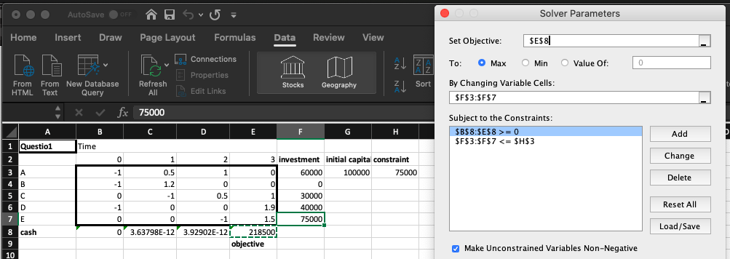

Question2

Question3

