1.

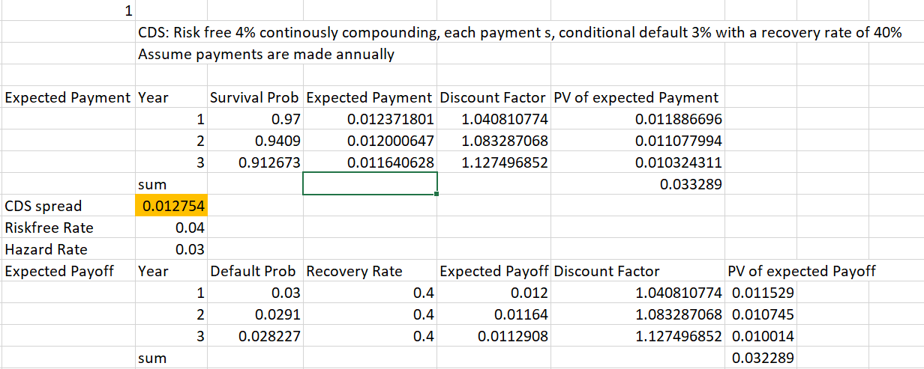

2.

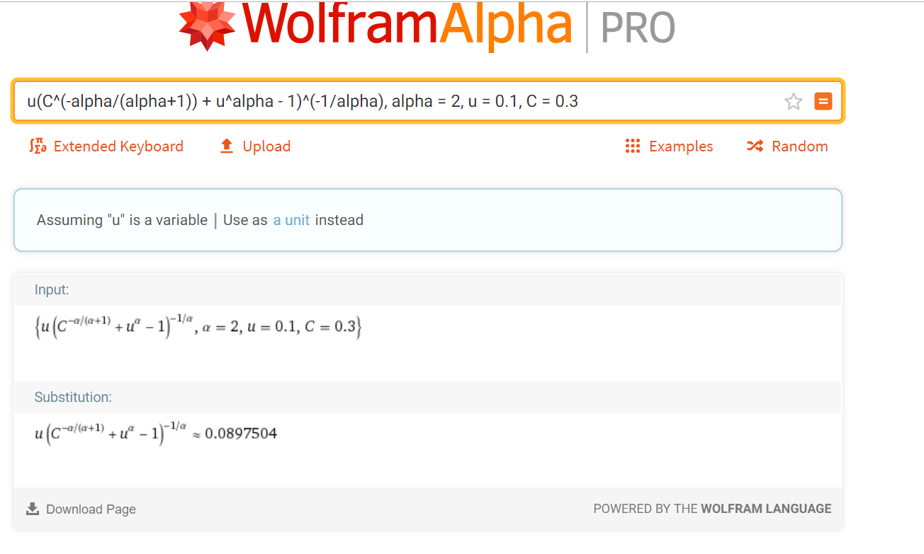

So v = 0.089, u = 0.1

Applying inverse CDF of Normal(0,1) to them, we get X = -1.281, Y = -1.3464.

3.

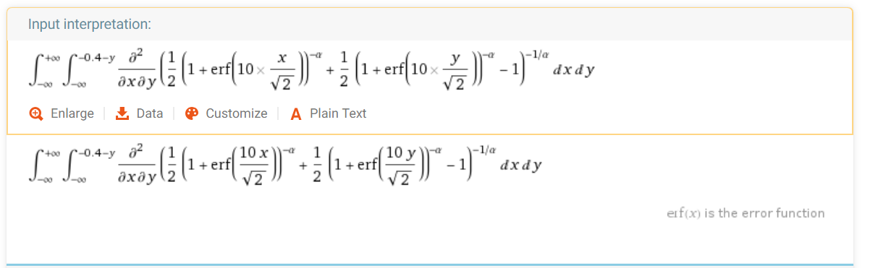

Somehow wolfram didn’t return a numerical value. I’ll try this in R later.