# FE590. Assignment #4.

## Yifu He

## 2019-05-08

# Instructions

When you have completed the assignment, knit the document into a PDF file, and upload *both* the .pdf and .Rmd files to Canvas.

Note that you must have LaTeX installed in order to knit the equations below. If you do not have it installed, simply delete the questions below.

library(knitr)  
library(stringi)  
library(devtools)

## Warning: package 'devtools' was built under R version 3.5.2

## Warning: package 'usethis' was built under R version 3.5.2

CWID = 10442277 #Place here your Campus wide ID number, this will personalize  
#your results, but still maintain the reproduceable nature of using seeds.  
#If you ever need to reset the seed in this assignment, use this as your seed  
#Papers that use -1 as this CWID variable will earn 0's so make sure you change  
#this value before you submit your work.  
personal = CWID %% 10000  
set.seed(personal)

# Question 1:

In this assignment, you will be required to find a set of data to run regression on. This data set should be financial in nature, and of a type that will work with the models we have discussed this semester (hint: we didn’t look at time series) You may not use any of the data sets in the ISLR package that we have been looking at all semester. Your data set that you choose should have both qualitative and quantitative variables. (or has variables that you can transform)Provide a description of the data below, where you obtained it, what the variable names are and what it is describing.

## Answer1 :

1. Description of Data : The data is based on the daily historical bitcoin market prices and other factors related to it from 23th Feb 2010 to 20th Feb 2018. This data set was obtained from www.kaggle.com. The dataset includes 24 predictors and 2899 entries.

set.seed(personal)  
setwd("/Users/yifuhe/Desktop")  
data1 = read.csv("bitcoin_dataset.csv")  
data = na.omit(data1)  
nr = nrow(data)  
nc = ncol(data)  
print(paste0("The number of rows in the data set are ", nrow(data)))

## [1] "The number of rows in the data set are 2899"

print(paste0("The number of columns in the data set are ", ncol(data)))

## [1] "The number of columns in the data set are 24"

head(data)

## Date btc_market_price btc_total_bitcoins btc_market_cap  
## 1 2010-02-23 00:00:00 0 2110700 0  
## 2 2010-02-24 00:00:00 0 2120200 0  
## 3 2010-02-25 00:00:00 0 2127600 0  
## 4 2010-02-26 00:00:00 0 2136100 0  
## 5 2010-02-27 00:00:00 0 2144750 0  
## 6 2010-02-28 00:00:00 0 2152850 0  
## btc_trade_volume btc_blocks_size btc_avg_block_size  
## 1 0 0 0.0002163347  
## 2 0 0 0.0002817211  
## 3 0 0 0.0002269054  
## 4 0 0 0.0003186765  
## 5 0 0 0.0002234162  
## 6 0 0 0.0002914506  
## btc_n_orphaned_blocks btc_n_transactions_per_block  
## 1 0 1  
## 2 0 1  
## 3 0 1  
## 4 0 1  
## 5 0 1  
## 6 0 1  
## btc_median_confirmation_time btc_hash_rate btc_difficulty  
## 1 0 3.153929e-05 2.527738  
## 2 0 3.571305e-05 3.781179  
## 3 0 2.781859e-05 3.781179  
## 4 0 3.195378e-05 3.781179  
## 5 0 3.251768e-05 3.781179  
## 6 0 3.045008e-05 3.781179  
## btc_miners_revenue btc_transaction_fees btc_cost_per_transaction_percent  
## 1 0 0 25100.00000  
## 2 0 0 179.24528  
## 3 0 0 1057.14286  
## 4 0 0 64.58206  
## 5 0 0 1922.22222  
## 6 0 0 154.28571  
## btc_cost_per_transaction btc_n_unique_addresses btc_n_transactions  
## 1 0 252 252  
## 2 0 195 196  
## 3 0 150 150  
## 4 0 176 176  
## 5 0 176 176  
## 6 0 165 165  
## btc_n_transactions_total btc_n_transactions_excluding_popular  
## 1 42613 252  
## 2 42809 196  
## 3 42959 150  
## 4 43135 176  
## 5 43311 176  
## 6 43476 165  
## btc_n_transactions_excluding_chains_longer_than_100 btc_output_volume  
## 1 252 12600  
## 2 196 14800  
## 3 150 8100  
## 4 176 29349  
## 5 176 9101  
## 6 165 13399  
## btc_estimated_transaction_volume btc_estimated_transaction_volume_usd  
## 1 50 0  
## 2 5300 0  
## 3 700 0  
## 4 13162 0  
## 5 450 0  
## 6 5250 0

data$Date = as.Date(data$Date)  
head(data) # after cleaning date column

## Date btc_market_price btc_total_bitcoins btc_market_cap  
## 1 2010-02-23 0 2110700 0  
## 2 2010-02-24 0 2120200 0  
## 3 2010-02-25 0 2127600 0  
## 4 2010-02-26 0 2136100 0  
## 5 2010-02-27 0 2144750 0  
## 6 2010-02-28 0 2152850 0  
## btc_trade_volume btc_blocks_size btc_avg_block_size  
## 1 0 0 0.0002163347  
## 2 0 0 0.0002817211  
## 3 0 0 0.0002269054  
## 4 0 0 0.0003186765  
## 5 0 0 0.0002234162  
## 6 0 0 0.0002914506  
## btc_n_orphaned_blocks btc_n_transactions_per_block  
## 1 0 1  
## 2 0 1  
## 3 0 1  
## 4 0 1  
## 5 0 1  
## 6 0 1  
## btc_median_confirmation_time btc_hash_rate btc_difficulty  
## 1 0 3.153929e-05 2.527738  
## 2 0 3.571305e-05 3.781179  
## 3 0 2.781859e-05 3.781179  
## 4 0 3.195378e-05 3.781179  
## 5 0 3.251768e-05 3.781179  
## 6 0 3.045008e-05 3.781179  
## btc_miners_revenue btc_transaction_fees btc_cost_per_transaction_percent  
## 1 0 0 25100.00000  
## 2 0 0 179.24528  
## 3 0 0 1057.14286  
## 4 0 0 64.58206  
## 5 0 0 1922.22222  
## 6 0 0 154.28571  
## btc_cost_per_transaction btc_n_unique_addresses btc_n_transactions  
## 1 0 252 252  
## 2 0 195 196  
## 3 0 150 150  
## 4 0 176 176  
## 5 0 176 176  
## 6 0 165 165  
## btc_n_transactions_total btc_n_transactions_excluding_popular  
## 1 42613 252  
## 2 42809 196  
## 3 42959 150  
## 4 43135 176  
## 5 43311 176  
## 6 43476 165  
## btc_n_transactions_excluding_chains_longer_than_100 btc_output_volume  
## 1 252 12600  
## 2 196 14800  
## 3 150 8100  
## 4 176 29349  
## 5 176 9101  
## 6 165 13399  
## btc_estimated_transaction_volume btc_estimated_transaction_volume_usd  
## 1 50 0  
## 2 5300 0  
## 3 700 0  
## 4 13162 0  
## 5 450 0  
## 6 5250 0

1. Aim for the project : TO PREDICT BITCOIN MARKET PRICES FROM THE PREDICTORS GIVEN BELOW. ALSO TO FIND WHICH OF THE PREDICTORS ARE CORRELATED TO MARKET PRICES..
2. Response Variable is btc_market_price This dataset has the following features.

Date : Date of observation btc_market_price : Average USD market price across major bitcoin exchanges. btc_total_bitcoins : The total number of bitcoins that have already been mined. btc_market_cap : The total USD value of bitcoin supply in circulation. btc_trade_volume : The total USD value of trading volume on major bitcoin exchanges. btc_blocks_size : The total size of all block headers and transactions. btc_avg_block_size : The average block size in MB. btc_n_orphaned_blocks : The total number of blocks mined but ultimately not attached to the main Bitcoin blockchain. btc_n_transactions_per_block : The average number of transactions per block. btc_median_confirmation_time : The median time for a transaction to be accepted into a mined block. btc_hash_rate : The estimated number of tera hashes per second the Bitcoin network is performing. btc_difficulty : A relative measure of how difficult it is to find a new block. btc_miners_revenue : Total value of coinbase block rewards and transaction fees paid to miners. btc_transaction_fees : The total value of all transaction fees paid to miners. btc_cost_per_transaction_percent : miners revenue as percentage of the transaction volume. btc_cost_per_transaction : miners revenue divided by the number of transactions. btc_n_unique_addresses : The total number of unique addresses used on the Bitcoin blockchain. btc_n_transactions : The number of daily confirmed Bitcoin transactions. btc_n_transactions_total : Total number of transactions. btc_n_transactions_excluding_popular : The total number of Bitcoin transactions, excluding the 100 most popular addresses. btc_n_transactions_excluding_chains_longer_than_100 : The total number of Bitcoin transactions per day excluding long transaction chains. btc_output_volume : The total value of all transaction outputs per day. btc_estimated_transaction_volume : The total estimated value of transactions on the Bitcoin blockchain. btc_estimated_transaction_volume_usd : The estimated transaction value in USD value.

# Looking at the data....  
set.seed(personal)  
summary(data)

## Date btc_market_price btc_total_bitcoins  
## Min. :2010-02-23 Min. : 0.000 Min. : 2110700   
## 1st Qu.:2012-02-23 1st Qu.: 6.714 1st Qu.: 8410825   
## Median :2014-02-19 Median : 236.000 Median :12418575   
## Mean :2014-02-22 Mean : 901.824 Mean :11522310   
## 3rd Qu.:2016-02-26 3rd Qu.: 604.460 3rd Qu.:15255538   
## Max. :2018-02-20 Max. :19498.683 Max. :16876825   
## btc_market_cap btc_trade_volume btc_blocks_size   
## Min. :0.000e+00 Min. :0.000e+00 Min. : 0.0   
## 1st Qu.:5.488e+07 1st Qu.:2.994e+05 1st Qu.: 779.5   
## Median :3.364e+09 Median :1.024e+07 Median : 15035.0   
## Mean :1.451e+10 Mean :8.231e+07 Mean : 36202.8   
## 3rd Qu.:8.229e+09 3rd Qu.:2.935e+07 3rd Qu.: 59897.5   
## Max. :3.265e+11 Max. :5.352e+09 Max. :157665.0   
## btc_avg_block_size btc_n_orphaned_blocks btc_n_transactions_per_block  
## Min. :0.0002163 Min. :0.0000 Min. : 1.0   
## 1st Qu.:0.0245796 1st Qu.:0.0000 1st Qu.: 54.5   
## Median :0.1996229 Median :0.0000 Median : 379.0   
## Mean :0.3567457 Mean :0.3581 Mean : 679.3   
## 3rd Qu.:0.6933442 3rd Qu.:0.0000 3rd Qu.:1245.7   
## Max. :1.1103268 Max. :7.0000 Max. :2722.6   
## btc_median_confirmation_time btc_hash_rate btc_difficulty   
## Min. : 0.000 Min. : 0 Min. :3.000e+00   
## 1st Qu.: 6.133 1st Qu.: 12 1st Qu.:1.627e+06   
## Median : 7.933 Median : 25981 Median :3.130e+09   
## Mean : 7.561 Mean : 1396897 Mean :1.820e+11   
## 3rd Qu.:10.271 3rd Qu.: 1132497 3rd Qu.:1.584e+11   
## Max. :47.733 Max. :25579249 Max. :2.968e+12   
## btc_miners_revenue btc_transaction_fees btc_cost_per_transaction_percent  
## Min. : 0 Min. : 0.000 Min. : 0.14   
## 1st Qu.: 47011 1st Qu.: 9.624 1st Qu.: 1.18   
## Median : 888738 Median : 21.405 Median : 2.46   
## Mean : 2306187 Mean : 61.201 Mean : 58.47   
## 3rd Qu.: 1862391 3rd Qu.: 51.014 3rd Qu.: 5.84   
## Max. :53191582 Max. :1495.947 Max. :88571.43   
## btc_cost_per_transaction btc_n_unique_addresses btc_n_transactions  
## Min. : 0.000 Min. : 110 Min. : 118   
## 1st Qu.: 4.172 1st Qu.: 17008 1st Qu.: 8056   
## Median : 7.839 Median : 131955 Median : 62960   
## Mean : 15.192 Mean : 196512 Mean :103257   
## 3rd Qu.: 14.976 3rd Qu.: 367857 3rd Qu.:191969   
## Max. :161.686 Max. :1072861 Max. :490644   
## btc_n_transactions_total btc_n_transactions_excluding_popular  
## Min. : 42613 Min. : 118   
## 1st Qu.: 2490264 1st Qu.: 6878   
## Median : 33231891 Median : 54894   
## Mean : 70431859 Mean : 95502   
## 3rd Qu.:112793186 3rd Qu.:187552   
## Max. :300576632 Max. :470650   
## btc_n_transactions_excluding_chains_longer_than_100 btc_output_volume   
## Min. : 118 Min. : 6150   
## 1st Qu.: 6836 1st Qu.: 496080   
## Median : 35658 Median : 1116561   
## Mean : 64000 Mean : 1567758   
## 3rd Qu.:115688 3rd Qu.: 2029856   
## Max. :318896 Max. :45992223   
## btc_estimated_transaction_volume btc_estimated_transaction_volume_usd  
## Min. : 7 Min. :0.000e+00   
## 1st Qu.: 96478 1st Qu.:9.700e+05   
## Median : 179252 Median :3.902e+07   
## Mean : 203961 Mean :2.131e+08   
## 3rd Qu.: 258903 3rd Qu.:1.386e+08   
## Max. :5825066 Max. :5.760e+09

#Analysing the given data set:---  
set.seed(personal)  
plot(data$Date, data$btc_market_price, xlab = "Date", ylab = "Bitcoin_Market_Price (USD)", col = "red")

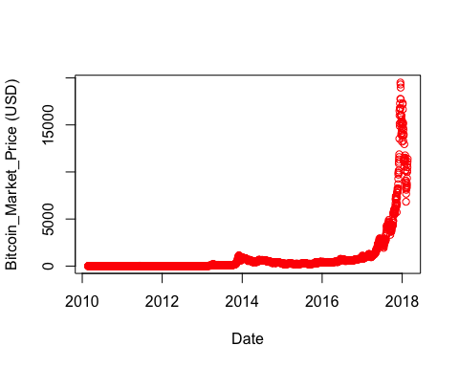

#training and testing data  
t_ind = sample(1:nr, 0.75 * nr, replace = F)  
train = data[t_ind,]  
test = data[-t_ind,]  
cor(train[, -c(1,24)])[1,]

## btc_market_price   
## 1.00000000   
## btc_total_bitcoins   
## 0.40648769   
## btc_market_cap   
## 0.99980760   
## btc_trade_volume   
## 0.86369765   
## btc_blocks_size   
## 0.68955479   
## btc_avg_block_size   
## 0.56025478   
## btc_n_orphaned_blocks   
## -0.08222715   
## btc_n_transactions_per_block   
## 0.54527049   
## btc_median_confirmation_time   
## 0.28260736   
## btc_hash_rate   
## 0.90001108   
## btc_difficulty   
## 0.89533355   
## btc_miners_revenue   
## 0.98480128   
## btc_transaction_fees   
## 0.78157994   
## btc_cost_per_transaction_percent   
## -0.01246046   
## btc_cost_per_transaction   
## 0.83623012   
## btc_n_unique_addresses   
## 0.66240921   
## btc_n_transactions   
## 0.56562461   
## btc_n_transactions_total   
## 0.69413628   
## btc_n_transactions_excluding_popular   
## 0.55462051   
## btc_n_transactions_excluding_chains_longer_than_100   
## 0.56676867   
## btc_output_volume   
## 0.10330967   
## btc_estimated_transaction_volume   
## 0.04587268

library(corrplot)

## corrplot 0.84 loaded

corrplot(cor(data[,2:12]), method = "circle")

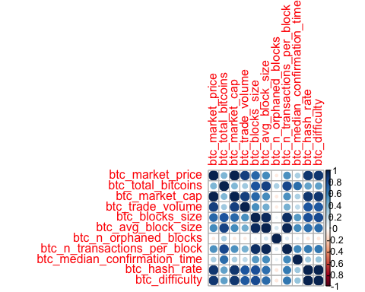

1. After analysing the data before selecting the best predictors, some of the conclusions made are :—

* Bitcoin market prices increases exponentially wrt date but falls in between 2016 and 2018 drastically.
* From the above correlation diagram and the values calculated, predictors which seem to be correlated to the market price are : btc_market_cap, btc_trade_volume, btc_hash_rate, btc_miners_revenue,btc_difficulty, btc_cost_per_transaction

# ——————————————————————————————————————-

## Question 2:

Pick a quantitative variable and fit at least four different models in order to predict that variable using the other predictors. Determine which of the models is the best fit. You will need to provide strong reasons as to why the particular model you chose is the best one. You will need to confirm the model you have selected provides the best fit and that you have obtained the best version of that particular model (i.e. subset selection or validation for example). You need to convince the grader that you have chosen the best model.

## Answer 2 :

(MOdel 1) SIMPLE LINEAR REGRESSION : Since this is a simple regression model .. let us select the best predictor instead of applying to all the predictors. Also after finding correlation, let us see what are the results after the best subset selection, forward subset selection and backward subset selection.

set.seed(personal)  
library(leaps)  
p = regsubsets(btc_market_price ~ btc_market_cap + btc_trade_volume + btc_hash_rate + btc_miners_revenue + btc_difficulty + btc_cost_per_transaction, data = train)  
q = regsubsets(btc_market_price ~ btc_market_cap + btc_trade_volume + btc_hash_rate + btc_miners_revenue + btc_difficulty + btc_cost_per_transaction, data = train, method = "forward")  
r = regsubsets(btc_market_price ~ btc_market_cap + btc_trade_volume + btc_hash_rate + btc_miners_revenue + btc_difficulty + btc_cost_per_transaction, data = train, method = "backward")  
summary(p)[7]

## $outmat  
## btc_market_cap btc_trade_volume btc_hash_rate btc_miners_revenue  
## 1 ( 1 ) "*" " " " " " "   
## 2 ( 1 ) "*" " " " " " "   
## 3 ( 1 ) "*" " " " " "*"   
## 4 ( 1 ) "*" "*" " " "*"   
## 5 ( 1 ) "*" " " "*" "*"   
## 6 ( 1 ) "*" "*" "*" "*"   
## btc_difficulty btc_cost_per_transaction  
## 1 ( 1 ) " " " "   
## 2 ( 1 ) " " "*"   
## 3 ( 1 ) " " "*"   
## 4 ( 1 ) " " "*"   
## 5 ( 1 ) "*" "*"   
## 6 ( 1 ) "*" "*"

summary(q)[7]

## $outmat  
## btc_market_cap btc_trade_volume btc_hash_rate btc_miners_revenue  
## 1 ( 1 ) "*" " " " " " "   
## 2 ( 1 ) "*" " " " " " "   
## 3 ( 1 ) "*" " " " " "*"   
## 4 ( 1 ) "*" "*" " " "*"   
## 5 ( 1 ) "*" "*" "*" "*"   
## 6 ( 1 ) "*" "*" "*" "*"   
## btc_difficulty btc_cost_per_transaction  
## 1 ( 1 ) " " " "   
## 2 ( 1 ) " " "*"   
## 3 ( 1 ) " " "*"   
## 4 ( 1 ) " " "*"   
## 5 ( 1 ) " " "*"   
## 6 ( 1 ) "*" "*"

summary(r)[7]

## $outmat  
## btc_market_cap btc_trade_volume btc_hash_rate btc_miners_revenue  
## 1 ( 1 ) "*" " " " " " "   
## 2 ( 1 ) "*" " " " " " "   
## 3 ( 1 ) "*" " " " " "*"   
## 4 ( 1 ) "*" " " "*" "*"   
## 5 ( 1 ) "*" " " "*" "*"   
## 6 ( 1 ) "*" "*" "*" "*"   
## btc_difficulty btc_cost_per_transaction  
## 1 ( 1 ) " " " "   
## 2 ( 1 ) " " "*"   
## 3 ( 1 ) " " "*"   
## 4 ( 1 ) " " "*"   
## 5 ( 1 ) "*" "*"   
## 6 ( 1 ) "*" "*"

After seeing the best, forward and the backward subset selection, the btc_market_cap i.e the total USD of bitcoin in circulation is the best predictor. So applying simple linear regression using this predictor.

set.seed(personal)  
model1 = lm(btc_market_price ~ btc_market_cap, data = train)  
model11 = lm(btc_market_price ~ btc_cost_per_transaction, data = train)  
summary(model1)

##   
## Call:  
## lm(formula = btc_market_price ~ btc_market_cap, data = train)  
##   
## Residuals:  
## Min 1Q Median 3Q Max   
## -96.264 -34.972 -4.253 7.860 285.249   
##   
## Coefficients:  
## Estimate Std. Error t value Pr(>|t|)   
## (Intercept) 3.791e+01 1.093e+00 34.7 <2e-16 ***  
## btc_market_cap 5.956e-08 2.507e-11 2375.5 <2e-16 ***  
## ---  
## Signif. codes: 0 '***' 0.001 '**' 0.01 '*' 0.05 '.' 0.1 ' ' 1  
##   
## Residual standard error: 47.97 on 2172 degrees of freedom  
## Multiple R-squared: 0.9996, Adjusted R-squared: 0.9996   
## F-statistic: 5.643e+06 on 1 and 2172 DF, p-value: < 2.2e-16

summary(model11)

##   
## Call:  
## lm(formula = btc_market_price ~ btc_cost_per_transaction, data = train)  
##   
## Residuals:  
## Min 1Q Median 3Q Max   
## -7196.7 -254.7 153.0 527.6 7766.0   
##   
## Coefficients:  
## Estimate Std. Error t value Pr(>|t|)   
## (Intercept) -527.598 35.182 -15.00 <2e-16 ***  
## btc_cost_per_transaction 93.914 1.321 71.07 <2e-16 ***  
## ---  
## Signif. codes: 0 '***' 0.001 '**' 0.01 '*' 0.05 '.' 0.1 ' ' 1  
##   
## Residual standard error: 1341 on 2172 degrees of freedom  
## Multiple R-squared: 0.6993, Adjusted R-squared: 0.6991   
## F-statistic: 5051 on 1 and 2172 DF, p-value: < 2.2e-16

We can see how strongly btc_market_cap affects the btc_market price as adj R^2 is nearly equal to 1. Also the second best predictor btc_cost_per_transaction has a adjusted R-squared = 0.7012. Both are satistically significant as seen by the p-values. Now we test this and predict values using testing dataset.

set.seed(personal)  
pred1 = predict(model1, newdata = test)  
pred11 = predict(model11, newdata = test)  
mss1 = mean((test$btc_market_price-pred1)^2)  
mss11 = mean((test$btc_market_price-pred11)^2)  
mss1

## [1] 2366.149

mss11

## [1] 1730603

# MSS is too high so this is not a good model. Simple Linear regression is not good to fit. So we procced to multiple regression.

(Model ii) Multiple Linear Regression :

c1 <- summary(p)$cp  
plot(c1,type='b',xlab="No. of Predictors",ylab=expression("Mallows C"[P]), col="red")  
  
points(which.min(c1), c1[which.min(c1)], pch=20, col="red")

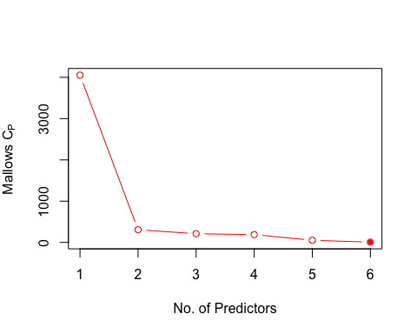 All the 6 predictors we selected have the minimum mallows Cp. So applying multiple regression model. But since btc_market_cap has adj R^2 = 0.996, we perform multiple linear regression with it and one multiple linear regression without it to exclude other variables as it is overshadowing others.

model12 = lm(btc_market_price ~ btc_market_cap + btc_trade_volume + btc_hash_rate + btc_miners_revenue + btc_difficulty + btc_cost_per_transaction, data = train)  
summary(model12)

##   
## Call:  
## lm(formula = btc_market_price ~ btc_market_cap + btc_trade_volume +   
## btc_hash_rate + btc_miners_revenue + btc_difficulty + btc_cost_per_transaction,   
## data = train)  
##   
## Residuals:  
## Min 1Q Median 3Q Max   
## -173.439 -13.540 -2.434 15.228 178.729   
##   
## Coefficients:  
## Estimate Std. Error t value Pr(>|t|)   
## (Intercept) 9.427e+00 8.232e-01 11.452 < 2e-16 ***  
## btc_market_cap 5.622e-08 1.727e-10 325.458 < 2e-16 ***  
## btc_trade_volume -2.816e-08 4.062e-09 -6.931 5.49e-12 ***  
## btc_hash_rate -2.151e-05 1.576e-06 -13.649 < 2e-16 ***  
## btc_miners_revenue 1.549e-05 1.093e-06 14.172 < 2e-16 ***  
## btc_difficulty 1.880e-10 1.431e-11 13.137 < 2e-16 ***  
## btc_cost_per_transaction 2.572e+00 5.970e-02 43.088 < 2e-16 ***  
## ---  
## Signif. codes: 0 '***' 0.001 '**' 0.01 '*' 0.05 '.' 0.1 ' ' 1  
##   
## Residual standard error: 28.34 on 2167 degrees of freedom  
## Multiple R-squared: 0.9999, Adjusted R-squared: 0.9999   
## F-statistic: 2.695e+06 on 6 and 2167 DF, p-value: < 2.2e-16

model13 = lm(btc_market_price ~ btc_trade_volume + btc_hash_rate + btc_miners_revenue + btc_difficulty + btc_cost_per_transaction, data = train)  
summary(model13)

##   
## Call:  
## lm(formula = btc_market_price ~ btc_trade_volume + btc_hash_rate +   
## btc_miners_revenue + btc_difficulty + btc_cost_per_transaction,   
## data = train)  
##   
## Residuals:  
## Min 1Q Median 3Q Max   
## -3432.5 -54.4 47.2 73.8 1636.1   
##   
## Coefficients:  
## Estimate Std. Error t value Pr(>|t|)   
## (Intercept) -6.371e+01 5.592e+00 -11.394 < 2e-16 ***  
## btc_trade_volume -2.327e-07 2.834e-08 -8.213 3.68e-16 ***  
## btc_hash_rate -2.781e-04 9.633e-06 -28.873 < 2e-16 ***  
## btc_miners_revenue 3.558e-04 2.256e-06 157.734 < 2e-16 ***  
## btc_difficulty 3.464e-09 7.186e-11 48.199 < 2e-16 ***  
## btc_cost_per_transaction -5.133e+00 3.869e-01 -13.264 < 2e-16 ***  
## ---  
## Signif. codes: 0 '***' 0.001 '**' 0.01 '*' 0.05 '.' 0.1 ' ' 1  
##   
## Residual standard error: 200.1 on 2168 degrees of freedom  
## Multiple R-squared: 0.9933, Adjusted R-squared: 0.9933   
## F-statistic: 6.444e+04 on 5 and 2168 DF, p-value: < 2.2e-16

So after applying multiple linear regression without the btc_market_cap,the conclusion is that all the other variables too are significant.

set.seed(personal)  
pred2 = predict(model12, newdata = test)  
mss2 = mean((test$btc_market_price - pred2)^2)  
mss2

## [1] 887.268

Still the error is significantly high but lower than simple linear. So we proceed to splines

(Model 3) : Polynomial regression : By the subset selections now select only and the above results drop btc_trade_volume

set.seed(personal)  
fit1 = lm(btc_market_price ~ poly(btc_market_cap, 2), data = train)  
fit2 = lm(btc_market_price ~ poly(btc_market_cap, 3), data = train)  
summary(fit1)

##   
## Call:  
## lm(formula = btc_market_price ~ poly(btc_market_cap, 2), data = train)  
##   
## Residuals:  
## Min 1Q Median 3Q Max   
## -106.601 -31.645 -6.336 4.144 281.421   
##   
## Coefficients:  
## Estimate Std. Error t value Pr(>|t|)   
## (Intercept) 912.059 1.014 899.600 < 2e-16 ***  
## poly(btc_market_cap, 2)1 113959.971 47.272 2410.731 < 2e-16 ***  
## poly(btc_market_cap, 2)2 -383.997 47.272 -8.123 7.54e-16 ***  
## ---  
## Signif. codes: 0 '***' 0.001 '**' 0.01 '*' 0.05 '.' 0.1 ' ' 1  
##   
## Residual standard error: 47.27 on 2171 degrees of freedom  
## Multiple R-squared: 0.9996, Adjusted R-squared: 0.9996   
## F-statistic: 2.906e+06 on 2 and 2171 DF, p-value: < 2.2e-16

summary(fit2)

##   
## Call:  
## lm(formula = btc_market_price ~ poly(btc_market_cap, 3), data = train)  
##   
## Residuals:  
## Min 1Q Median 3Q Max   
## -135.140 -25.472 -17.719 4.841 268.138   
##   
## Coefficients:  
## Estimate Std. Error t value Pr(>|t|)   
## (Intercept) 9.121e+02 9.546e-01 955.389 <2e-16 ***  
## poly(btc_market_cap, 3)1 1.140e+05 4.451e+01 2560.235 <2e-16 ***  
## poly(btc_market_cap, 3)2 -3.840e+02 4.451e+01 -8.627 <2e-16 ***  
## poly(btc_market_cap, 3)3 7.430e+02 4.451e+01 16.692 <2e-16 ***  
## ---  
## Signif. codes: 0 '***' 0.001 '**' 0.01 '*' 0.05 '.' 0.1 ' ' 1  
##   
## Residual standard error: 44.51 on 2170 degrees of freedom  
## Multiple R-squared: 0.9997, Adjusted R-squared: 0.9997   
## F-statistic: 2.185e+06 on 3 and 2170 DF, p-value: < 2.2e-16

fita = lm(btc_market_price ~ btc_trade_volume + btc_hash_rate + btc_miners_revenue + btc_difficulty + btc_cost_per_transaction + poly(btc_market_cap, 2), data = train)  
fitb = lm(btc_market_price ~ btc_trade_volume + btc_hash_rate + btc_miners_revenue + btc_difficulty + btc_cost_per_transaction + poly(btc_market_cap, 3), data = train)  
fitc = lm(btc_market_price ~ btc_trade_volume + btc_hash_rate + btc_miners_revenue + btc_difficulty + btc_cost_per_transaction + poly(btc_market_cap, 4), data = train)  
fitd = lm(btc_market_price ~ btc_trade_volume + btc_hash_rate + btc_miners_revenue + btc_difficulty + btc_cost_per_transaction + poly(btc_market_cap, 5), data = train)  
anova(fita,fitb,fitc,fitd)

## Analysis of Variance Table  
##   
## Model 1: btc_market_price ~ btc_trade_volume + btc_hash_rate + btc_miners_revenue +   
## btc_difficulty + btc_cost_per_transaction + poly(btc_market_cap,   
## 2)  
## Model 2: btc_market_price ~ btc_trade_volume + btc_hash_rate + btc_miners_revenue +   
## btc_difficulty + btc_cost_per_transaction + poly(btc_market_cap,   
## 3)  
## Model 3: btc_market_price ~ btc_trade_volume + btc_hash_rate + btc_miners_revenue +   
## btc_difficulty + btc_cost_per_transaction + poly(btc_market_cap,   
## 4)  
## Model 4: btc_market_price ~ btc_trade_volume + btc_hash_rate + btc_miners_revenue +   
## btc_difficulty + btc_cost_per_transaction + poly(btc_market_cap,   
## 5)  
## Res.Df RSS Df Sum of Sq F Pr(>F)   
## 1 2166 1024462   
## 2 2165 690414 1 334048 1318.18 < 2.2e-16 ***  
## 3 2164 650834 1 39580 156.18 < 2.2e-16 ***  
## 4 2163 548141 1 102694 405.24 < 2.2e-16 ***  
## ---  
## Signif. codes: 0 '***' 0.001 '**' 0.01 '*' 0.05 '.' 0.1 ' ' 1

pred3 = predict(fit1, newdata = test)  
mss3 = mean((test$btc_market_cap - pred3)^2)  
mss3

## [1] 1.67828e+21

The mse for this is higher than simple and multiple linear regression. So we discard this model.

(Model iv) So this time I choose random forrest over GAM and other techniques such as splines because they all have polynomials involved and by intution I thought those would give somewhat the same result. The reason I chose the random forest dataset size is medium not large

set.seed(personal)  
library(randomForest)

## randomForest 4.6-14

## Type rfNews() to see new features/changes/bug fixes.

?randomForest  
model4 <- randomForest(x = train[,c(4, 10, 11, 12, 15)], y = train$btc_market_price, ntree = 501)  
summary(model4)

## Length Class Mode   
## call 4 -none- call   
## type 1 -none- character  
## predicted 2174 -none- numeric   
## mse 501 -none- numeric   
## rsq 501 -none- numeric   
## oob.times 2174 -none- numeric   
## importance 5 -none- numeric   
## importanceSD 0 -none- NULL   
## localImportance 0 -none- NULL   
## proximity 0 -none- NULL   
## ntree 1 -none- numeric   
## mtry 1 -none- numeric   
## forest 11 -none- list   
## coefs 0 -none- NULL   
## y 2174 -none- numeric   
## test 0 -none- NULL   
## inbag 0 -none- NULL

pred4 = predict(model4, newdata = test)  
mss4 = mean((test$btc_market_price - pred4)^2)  
mss4

## [1] 35380.11

SO my intution that the random forest will produce better results on test is false. Hence i Will choose multiple linear regression over the other models as it has the less test error. Also this is because of overfitting. All the models fit into the training set but do poorly on test data. This can be expected as this is a to predict future bitcoin market prices.

# Question 3:

Do the same approach as in question 2, but this time for a qualitative variable.

## Answer 3 : As there is no binary variable for the above dataset lets create one :——

set.seed(personal)  
mprice = mean(data$btc_market_price)  
mprice

## [1] 901.8236

market_price <- rep("Greaterthanmean", nr)  
market_price[data$btc_market_price < mprice] <- "Not_greater_than_mean"  
data$market_price <- market_price  
data$market_price <- as.factor(data$market_price)

(Model i) : Logistic Regression Model : Now Im changing the test set and then taking the 6 predictors for which my correlation was high.

set.seed(personal)  
t_ind2 = sample(1:nr, 0.70 * nr, replace = FALSE)  
train2 = data[t_ind2,]  
test2 = data[-t_ind2,]  
direction = test2$market_price  
glm.fit = glm(market_price ~ btc_market_cap + btc_trade_volume + btc_hash_rate + btc_miners_revenue + btc_difficulty + btc_cost_per_transaction, data = train2, family = binomial)

## Warning: glm.fit: algorithm did not converge

## Warning: glm.fit: fitted probabilities numerically 0 or 1 occurred

prob = predict(glm.fit, test2, type = "response")  
nrtest2 = round(0.30 * nr)  
p11 = rep("Not_greater_than_mean", nrtest2)  
p11[prob > 0.5] = "Greaterthanmean"  
table(p11, direction)

## direction  
## p11 Greaterthanmean Not_greater_than_mean  
## Greaterthanmean 2 760  
## Not_greater_than_mean 108 0

No need to calculate further as Logistic Regression performed very badly on this dataset.

(Model ii) LDA Model:—–

library(MASS)  
set.seed(personal)  
fit33 = lda(market_price ~ btc_market_cap + btc_trade_volume + btc_hash_rate + btc_miners_revenue + btc_difficulty + btc_cost_per_transaction, data = train2)  
p2 = predict(fit33, test2)$class  
table(p2, direction)

## direction  
## p2 Greaterthanmean Not_greater_than_mean  
## Greaterthanmean 86 0  
## Not_greater_than_mean 24 760

#Misclassification Error rate  
miscl = mean(p2 != direction)  
miscl

## [1] 0.02758621

We see only 35 datapoints were misclassified. LDA gave a very low missclassification error.

(Model iii)

set.seed(personal)  
fit44 = qda(market_price ~ btc_market_cap + btc_trade_volume + btc_hash_rate + btc_miners_revenue + btc_difficulty + btc_cost_per_transaction, data = train2)  
p3 = predict(fit44, test2)$class  
table(p3, direction)

## direction  
## p3 Greaterthanmean Not_greater_than_mean  
## Greaterthanmean 107 17  
## Not_greater_than_mean 3 743

#Misclassification Error rate  
miscl1 = mean(p3 != direction)  
miscl1

## [1] 0.02298851

QDA performs better than LDA and gives an error rate of 0.0206 which is considered to be very low.

(Model iv) KNN :

set.seed(personal)  
library(class)  
trainKNN = as.matrix(data.frame(train2$btc_market_cap, train2$btc_trade_volume, train2$btc_miners_revenue, train2$btc_difficulty, train2$btc_cost_per_transaction))  
testKNN = as.matrix(data.frame(test2$btc_market_cap, test2$btc_trade_volume, test2$btc_miners_revenue, test2$btc_difficulty, test2$btc_cost_per_transaction))  
direction2 = train2$market_price  
pKNN1 = knn(trainKNN, testKNN, direction2,k=1)  
pKNN2 = knn(trainKNN, testKNN, direction2,k=3)  
pKNN3 = knn(trainKNN, testKNN, direction2,k=5)  
pKNN4 = knn(trainKNN, testKNN, direction2,k=10)  
pKNN5 = knn(trainKNN, testKNN, direction2,k=25)  
pKNN6 = knn(trainKNN, testKNN, direction2,k=67)  
  
error1 = mean(pKNN1 != direction)  
error2 = mean(pKNN2 != direction)  
error3 = mean(pKNN3 != direction)  
error4 = mean(pKNN4 != direction)  
error5 = mean(pKNN5 != direction)  
error6 = mean(pKNN6 != direction)  
error = c(error1, error2, error3, error4, error5, error6)  
plot(error, type='b', xlab="k", ylab="Error", col="red")  
points(which.min(error), error[which.min(error)], pch=20, col="black")

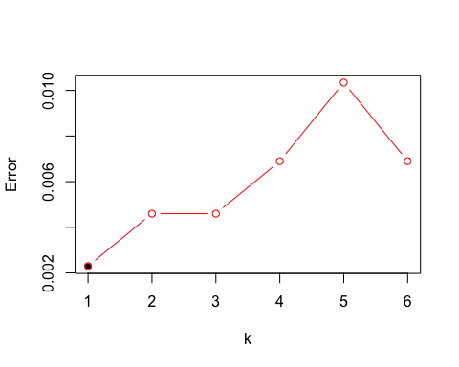

error1

## [1] 0.002298851

Out of all the models KNN gives the lowest missclassification error on the test set . Hence KNN will be selectedf to give the best prediction for the data and the created binary variable #Question 4:

(Based on ISLR Chapter 9 #7) In this problem, you will use support vector approaches in order to predict whether a given car gets high or low gas mileage based on the Auto data set.

## (a)

Create a binary variable that takes on a 1 for cars with gas mileage above the median, and a 0 for cars with gas mileage below the median.

set.seed(personal)  
library(ISLR)  
attach(Auto)  
#To make a binary variable use ifelse  
median_mileage = median(Auto$mpg)  
bin.var = ifelse(Auto$mpg > median_mileage, 1, 0)  
Auto$binary.mpg = as.factor(bin.var)

## (b)

Fit a support vector classifier to the data with various values of cost, in order to predict whether a car gets high or low gas mileage. Report the cross-validation errors associated with different values of this parameter. Comment on your results.

set.seed(personal)  
library(e1071)

## Warning: package 'e1071' was built under R version 3.5.2

x = tune(svm, binary.mpg~., data = Auto, kernel = "linear", ranges = list(cost = c(0.01, 0.1, 1, 5, 10, 100)))  
summary(x)

##   
## Parameter tuning of 'svm':  
##   
## - sampling method: 10-fold cross validation   
##   
## - best parameters:  
## cost  
## 1  
##   
## - best performance: 0.01275641   
##   
## - Detailed performance results:  
## cost error dispersion  
## 1 1e-02 0.07391026 0.04245856  
## 2 1e-01 0.05108974 0.04191745  
## 3 1e+00 0.01275641 0.01344780  
## 4 5e+00 0.01782051 0.01229997  
## 5 1e+01 0.01782051 0.01229997  
## 6 1e+02 0.03051282 0.01976051

print("The cross-validation error is minimized for cost = 1")

## [1] "The cross-validation error is minimized for cost = 1"

## (c)

Now repeat for (b), this time using SVMs with radial and polynomial basis kernels, with different values of gamma and degree and cost. Comment on your results.

set.seed(personal)  
y = tune(svm, binary.mpg ~., data = Auto, kernel = "polynomial", ranges = list(cost = c(0.01, 0.1, 1, 5, 10, 100), degree = c(2, 3, 4)))  
z = tune(svm, binary.mpg ~., data = Auto, kernel = "radial", ranges = list(cost = c(0.01, 0.1, 1, 5, 10, 100), gamma = c(0.01, 0.1, 1, 5, 10, 100, 1000)))  
summary(y)

##   
## Parameter tuning of 'svm':  
##   
## - sampling method: 10-fold cross validation   
##   
## - best parameters:  
## cost degree  
## 100 2  
##   
## - best performance: 0.3060897   
##   
## - Detailed performance results:  
## cost degree error dispersion  
## 1 1e-02 2 0.5535897 0.04171890  
## 2 1e-01 2 0.5535897 0.04171890  
## 3 1e+00 2 0.5535897 0.04171890  
## 4 5e+00 2 0.5535897 0.04171890  
## 5 1e+01 2 0.4844231 0.11172253  
## 6 1e+02 2 0.3060897 0.05506460  
## 7 1e-02 3 0.5535897 0.04171890  
## 8 1e-01 3 0.5535897 0.04171890  
## 9 1e+00 3 0.5535897 0.04171890  
## 10 5e+00 3 0.5535897 0.04171890  
## 11 1e+01 3 0.5535897 0.04171890  
## 12 1e+02 3 0.3445513 0.06156313  
## 13 1e-02 4 0.5535897 0.04171890  
## 14 1e-01 4 0.5535897 0.04171890  
## 15 1e+00 4 0.5535897 0.04171890  
## 16 5e+00 4 0.5535897 0.04171890  
## 17 1e+01 4 0.5535897 0.04171890  
## 18 1e+02 4 0.5535897 0.04171890

summary(z)

##   
## Parameter tuning of 'svm':  
##   
## - sampling method: 10-fold cross validation   
##   
## - best parameters:  
## cost gamma  
## 100 0.01  
##   
## - best performance: 0.01532051   
##   
## - Detailed performance results:  
## cost gamma error dispersion  
## 1 1e-02 1e-02 0.57647436 0.03687622  
## 2 1e-01 1e-02 0.08923077 0.06276147  
## 3 1e+00 1e-02 0.07403846 0.04271928  
## 4 5e+00 1e-02 0.05115385 0.04018094  
## 5 1e+01 1e-02 0.02557692 0.01709522  
## 6 1e+02 1e-02 0.01532051 0.01788871  
## 7 1e-02 1e-01 0.19852564 0.08608860  
## 8 1e-01 1e-01 0.08166667 0.05510683  
## 9 1e+00 1e-01 0.05628205 0.03983401  
## 10 5e+00 1e-01 0.02814103 0.01893035  
## 11 1e+01 1e-01 0.02044872 0.02020886  
## 12 1e+02 1e-01 0.02301282 0.02244393  
## 13 1e-02 1e+00 0.57647436 0.03687622  
## 14 1e-01 1e+00 0.57647436 0.03687622  
## 15 1e+00 1e+00 0.06378205 0.03674375  
## 16 5e+00 1e+00 0.06641026 0.03678591  
## 17 1e+01 1e+00 0.06641026 0.03678591  
## 18 1e+02 1e+00 0.06641026 0.03678591  
## 19 1e-02 5e+00 0.57647436 0.03687622  
## 20 1e-01 5e+00 0.57647436 0.03687622  
## 21 1e+00 5e+00 0.51762821 0.05340278  
## 22 5e+00 5e+00 0.51256410 0.06327615  
## 23 1e+01 5e+00 0.51256410 0.06327615  
## 24 1e+02 5e+00 0.51256410 0.06327615  
## 25 1e-02 1e+01 0.57647436 0.03687622  
## 26 1e-01 1e+01 0.57647436 0.03687622  
## 27 1e+00 1e+01 0.54839744 0.05805619  
## 28 5e+00 1e+01 0.53814103 0.05381159  
## 29 1e+01 1e+01 0.53814103 0.05381159  
## 30 1e+02 1e+01 0.53814103 0.05381159  
## 31 1e-02 1e+02 0.57647436 0.03687622  
## 32 1e-01 1e+02 0.57647436 0.03687622  
## 33 1e+00 1e+02 0.57647436 0.03687622  
## 34 5e+00 1e+02 0.57647436 0.03687622  
## 35 1e+01 1e+02 0.57647436 0.03687622  
## 36 1e+02 1e+02 0.57647436 0.03687622  
## 37 1e-02 1e+03 0.57647436 0.03687622  
## 38 1e-01 1e+03 0.57647436 0.03687622  
## 39 1e+00 1e+03 0.57647436 0.03687622  
## 40 5e+00 1e+03 0.57647436 0.03687622  
## 41 1e+01 1e+03 0.57647436 0.03687622  
## 42 1e+02 1e+03 0.57647436 0.03687622

print("The lowest cross-validation error for a polynomial kernel, is obtained for a degree of 2 and a cost of 100.")

## [1] "The lowest cross-validation error for a polynomial kernel, is obtained for a degree of 2 and a cost of 100."

print("The lowest cross-validation error for a radial kernel, is obtained for a gamma for 0.01 and a cost of 100.")

## [1] "The lowest cross-validation error for a radial kernel, is obtained for a gamma for 0.01 and a cost of 100."

## (d)

Make some plots to back up your assertions in (b) and (c). Hint: In the lab, we used the plot() function for svm objects only in cases with p=2 When p>2,you can use the plot() function to create plots displaying pairs of variables at a time. Essentially, instead of typing plot(svmfit , dat) where svmfit contains your fitted model and dat is a data frame containing your data, you can type plot(svmfit , dat, x1~x4) in order to plot just the first and fourth variables. However, you must replace x1 and x4 with the correct variable names. To find out more, type ?plot.svm.

set.seed(personal)  
svm_linear = svm(binary.mpg~., data = Auto, kernel = "linear", cost = 1)  
svm_polynomial = svm(binary.mpg~., data = Auto, kernel = "polynomial", cost = 100, degree = 2)   
svm_radial = svm(binary.mpg~., data = Auto, kernel = "radial", cost = 100, gamma = 0.01)  
  
plottings = function(fitting) {  
for (i in names(Auto)[!(names(Auto) %in% c("mpg", "binary.mpg", "name"))]) {  
 plot(fitting, Auto, as.formula(paste("mpg~", i, sep = "")))  
 }  
}  
plottings(svm_linear)

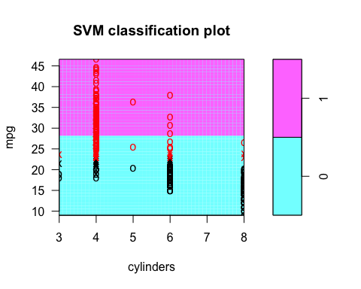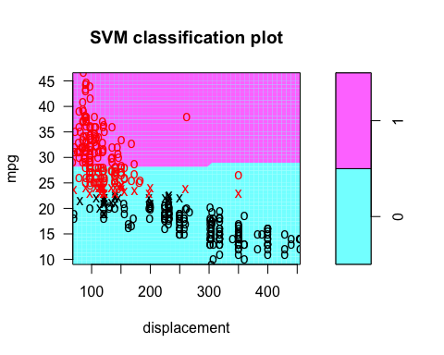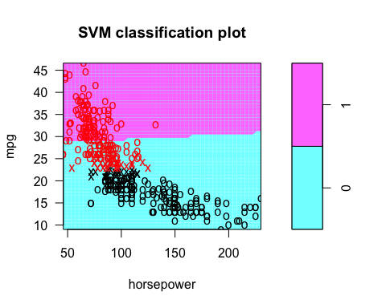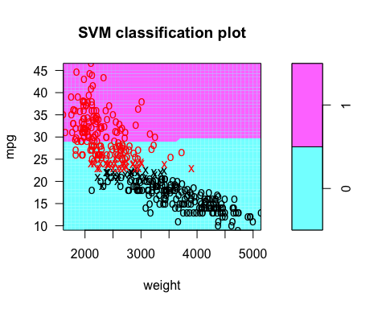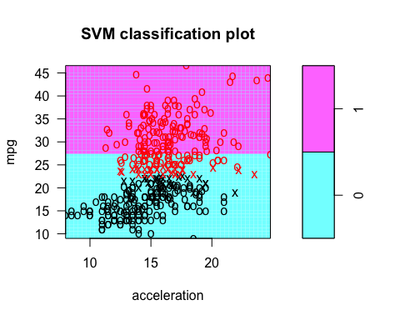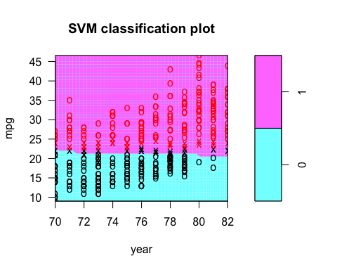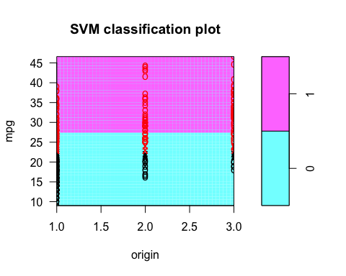

plottings(svm_polynomial)

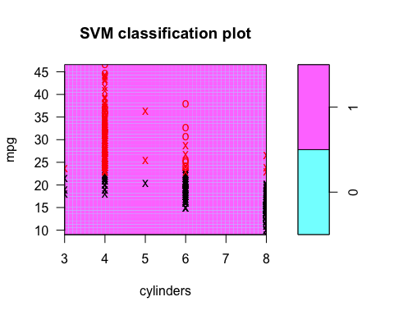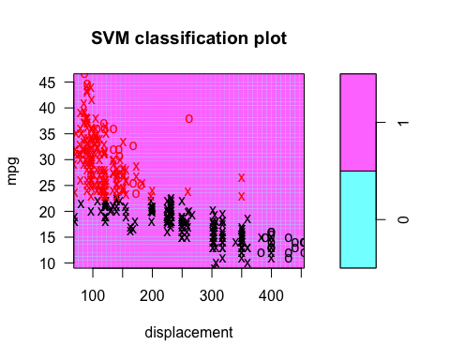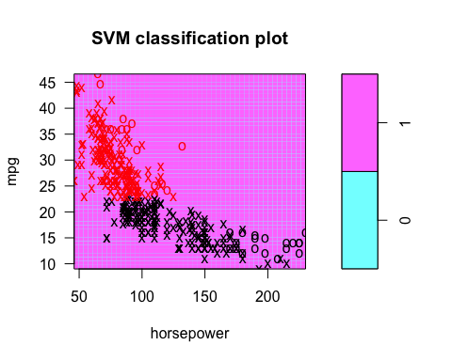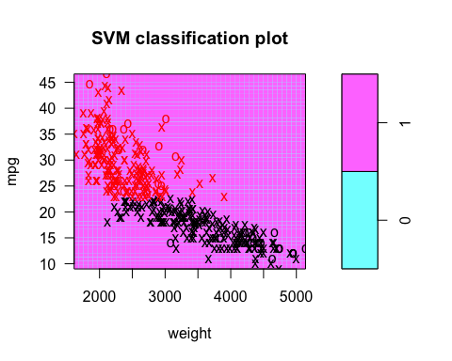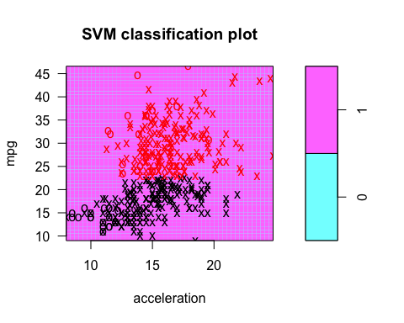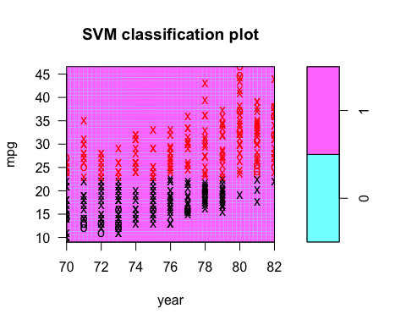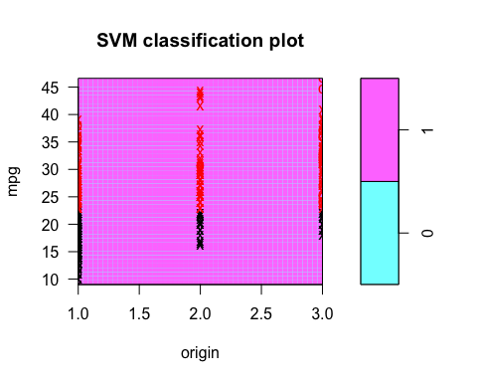

plottings(svm_radial)

