**G6-Report**

**Members: Zepu li, You yu, Yifu He, Heng lu**

**Rank until due: 1st**

**P&L:2.00%, $20003.49**

**Stocks and futures** **picking**

First of all, we chose to begin with long position since it is the most simple and intuitive way for us as new traders. Viewing the recent highly drop of the US stock market, we thought that it was not the right time to do so.

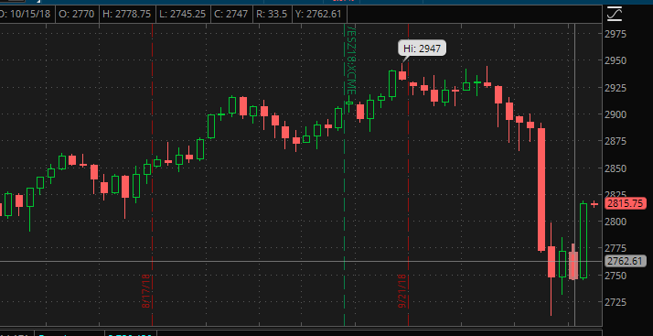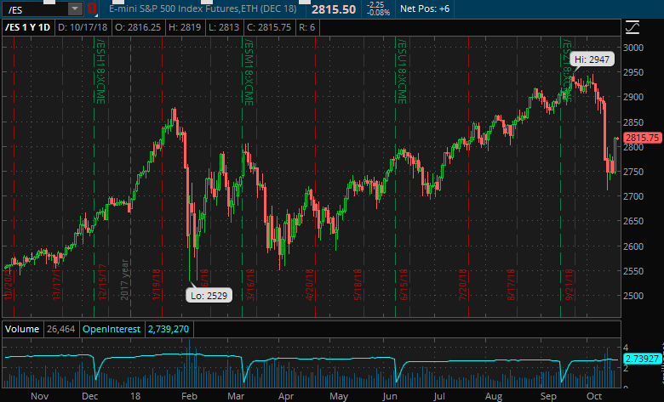 We first took a look at the /ES future. As is shown in the first picture, the price of it was showing a rising trend and started fluctuating from September 20th. We kept tracking it and we thought that it seemed to be a bottom of the price (shown in the second picture) which is a good time for us to make our long position.

For the TSLA and AMD stock, we have more ways to get information to choose the right time make our long position.

As TSLA is the leader in new energy auto industry, we believe it has a bright future on auto market. Its current stock price may be a little higher than its suitable value, however, it deserves an overestimated value.

As AMD is one of the biggest manufactures and merchants of integrated circuits, it recently declared a new technology on their products. Addition to the expectation of shortage in Intel’s supply on microchips, the market became quite optimistic about AMD, which rose its stock price up to 2 times just in two months. And then, after its short drop along with the index price, we held our long position on it, additionally according to a little technical analysis.

We have not yet completely set up our portfolio, neither do we have taken our hedge. We intend to hold short position on TSLA and AMD options, which will lock our assets value. We will continue to focus on the market, to figure out the appropriate compound and number of how much future contracts we should hold.

We noticed that, the volatility of /NQ price is close to stock prices of our holds, so we had two futures contracts on short position. Meanwhile, we let the assets value of our portfolio close to the value of futures contract.

Next time, we will calculate a suitable number of futures contracts we should hold.