**G6-Report2**

**Members: You yu, Yifu He, Zepu li, Heng lu**

**Rank until due: 1st**

**P&L:7.80%, $78014.95**

**Stocks and futures picking**

First of all, we chose to begin with long position since it is the most simple and intuitive way for us as new traders. Viewing the recent highly drop of the US stock market, we thought that it was not the right time to do so.

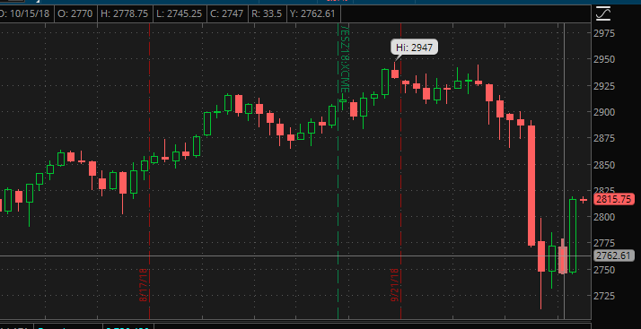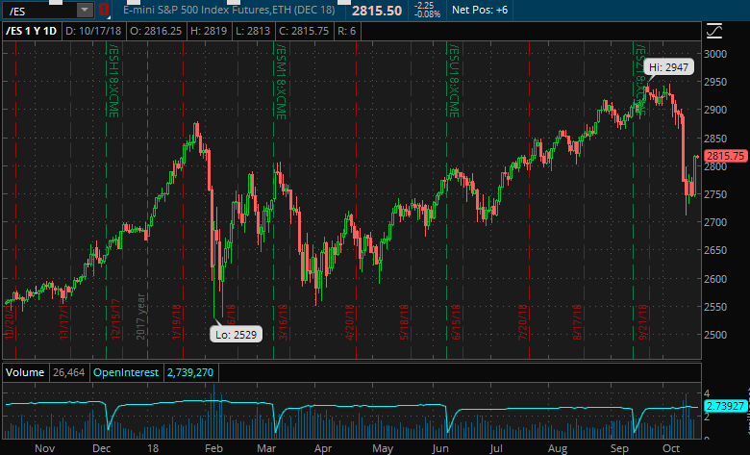 We first took a look at the /ES future. As is shown in the first picture, the price of it was showing a rising trend and started fluctuating from September 20th. We kept tracking it and we thought that it seemed to be a bottom of the price (shown in the second picture) which is a good time for us to make our long position.

For the TSLA and AMD stock, we have more ways to get information to choose the right time make our long position.

As TSLA is the leader in new energy auto industry, we believe it has a bright future on auto market. Its current stock price may be a little higher than its suitable value, however, it deserves an overestimated value.

As AMD is one of the biggest manufactures and merchants of integrated circuits, it recently declared a new technology on their products. Addition to the expectation of shortage in Intel’s supply on microchips, the market became quite optimistic about AMD, which rose its stock price up to 2 times just in two months. And then, after its short drop along with the index price, we held our long position on it, additionally according to a little technical analysis.

We have not yet completely set up our portfolio, neither do we have taken our hedge. We intend to hold short position on TSLA and AMD options, which will lock our assets value. We will continue to focus on the market, to figure out the appropriate compound and number of how much future contracts we should hold.

We noticed that, the volatility of /NQ price is close to stock prices of our holds, so we had two futures contracts on short position. Meanwhile, we let the assets value of our portfolio close to the value of futures contract.

**Hedging and other trials, 11/2/2018：**

As referred above, we set up our portfolio with 500 shares of TSLA and 4000 shares of AMD. Then we calculated the number of futures contracts we needed to short on in order that we could make profit no matter the market went up and down. For the calculation of contracts number, we download the daily close prices of each during the past two months. In order to get rid of the influence of the quarter reports, we chose the date from 7/29 to 9/29. Then, we figured out the correlation between each stock return and Nasdaq Index futures return. Based on that, we could decide the number of contracts we should hold.

The trade price of TSLA was 262.15 per share. The trade price of AMD was 27.35 per share. The trade price of NQ was 7284.75.

We used the formula below to calculate the number of futures contracts:

$$Number of futures=\sum_{i=a,b,…}{β_{i}×\frac{V_{i}}{V_{F}}}$$

However, things never go perfectly. We encountered a severe drop of 8% in AMD stocks on 27th, Oct, just 3 days before its scheduled report of the 3rd quarter. Thus, we unloaded all AMD shares and changed the assets into Intel’s shares. As the result, it seemed we made a wise decision for that AMD’s profit was under the market expectation and Intel’s report was kind of pretty. So, we made a great deal of profit.

|  |  |  |  |  |  |  |  |
| --- | --- | --- | --- | --- | --- | --- | --- |
|  | Trade price | quantity | delta | value | Stand deviation of daily return | beta | Future number |
| TSLA | 262.15 | 500 | 500 | 131,075 | 4.58524E-05 | 1.24 | 1.249 |
| AMD | 27.35 | 6000 | 6000 | 164,100 | 2.87E-05 | 0.77 | 0.863 |
| /NQ | 7284.75 | -2 | -40 | -291,390 | 3.65714E-05 | 1 | — |
|  | | | | | | | |
| INTC | 43.52 | 3500 | 3500 | 152,320 | 3.68986E-05 | 1.01 | 1.056 |

|  |  |
| --- | --- |
| TSLA |  |
| AMD |  |
| NASDAQ Futures |  |
| INTC |  |

Meanwhile, we also tried another two portfolios. One of them was that we held the long position on AZN and short position on BMY simultaneously. Both these companies are medical and biological incorporations, and according to their highly similar trends in daily price, we held the same weight in their values. However, as the volatility of them were extremely large and seemed almost unpredictable, we unloaded them just after holding them a short time.

|  |  |
| --- | --- |
| AZN |  |
| BMY |  |

The other trial portfolio was that we bought REGN shares and its put options. And we will await its feedback. We will include the outcome of this portfolio in the next report.