The Igor Synth filter is a combined lowpass and comb filter, which takes the form:

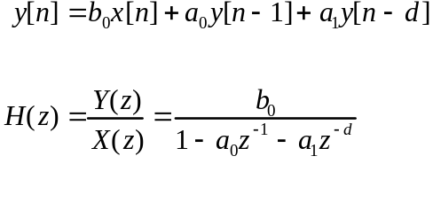

where

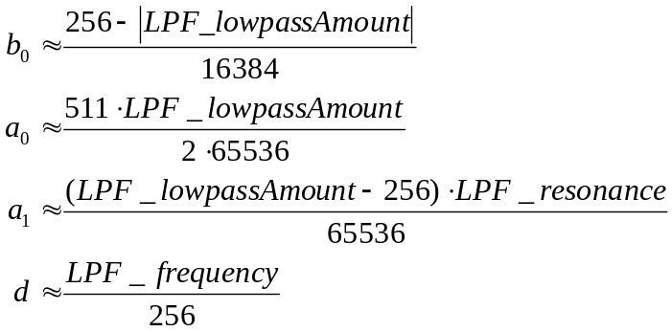

The following plots show the effects of the three filter parameters Lowpass Amount, Resonance Amount, and Resonance Frequency:

where

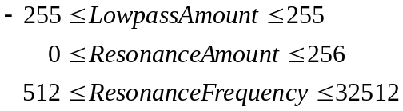

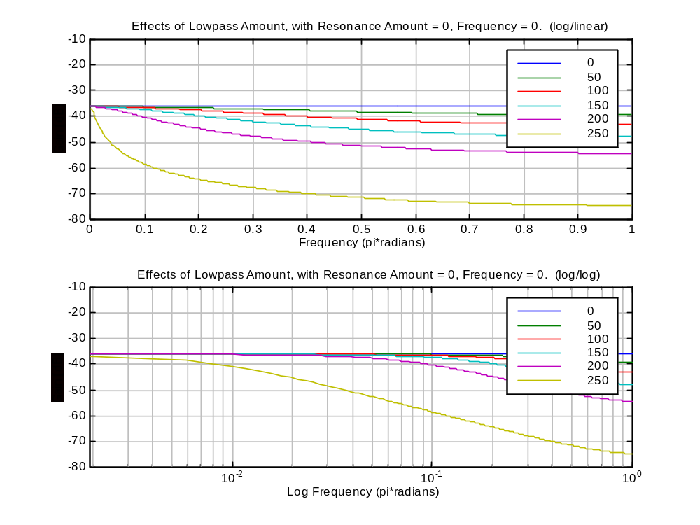

Positive Lowpass Amount behaves like a lowpass filter.

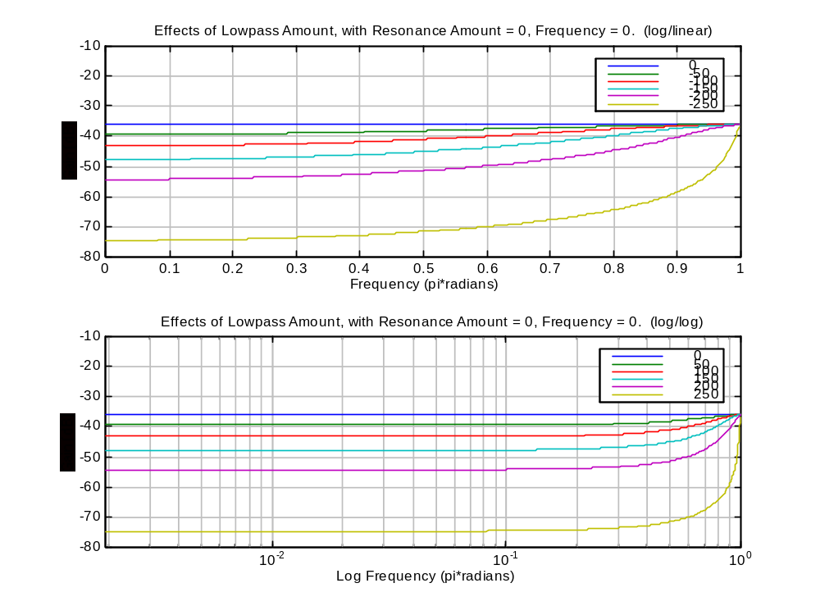

Negative Lowpass Amount behaves as a high pass filter.

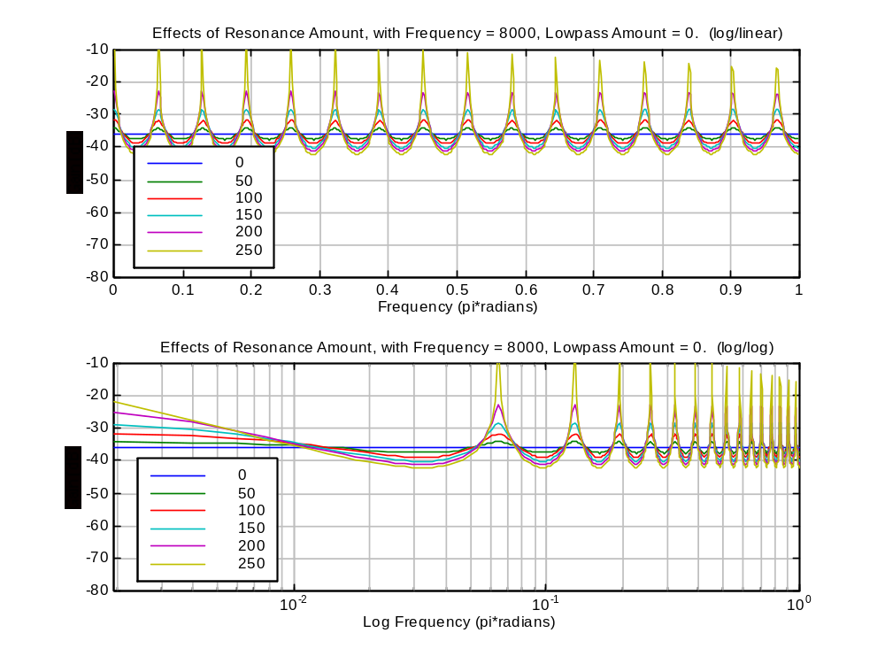

Resonance Amount controls the amplitude of the ripples

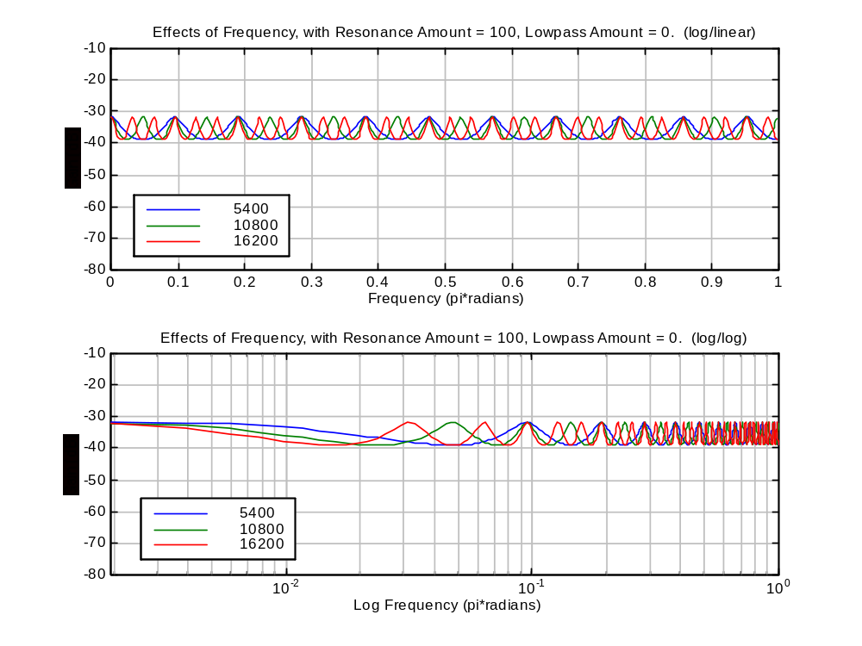

Resonance Frequency controls the spacing of the ripples

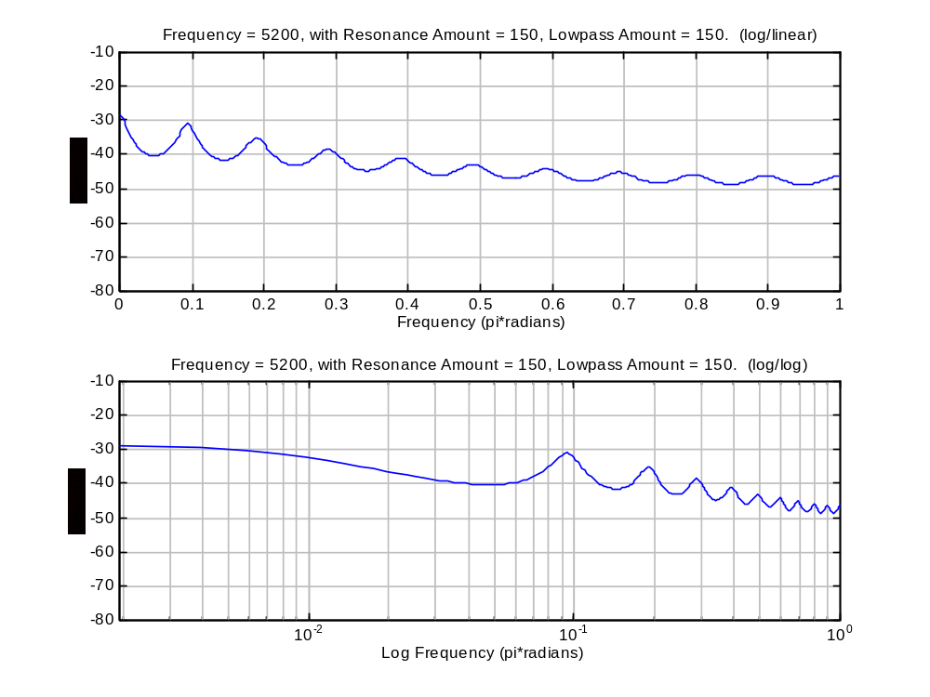

This is seen in the code (eg. GenSynthFiltersU3232.c), implemented as:

where:
