Butter: A Density-Aware Adaptive Traffic Light System Using Deep Learning Based Vehicle Detector and Fuzzy Priority Scheduling
Anoushka Basak (24BAI0153)

Abstract
Fixed-time traffic signals do not adapt to real-time variation in vehicle density, often forcing a heavily congested approach to wait through a full signal cycle while a lighter cross-approach receives equal green time. This project, Butter, addresses this by combining YOLOv8-based vehicle detection with a custom-built fuzzy inference engine and weighted priority scheduling to dynamically allocate green-light duration at a four-way intersection. Per-approach congestion is estimated from detection output and combined with wait-time-since-last-green through a Mamdani-style fuzzy system to compute priority; paired approaches sharing a signal phase are aggregated using a maximum rule, so a single severely congested approach can trigger an extended green phase regardless of its lighter counterpart. The system is evaluated in SUMO against a fixed-time baseline, comparing average wait time and throughput. The system is expected to reduce average wait time for congested approaches relative to fixed-cycle control, while remaining deployable on existing CCTV infrastructure without requiring specialized sensors — offering a low-cost retrofit path for adaptive signal control at intersections with significant demand imbalance across approaches.

Literature Survey
Adaptive traffic signal control has been an active research area for several decades, with approaches broadly falling into three categories relevant to this project: fuzzy-logic-based controllers, vision/deep-learning-based density estimation, and simulation-based evaluation frameworks such as SUMO.
Fuzzy logic control of traffic signals is well established, tracing back to foundational work in the late 1970s and maturing through the 1990s and 2000s as a technique for handling the inherent uncertainty in traffic measurements [10]. Early fuzzy controllers used simple inputs such as queue length and vehicle gap to adjust green-light duration [6], and later work extended this to four-way intersections explicitly designed for mixed traffic conditions, including a high proportion of two-wheelers [6] — a consideration directly relevant to Indian road conditions. Comparative work has since benchmarked fuzzy controllers against reinforcement-learning approaches such as Q-learning, generally finding fuzzy logic more interpretable and easier to tune with limited data, while RL approaches scale better across multiple coordinated intersections [5]. Neuro-fuzzy hybrids, which learn membership functions and rules from data rather than hand-tuning them, have also been explored as a way to reduce manual design effort, though at some cost to interpretability [9]. Other work has combined fuzzy logic directly with machine-learning-based detection in a single pipeline validated in SUMO [1], structurally similar to the approach taken in this project.
More recent work has shifted the detection layer from classical computer vision (background subtraction, blob analysis) toward deep-learning object detectors, primarily variants of YOLO, due to their robustness to occlusion, lighting variation, and camera angle compared to classical methods. Several studies use YOLO-based detection directly to drive adaptive signal timing based on queue density and per-vehicle waiting time [3], with more recent work (YOLOv11) demonstrating further improvements in detection accuracy and responsiveness for smart-city deployments [4]. Complementary work has focused specifically on improving density estimation itself, for example combining YOLOv8 with kernel density estimation to produce a more spatially precise congestion map than simple bounding-box counting [7]. System-level implementations combining a detection module, a signal-switching algorithm, and a lane-priority mechanism into one architecture [8] closely mirror the modular structure adopted in this project (detection → density scoring → priority inference → scheduling).
On the simulation side, SUMO has been used not only as a testbed for control algorithms but also in direct combination with vision-based tracking systems: one study built a YOLO-based vehicle and pedestrian tracking pipeline and incorporated its output into SUMO to reconstruct realistic turning-movement counts for intersection analysis [2], confirming that a vision-to-simulation bridge of the kind required by this project (given that SUMO's own simulated vehicles cannot be fed through a real-world-trained detector) is a viable and previously validated pattern.
Collectively, this body of work supports the overall approach taken in this project — combining a modern deep-learning detector with an interpretable fuzzy decision layer, evaluated in SUMO — while also indicating that reinforcement-learning-based coordination becomes the more common approach once multiple intersections must be coordinated jointly [5], which is noted here as a direction for future work beyond the current single-intersection scope.

Architecture Diagram
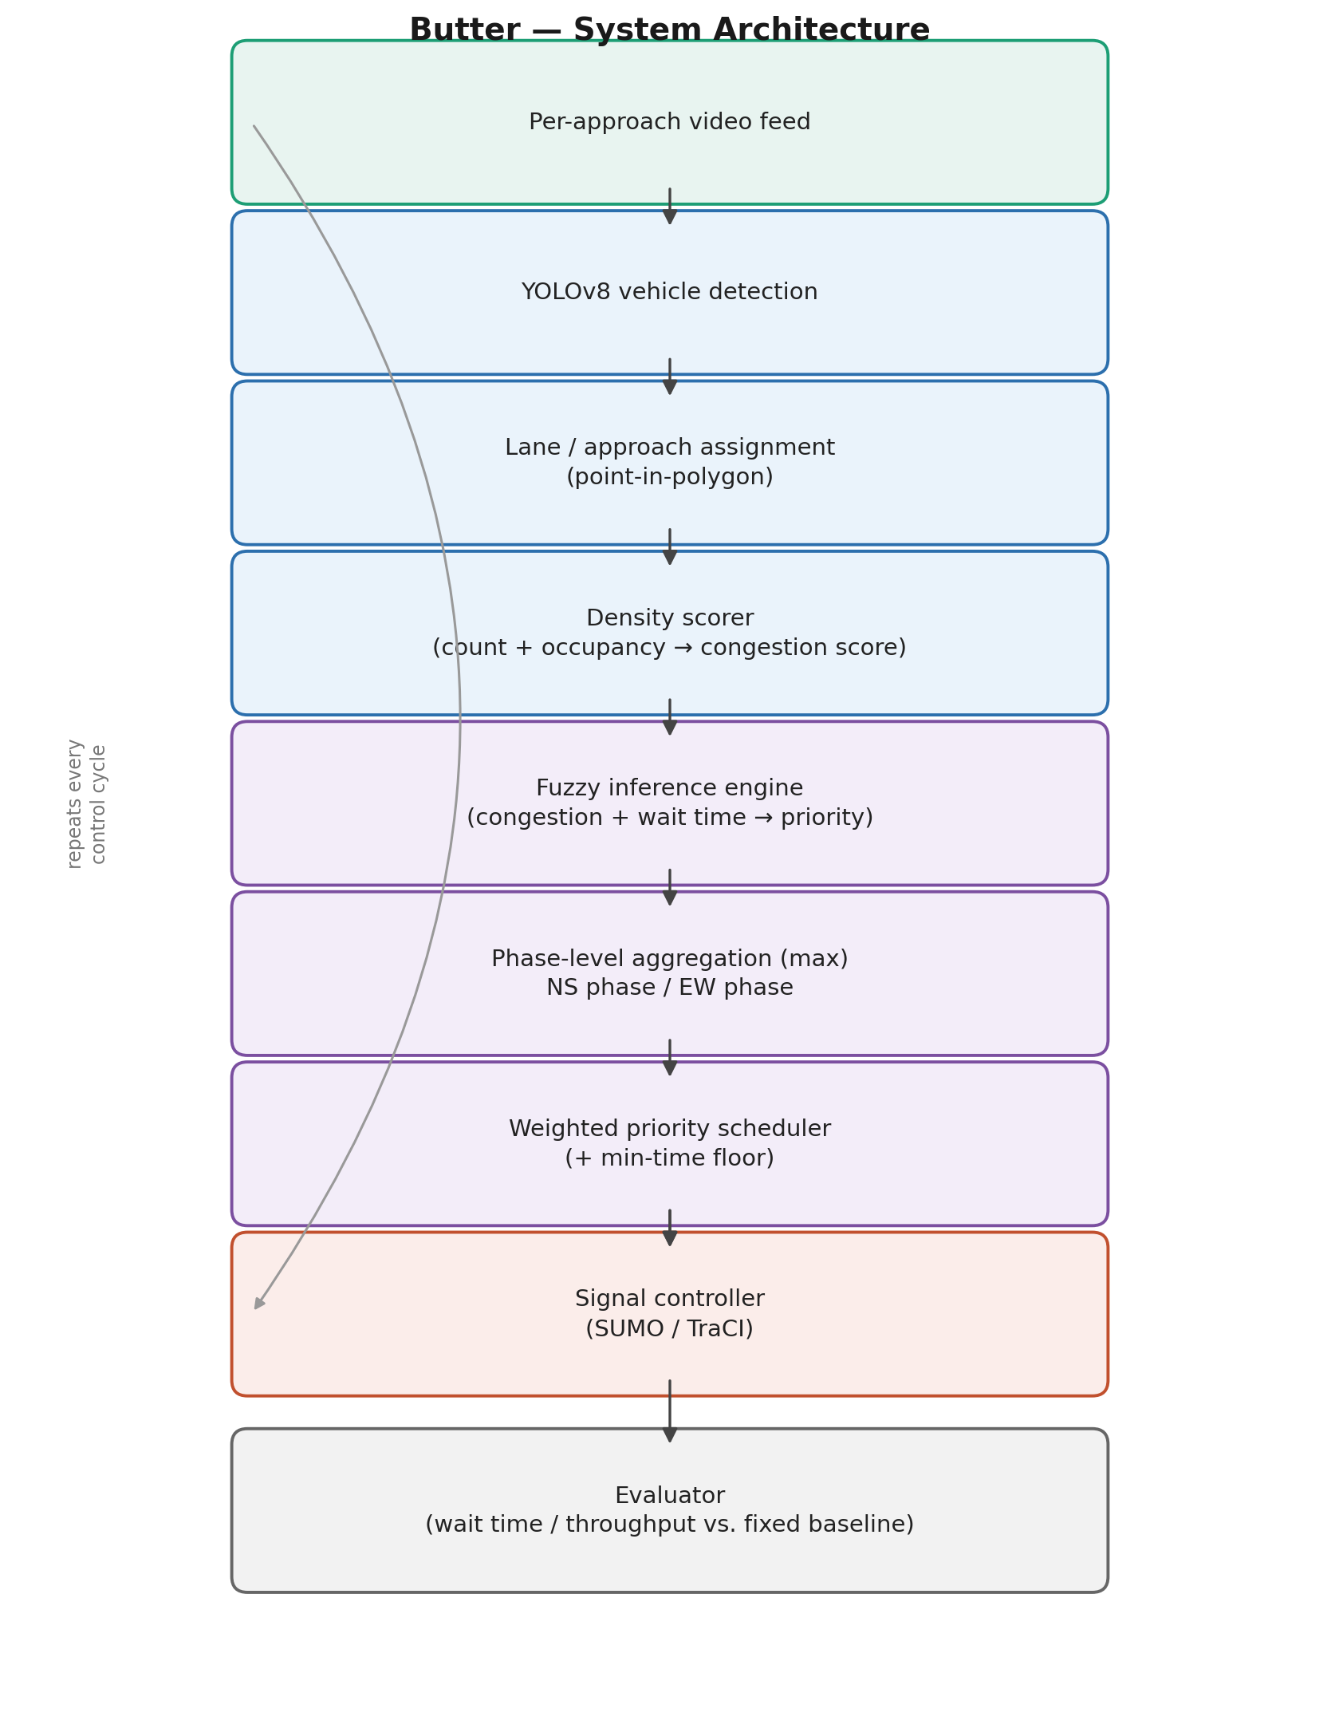
Figure 1: End-to-end system pipeline. Detection (blue) and fuzzy decision-making (purple) stages operate independently per approach each control cycle; phase aggregation and scheduling combine paired approaches (North–South and East–West) before signal timing is pushed to the SUMO/TraCI-controlled simulation and logged by the evaluator.

References
[1] "Fuzzy Logic Based Adaptive Traffic Signal Control for Different Scenarios," ResearchGate, 2023. https://www.researchgate.net/publication/374153407_Fuzzy_Logic_Based_Adaptive_Traffic_Signal_Control_for_Different_Scenarios
[2] M. S. Shirazi et al., "Intersection analysis using computer vision techniques with SUMO," Intelligent Transportation Infrastructure, Oxford Academic, 2023. https://doi.org/10.1093/iti/liad003
[3] "Traffic Management System Using YOLO Algorithm," MDPI, 2024. https://www.mdpi.com/2673-4591/59/1/210
[4] "Smart traffic management system using YOLOv11 for real-time vehicle detection and dynamic flow optimization in smart cities," Neural Computing and Applications, Springer, 2026. https://link.springer.com/article/10.1007/s00521-025-11434-9
[5] "Comparative Evaluation of Fuzzy Logic and Q-Learning for Adaptive Urban Traffic Signal Control," Electronics, MDPI, 2025. https://doi.org/10.3390/electronics14142759
[6] "Review of Traffic Signal Control based on Fuzzy Logic," Academia.edu, 2016. https://www.academia.edu/106790883/Review_of_Traffic_Signal_Control_based_on_Fuzzy_Logic
[7] "Vehicle Density Estimation Using Improved YOLOv8 Object Detection Model with Kernel Density Estimation," Springer, 2025. https://link.springer.com/chapter/10.1007/978-3-031-86290-8_4
[8] "Smart Traffic Surveillance System with Adaptive Traffic Control Signal using YOLO," IJERT, 2025. https://www.ijert.org/smart-traffic-surveillance-system-with-adaptive-traffic-control-signal-using-yolo
[9] "Traffic Signal Control Based on Adaptive Neuro-Fuzzy Inference," ResearchGate, 2008. https://www.researchgate.net/publication/224385413_Traffic_Signal_Control_Based_on_Adaptive_Neuro-Fuzzy_Inference
[10] M. Koukol et al., "Fuzzy Logic in Traffic Engineering: A Review on Signal Control," Mathematical Problems in Engineering, Wiley, 2015. https://doi.org/10.1155/2015/979160

