Plant Disease Detection in Pepper Bell Leaves
Identifying Bacterial Spot Disease Using Image Processing and Machine Learning
Image Processing: Individual Assignment | KIC-HNDCSAI-252F-003
Project Files: Mega Drive Image Processing Individual Assignment
- Introduction and Objective
Leaf diseases constitute a major problem faced by agricultural scientists and farmers. One can note that a plant can look healthy in the morning and by the end of the day, one might see some visible signs of illness. Also, by the time one notices the symptoms, the process of spreading diseases can begin. In the case of bell peppers, there can be some rapid development of diseases that lead to dark spots and yellow edge leaves.
The aim of this research work is to create an algorithm based on image processing techniques which would help to diagnose whether the leaf of a bell pepper is healthy or whether there are any signs of disease. This method does not necessarily require sophisticated equipment and can be run on a normal computer or even mobile device, making it much faster than other methods. In other words, it would allow obtaining a result on the basis of just one image.
This research work involves the usage of a traditional image processing technique as well as the machine learning approach to solving the problem at hand. At first, leaf images are preprocessed. Then, there is diseased region segmentation through color detection. The next step includes the extraction of different features that characterize color, texture and shape of lesions. After that, we use the Support Vector Machine classifier to classify the images into 'healthy' and 'sick' groups.
- Methodology
  - Dataset and Image Collection
The pictures came from the PlantVillage dataset, which is an open-source labeled dataset of pictures of leaves of plants. Two sets were considered in this dataset: first, the pictures of healthy pepper bell leaves and second, the pictures of leaves with bacterial spot disease. The PlantVillage dataset contains more than 1,400 pictures of healthy leaves and nearly 1,000 pictures of leaves with bacteria disease. However, to ensure balance and simplicity of use, only 100 pictures for each set were taken, making it a total of 200 pictures.
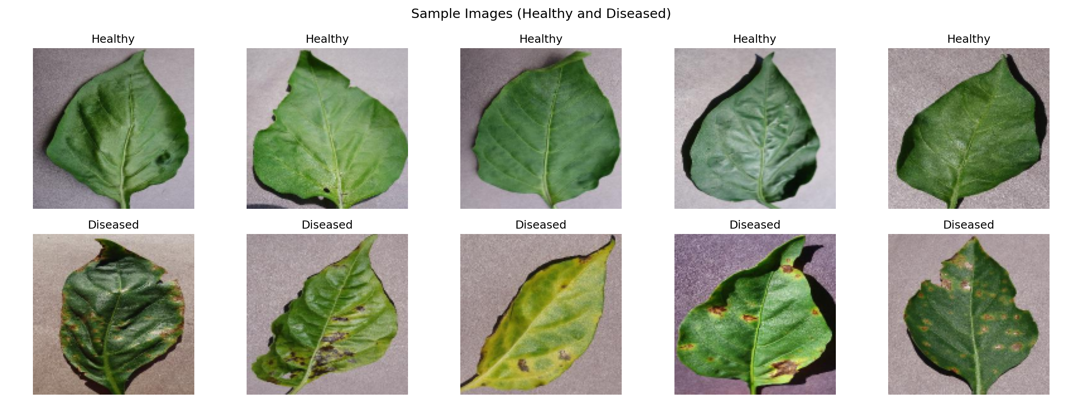  Figure 1: Sample images: healthy (top) and diseased (bottom). | 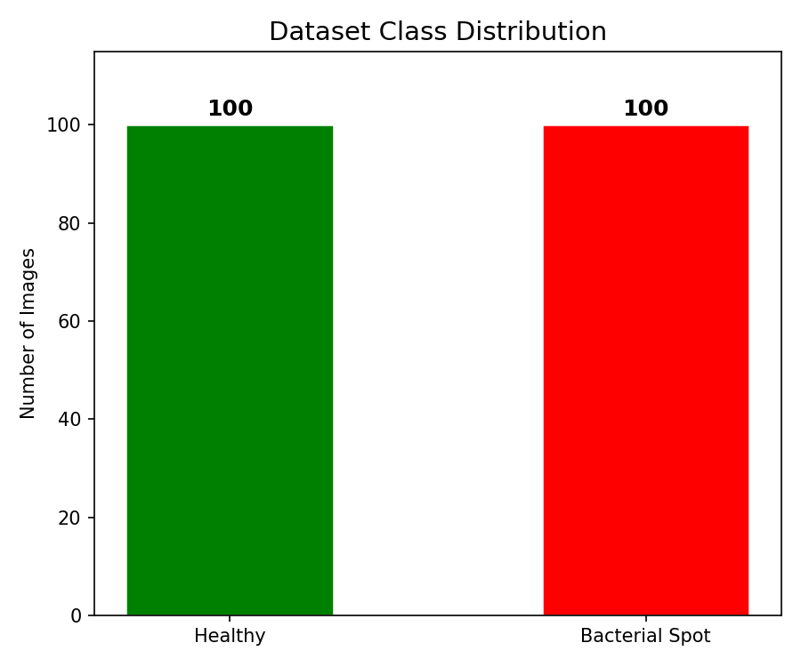  Figure 2: Dataset class distribution: 100 per class.
  - Preprocessing
Each picture was reduced to a size of 128 x 128 pixels to have consistent input sizes. This was followed by Gaussian blurring using a 5 x 5 kernel to reduce noise at the pixel level. Without the blurring process, the presence of either bright or dark random pixels would fall within the range of colors required to detect plant disease spots, causing erroneous detection. No further pre-processing was performed since the PlantVillage dataset was taken under controlled settings.
  - HSV Color Segmentation
Segmentation was conducted in the HSV (hue, saturation, value) color space instead of RGB. Segmentation in the HSV space is more reliable for color-based recognition due to the fact that HSV decomposes color and luminance. Two binary masks were obtained from the image. First mask isolates healthy green vegetation based on hues between 25 to 85 while the Second mask covers colors of a brown yellowish type corresponding to infected plants; specifically, hues are set between 5 to 25 to ensure a wide enough range covering dark lesions and lighter yellows surrounding them.
After constructing disease masks, two morphological techniques are performed to remove noise. MORPH_OPEN eliminates isolated noise pixels, while MORPH_DILATE expands existing regions to avoid segmentation of close by lesions into separate clusters. Both operations are carried out using 3×3 structure element. Disease percentage is found as the ratio of pixels belonging to disease mask to the total number of pixels in healthy and disease areas.
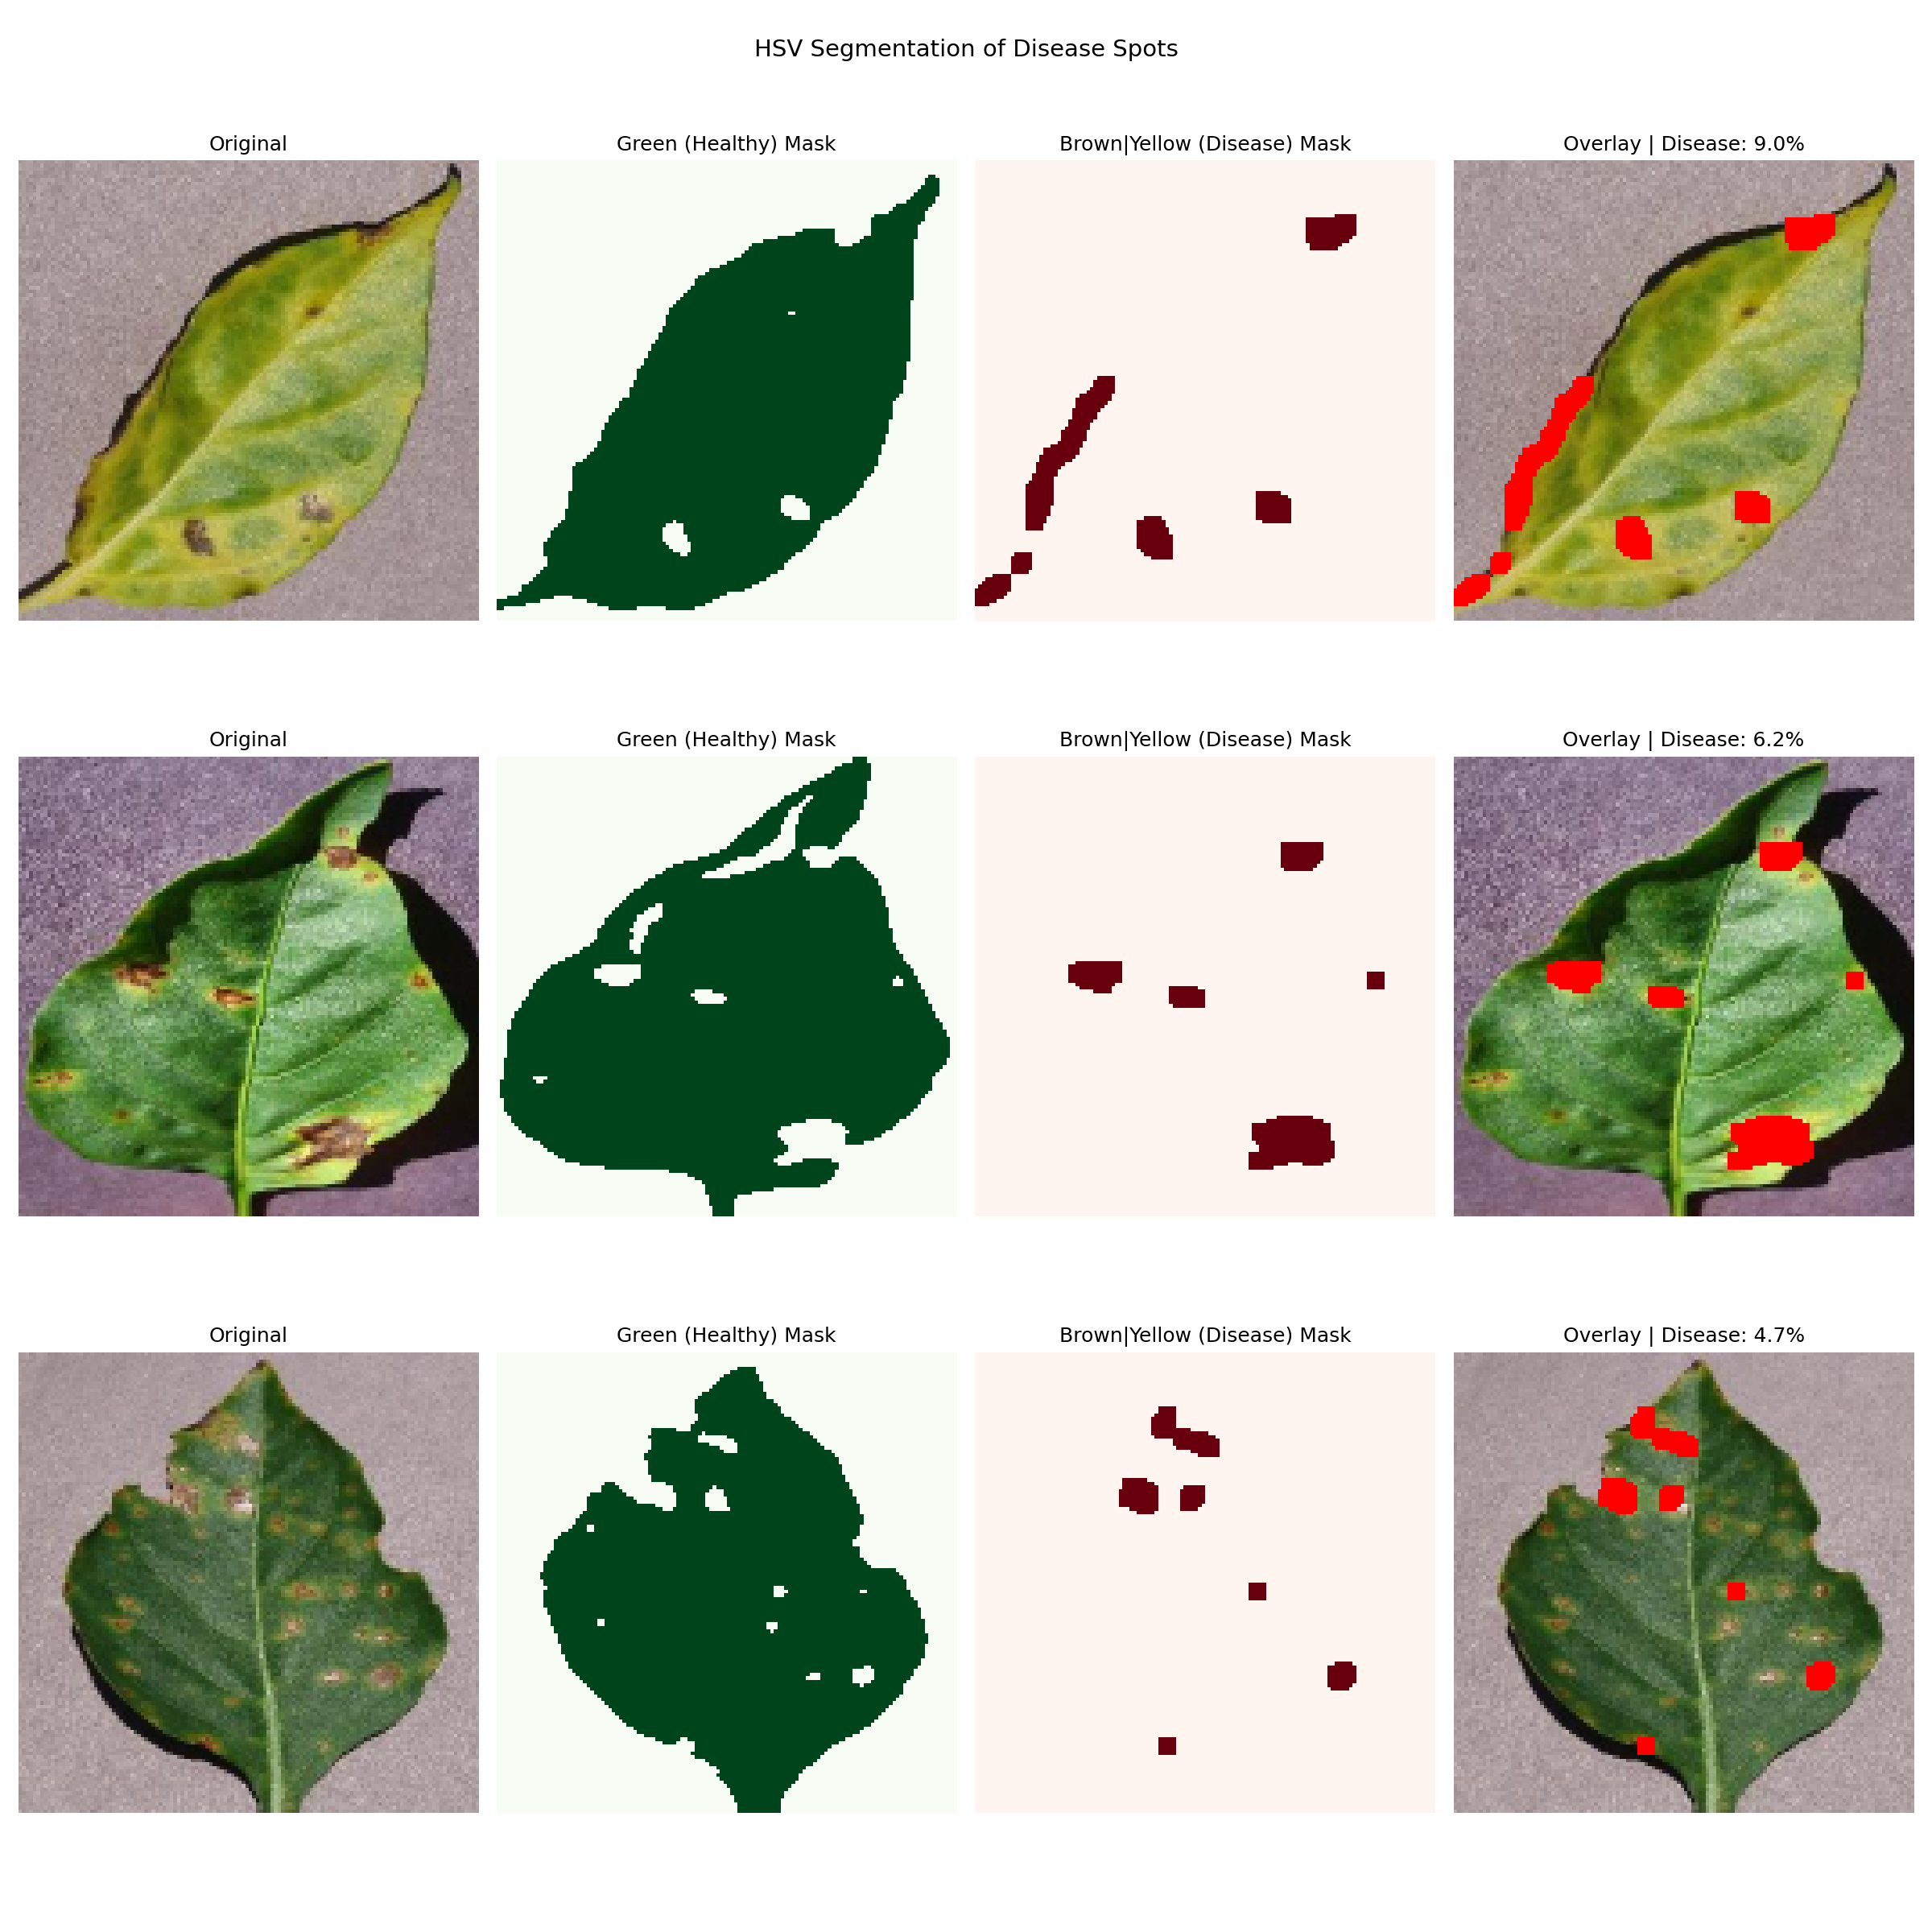
Figure 3: HSV segmentation across three diseased leaves: Original image, healthy area mask, disease mask, and the red overlay showing detected lesion regions.
  - Contour Detection and Edge Detection
The contours detection process comes next after segmentation, with the help of the OpenCV function findContours that is used to detect the contours from the disease mask. In the process, contours having fewer than 10 pixels are eliminated in order to minimize the amount of noise. Contours count and mean size become the next set of features to be extracted from the image. Moreover, a boundary level view of the image is obtained through the Canny edge detection method on the grayscale image with thresholds 50 and 150.
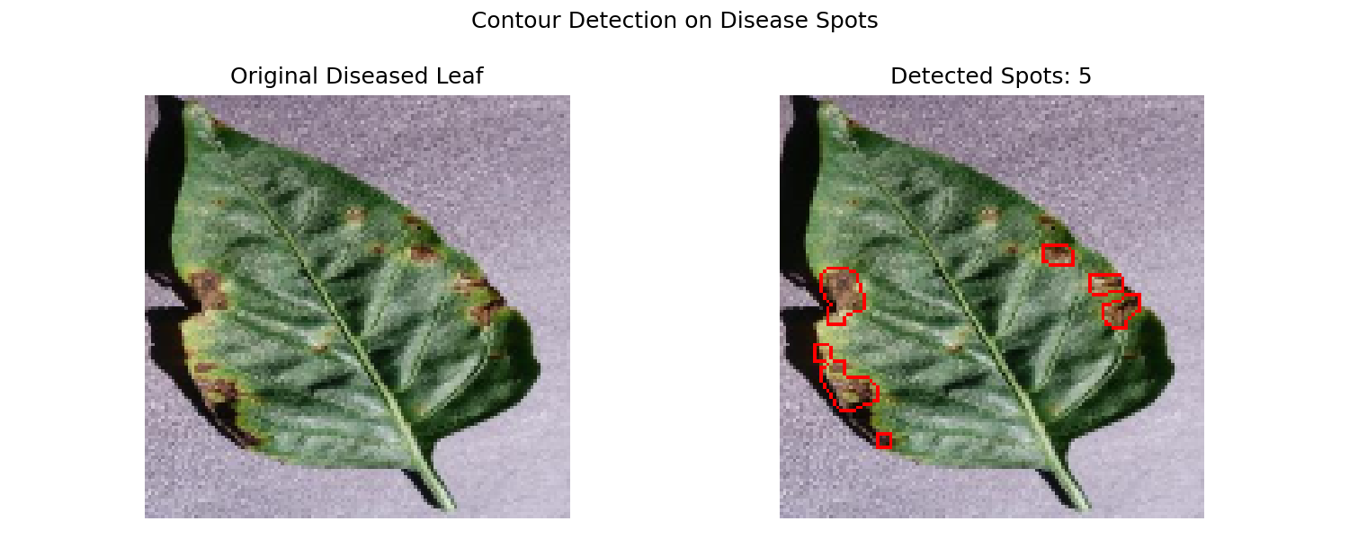  Figure 4: Contour detection: lesion boundaries drawn on a diseased leaf. | 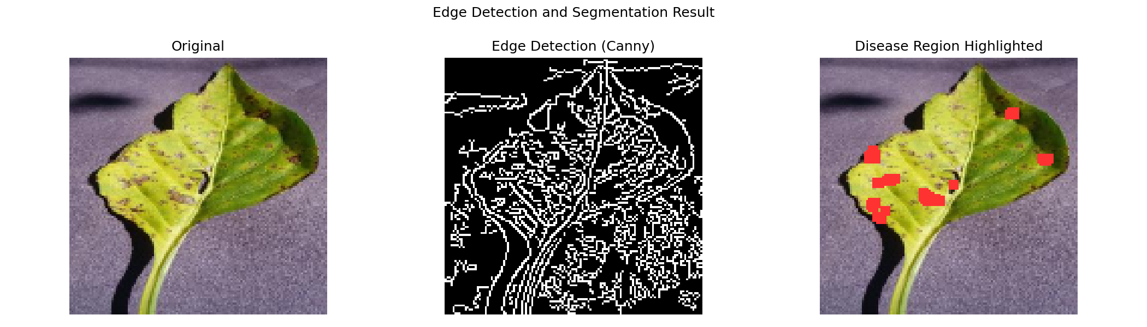  Figure 5: Canny edge detection showing disease boundaries.
  - Feature Extraction
The feature vector with 56 components is created by combining three sets of features. The color features (48) are generated from the histograms of each color channel with 16 bins in the HSV color space, allowing the creation of color histograms. The texture features (5) are calculated from the Gray Level Cooccurrence Matrix (GLCM) generated at distance 1 across three different orientations and include contrast, dissimilarity, homogeneity, energy, and correlation. This matrix has been used in the current study since it is observed that diseased tissue pixels tend to have rough and irregular textures and can be analyzed using these metrics. The spot features (3) include the disease percentage, the number of contours, and the average contour area.
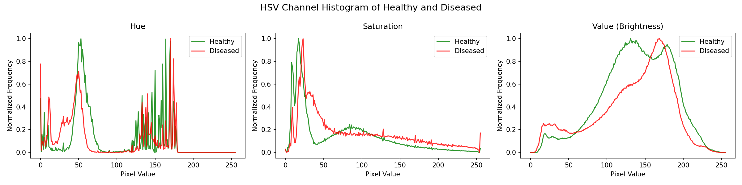  Figure 6: Mean HSV histograms: healthy vs diseased leaves. | 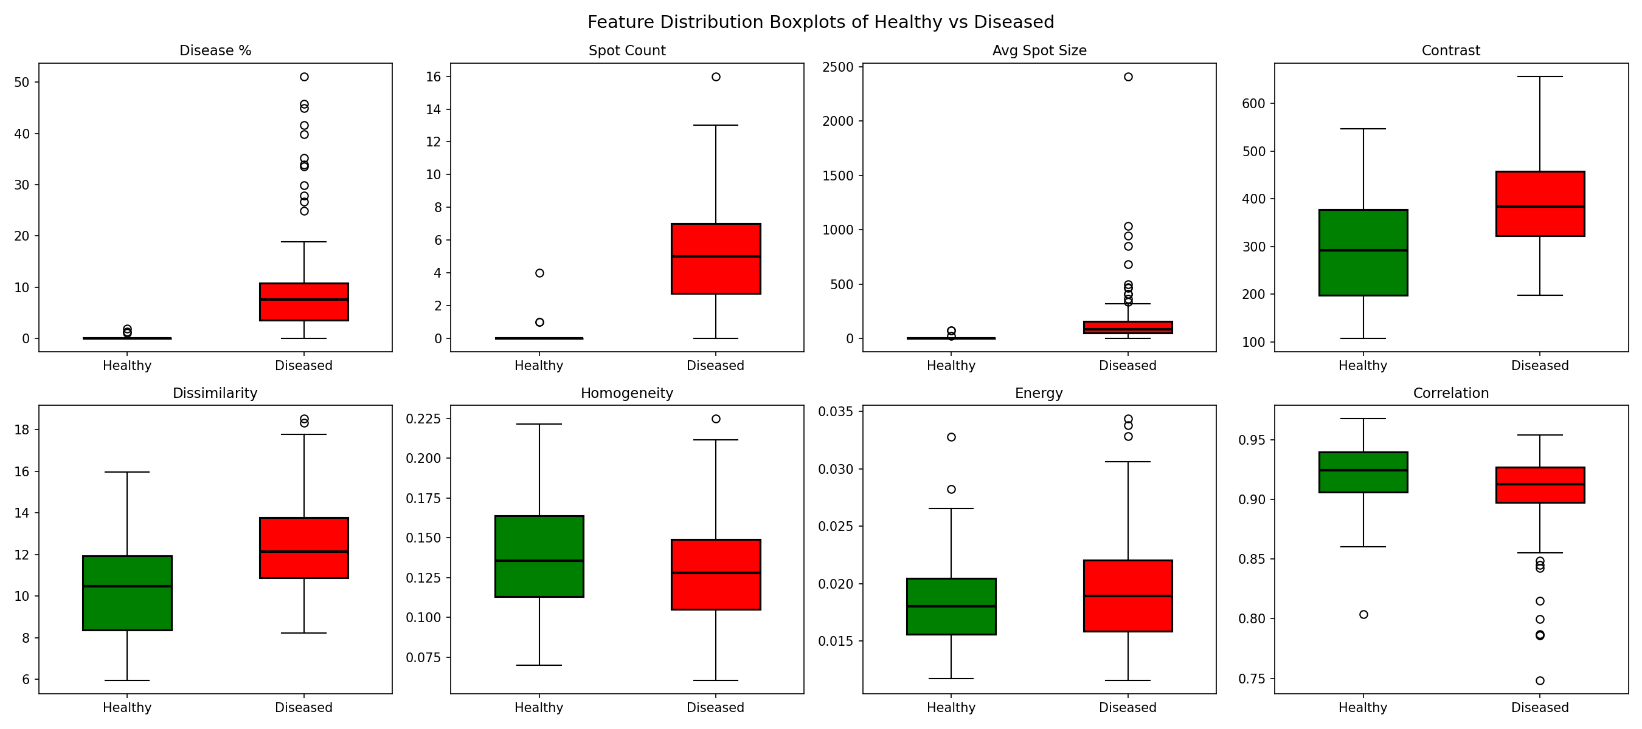  Figure 7: GLCM texture feature distributions by class.
  - Classification
Support Vector Machine using Radial Basis Function Kernel was used to perform classification tasks and using this is suitable when the number of input variables is large, but the size of the training data is smaller, which is exactly how the current setup works. The value of parameter C was chosen to be 1 to prevent overfitting because we had only 160 training images. Feature scaling was done using StandardScalar before performing training to accommodate for the SVM algorithm, which was sensitive to scaling. Splitting of the data set consisting of 200 images into training and testing sets was done in 80/20 ratio with stratification.
- Results
  - Segmentation and Disease Area
The outcome of the segmentation process was distinct. Leaves that were healthy had an average disease percentage of 0.00 Percent, signifying that there was no false alarm generated due to color segmentation parameters. Leaves that were diseased had an average affected area of 11.45 Percent. In terms of classification based on severity, most of the diseased leaves fell under the mild-to-moderate category while some were heavily covered.
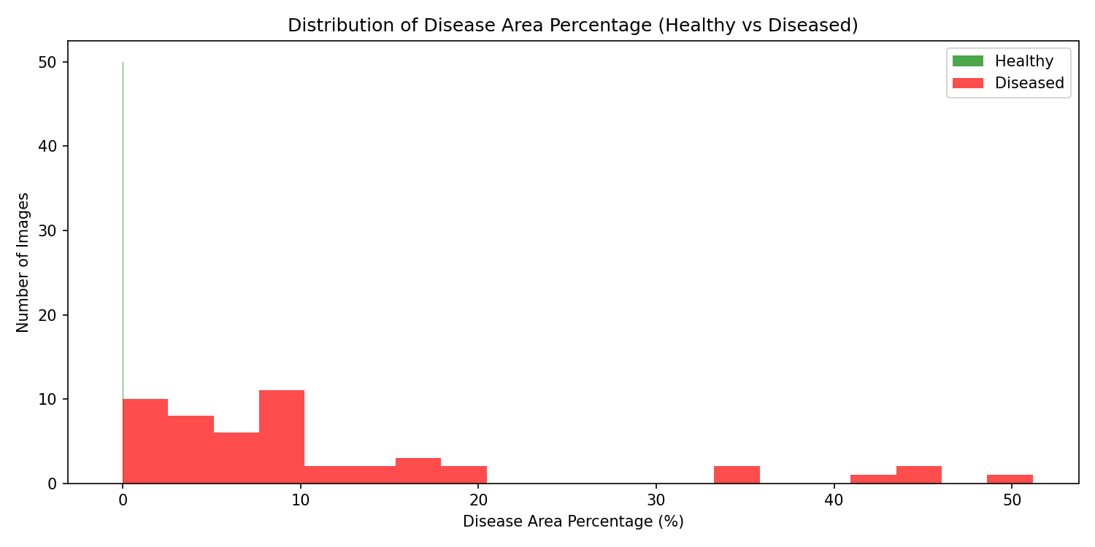  Figure 8: Disease area percentage distribution: healthy leaves sit at 0%, diseased leaves spread from 3 to 50%. | 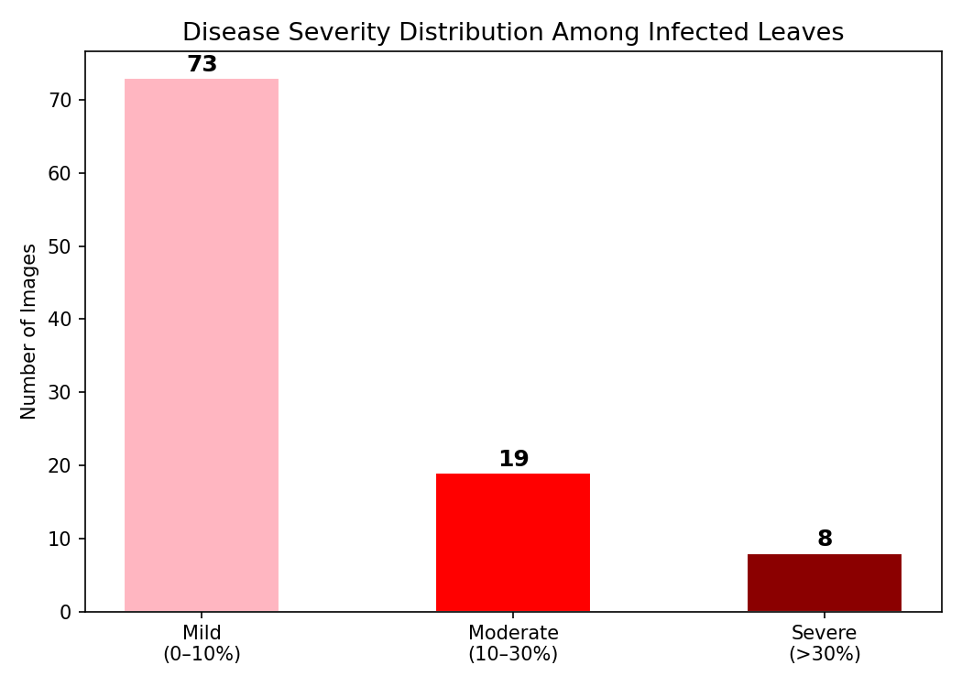  Figure 9: Severity breakdown of diseased leaves into mild, moderate and severe categories.
  - Classifier Accuracy
For the support vector machine, the accuracy achieved was 95.00 Percent on the testing data with 40 images. The training accuracy for the SVM model was 100.00 Percent, and hence the difference between the two was 5.00 Percent, which is reasonably low to rule out the possibility of overfitting. When five fold cross validation was performed using all 200 images, an average accuracy of 96.00 Percent with a standard deviation of 1.22 Percent.
Evaluation Stage | Accuracy | Precision | Recall
Training (160 images) | 100.00% | — | —
Test Set (40 images) | 95.00% | 0.95 avg | 0.95 avg
5 Fold Cross Validation | 96.00% ±1.22% | — | —
Unseen Images (60) | 93.33% | 0.94 avg | 0.94 avg
Table 1: Model accuracy across all evaluation stages.
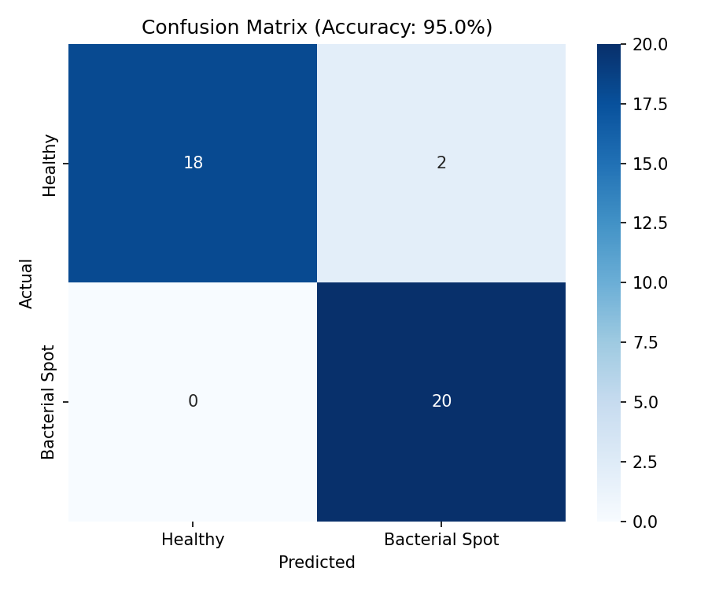  Figure 10: Confusion matrix of results 2 wrong predictions out of 40 test images. | 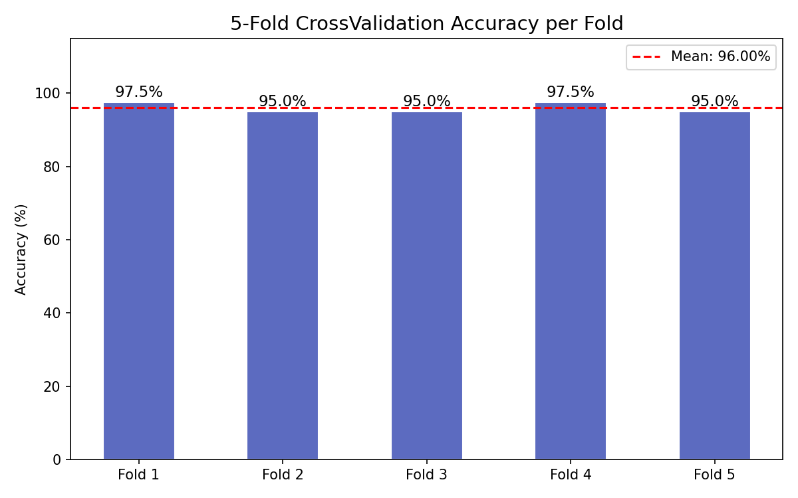  Figure 11: Per fold cross validation accuracy (mean 96.00%).
  - Unseen Image Validation
For real world accuracy testing, thirty new images belonging to each category that do not belong to the set of 200 images were selected from the test data. This resulted in an accuracy score of 93.33 Percent, with the precision being 0.91 in case of healthy images and 0.96 in case of disease images. It is notable that a slight reduction in the overall accuracy, from 96.00 Percent in cross validation to 93.33 Percent, is quite reasonable.
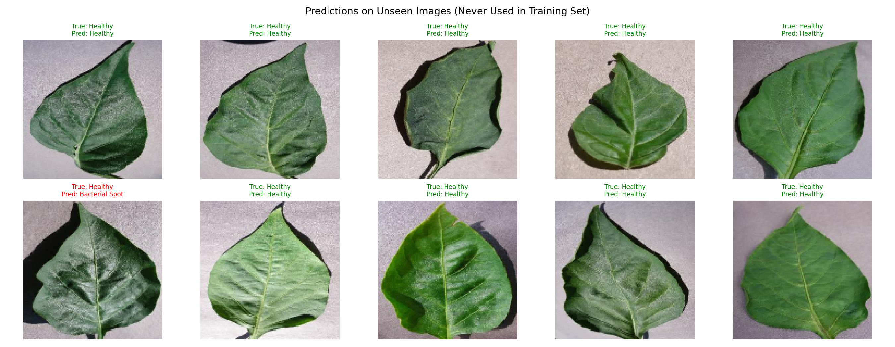
Figure 12: Predictions on 60 unseen images: green labels are correct, red are misclassified.
  - Misclassified Images
However, out of the 40 images used for testing, only 2 images were wrong classification results, where healthy leaves were predicted to be infected by diseases. Upon careful observation of the images using the disease mask, these healthy leaves had naturally browning areas around the edges of the leaves or the area connecting the leaves and stems, which fell within the brown yellow HSV color space. These regions were segmented by the algorithm, increasing the importance of the diseased areas to a level where the classifier was tricked.
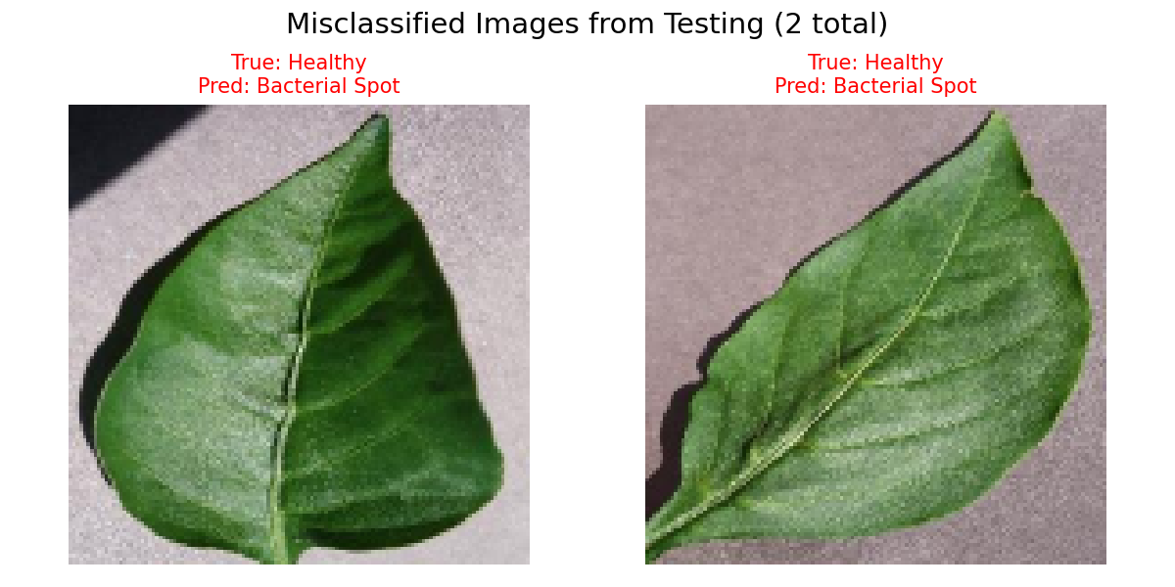  Figure 13: The 2 misclassified leaves: natural edge browning caused false positives in the mask. | 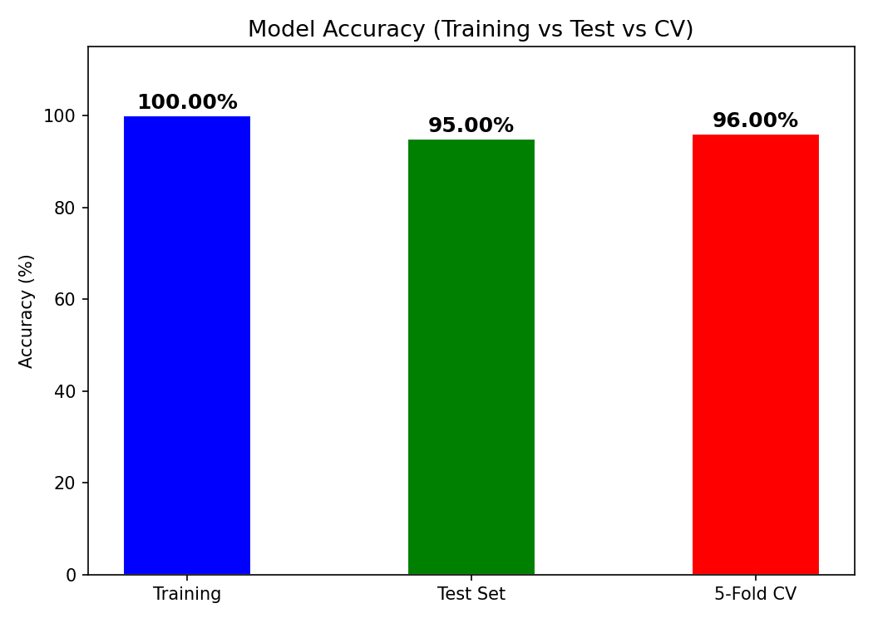  Figure 14: Accuracy comparison across all evaluation methods.
- Discussion
  - What Worked Well
In this regard, the proposed algorithm turned out to be more resilient than expected, considering the simplicity of its implementation. HSV segmentation successfully distinguished the regions of the lesion, while the feature of disease percentage alone provided class separation without any mean overlap (0.00 Percent compared to 11.45 Percent). Texture features based on GLCM contributed to the discrimination capability in addition to the color features: infected tissue had higher values for contrast and dissimilarity; this result correlates with the fact that lesions create rough surface structures, as opposed to smooth structures of healthy tissue. Similar performance results in all five folds (95.0 Percent to 97.5 Percent) imply the stability of the classification algorithm.
  - Limitations and Challenges
Indeed, the major weakness of this method lies in these fixed HSV thresholds. Their efficiency is justified by the controlled acquisition conditions of these images; however, different lighting conditions, whether bright daylight, cloudy sky, or artificial light sources, will influence the pixel value of the image and thus negatively affect its color detection capability. The natural brown coloration of old leaves is another issue that can make the classification harder, as evidenced by the two wrongly classified images. In addition, the sample set used consisting of 200 images is not large enough to validate the model.
  - Possible Improvements
The strength of the solution can be improved in several ways without requiring significant changes to the algorithm. The first improvement involves adapting the thresholds in HSV space using the image’s own color histogram rather than using global thresholds that may not work well with varying lighting conditions. Another improvement involves using Local Binary Patterns (LBP), in addition to Haralick features, to add more texture based information to the classification model. A further improvement can involve collecting more images for training that vary in lighting conditions and leaf development stages to make the classifier more robust. From a long term perspective, the best improvement is to use deep learning to replace the hard coded engineered features with learned ones.
- Conclusion
This project outlines a full functioning image processing pipeline used for disease detection on the basis of leaf images of pepper bell. It covers preprocessing (Gaussian filter), color segmentation based on HSV segmentation in order to extract the diseased areas, contour and edge detection for lesion detection, texture extraction using GLCM method and color histograms as feature vectors, and finally classification using support vector machine.
The experiment demonstrated a high level of performance regardless of the method chosen for estimation. Test set score was equal to 95.00 percent, cross validation result reached 96.00 Percent, while an evaluation on entirely unknown images resulted in 93.33 Percent. Disease percent indicator showed an absolute separation between non diseased images (0.00 Percent) and images of diseased samples (11.45 Percent), with only 2 out of 40 test cases misclassified. These cases turned out to be false negatives caused not by classifier errors but due to mistaken detection of natural leaf browning as disease.
Goals have been achieved successfully as planned. Segmentation workflow allows to accurately detect and quantify the amount of disease regions in an image. Classifier demonstrates a high level of performance without any signs of overfitting. Real world performance was tested successfully using completely unseen images. Further research is needed to develop automatic color thresholding, increase the number and diversity of images in the dataset, and consider deep learning approaches.

