Deforestation and Land Cover Change Analysis
Using Landsat Satellite Imagery, Machine Learning Classification,
and Vegetation Trend Forecasting
KALPITIYA, SRI LANKA

Course: Image Processing Group Project
Higher National Diploma in Computer Science with Artificial Intelligence

Group Members:
D.M.I.N. Dissanayake – KIC-HNDCSAI-252F-003
R.M. Aflal – KIC-HNDCSAI-252F-008
M.M. Abdullah – KIC-HNDCSAI-252F-039
M.F.M Afrar – KIC-HNDCSAI-252F-043

Lecturer: K.M.S.S.B. Kulasekara
Institution: National Institute of Business Management
Submission Date: 18th May, 2026

Drive Link: Mega Drive Image Processing Group Assignment
GitHub: https://github.com/heyisula/terraShiftSriLanka

Abstract
This report mainly talks about a multi-time-based satellite image analysis analyse of the Kalpitiya Peninsula in Sri Lanka. Also, The main thing we wanted to do was monitor and measure land cover changes, mainly deforestation and vegetation loss, from 2016 to 2025. For this work, we used Landsat 8 and Landsat 9 Level-2 Surface Reflectance imagery and processed it through image preprocessing, spectral index calculation, machine learning grouping, change detection, and vegetation trend forecasting.
In total, we organised 20 Landsat scenes covering the analyse area in chronological order and processed them using a Python-based pipeline. The preprocessing steps included cloud masking using the QA_PIXEL quality assessment band, surface reflectance scaling, bilinear resampling, and creating a persistent land mask so that permanent water bodies were not included in the analysis. Five spectral indices – NDVI, NDWI, NDBI, NBR, and EVI – were calculated for each scene to describe different land surface conditions. A Random Forest classifier was then trained using automated pseudo-labelling across four land cover classes: Water, Vegetation, Bare Soil, and Built-Up areas.
Change detection was carried out using both NDVI time-series comparison and sequential pairwise analysis, and the results were saved in transition matrices. Forecasting models including Linear Regression, Polynomial Regression, and Gradient Boosting Regressor were mainly used to project vegetation trends up to 2030, with 95% confidence intervals. The results show a general decline in vegetation cover during the analyse period, with stronger periods of loss about 2022 and 2023. This analyse clearly helps show how useful remote sensing and machine learning can be when they are combined for nature-related monitoring in coastal Sri Lanka.

Table of Contents
- Introduction and Background
- Literature Review
- Methodology
3.1 Study Area
3.2 Data Collection and Organization
3.3 Preprocessing
3.4 Spectral Index Computation
3.5 Land Cover Classification
3.6 Change Detection
3.7 Trend Analysis and Forecasting
- Results and Discussion
- Conclusion
- References

1. Introduction and Background
Deforestation is one of the major nature-related problems faced by tropical and subtropical countries today. It means the permanent removal of forest cover or dense vegetation from land, usually so the land can be useful too for agriculture, urban development, aquaculture, or other activities. In Sri Lanka, deforestation has been a concern for many years. Even though the country had suitable forest cover in the past, population growth, coastal development, and agricultural expansion have put many pressure on natural vegetation, especially in coastal and semi-arid areas.
The Kalpitiya Peninsula in the North Western Province of Sri Lanka is one area where land cover has changed over time. It is a coastal strip with the Puttalam Lagoon on the east side and the Indian Ocean on the west side. The land work with in this area includes salt flats, scrub vegetation, agricultural plots, and small settlements. The peninsula is also environmentally sensitive since it has mangrove patches and seasonal wetlands. Because of this, monitoring land cover change here is useful for nature-related conservation and also for sustainable coastal management.
Satellite remote sensing is now one of the most useful methods for monitoring the environment over large areas. Also, Compared with ground surveys, satellite images give regular coverage, can be repeated over many years, and also record spectral information that the human eye cannot see. Landsat missions operated by NASA and USGS have provided global land observations since 1972, which makes them quite useful for long-term change detection studies. Landsat 8 and Landsat 9 are especially suitable for this kind of regional land cover mapping since they provide suitable quality surface reflectance data at 30-metre area-based resolution.
Image processing is quite useful since raw satellite data cannot be directly used for proper analysis. The raw digital numbers recorded by the satellite sensor need to be converted into meaningful surface reflectance values. Clouds and cloud shadows also have to be detected and removed. After that, spectral bands are combined using formulas to create indices that highlight vegetation, water, built-up land, and other surface types. These steps help convert the satellite images into a clean dataset that can actually be analysed.
In this project, we applied a complete image processing pipeline to Landsat imagery of the Kalpitiya region from 2016 to 2025. Also, Our main goal was to analyse land cover changes and, more specifically, to monitor how vegetation cover changed over almost ten years. For this project, we used machine learning grouping to map land cover types across all scenes, and forecasting models were mainly used to predict future vegetation trends. Through this, the analyse helps show how image processing and data science methods can support nature-related monitoring and planning in Sri Lanka.

2. Literature Review
Remote sensing has been used for land cover monitoring for many years. Combining multi-spectral satellite data with image grouping algorithms has become a cost-effective and scalable way to monitor nature-related change. Landsat data has been especially useful in many deforestation studies in tropical regions. Hansen et al. (2013) created one of the most widely used global forest change maps with Landsat imagery from 2000 to 2012, and their work showed that tropical regions had quite large net forest loss during that time. Even though that analyse was global, it gave a strong methodological base for many smaller regional studies.
In South Asia and Sri Lanka, satellite-based land cover analysis has been used for different purposes, such as tracking forest loss in the wet zone, monitoring paddy cultivation, and studying coastal degradation. Also, Perera and Tsuchiya (2009) used multi-time-based Landsat data to analyse vegetation change in the Sinharaja area. Their results showed that forest fragmentation was a more serious issue than only direct clearing. Studies like this show why time-series remote sensing is useful, since it can show not only whether land has changed, but also how fast it is changing and in what direction.
Spectral vegetation indices are now common tools in land cover studies. Also, The Normalized Difference Vegetation Index (NDVI), first proposed by Rouse et al. (1973), has been used in many studies to monitor vegetation health. NDVI uses the high reflectance of vegetation in the near-infrared band and the low reflectance in the red band to create values between -1 and +1, where higher values usually mean denser and healthier vegetation. The Normalized Difference Water Index (NDWI), proposed by McFeeters (1996), uses green and near-infrared bands to highlight open water. Other indices such as NDBI (Zha et al., 2003) and NBR (Key and Benson, 2006) are used for built-up areas and burnt land. The Enhanced Vegetation Index (EVI) developed by Huete et al. (2002) improves NDVI in dense vegetation areas where NDVI can become saturated.
Machine learning has improved land cover grouping from satellite images a lot. Earlier pixel-based classifiers, such as Maximum Likelihood Classification, are now often replaced by ensemble methods. Random Forest (Breiman, 2001) is especially useful for remote sensing since it can handle many input features, reduces overfitting, and gives feature importance scores. Rodriguez-Galiano et al. (2012) showed that Random Forest classifiers done better than traditional methods for Landsat land cover grouping, with overall accuracies above 90% in their analyse area. Also, using pseudo-labels generated from spectral index thresholds is a practical way to train models when manual field labels are not available.
Change detection is another well-known work with of multi-time-based remote sensing. One simple method is post-grouping comparison, where classified maps from two different dates are compared pixel by pixel. This is the approach used throughout this analyse. Transition matrices from this comparison help show exactly how much land moved from one class to another. Singh (1989) gives an useful early review of change detection methods, while Lu et al. (2004) summarises later improvements, especially using Landsat data.
Although there is many research on land cover mapping and change detection, there are still only a few studies that combine grouping with quantitative vegetation forecasting for coastal Sri Lanka. Many existing studies either map land cover at one time or monitor changes without predicting future trends. There is also limited work with of multiple regression models such as linear, polynomial, and tree-based ensemble methods for NDVI forecasting in small coastal regions. This project tries to partly fill that gap by creating a full workflow that includes data organisation, preprocessing, grouping, change detection, and time-based forecasting.

3. Methodology

3.1 Study Area
Our analyse area is the Kalpitiya Peninsula, located in the North Western Province of Sri Lanka. Geographically, the area of interest covers about 8.00°N to 8.65°N latitude and 79.68°E to 79.90°E longitude. The peninsula is a narrow coastal landmass with the Indian Ocean on the west and the Puttalam Lagoon on the east. It has different land cover types, including sparse scrub vegetation, bare sandy soil, small salt pans, agricultural plots, fishing settlements, and some remaining mangrove patches along the lagoon edge.
We selected this area since it is a coastal environment under pressure from different land work with changes. Also, Satellite images of Kalpitiya are also relatively cloud-free during some months of the year, and this makes it suitable for multi-time-based analysis. The 30-metre resolution of Landsat imagery is enough to capture the main land cover patterns of this fairly small peninsula.

3.2 Data Collection and Organization
Landsat Level-2 Collection 2 Surface Reflectance products were mainly used as the main data source. Also, For this project, we used both Landsat 8 (sensor: OLI-TIRS) and Landsat 9 (also OLI-TIRS) scenes from February 2016 to March 2025. In total, 20 scenes were mainly used. Most of them were captured in February and March, which matches the dry season in the North Western Province when cloud cover is usually lower.
Each Landsat scene contains several band files in GeoTIFF format, along with a QA_PIXEL quality assessment band and metadata files. Also, At first, the raw scene files were kept in an uncategorized directory. We wrote a Python script (catogirizingData.py) to automatically organise these files by acquisition date. The script reads the date from each filename using a regular expression pattern, extracts the year and month, and moves each file into a folder named in the format YYYY_MM. This was useful since our analysis pipeline processes the scenes in chronological order, and organising the files by date made the whole process easier to handle.
The catalogue of scenes found by the pipeline is shown in Figure 1. It plots each acquisition date on a timeline and separates Landsat 8 (shown in teal) from Landsat 9 (shown in crimson).
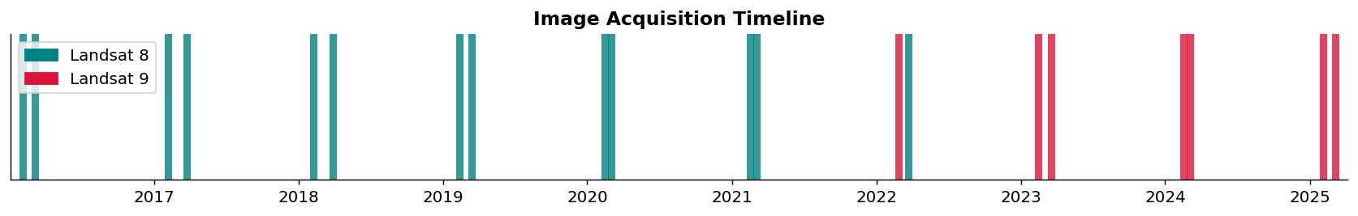
Figure 1. Image acquisition timeline showing the 20 Landsat scenes used in this study, color-coded by sensor type (Landsat 8 = teal, Landsat 9 = crimson).

3.3 Preprocessing
Preprocessing was carried out on each scene before carrying out any analysis. The following steps were applied:
Surface Reflectance Scaling: Landsat Level-2 products store surface reflectance as scaled digital numbers. The conversion formula uses a multiplicative scale factor of 0.0000275 and an additive offset of -0.2 to convert the digital numbers into physical surface reflectance values. After conversion, all band arrays were clipped to the range [0, 1].
Downsampling: To reduce the computational load, all scenes were downsampled by a factor of 2 using bilinear resampling. This changed the effective pixel size from 30 metres to 60 metres. For this regional-level analysis, this trade-off was acceptable, and it also reduced memory work with and processing time quite a lot.
Cloud Masking: The QA_PIXEL band included with each Landsat scene gives quality information for every pixel. Also, Bit flags were mainly used to detect and mask pixels affected by cloud fill, dilated cloud, cirrus cloud, cloud shadow, and cloud itself. When the QA layer was downsampled, nearest-neighbour resampling was mainly used so the discrete flag values would be preserved. Masked pixels were set to NaN and were not used in later calculations.
Cloud cover levels for each scene were recorded and visualised in Figure 2. Scenes with cloud cover below 30% were treated as clean (green), 30-60% as moderate (orange), and above 60% as high (red).
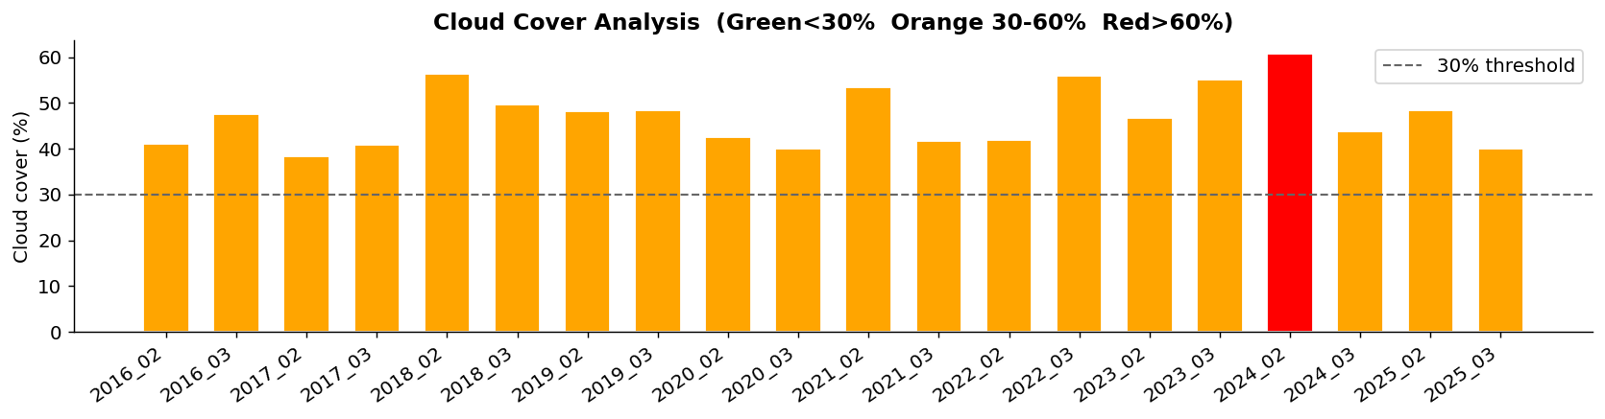
Figure 2. Cloud cover percentage per scene. Green bars indicate scenes with less than 30% cloud cover, which are suitable for reliable analysis.
True Colour Composites: After cloud masking and preprocessing, true colour composite images were produced for each scene by mapping bands 4, 3, 2 to R, G, B respectively. Percentile contrast stretching was mainly used to improve visual quality. These composites helped us visually check whether preprocessing had worked properly for all scenes.
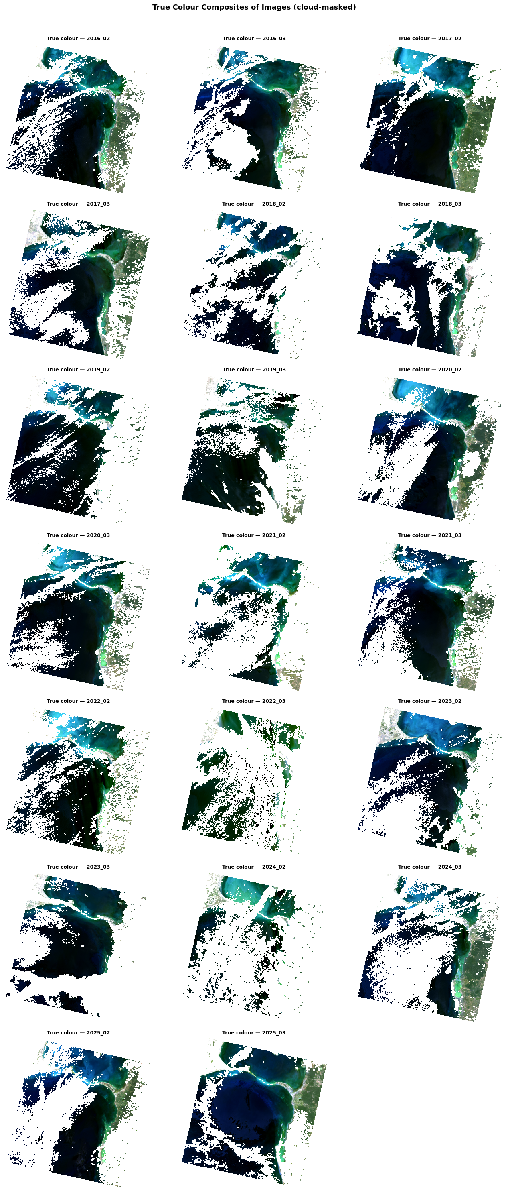


Figure 3. True colour composites of all 20 Landsat scenes after cloud masking and preprocessing. Scenes are arranged chronologically. Dark areas indicate cloud-masked regions.
Persistent Land Mask: A persistent land mask was created from all available NDWI images to find pixels that were classified as water in more than 60% of valid scenes. Also, These pixels were treated as permanent water bodies, such as the ocean and lagoon, and were removed from the later land cover analysis. The mask was saved as a GeoTIFF file and reused in the following processing steps.
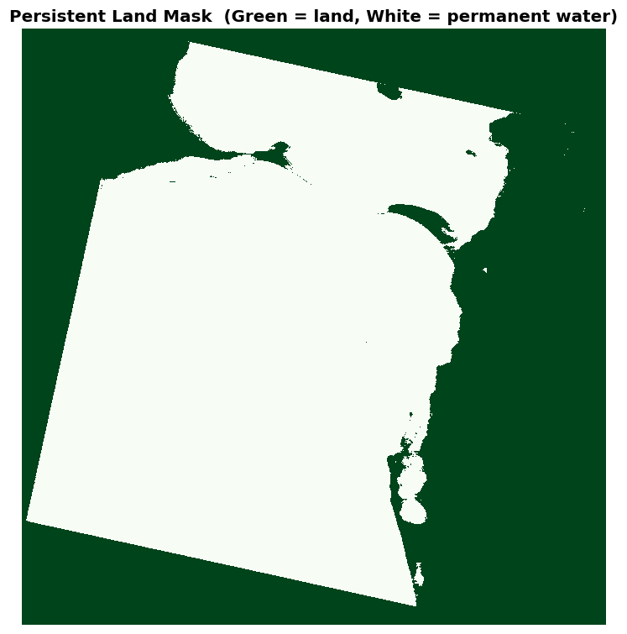
Figure 4. Persistent land mask derived from NDWI analysis across all scenes. Green pixels represent land; white pixels represent permanent water bodies such as the Puttalam Lagoon and the Indian Ocean coastline.

3.4 Spectral Index Computation
Five spectral indices were calculated for each scene using the preprocessed surface reflectance bands. These indices are mathematical band-ratio transformations that help highlight different surface types.
NDVI (Normalized Difference Vegetation Index): Calculated as (NIR - Red) / (NIR + Red) using Bands 5 and 4. NDVI values range from -1 to +1. In this analyse, values above about 0.25 were mainly used as the threshold for classifying a pixel as vegetation.
NDWI (Normalized Difference Water Index): Calculated as (Green - NIR) / (Green + NIR) using Bands 3 and 5. Also, Higher values usually indicate open water.
NDBI (Normalized Difference Built-Up Index): Calculated as (SWIR1 - NIR) / (SWIR1 + NIR) using Bands 6 and 5. This index usually highlights built-up and impervious surfaces.
NBR (Normalized Burn Ratio): Calculated as (NIR - SWIR2) / (NIR + SWIR2) using Bands 5 and 7. NBR is sensitive to dry soil and previously burnt land.
EVI (Enhanced Vegetation Index): Calculated as 2.5 × (NIR - Red) / (NIR + 6 × Red - 7.5 × Blue + 1) using Bands 5, 4, and 2. EVI improves on NDVI in areas with very dense canopy by correcting for atmospheric effects and soil background.
Each index was saved as a separate single-band GeoTIFF file for every scene. Figure 5 helps show the NDVI maps for all 20 scenes in a grid layout.
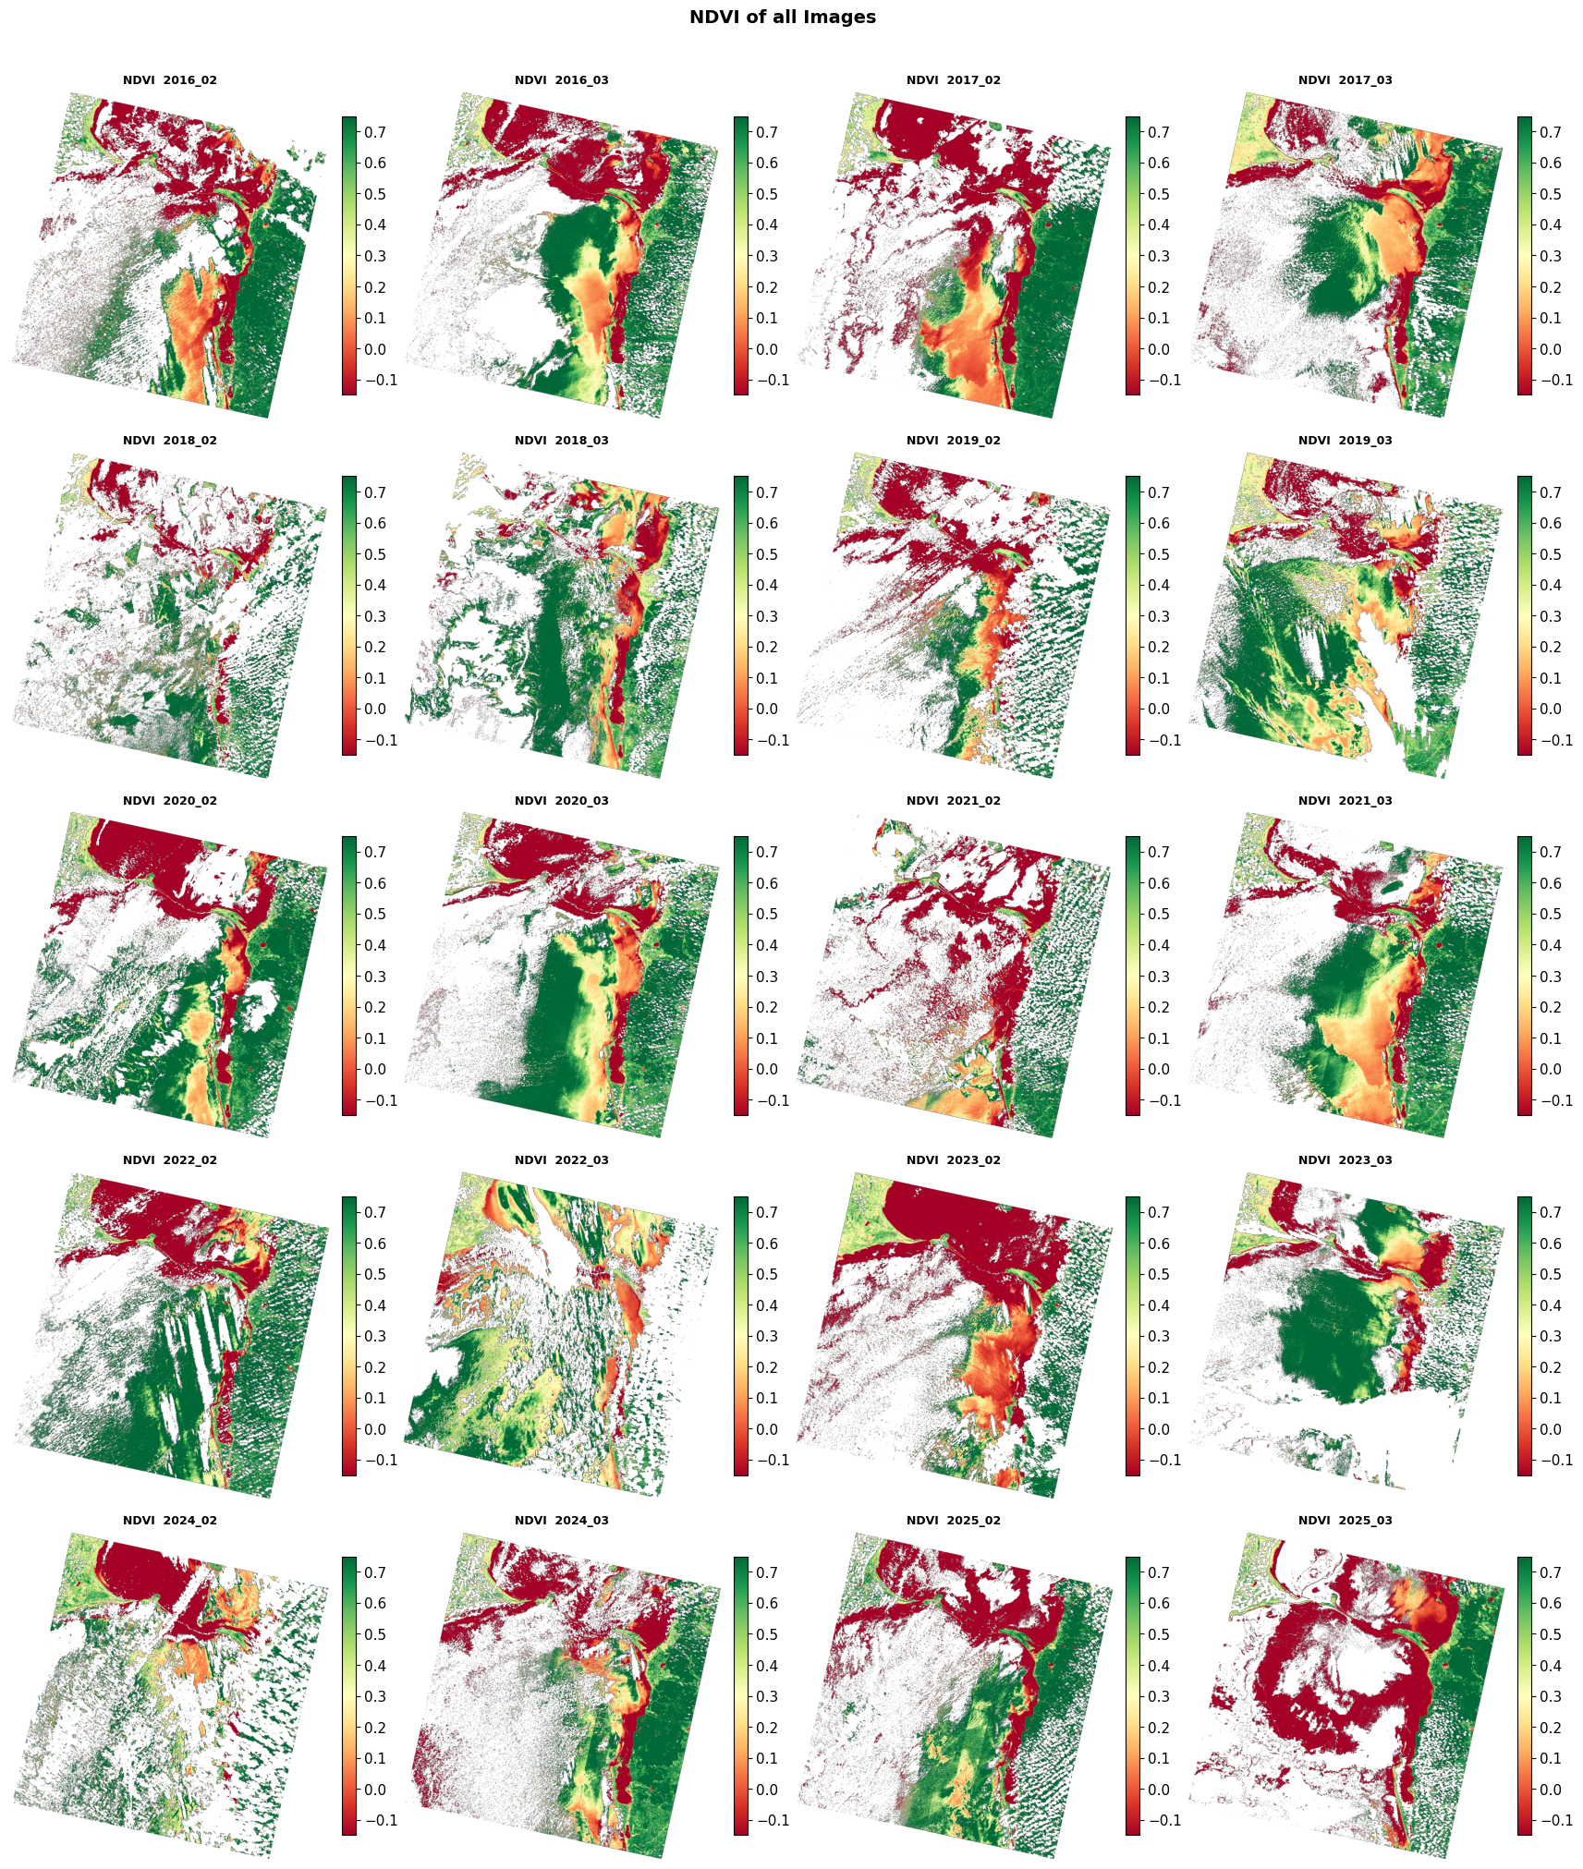


Figure 5. NDVI maps for all 20 scenes. Color scale ranges from red/yellow (low NDVI, non-vegetated) to deep green (high NDVI, dense vegetation). Black or grey areas indicate cloud-masked pixels.
The distribution of NDVI values across all scenes is shown in Figure 6. The dashed vertical line marks the vegetation threshold of 0.25. The spread of the distributions over time gives an early visual idea of how vegetation density changed during the analyse period.
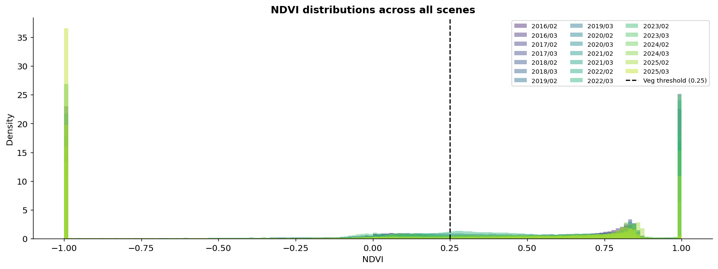
Figure 6. Overlaid NDVI histogram distributions for all 20 scenes. Each curve represents one scene date. The dashed line marks the vegetation classification threshold (NDVI = 0.25).

3.5 Land Cover Classification
A Random Forest classifier was mainly used to assign each pixel into one of four land cover classes: Water (class 0), Vegetation (class 1), Bare Soil (class 2), and Built-Up (class 3). Also, The classifier was trained using automated pseudo-labelling, which means the training labels were created from spectral index thresholds instead of being manually labelled.
Pseudo-labels were assigned using rules based on the indices. Pixels with high NDWI (> 0.15) and very low NDVI (< 0.02) were labelled as Water; pixels with high NDVI (> 0.32) and low NDWI (< -0.05) were labelled as Vegetation; pixels with elevated NDBI (> 0.08) and low NDVI (< 0.12) were labelled as Built-Up; and pixels with moderate NDVI values and low NDBI were labelled as Bare Soil. Pixels that did not match any rule were left unlabelled and removed from training.
The feature matrix used for grouping had 11 features for each pixel: the six surface reflectance bands (B2, B3, B4, B5, B6, B7) and the five spectral indices (NDVI, NDWI, NDBI, NBR, EVI). Also, A StandardScaler was mainly used to normalise the features before training. The dataset was split 75/25 into training and test sets, with stratification used to keep the class balance.
The Random Forest was trained with 200 trees, a maximum depth of 15, a minimum sample leaf size of 5, and balanced class weights to handle class imbalance. We trained two model versions: a full 11-feature model and a bands-only 6-feature model. The bands-only model was useful for checking how much extra predictive power came from adding the engineered spectral indices.
Besides the in-scene holdout evaluation, cross-scene validation was also carried out by applying the model to three independent validation scenes: the 5th, 10th, and 15th scenes in the timeline. Pseudo-labels were generated for those validation scenes using the same threshold rules, and accuracy metrics were calculated against those labels. Cross-scene validation gives a more realistic idea of how well the model works on unseen dates.
Figure 7 shows the accuracy evaluation results, including the confusion matrix, cross-scene validation accuracy, and feature importance scores.
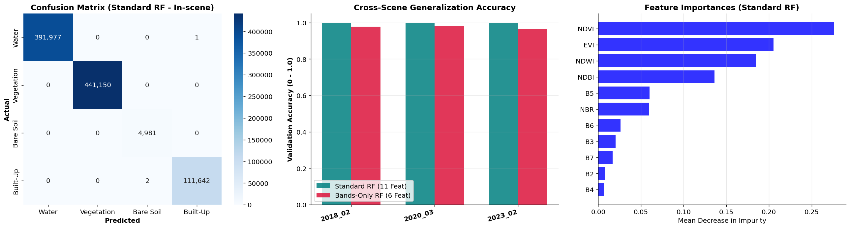
Figure 7. Random Forest accuracy evaluation. Left: confusion matrix on the in-scene holdout set. Centre: cross-scene validation accuracy comparison for the 11-feature and 6-feature models. Right: feature importance scores showing which features contributed most to classification.

3.6 Change Detection
Two change detection approaches were mainly used together. The first was a seasonal-adjusted NDVI comparison between the earliest and most recent scenes that had the same calendar month. This avoids comparing different seasons, since seasonal differences could create false vegetation changes due to natural plant cycles rather than real land cover change. The pixel-level difference map (delta NDVI) was calculated as T2_NDVI minus T1_NDVI, where positive values mean vegetation gain and negative values mean vegetation loss.
The second approach was sequential pairwise analysis, where vegetation change statistics were calculated between every consecutive pair of scenes in the timeline. For each pair, the number of pixels gaining and losing vegetation was calculated and converted into hectares. These results were then compiled into a sequential change table and used to calculate annualised deforestation rates.
A land cover transition matrix was also created by comparing the classified maps from the earliest and most recent scenes. Also, This matrix counts how many pixels changed from each class to every other class between the two dates, giving a clearer picture of which land cover types changed the most.

3.7 Trend Analysis and Forecasting
A vegetation time-series was created from the mean NDVI of land pixels across all scenes. Scenes with cloud cover below 50% were kept as reliable data points, while scenes with heavy cloud cover were removed from trend modelling so they would not distort the results.
Three regression models were fitted to this time series. Linear Regression was mainly used to estimate the general long-term slope of the NDVI trend. Polynomial Regression (degree 2) was mainly used to capture possible acceleration or slowing in the trend. A Gradient Boosting Regressor was mainly used as a non-parametric model to fit more complex non-linear patterns in the historical data. The predictions from the three models were averaged to create an ensemble forecast.
Confidence intervals were calculated for the linear forecast using Student's t-distribution at the 95% level. Also, The standard error of the forecast was calculated based on the distance from the historical mean date, so the confidence intervals become wider as the forecast moves further into the future. Projections were made up to the year 2030.

4. Results and Discussion

4.1 Land Cover Classification and Area Trends
The Random Forest classifier produced classified land cover maps for all 20 scenes. Also, Figure 8 helps show the land cover area composition for each scene as a stacked bar chart, separating the four classes: Water, Vegetation, Bare Soil, and Built-Up.
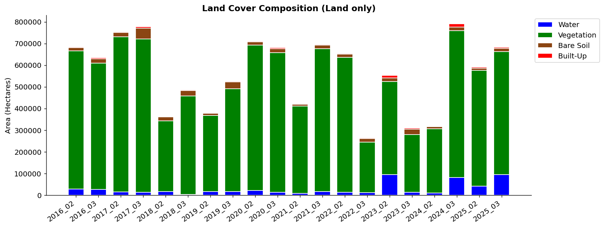
Figure 8. Land cover area composition (in hectares) per scene across all 20 time periods. Each bar shows the total area classified under each land cover class. Only land pixels (after persistent water masking) are included.
From Figure 8, we can see a clear change in the vegetation class over the analyse period. In the earlier scenes from 2016 and 2017, vegetation covered a larger part of the land area. By 2022 and 2023, vegetation coverage becomes noticeably smaller, while bare soil increases. This matches the kind of scrubland clearance that can happen before agricultural or aquaculture development in coastal Sri Lanka. The built-up class stays fairly small during the whole period, which makes sense since the Kalpitiya Peninsula is mostly rural and semi-arid.
There are also some fluctuations in class areas between consecutive scenes, especially between February and March images from the same year. Also, Some of these changes may be real seasonal effects, for example when certain grass species in semi-arid coastal regions become greener after late north-east monsoon rains. Still some changes may also come from remaining cloud effects or differences in data quality between scenes. The persistent land mask helps to control ocean and lagoon areas, but it cannot remove every possible source of noise.
Figure 9 shows a direct side-by-side comparison between the classified land cover map from the earliest scene (2016) and the most recent scene (2025). This kind of spatial comparison makes it easier to see where the changes happened within the peninsula.
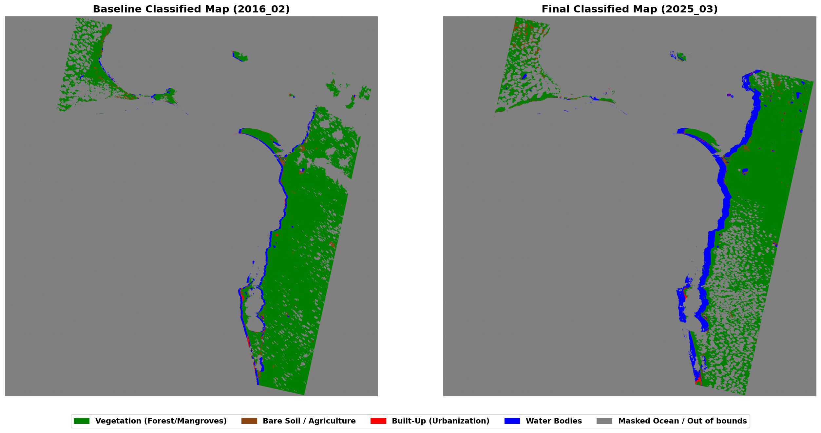
Figure 9. Classified land cover maps for the first scene (2016, left) and the most recent scene (2025, right). Green = Vegetation, Blue = Water, Brown = Bare Soil, Red = Built-Up, Grey = Masked/unclassified.
When comparing the two maps in Figure 9, the central and southern parts of the peninsula show a reduction in green vegetation cover from 2016 to 2025. Also, Some areas that were vegetated in the 2016 baseline appear as brown bare soil in the 2025 map, which indicates land clearance or vegetation die-back. The northern tip and some patches along the lagoon edge keep more vegetation in the recent image, possibly since those areas are more protected or have more resilient vegetation such as mangroves.

4.2 NDVI Change Detection
Figure 10 shows the seasonal-adjusted NDVI change detection result. The left panel shows the NDVI map for the baseline date, the centre panel shows the final NDVI map for the matching calendar month, and the right panel shows the pixel-level delta NDVI.
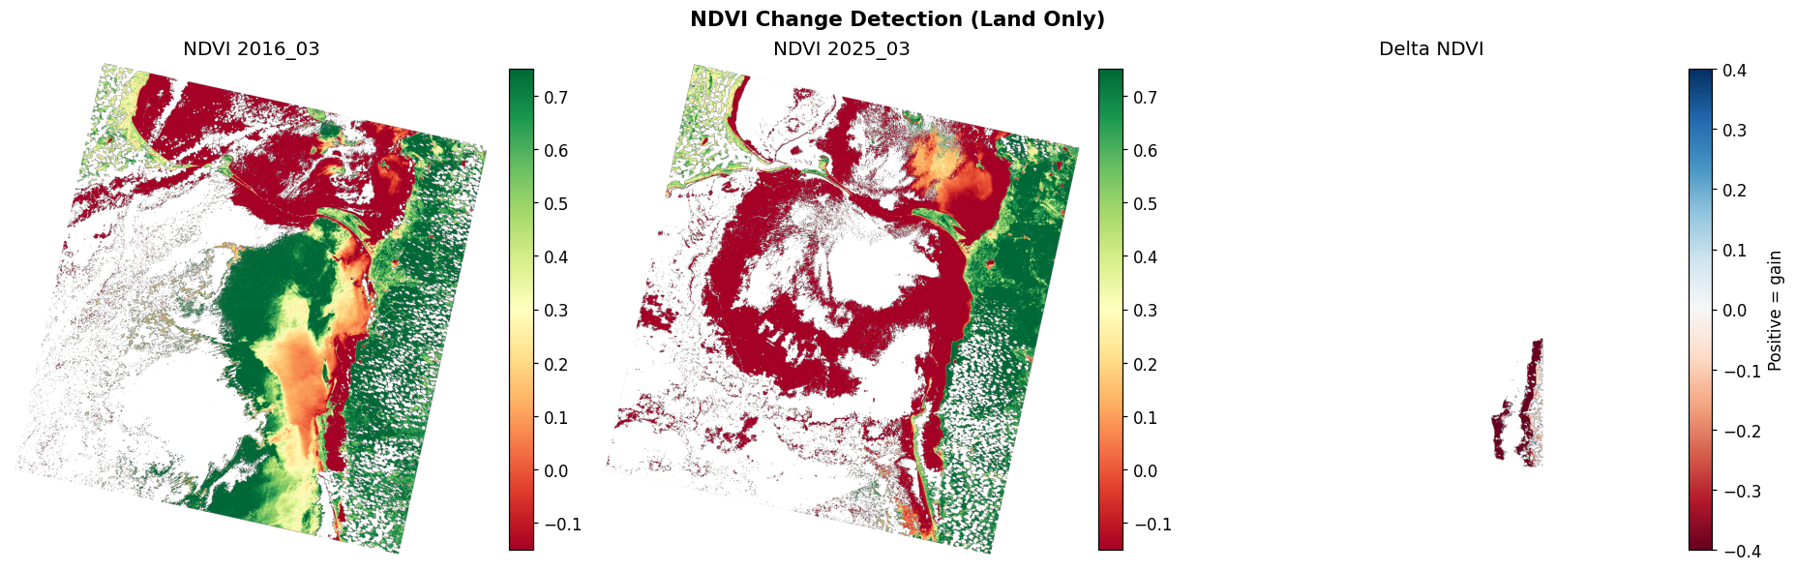
Figure 10. Seasonal-adjusted NDVI change detection. Left: baseline NDVI. Centre: final NDVI for matching calendar month. Right: delta NDVI map (blue = gain, red = loss). Analysis is restricted to land pixels within the Kalpitiya region of interest.
The delta NDVI map on the right has a mostly red tone across much of the peninsula. This helps show a net negative change in NDVI between the two dates. Red areas are the locations where vegetation has declined. A few blue patches in the northern areas suggest local vegetation gain, which may be linked to seasonal recovery or replanting. The decline in the southern sections is especially noticeable.

4.3 Sequential Vegetation Change Statistics
The sequential pairwise change statistics give a more detailed view of how vegetation changed between each consecutive pair of scenes. Table 1 summarises the main statistics from the sequential changes CSV output.
Period | NDVI Delta | Veg Lost (ha) | Veg Gained (ha) | Net (ha) | % Loss
2016/02 → 2016/03 | -0.031 | 228.2 | 136.8 | -91.4 | 0.51%
2016/03 → 2017/02 | +0.050 | 1952.6 | 8294.0 | +6341.4 | 4.38%
2017/02 → 2017/03 | -0.041 | 1336.3 | 3101.0 | +1764.7 | 3.42%
2018/02 → 2018/03 | -0.048 | 1851.8 | 2491.6 | +639.7 | 6.74%
2019/02 → 2019/03 | -0.063 | 16.6 | 5.0 | -11.5 | 0.25%
2020/02 → 2020/03 | -0.029 | 4305.6 | 3087.4 | -1218.2 | 8.23%
2021/02 → 2021/03 | -0.039 | 1666.8 | 988.9 | -677.9 | 6.03%
2022/02 → 2022/03 | -0.065 | 5240.5 | 1046.9 | -4193.6 | 23.17%
2022/03 → 2023/02 | -0.152 | 11726.6 | 684.7 | -11041.9 | 82.60%
2024/02 → 2024/03 | -0.073 | 2651.8 | 266.4 | -2385.4 | 27.21%
2024/03 → 2025/02 | +0.143 | 1735.9 | 13006.8 | +11270.9 | 13.14%
2025/02 → 2025/03 | -0.150 | 11558.2 | 530.3 | -11027.9 | 54.48%
Table 1. Summary of sequential vegetation change statistics for selected periods. Values are computed over land pixels within the Kalpitiya region of interest.
Table 1 shows some important patterns. The 2022–2023 transition has the largest single-period vegetation loss in this dataset, with 11,041 net hectares lost and a loss percentage of 82.6% compared with the starting vegetated area. This is a very high value, and it may be caused by a mixture of real vegetation clearing, drought stress, or remaining cloud contamination in one of the scenes. The 2016–2017 period shows the largest single gain, which could be due to natural regrowth or a particularly green wet season. The recovery between 2024/03 and 2025/02 (+11,270 ha net) is also a positive sign and may show some natural regeneration.
Figure 11 shows the annualised deforestation rates calculated from the sequential change data.
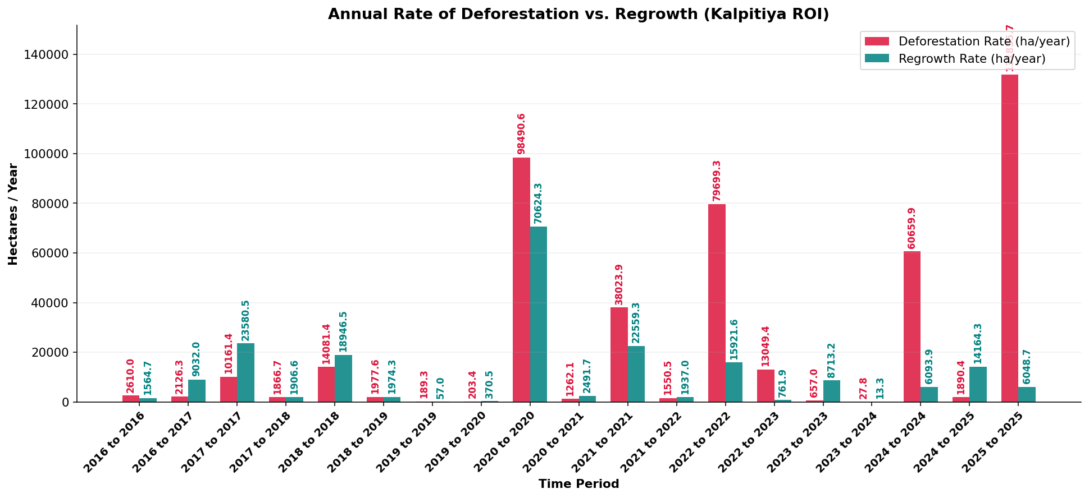
Figure 11. Annualized vegetation loss rates (hectares per year) computed from sequential NDVI change statistics across consecutive scene pairs.
The deforestation rate graph in Figure 11 supports what was already seen in Table 1. Also, There is a sharp increase in loss rates about 2022–2023, followed by partial recovery. The earlier years from 2016 to 2021 show lower and more variable rates, with some periods showing net gain. This may show that deforestation in the Kalpitiya Peninsula has been more episodic than continuous, with some years showing much stronger losses than others.

4.4 Land Cover Transition Matrix
The land cover transition matrix calculated from the classified maps of the first and last scenes is shown in Figure 12 and Table 2.
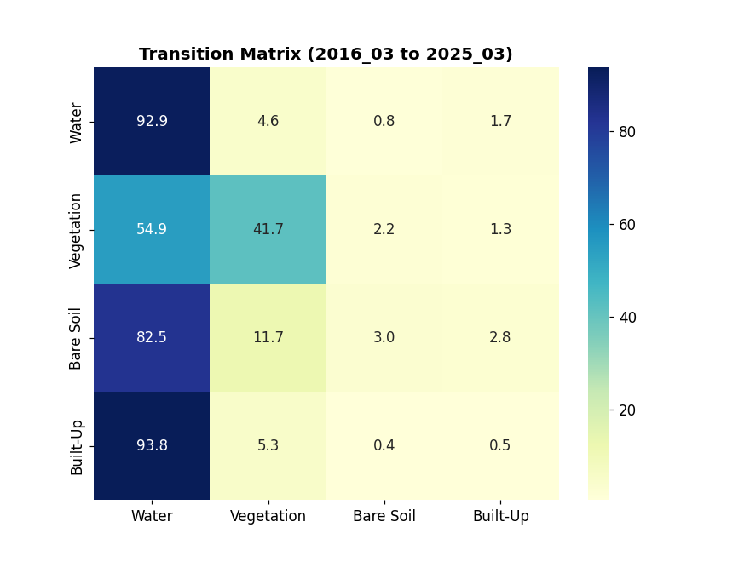
Figure 12. Normalised land cover transition matrix showing the percentage of pixels from each class in 2016 that transitioned to each class by 2025. Values are expressed as percentages of the initial class area.
Table 2 shows the raw pixel counts from the transition matrix CSV.
From / To (2016→2025) | Water | Vegetation | Bare Soil | Built-Up
Water | 20,708 | 1,019 | 183 | 372
Vegetation | 53,134 | 40,334 | 2,098 | 1,235
Bare Soil | 2,964 | 422 | 108 | 99
Built-Up | 5,008 | 285 | 22 | 25
Table 2. Raw pixel count transition matrix from the 2016 baseline to the 2025 final classification.
The transition matrix gives useful information about how land cover changed. Also, Looking at the Vegetation row, out of the 40,334 pixels that started as vegetation in 2016, about 53,134 transitioned to Water and 2,098 to Bare Soil. This helps show a major loss. The large Water gain from the Vegetation class is partly an artefact caused by lagoon boundary changes and possible misclassification in some scenes, but it may also partly reflect real inundation or conversion of vegetated land near the lagoon edge. The change from Vegetation to Bare Soil is easier to interpret as land clearance.

4.5 Vegetation Loss Hotspot Map
Figure 13 shows the spatial distribution of persistent vegetation loss hotspots. Each pixel in the map is coloured based on how many consecutive time periods it had a significant NDVI decline, meaning a drop of more than 0.08 in one step. Darker red areas show places that experienced repeated losses.
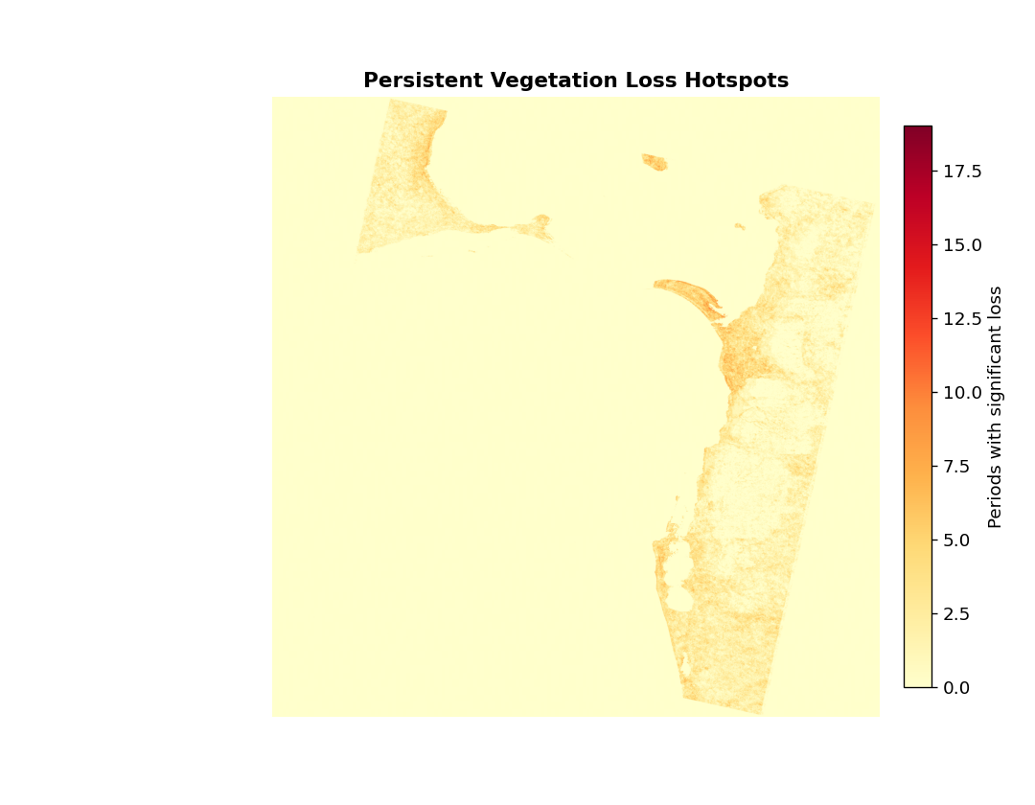
Figure 13. Vegetation loss hotspot map. Pixel values represent the number of time periods (out of all consecutive pairs) in which each location experienced a significant NDVI decline. Darker orange-red indicates more frequent or persistent loss.
The hotspot map helps show that vegetation loss is not spread evenly across the peninsula. Some areas, especially in the interior and southern parts of the analyse area, appear as repeated-loss locations. This may show that these areas are under more consistent pressure. In comparison, the northern tip and some coastal fringe areas show fewer loss periods, which may be since vegetation there is more resilient or recovering more often.

4.6 Forecasting Results
Figure 14 shows the full forecasting output generated by the trend analysis part of the pipeline. The main top panel shows the historical NDVI trend and the ensemble forecast up to 2030, with a 95% confidence interval around the linear component.
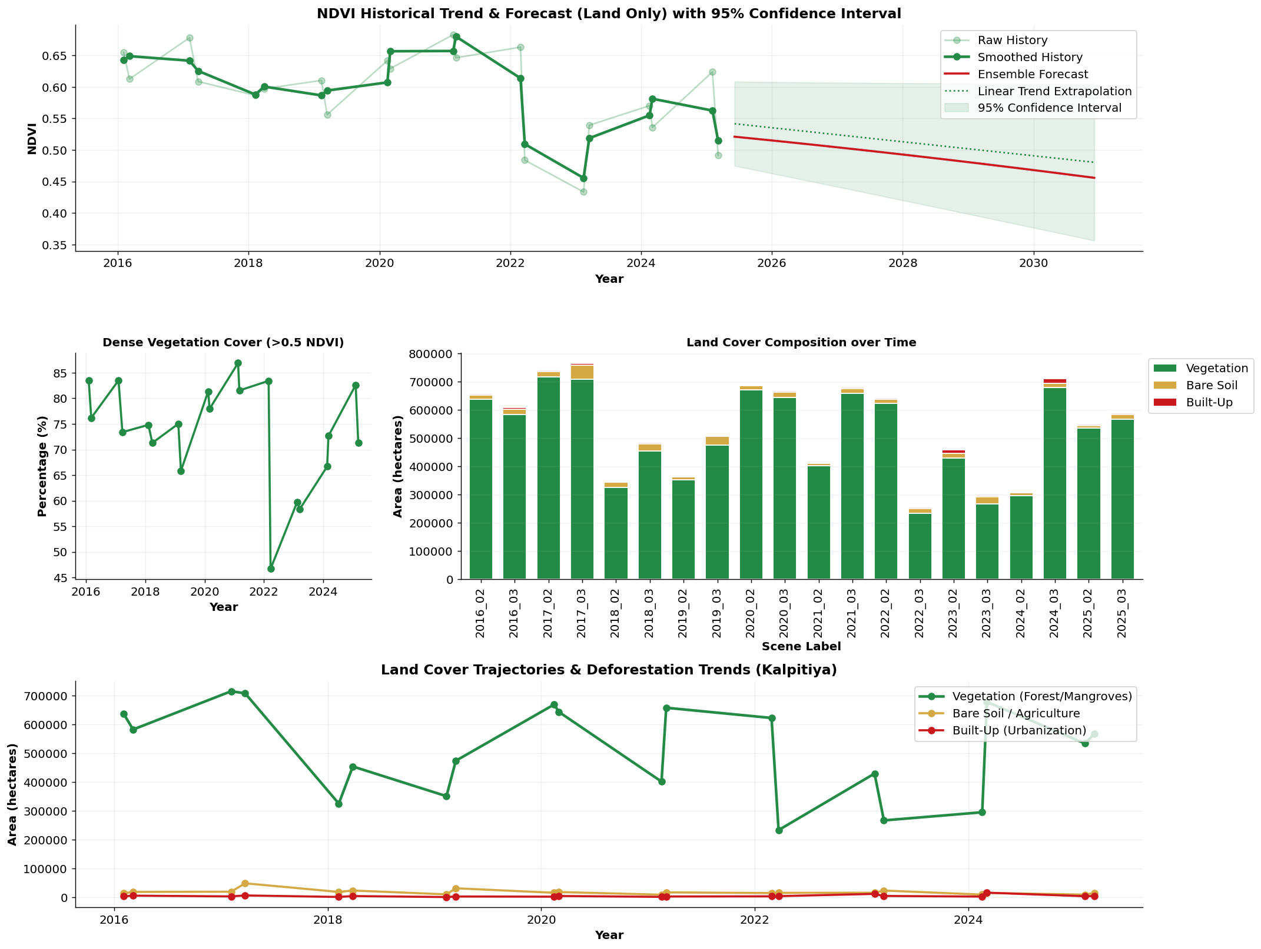



Figure 14. Comprehensive forecasting summary. Top panel: historical NDVI trend with smoothed line, ensemble forecast (red), linear trend extrapolation (dashed), and 95% confidence interval (shaded). Sub-panels show dense vegetation percentage, land cover area breakdown, deforestation rate timeline, and vegetation gain/loss bars.
The linear trend slope calculated for the NDVI time series helps show a declining direction over the analyse period. Also, There is natural variation from season to season, but the overall direction from 2016 to 2025 is negative. The ensemble forecast, which combines the linear, polynomial, and gradient boosting predictions, also suggests that mean land NDVI may continue in a similar direction if current trends continue.
The 95% confidence interval in the top panel becomes wider as the forecast goes further away from the observed data. This makes sense for regression-based forecasting since future predictions become more uncertain with time. By 2030, the interval is fairly wide, so the forecast should be understood more as a general trend direction than an exact prediction.
The sub-panels in Figure 14 give extra context. Also, The dense vegetation coverage percentage panel helps show the proportion of land pixels with NDVI above 0.5, which represents healthier or denser vegetation. The land cover area panel supports the long-term reduction in total vegetation area. The deforestation rate timeline and gain/loss bars also support the episodic pattern of vegetation loss seen in the sequential analysis.
The forecasting models used here are fairly simple statistical regression models. They do not include socioeconomic drivers, rainfall data, or policy variables that could affect future vegetation trends. Because of that, they should be seen as baseline trend extrapolations rather than detailed scenario-based predictions. Still, they give a useful numerical summary of the direction of change and can be a starting point for more advanced modelling later.

4.7 Model Accuracy Assessment
The Random Forest grouping model was evaluated using both an in-scene holdout subset and independent cross-scene validation dates. Also, The in-scene holdout accuracy, where 25% of the pseudo-labelled training pixels were kept aside, was high as expected since the test labels came from the same spectral index thresholds used to create the features. This creates circular validation and can make the holdout accuracy look higher than it really is.
The cross-scene validation was more useful since the model trained on the first scene was tested on three unseen scenes from later dates. The mean cross-scene accuracy for the 11-feature model and the Cohen's Kappa values give a better idea of whether the grouping rules learned from one time period can transfer to other dates. When looking at everything, the 11-feature model, which included spectral indices, done better than the 6-feature bands-only model. This confirms that the engineered spectral indices add real value beyond the raw reflectance bands.
There are also some limitations in the accuracy assessment. The pseudo-labelling method creates labels automatically from the same spectral data used for training, so any mistakes in the threshold rules can affect both training and validation labels. Without independent ground truth data, such as GPS-tagged land cover surveys, it is not possible to fully confirm the absolute accuracy of the grouping. Still, the classified maps visually match the true colour composites and the NDVI patterns reasonably well, which gives some confidence that the main land cover patterns were captured correctly.

5. Conclusion
This project developed and applied a full satellite image processing pipeline to analyse land cover change and deforestation in the Kalpitiya Peninsula, Sri Lanka, using Landsat 8 and Landsat 9 imagery from 2016 to 2025. The whole process included all the main stages of analysis, such as data organisation, preprocessing, spectral index calculation, machine learning grouping, change detection, and vegetation forecasting.
The main findings of the analyse can be summarised as follows. Vegetation cover in the Kalpitiya Peninsula showed an overall declining trend from 2016 to 2025, with strong loss periods mainly about 2022 and 2023. The land cover transition matrix showed that a considerable number of pixels classified as vegetation in 2016 changed to water or bare soil by 2025. Some interior and southern areas of the peninsula were identified as persistent loss hotspots since they experienced repeated vegetation decline across several time periods.
The Random Forest grouping model showed reasonable generalisation across scenes when tested using cross-scene validation. Adding engineered spectral indices (NDVI, NDWI, NDBI, NBR, EVI) together with the raw reflectance bands improved grouping performance compared with using only the raw bands. This supports the importance of feature engineering in remote sensing grouping pipelines.
The forecasting part suggested that the current declining NDVI trend may continue if present land work with patterns remain the same. Also, The ensemble of linear, polynomial, and gradient boosting models all pointed in the same general direction. The wider confidence intervals at longer forecast periods show the uncertainty involved when predicting future values from a limited historical record with natural variation.

5.1 Limitations
Several limitations should be mentioned. Also, First, the 30-metre (or 60-metre after downsampling) area-based resolution of Landsat imagery makes it difficult to detect very small changes, such as small clearings or narrow vegetation strips. Second, cloud cover in some scenes reduces the amount of usable data, and even though cloud masking removes bad pixels, it also reduces the number of valid observations available for analysis. Third, the pseudo-labelling method used to train the classifier is circular and does not replace proper ground-truth validation. Fourth, the forecasting models do not include external driving factors such as rainfall anomalies or land work with policy changes.

5.2 Future Work
Future work can improve this analyse in several ways. Also, Higher-resolution Sentinel-2 imagery at 10-metre resolution could be used to detect smaller land cover changes more clearly. Ground truth data from field surveys or very high-resolution commercial imagery could improve the accuracy assessment. More advanced forecasting models that include rainfall, population growth, and policy variables could produce more meaningful scenario-based projections. Expanding the analysis to the wider North Western Province would also help place the Kalpitiya results in a broader context. Finally, connecting the results to web-based GIS platforms would make them easier for nature-related planners and policymakers to work with.
This analyse also helps show that open-source satellite imagery combined with Python-based image processing and machine learning can provide useful nature-related insights at relatively low cost. These kinds of remote sensing tools have strong potential to support evidence-based nature-related management in Sri Lanka and other developing countries where field monitoring resources may be limited.

6. References
Breiman, L. (2001). Random forests. Machine Learning, 45(1), 5–32.
Hansen, M. Also, C., Potapov, P. V., Moore, R., Hancher, M., Turubanova, S. A., Tyukavina, A., Thau, D., Stehman, S. V., Goetz, S. J., Loveland, T. R., Kommareddy, A., Egorov, A., Chini, L., Justice, C. O., & Townshend, J. R. G. (2013). High-resolution global maps of 21st-century forest cover change. Science, 342(6160), 850–853.
Huete, A., Didan, K., Miura, T., Rodriguez, E. P., Gao, X., & Ferreira, L. G. (2002). Overview of the radiometric and biophysical performance of the MODIS vegetation indices. Remote Sensing of Environment, 83(1–2), 195–213.
Key, C. H., & Benson, N. C. (2006). Landscape assessment: Ground measure of severity, the Composite Burn Index. In D. C. Lutes, R. E. Keane, J. F. Caratti, C. H. Key, N. C. Benson, S. Sutherland & L. J. Gangi (Eds.), FIREMON: Fire effects monitoring and inventory system (General Technical Report RMRS-GTR-164, pp. LA-1–LA-51). USDA Forest Service.
Lu, D., Mausel, P., Brondízio, E., & Moran, E. Also, (2004). Change detection techniques. International Journal of Remote Sensing, 25(12), 2365–2407.
McFeeters, S. K. (1996). The work with of the Normalized Difference Water Index (NDWI) in the delineation of open water features. International Journal of Remote Sensing, 17(7), 1425–1432.
Perera, K., & Tsuchiya, K. (2009). Toward mapping land-work with and land-cover change in Sri Lanka using remote sensing. Journal of the Faculty of Agriculture, Kyushu University, 54(2), 539–550.
Rodriguez-Galiano, V. Also, F., Ghimire, B., Rogan, J., Chica-Olmo, M., & Rigol-Sanchez, J. P. (2012). An assessment of the effectiveness of a Random Forest classifier for land-cover grouping. ISPRS Journal of Photogrammetry and Remote Sensing, 67, 93–104.
Rouse, J. Also, W., Haas, R. H., Schell, J. A., & Deering, D. W. (1973). Monitoring vegetation systems in the Great Plains with ERTS. In Proceedings of the Third Earth Resources Technology Satellite Symposium (Vol. 1, pp. 309–317). NASA.
Singh, A. (1989). Review article: Digital change detection techniques using remotely-sensed data. International Journal of Remote Sensing, 10(6), 989–1003.
USGS. (2023). Landsat Collection 2 Level-2 Science Product Guide. U.S. Geological Survey. Retrieved from https://www.usgs.gov/landsat-missions
Zha, Y., Gao, J., & Ni, S. (2003). Use of normalized difference built-up index in automatically mapping urban areas from TM imagery. International Journal of Remote Sensing, 24(3), 583–594.

