A Project Report on
“Analysis of Online Financial Frauds in India: Trends, Causes and Cyber security Measures”
Submitted to

Osmania University, Hyderabad-500007
in partial fulfilment of the requirements
for the award of the degree of

Bachelor of Business Administration (FINANCE)
Submitted By
MOHIT PRASAD MISHRA

2085-23-684-172

Under the Guidance of
Mrs. MANASA DEVI
ASSOCIATE PROFESSOR

Department of Management
Avinash College of Commerce, Kukatpally
Hyderabad -500072


2023 - 2026

A Project Report on
“Analysis of Online Financial Frauds in India: Trends, Causes and Cyber security Measures”
Submitted to

Osmania University, Hyderabad-500007
in partial fulfilment of the requirements
for the award of the degree of

Bachelor of Business Administration (FINANCE)
Submitted By
MOHIT PRASAD MISHRA

2085-23-684-172

Under the Guidance of
Mrs. MANASA DEVI
ASSOCIATE PROFESSOR

Department of Management
Avinash College of Commerce, Kukatpally
Hyderabad -500072


2023 - 2026

INTERNAL GUIDE EXTERNAL EXAMINER

CERTIFICATE

________________________________________________________
Avinash College of Commerce
ACC Towers, Plot No. 21, 22, 53 & 54 Ushamullapudi Road, Behind South India Shopping Mall, A.S. Raju Nagar, Kukatpally Housing Board Colony, Kukatpally, Hyderabad.

Date:
CERTIFICATE
This is to certify that the project entitled “Analysis of Online Financial Frauds in India: Trends, Causes and Cyber security Measures” submitted to Osmania University, in partial fulfilment of the requirements for the award of the degree of Bachelor of Business Administration (FINANCE) is a bonafide record of original project work done by Mohit Prasad Mishra Reg. No. 208523684172 during the period of December-2025 to April-2026 in the Department of Management, Avinash College of Commerce, Kukatpally, Hyderabad- 500072.

External Examiner Internal Guide Head of the Department Principal

CERTIFICATE

This is to certify that the project entitled Analysis of Online Financial Frauds in India: Trends, Causes and Cyber security Measures submitted to Osmania University, in partial fulfilment of the requirements for the award of the degree of Bachelor of Business Administration (BBA/ BBA-Business Analytics), is a bonafide record of original project work done by Mohit Prasad Mishra , Reg. No. 208523684172, during the period of December-2025 to April-2026 in the Department of Management, Avinash College of Commerce, Kukatpally, Hyderabad-500072. Under my supervision and guidance, the project has not previously formed the basis for the award of any Degree, Diploma, Associate ship, fellowship, or other similar title to any other candidate of any University. The project represents entirely an independent work of the candidate.

Name of the Internal Guide Signature of the Internal Guide

DECLARATION

I, Mohit Prasad Mishra hereby declare that this project report titled Analysis of Online Financial Frauds in India: Trends, Causes and Cyber security Measures Submitted to Osmania University, in partial fulfilment of the requirements for the award of the degree of Bachelor of Business Administration (BBA/ BBA-Business Analytics) is a bonafide record of original project work done by me during the period of December 2025 to April 2026 under the supervision and guidance of Mrs. MANASA DEVI and it has not formed the basis for the award of any Degree, Diploma, Associateship, Fellowship or other similar title to any other candidate of any University.

Signature of the Student

ACKNOWLEDGEMENT

ACKNOWLEDGEMENT

This project is the end of my journey in obtaining my Management degree. At the end of my project, it is a pleasant task to express my thanks to all those who contributed in many ways to the success of this study and made it an unforgettable experience for me.
I sincerely record my thanks to Dr. AVINASH BRAHMADEVARA, the Chairman of Avinash Group of Institutions, and other members of the management committee for encouraging me to take up this UG program in this reputed Institution.
I am grateful to our Principal, Ms. M. V. PHANIMALA for providing us the opportunity and platform to work on the project and providing all the necessary facilities for the successful completion of this work.
I express my humble gratitude to Head of the Department for guiding, supporting, and inspiring me during my project work.
I am happy to express my gratitude to my project guide “Mrs. MANASA DEVI”, parents, friends, respondents and the almighty.

Mohit Prasad Mishra

CONTENTS

CONTENTS

Certificate | i- ii
Declaration | iii
Acknowledgement | iv
Contents | v
List of Tables | vi
List of Figures | vii

Chapter | Title | Page No.
I | INTRODUCTION | 1-6
II | REVIEW OF LITERATURE | 7-13
III | CONCEPTUAL STUDY/  INDUSTRY PROFILE AND COMPANY PROFILE | 14-20
IV | DATA ANALYSIS AND INTERPRETATION | 21-40
V | FINDINGS, SUGGESTIONS AND CONCLUSION
 | BIBLIOGRAPHY
 | APPENDIX

LIST OF TABLES

LIST OF TABLES
Table No. | Title | Page No.
1 | Name | 21
2 | What is your age group? | 21
3 | What is your gender? | 22
4 | What is your current occupation? | 23
5 | How frequently do you use digital financial services (such as UPI, mobile banking, or online banking)? | 24
6 | Which of the following digital payment methods do you use most frequently? | 25
7 | For what purposes do you usually use digital payment services? | 26
8 | Are you aware of common types of online financial fraud such as phishing, OTP scams, and fake payment links? | 27
9 | Through which source did you first learn about online financial fraud? | 28
10 | Do you know that sharing sensitive information such as OTP, PIN, or banking details can lead to financial fraud? | 29
11 | Have you ever been a victim of online financial fraud? | 30
12 | If yes, what type of fraud did you experience? | 31
13 | Did you report the incident to your bank or the appropriate authorities? | 32
14 | Do you regularly update your banking applications and mobile device security settings? | 33
15 | Do you use strong and unique passwords for your digital banking accounts? | 34
16 | Before making online payments, do you verify the authenticity of the website or application? | 35
17 | Do you believe financial institutions provide sufficient awareness programs about online financial fraud prevention? | 36
18 | In your opinion, how effective are current cybersecurity measures in preventing online financial fraud? | 37
19 | What do you think is the primary cause of online financial fraud in India? | 38
20 | Which of the following measures do you think would most effectively reduce online financial fraud in India? | 39

LIST OF FIGURES

LIST OF FIGURES
Figure No. | Title | Page No.
1 | Name | 21
2 | What is your age group? | 21
3 | What is your gender? | 22
4 | What is your current occupation? | 23
5 | How frequently do you use digital financial services (such as UPI, mobile banking, or online banking)? | 24
6 | Which of the following digital payment methods do you use most frequently? | 25
7 | For what purposes do you usually use digital payment services? | 26
8 | Are you aware of common types of online financial fraud such as phishing, OTP scams, and fake payment links? | 27
9 | Through which source did you first learn about online financial fraud? | 28
10 | Do you know that sharing sensitive information such as OTP, PIN, or banking details can lead to financial fraud? | 29
11 | Have you ever been a victim of online financial fraud? | 30
12 | If yes, what type of fraud did you experience? | 31
13 | Did you report the incident to your bank or the appropriate authorities? | 32
14 | Do you regularly update your banking applications and mobile device security settings? | 33
15 | Do you use strong and unique passwords for your digital banking accounts? | 34
16 | Before making online payments, do you verify the authenticity of the website or application? | 35
17 | Do you believe financial institutions provide sufficient awareness programs about online financial fraud prevention? | 36
18 | In your opinion, how effective are current cybersecurity measures in preventing online financial fraud? | 37
19 | What do you think is the primary cause of online financial fraud in India? | 38
20 | Which of the following measures do you think would most effectively reduce online financial fraud in India? | 39

ABSTRACT
India's shift toward digital financial services has been one of the more striking economic developments of the past decade. Online banking, mobile wallets, and UPI have become routine parts of daily life for a growing number of people — transactions that once required a branch visit now happen in seconds from a phone. That convenience is real and valuable. But the same expansion that has brought more people into the digital economy has also handed cybercriminals a much larger playing field. Phishing messages, fake websites, OTP scams, identity theft, social engineering — fraudsters have found no shortage of ways to exploit users and extract financial details. For individuals, banks, and regulators alike, online financial fraud has become something that can no longer be treated as a peripheral concern.
This study examines online financial fraud in India — how it has developed, what's driving it, and how effectively current cybersecurity measures are responding to it. Several factors come into the picture: gaps in technology, the uneven level of security awareness among users, risky digital habits, and the way fraud techniques keep adapting to outpace defenses. The study also draws on existing research and public reports to understand the relationship between India's rapid digital financial growth and the cyber risks that have come with it.
Part of the focus falls on the tools that modern cybersecurity brings to fraud detection — AI, machine learning, and real-time transaction monitoring among them — and how well these are being put to use. Alongside that, the study looks at digital literacy as a front-line defense: users who can recognize a fraud attempt are harder to deceive, regardless of what technical systems are in place. Stronger policy frameworks and better coordination between banks, financial institutions, and government bodies are also part of the picture. The broader argument running through the research is a straightforward one: digital financial services have delivered genuine benefits, but sustaining those benefits requires security infrastructure and public awareness that are genuinely keeping pace with the threats.

Keywords: • Online Financial Fraud • Cybersecurity • Digital Payments • Digital Literacy

CHAPTER I
INTRODUCTION

1.1 INTRODUCTION
Over the past ten years or so, digital technology has quietly but significantly changed how people in India manage their money. Whether it's internet banking, mobile payment apps, digital wallets, or UPI things that used to mean a trip to the bank can now happen in seconds from a phone. That kind of convenience has drawn millions of people into the formal financial system who might never have participated before. Add in strong government backing for digital payments, and it's no surprise India has become one of the world's fastest-growing markets for cashless transactions. But with that growth comes a darker side. As more people and more money move through digital channels, the openings for fraud grow too. Platforms that are increasingly connected also become increasingly exposed. Online financial fraud isn't just a niche concern anymore it's something that genuinely threatens confidence in the entire system, and understanding it properly has become urgent.
So what exactly is online financial fraud? At its core, it's any deliberate attempt to steal money or sensitive financial information through digital means. And here's what often surprises people: it doesn't require sophisticated hacking. Most of the time, it's about manipulation. Fraudsters pose as bank representatives, helpdesk agents, or fintech staff anyone who might plausibly need your information. Once they've built a bit of trust, they go after OTPs, card details, or login credentials. Phishing emails, fake investment sites, dodgy links, and bogus loan schemes are the usual tools. What makes digital fraud especially troubling is the scale. A criminal doesn't need to meet victims face to face they can target thousands of people simultaneously from anywhere in the world. And because fraud methods keep shifting and evolving, any protection system has to keep evolving too.
The explosion of mobile banking and UPI has brought enormous benefits faster payments, easier access, and real inclusion for people who were previously locked out of formal finance. But it's also expanded the attack surface for criminals. Fraudulent payment requests, QR code scams, and deceptive messages aimed at mobile users have become routine. Banks and fintech companies do put security in place encryption, two-factor authentication, transaction alerts but these systems can't fully compensate for human behaviour. People click suspicious links. They share information when someone sounds official and urgent. This is the uncomfortable truth: cybersecurity is only partly a technical challenge. Human judgment is just as important, which means awareness and education have to be central to any serious prevention effort.
One thing that makes India's situation particularly complex is the uneven spread of digital literacy. Digital financial services have reached people across the country, including many in rural areas encountering formal banking for the first time. That's genuinely positive. But access to technology and understanding of how to use it safely are two very different things. Many new users simply don't know what warning signs look like they may not realize, for instance, that no legitimate bank will ever call and ask for a password or OTP. Fraudsters know this and exploit it deliberately. The appeal of fast returns also makes some people vulnerable to fake investment schemes or misleading job offers. When technology spreads faster than the knowledge needed to navigate it safely, exploitation follows. Closing that gap through practical, accessible awareness programs is one of the most important things that can be done.
India does have a legal and regulatory structure in place to address these problems. The Information Technology Act covers cyber offenses, there are regulatory requirements pushing financial institutions to improve their cybersecurity, and there are formal channels for reporting fraud. But enforcement is genuinely difficult. Digital crimes can span multiple cities, countries, and jurisdictions. Building a case requires technical evidence that isn't always easy to gather or preserve. Investigations take time, and offenders are often hard to identify before they've covered their tracks. On top of that, the pace of technological change tends to outrun the pace of legal reform. None of this means the framework is useless but it does mean there's real work to be done in evaluating what's working and what isn't.
The damage from online financial fraud isn't just financial, though the financial damage is real and can be severe. People who lose savings to fraud face genuine disruption to their lives and plans. Small businesses hit by fraudulent transactions may struggle to recover, and financial institutions end up carrying significant costs related to fraud monitoring, investigation, and remediation. But beyond the immediate losses, there's a longer-term problem: trust. When fraud is widespread, people start to doubt whether digital payments are worth the risk. And if users pull back from digital systems even when those systems genuinely serve them well the whole project of financial inclusion and digital transformation is set back. That makes understanding and addressing fraud not just a matter of individual protection, but a matter of national economic interest.
There's also a human and emotional dimension that tends to get overlooked in technical discussions of fraud. People who've been deceived don't just lose money they lose confidence. Embarrassment, anxiety, and self-doubt are common responses. Some victims stop using digital financial services altogether, retreating to cash even when it's less convenient, simply because the sense of safety matters more than the efficiency. Fear can spread through social networks too, shaping how communities perceive digital finance overall. Dealing with fraud effectively means more than just preventing attacks from happening. It also means responding well when they do communicating clearly with victims, supporting them through the process, and being transparent about what happened and what's being done. Done well, that kind of response can actually rebuild and strengthen trust.
Technology is being deployed more aggressively against fraud, and some of the tools are genuinely impressive. AI and machine learning systems can scan huge volumes of transaction data in real time, flagging unusual patterns that human analysts would never catch at that scale. Predictive analytics can identify warning signs before significant harm occurs. Blockchain is being explored for its potential to improve transparency and make financial data harder to tamper with. These are promising directions. But adoption isn't straightforward. Advanced systems are expensive, they require solid infrastructure, and they need skilled people to run them resources that smaller institutions may not have. There's also the question of what it means to monitor financial behaviour at scale: data privacy and ethical use of information are legitimate concerns that can't be treated as afterthoughts.
Research into online financial fraud in India has expanded meaningfully in recent years, but most of it still tends to examine one piece of the puzzle at a time technical fixes here, regulatory analysis there, behavioural insights somewhere else. Very little of it pulls these threads together into a coherent whole. That's a problem. India has a uniquely diverse financial landscape, and digital adoption is accelerating rapidly across very different populations and contexts. To make sense of what's actually driving fraud and to design responses that actually work you need an approach that combines statistical data with attention to social realities and cybersecurity strategy. That kind of integrated analysis is what's currently missing.
This study sets out to fill that gap, at least in part. By examining online financial fraud in India from multiple angles trends, causes, and the effectiveness of current countermeasures — it aims to go beyond simply documenting that fraud happens and start explaining why it keeps happening and what conditions allow it to thrive. Technology, human behaviour, regulation, and economic factors all play a role, and treating them as separate problems leads to incomplete answers. Protecting digital financial systems in a meaningful way requires cooperation across institutions, government, and individual users. It requires ongoing adaptation as threats evolve. And it requires a genuine commitment to awareness, security, and trust-building not as one-off initiatives, but as continuous priorities. That, ultimately, is what sustainable digital financial inclusion depends on.

1.2 NEED OF THE STUDY
- The rapid growth of digital payments in India has increased exposure to online financial fraud, creating a need for focused analysis.
- Rising cases of phishing, OTP scams, and digital payment fraud indicate gaps in existing cybersecurity measures.
- Limited digital literacy and user awareness make individuals more vulnerable to online financial fraud.
- The effectiveness of current legal and regulatory frameworks in preventing cyber fraud requires critical evaluation.
- There is a need for an integrated, India-specific cybersecurity framework to reduce online financial fraud risks.

1.3 SCOPE OF THE STUDY
This study focuses on analyzing online financial frauds within the Indian digital payment ecosystem, particularly in online banking, UPI, and fintech platforms. It examines recent trends and patterns of fraud cases to understand their growth and evolution. The study identifies key causes, including technological vulnerabilities and user behavioral factors. It evaluates existing cybersecurity measures and regulatory frameworks implemented in India. The research also considers the economic and social impact of online financial fraud on individuals and financial institutions. However, the study is limited to the Indian context and does not cover international comparative analysis in detail.
1.4 OBJECTIVES OF THE STUDY
- To analyze the recent trends and patterns of online financial frauds in India.
- To identify the major causes and risk factors contributing to online financial fraud.
- To evaluate the effectiveness of existing cybersecurity measures and regulatory frameworks in India.
- To suggest suitable cybersecurity strategies to reduce and prevent online financial fraud in the Indian context.

1.5 RESEARCH METHODOLOGY
1.5.1 Research Design
The study follows a descriptive and analytical research design to examine trends, causes, and cybersecurity measures related to online financial fraud in India. It helps in systematically analyzing user behavior and fraud patterns.
1.5.2 Sampling Method
Convenience sampling method is used to select respondents who actively use digital payment platforms such as UPI and online banking. Participants are chosen based on accessibility and willingness.
1.5.3 Sampling Size
The study includes a sample size of 100 digital payment users from different age groups and backgrounds to ensure diverse responses.
1.5.4 Framework of Analysis
The analysis is based on trend identification, cause analysis, and evaluation of cybersecurity measures using percentage analysis and simple statistical tools.

1.5.5 Data Collection
Both primary and secondary data are used; primary data is collected through questionnaires, while secondary data is gathered from journals, reports, and official publications.
1.6 LIMITATIONS OF THE STUDY
- The study is based on a limited number of respondents, so the results may not fully represent every digital payment user in India.
- Some responses depend on participants’ personal experiences and memory, which may not always be completely accurate.
- The research focuses only on India, so the findings may not apply to other countries with different digital systems.
- Since technology and fraud methods keep changing quickly, some findings may become outdated over time.
- Due to time and resource limitations, the study does not go deeply into the technical working of advanced cybersecurity systems.
1.7 CHAPTERISATION
CHAPTERS | TITLE
Chapter 1 | Introduction
Chapter 2 | Review of Literature
Chapter 3 | Conceptual Study
Chapter 4 | Analysis and Interpretation
Chapter 5 | Findings, Suggestions and Conclusion

CHAPTER II
REVIEW OF LITERATURE

2.1 REVIEW OF LITERATURE
1.(ArXiv Study, 2025) Artificial Intelligence and Blockchain for Cybersecurity
This 2025 ArXiv paper explores what happens when AI and blockchain are used together to address cybersecurity challenges in finance — and the combination is interesting. Blockchain brings structural integrity to the picture: because transaction records become effectively tamper-proof, it's much harder for fraudsters to manipulate or conceal their activity. Layer in AI's ability to detect suspicious patterns in real time, and you have a system that's both harder to corrupt and quicker to respond when something looks wrong. The study frames this as more than just incremental improvement. Decentralized security architectures, it argues, offer a fundamentally different level of protection for financial data. The recommendation is clear: financial systems of the future should be building these technologies in from the ground up, not bolting them on afterward.
2.(ArXiv Study, 2025) Adaptive Machine Learning for Fraud Detection
Where many studies treat fraud detection as a static problem, this 2025 paper addresses something more uncomfortable: fraud methods change, and security systems that can't change with them become less useful over time. The research centers on machine learning models that are designed to adapt — learning from new transaction data, updating their understanding of what suspicious behavior looks like, and improving their accuracy as they go. The case made here isn't just that machine learning works. It's that adaptability is the whole point. A model that was trained on yesterday's fraud patterns may miss tomorrow's. Continuous updating isn't optional; it's the mechanism by which these systems stay relevant. The study positions this kind of dynamic, learning-capable security infrastructure as essential for keeping up with the pace at which cybercriminals evolve
3.(Hansraj College Journal, 2025) Cyber Fraud in India's Digital Payment Ecosystem
This 2025 Hansraj College study focuses specifically on India's digital payment landscape, and the growth curve it documents for fraud is notable. UPI's expansion has been remarkable in terms of reach and adoption, but it's also drawn more criminal attention. The study finds that a significant portion of users remain largely unaware of the cybersecurity risks they're exposed to with every transaction. Institutions are called on to implement more robust monitoring, but the study is clear that monitoring alone won't fix the problem if users don't understand what safe behavior looks like. Improving digital literacy — in a practical, accessible way — comes through as the central recommendation, alongside stronger platform-level protections.
4.(IEEE Study, 2024) Artificial Intelligence for Fraud Detection in Financial Systems
The 2024 IEEE study makes a compelling case for AI as a game-changer in financial fraud detection. The core finding is straightforward: machine learning systems can process transaction data at a scale and speed that human analysts simply can't match, catching unusual patterns early and flagging potential fraud before it escalates. Compared to traditional rule-based systems, AI-driven monitoring is faster, more accurate, and less prone to the kind of errors that come with manual review. The study is honest about the trade-offs, though. Rolling out these systems takes real investment — in technology, certainly, but also in hiring and developing the professionals needed to run them. Still, the overall assessment is optimistic. The capabilities AI brings to fraud detection are substantial enough that the case for adoption, despite the costs, is hard to argue against.
5.(Taylor & Francis, 2024) Consumer Vulnerability in Digital Payment Systems
Taylor & Francis's 2024 study asks a question that gets to the heart of a lot of fraud research: why do people fall for it? The answer, the researchers find, has less to do with carelessness than with gaps in knowledge. Many users simply don't understand how digital payment systems work well enough to recognize when something is wrong. Cybercriminals are skilled at exploiting that — social engineering in particular works because it manipulates people rather than attacking systems. The study makes a strong argument for digital literacy as a front-line defense, suggesting that informed users present a meaningfully smaller target. It also recommends that payment platforms be designed with user protection built in, rather than treating security as the user's problem to figure out.
6.(IGI Global, 2024) Financial Security in the Indian Banking Sector
IGI Global's 2024 research examines the fraud landscape in Indian banking specifically, cataloguing the major challenges institutions face — online fraud, ATM skimming, identity theft — and asking what can actually be done about them. The study shows genuine enthusiasm for emerging technologies. Biometric authentication and AI-based fraud detection are highlighted as tools with real potential to strengthen how banks identify and respond to threats. The case for multi-layered security frameworks — where no single control point is relied on exclusively — runs through the research as a guiding principle. The conclusion mirrors a theme found across this field: technological innovation isn't optional for Indian banking institutions that want to stay ahead of increasingly sophisticated fraud.
7.(SAGE Journals, 2024) Socio-Economic Impact of Financial Cybercrime
SAGE's 2024 paper takes the widest lens of any study in this review, examining how financial cybercrime affects developing economies at a structural level. The findings go beyond individual losses. Persistent fraud undermines public confidence in digital financial systems, and that erosion of trust can slow the entire arc of digital financial development — which has real economic consequences. For countries like India, where digital inclusion is tied up with broader development goals, this matters a great deal. The study calls for stronger cybersecurity policy and expanded digital literacy, framing both as economic priorities rather than just security concerns. The closing argument is perhaps the most pointed: secure digital financial systems aren't just a consumer protection issue. They're a prerequisite for sustainable development.
8.(Bentham Publishing, 2023) Digital Financial Security and Risk Management
Bentham's 2023 contribution approaches cybersecurity not as a standalone concern but as something that needs to be woven into how financial institutions manage risk overall. The argument is that digital environments are persistently exposed — threats don't stop, so security can't be treated as a project with an end date. What makes this study particularly useful is its attention to the regulatory dimension. Governing bodies, the authors argue, aren't optional participants; they play a central role in setting the standards that institutions operate by. The broader framework the study proposes combines technology, regulatory oversight, and employee awareness — recognizing that none of these elements works well in isolation. It's a holistic take that moves beyond purely technical fixes toward something more durable.

9.Digital Fraud Risk in Financial Ecosystems (JISIS Journal, 2023)
The JISIS 2023 study takes a systems-level view of digital fraud, asking how the broader ecosystem of financial institutions — not just individual organizations — can be made more resilient. The findings reflect the reality that digital financial services have become an attractive target: more transactions, more data, more potential payoff for criminals. One of the study's more notable arguments is about the value of information sharing. When financial institutions and regulators share intelligence about emerging threats, the whole system becomes better at detecting and responding to fraud. No single institution can see the full picture on its own. The study pushes for a coordinated, collaborative approach — recognizing that in an interconnected financial ecosystem, isolated defenses have built-in limitations.
10.(ProQuest Study, 2023) Fraud Risk Management in Banking Institutions
The ProQuest study from 2023 examines how banking institutions actually manage fraud risk in practice — looking at the internal systems, audit processes, and governance structures that either strengthen or weaken their defenses. Transaction monitoring and pattern recognition emerge as central tools, but the study makes the case that these only work well within a broader framework of accountability and compliance. Governance matters here in a concrete way: strong internal controls and clear oversight structures reduce the conditions under which fraud can go undetected. The study's conclusion is that fraud prevention in banking isn't just a technical function — it's a governance function, and institutions that treat it as such tend to perform better at catching problems early.
11.(Emerald Publishing, 2023) Cybersecurity Readiness in Financial Institutions
Emerald's 2023 research takes stock of where financial institutions actually stand when it comes to handling cyber threats — and finds meaningful gaps. Infrastructure weaknesses and slow incident response are identified as recurring problems. The study makes the case for investment in modern security tools, but also highlights something less tangible: organizational culture. Institutions that build a genuine security culture — where staff at all levels understand the stakes and take responsibility accordingly — tend to be better positioned than those that treat cybersecurity as an IT department concern. Employee training is presented not as a nice-to-have but as a structural necessity. The core message is that cybersecurity readiness requires continuous, institution-wide effort, not periodic reviews.
12.(Emerald DPRG, 2023) Digital Regulation and Cybersecurity Governance
This Emerald study from 2023 places regulatory governance at the center of the cybersecurity conversation, and makes a convincing case for why it belongs there. Guidelines that sit still quickly become outdated as threats evolve, which means regulators can't treat their frameworks as finished products. The research argues for active, ongoing collaboration between financial institutions and governing bodies — not just compliance with rules, but genuine partnership in identifying and responding to emerging risks. Trust, interestingly, features prominently in the discussion. Well-designed governance frameworks don't just reduce fraud — they give users reason to believe digital transactions are safe, which matters enormously for adoption and growth. Effective regulation, the study suggests, is a public good in its own right.
13.(Sanjana, 2023) Cyber Fraud in Digital Banking Platforms
Sanjana's 2023 study on cyber fraud in digital banking takes a notably balanced approach to the question of cause. Rather than pointing primarily at technical vulnerabilities or primarily at user behaviour, the research treats both as genuine contributors. Weak passwords, unsafe practices, and general user negligence emerge alongside institutional security gaps as factors that enable fraud. What this framing produces is a more nuanced set of recommendations — strengthening bank security systems matters, but so does investing in user education. Neither side of the equation can carry the whole weight. The study's conclusion is that sustainable fraud prevention has to address both simultaneously, and that approaches treating technology and awareness as separate concerns tend to fall short.
14.Koul, (2022) Analysing Cyber Trends in Online Financial Frauds Koul's 2022 study takes a close look at how cyber fraud has grown in step with the rise of digital financial systems and the picture isn't flattering. As online transactions have multiplied, so have the openings for criminals to exploit them. Koul traces how methods like phishing, identity theft, and social engineering have become go-to tools for stealing financial information, often targeting people who simply don't know what to look out for. What's striking about the findings is the emphasis on human vulnerability as much as technical weakness. The study makes a strong case for tougher authentication systems and routine transaction monitoring, but also argues that financial institutions can't just rely on technology they need to actively invest in educating their users. Without that, even the best security infrastructure has gaps that fraudsters are happy to walk through.
15.(Sharif et al., 2022) Financial Losses and Cyber Security Trends
Sharif and colleagues take a broad view in their 2022 work, mapping out the scale of financial losses from cybercrime globally and tracing how attacks have grown more sophisticated over time. Their core argument is that the shift toward digital platforms hasn't just brought convenience it’s also introduced significant exposure that many institutions haven't fully accounted for. The researchers push back against the tendency to treat cybersecurity as something you deal with after a problem hits. Instead, they argue for proactive strategies: investing in advanced detection systems, building out security infrastructure before threats materialize. The conclusion is blunt organizations that wait to react will keep losing ground. Getting ahead of fraud requires genuine commitment, not just crisis response.
16.(Academic Study, 2022) Cyber Security Issues in Digital Banking
This 2022 study zeroes in on the security challenges that digital banking and online payment platforms face day to day. The threats catalogued — malware, phishing emails, unauthorized system access — aren't new, but the research makes clear they remain effective precisely because so many organizations still rely on outdated infrastructure. Weak encryption and stale security policies are highlighted as persistent problems, not just theoretical risks. The study doesn't mince words: many institutions simply aren't keeping pace with the environments they operate in. The recommendations focus on stronger data protection and more consistent monitoring of digital networks. The underlying message is that safety in digital banking isn't a one-time fix. It demands ongoing attention and regular reassessment of what's actually in place.
17.(Gomes, 2022) Cyber Security and Internet Banking Issues
Gomes brings a practical focus to the cybersecurity challenges in internet banking, working through the specific threats — phishing, malware, unauthorized account access — that cause the most harm. What stands out in the 2022 study is how much attention Gomes pays to user behavior as a factor. It's not just that security systems have weaknesses; it's that users routinely help attackers by sharing sensitive information they shouldn't, often because they don't realize the risk. The study calls for stronger authentication and encrypted channels on the institutional side, but equally emphasizes the need for direct, ongoing customer education. The conclusion that comes through clearly is that better technology and better-informed users aren't competing priorities — both are necessary, and neither alone is sufficient to meaningfully reduce online banking fraud.
18.(IEEE Study, 2024) Artificial Intelligence for Fraud Detection in Financial Systems
The 2024 IEEE study makes a compelling case for AI as a game-changer in financial fraud detection. The core finding is straightforward: machine learning systems can process transaction data at a scale and speed that human analysts simply can't match, catching unusual patterns early and flagging potential fraud before it escalates. Compared to traditional rule-based systems, AI-driven monitoring is faster, more accurate, and less prone to the kind of errors that come with manual review. The study is honest about the trade-offs, though. Rolling out these systems takes real investment — in technology, certainly, but also in hiring and developing the professionals needed to run them. Still, the overall assessment is optimistic. The capabilities AI brings to fraud detection are substantial enough that the case for adoption, despite the costs, is hard to argue against.
19.(Voice of Research, 2021) Cybercrime Trends and Legal Framework in India
This 2021 study looks at how India's legal framework is holding up against the reality of cybercrime — and the assessment is mixed. The Information Technology Act provides a foundation, but the study identifies a persistent gap between what the law says and how effectively it's enforced. Investigations are complex, technical evidence is hard to gather and preserve, and specialist expertise among enforcement agencies is uneven. The researchers don't write off the framework — they argue it can work better with the right improvements. Stronger enforcement capacity and more technically skilled investigators top the list of recommendations. The broader point is that legal structures need active maintenance to stay relevant in an environment where both the technology and the criminal methods evolve quickly.
20.(Kumar, 2021) Cyber Crimes in India: Trends and Prevention
Kumar's 2021 study examines how cybercrime in India has developed, with particular attention to financially motivated offenses. Phishing, credit card fraud, and identity theft are the dominant patterns the research identifies — familiar methods that remain effective because they keep finding willing victims. The study doesn't treat this as inevitable, though. Kumar argues that a combination of stronger policy, better enforcement, and genuine public education can shift the equation. Awareness campaigns come across as especially important — not as a substitute for technical or legal improvement, but as a necessary complement. The conclusion drawn is that reducing cybercrime in India requires progress on multiple fronts simultaneously, and stalling on any one of them weakens the overall effort.

CHAPTER III
CONCEPTUAL STUDY

1. Challenges in the Analysis of Online Financial Frauds in India
Rapidly Changing Fraud Methods
One of the most persistent challenges in studying online financial fraud is simply keeping up with it. Cybercriminals don't sit still — they continuously refine their tactics, moving from phishing emails to fake customer care calls to malicious apps, and often cycling through multiple methods at once. By the time researchers or institutions have mapped a particular fraud pattern, the people behind it have often already shifted approach. This constant evolution makes it genuinely difficult to build analysis frameworks that stay relevant, and it means that any understanding of fraud methods has a shelf life that keeps getting shorter.
Low Awareness Among Users
A significant portion of digital payment users in India are navigating financial technology without a solid understanding of the risks that come with it. This isn't about carelessness — many users simply haven't had access to clear, practical guidance on what safe behavior online looks like. As a result, people can unknowingly hand over OTPs, respond to fraudulent calls, or follow malicious links without realizing anything is wrong until money has already moved. What makes this especially difficult from a research standpoint is that many of these incidents never get reported. Victims may feel embarrassed, assume nothing can be done, or not know where to turn — which means the actual scale of the problem is consistently underrepresented in the data.
Limited Availability of Accurate Data
Building a rigorous picture of online financial fraud in India runs into a fundamental problem: the data is incomplete. Official reporting captures only a fraction of actual incidents, partly because of the awareness gap mentioned above, and partly because reporting mechanisms aren't always easy to access or trust. Financial institutions may also be reluctant to publicize breach or fraud data for reputational reasons. For researchers, this creates real methodological challenges — it's hard to analyze a phenomenon accurately when the dataset you're working with systematically misses a large portion of what's actually happening. Any findings drawn from available data need to be understood with that limitation in mind.
2. Benefits of Studying Online Financial Frauds in India
Understanding Fraud Techniques
There's genuine value in studying how online financial fraud actually works — not just cataloguing that it exists, but understanding the mechanics behind it. How do fraudsters identify and approach targets? What psychological techniques do they use to create urgency or build false trust? Where in a digital transaction are the points of greatest vulnerability? Answering these questions produces knowledge that is directly actionable. Institutions can use it to harden specific weak points in their systems. Policymakers can use it to design more targeted interventions. And researchers can use it as a foundation for anticipating where fraud methods are likely to evolve next, rather than always responding after the fact.
Improving Security Measures
Research into fraud patterns has a direct and practical payoff for the institutions responsible for protecting digital financial systems. When banks and fintech platforms understand how fraud actually occurs — rather than working from general assumptions — they're in a much better position to build security measures that address real vulnerabilities rather than hypothetical ones. This kind of evidence-based approach to cybersecurity tends to produce more effective outcomes than generic hardening. It also helps institutions prioritize where to invest limited resources, which matters particularly for smaller banks and payment providers that can't spread their security budgets across every possible threat at once.
Helping Users Stay Safe
Understanding fraud trends makes it significantly easier to design user education that actually connects. Generic warnings about "being careful online" have limited effect; what works better is specific, concrete guidance rooted in how fraud is currently operating. When research identifies that a particular type of scam is targeting mobile payment users, or that a specific manipulation technique is being used to extract OTPs, that information can be translated into awareness campaigns that give people something tangible to act on. Over time, a user base that understands what real threats look like becomes meaningfully harder to exploit — which reduces fraud incidents regardless of what security systems are or aren't in place on the back end.
3. Importance of Analyzing Online Financial Frauds in India
Increasing Use of Digital Payments
India's digital payment landscape has grown at a pace that would have seemed unlikely even a decade ago. UPI alone now processes hundreds of millions of transactions every month, and mobile banking has pulled in users from demographics that had little previous engagement with formal financial systems. That scale of adoption is genuinely impressive — but it also means an ever-larger pool of people are making financial decisions through digital channels, many of them without deep familiarity with the risks involved. The importance of studying fraud in this context isn't abstract. The more central digital payments become to daily economic life, the more consequential the failure to understand and address fraud becomes — for individuals, for institutions, and for the broader project of financial inclusion.
Identifying Weaknesses in Digital Systems
Fraud analysis serves a diagnostic function that's hard to replicate through other means. When you look carefully at how fraud incidents actually unfold — which systems were involved, what steps the attacker took, where the user or institution lost control of the situation — you start to see patterns in where digital payment infrastructure is genuinely vulnerable. Some of these weaknesses are technical; others are process-related or rooted in the design of user interfaces. Identifying them through the lens of real fraud cases produces more actionable insights than theoretical security audits, because it reflects what attackers have actually found worth exploiting rather than what analysts think might be at risk.
Supporting Better Policies and Regulations
Good policy in this area depends on good information, and that's precisely what systematic fraud research can provide. Regulatory frameworks developed without a clear empirical foundation tend to be either too broad to be practically useful or too narrow to address the range of threats that actually exist. When researchers document what's happening — which fraud types are growing, which populations are most affected, which institutional practices correlate with better or worse outcomes — they give policymakers something concrete to work with. The result is a feedback loop where research informs regulation, regulation shapes institutional behavior, and improved institutional behavior produces the kind of safer digital environment that makes further adoption possible.
4. Impact of Online Financial Frauds in India
Financial Loss to Individuals
For the people directly affected, online financial fraud can be genuinely devastating. Losses aren't always small — victims sometimes lose savings built up over years, or funds they were relying on for immediate needs. Unlike some other financial setbacks, fraud losses often come without warning and can be difficult or impossible to recover. The financial impact falls unevenly too: people with fewer resources to absorb a sudden loss tend to be hit harder, and the populations most actively being brought into digital financial systems — rural users, first-time banking customers, older adults — are often the ones with the least experience recognizing fraud attempts. The cumulative financial harm across millions of such incidents is substantial, even when individual cases go unreported.
Loss of Trust in Digital Payments
Trust is the infrastructure that digital financial systems run on, and fraud erodes it in ways that can be slow to repair. When someone is defrauded through a mobile payment app or online banking platform, the rational response is to become more cautious about using those channels — sometimes to the point of abandoning them. That behavioral shift matters beyond the individual: when fraud stories circulate through communities, they shape the attitudes of people who haven't personally been victimized. Fear of fraud can slow adoption, push users back toward cash, and undermine the gains in financial inclusion that have taken considerable effort to achieve. Managing that trust dimension is one of the less visible but genuinely important reasons to take fraud prevention seriously.
Effect on Financial Institutions
Banks and fintech platforms don't just watch fraud happen to their customers — they absorb real costs from it themselves. Direct financial exposure comes through fraud-related compensation, refund obligations, and operational costs associated with investigation and remediation. Beyond the numbers, institutional reputations can take meaningful damage when fraud incidents become public, particularly if the response is seen as slow or inadequate. Regulatory scrutiny intensifies after high-profile cases, adding compliance costs and sometimes resulting in formal penalties. For smaller institutions with thinner margins and less resilient brand equity, a serious fraud incident can have consequences that extend well beyond the immediate financial hit.
5. Role of Cybersecurity in Preventing Online Financial Frauds
Protecting Financial Information
At its most fundamental level, cybersecurity exists to prevent unauthorized access to the data and systems that digital financial transactions depend on. Encryption protects information in transit and at rest. Access controls limit who can interact with sensitive systems and under what conditions. Multi-factor authentication creates additional barriers between attackers and accounts. These aren't glamorous features, but they form the backbone of a secure digital financial environment. The challenge is that they only work when they're properly implemented, regularly updated, and actually used — conditions that require ongoing institutional commitment rather than one-time deployment. Security infrastructure that isn't maintained tends to degrade quietly, often without anyone noticing until something goes wrong.
Detecting Fraudulent Transactions
Prevention isn't always possible, which makes detection the next critical line of defense. Modern fraud detection increasingly relies on AI and machine learning systems capable of analyzing transaction patterns across enormous datasets in real time — flagging anomalies that would be invisible to manual review and responding faster than any human analyst could. These systems can identify when a transaction deviates from a user's normal behavior, when sequences of activity match known fraud patterns, or when account access is happening from unexpected locations or devices. The better these detection systems get, the shorter the window between a fraud attempt beginning and intervention occurring — which directly reduces the damage done in each incident.

Promoting Safe Digital Practices
Cybersecurity isn't only about systems and algorithms — it's also about behavior. An institution can have excellent technical defenses and still experience fraud if users are sharing passwords, responding to phishing messages, or using unsecured networks for financial transactions. This is why user education is treated as a genuine component of cybersecurity strategy rather than an afterthought. Awareness campaigns, in-app guidance, clear communication about what legitimate institutions will and won't ask for — these interventions change user behavior in ways that complement technical protections. The most resilient approach combines both: strong systems that limit what attackers can do even when they do gain access, and informed users who are harder to manipulate in the first place.
6. Objectives of the Study
To Study Fraud Trends
A central goal of this research is to build a clear, evidence-based picture of how online financial fraud has developed in India over recent years. This involves looking beyond headline statistics to understand the trajectories involved — which fraud types have grown fastest, how incident patterns have shifted as digital payment adoption has expanded, and where the trends suggest pressure is likely to intensify. Understanding the shape of the problem is a necessary first step before asking what to do about it, and it provides a baseline against which the effectiveness of future interventions can eventually be measured.
To Identify the Causes of Fraud
Beyond documenting that fraud occurs, this study aims to understand why it occurs — which means looking at the full range of contributing factors rather than settling for simple explanations. Technological vulnerabilities matter, but so do user behaviors, institutional practices, regulatory gaps, and the economic incentives that make digital financial fraud an attractive criminal activity. Causes that are properly understood are causes that can be addressed. The aim here is to produce an analysis specific enough to be useful — identifying where the leverage points are for intervention rather than offering the kind of general observations that don't translate into actionable change.

To Evaluate Cybersecurity Measures
This study also sets out to assess how well existing cybersecurity practices are actually working — not in theory, but against the evidence of what fraud trends tell us about their real-world effectiveness. Where security measures appear to be holding, the research aims to understand what's working and why. Where gaps remain or fraud continues to grow despite security investment, the goal is to identify what's missing and what kinds of improvements would make the most difference. The intention is to offer practical, grounded recommendations that financial institutions, regulators, and policymakers can draw on — moving the conversation from general principles toward specific, implementable steps.

CHAPTER IV
DATA ANALYSIS AND INTERPRETATION

PERCENTAGE ANALYSIS AND INTERPRETATION
1Q. What is your age group?
Table 4.1
S.No | Options | No. of respondents | Percentage
1 | Below 18 Years | 16 | 16%
2 | 18-25 Years | 53 | 53%
3 | 26-35 Years | 16 | 16%
4 | 36-45 Years | 9 | 9%
5 | Above 45 Years | 6 | 6%
 | Total | 100 | 100%
SOURCE: Primary data

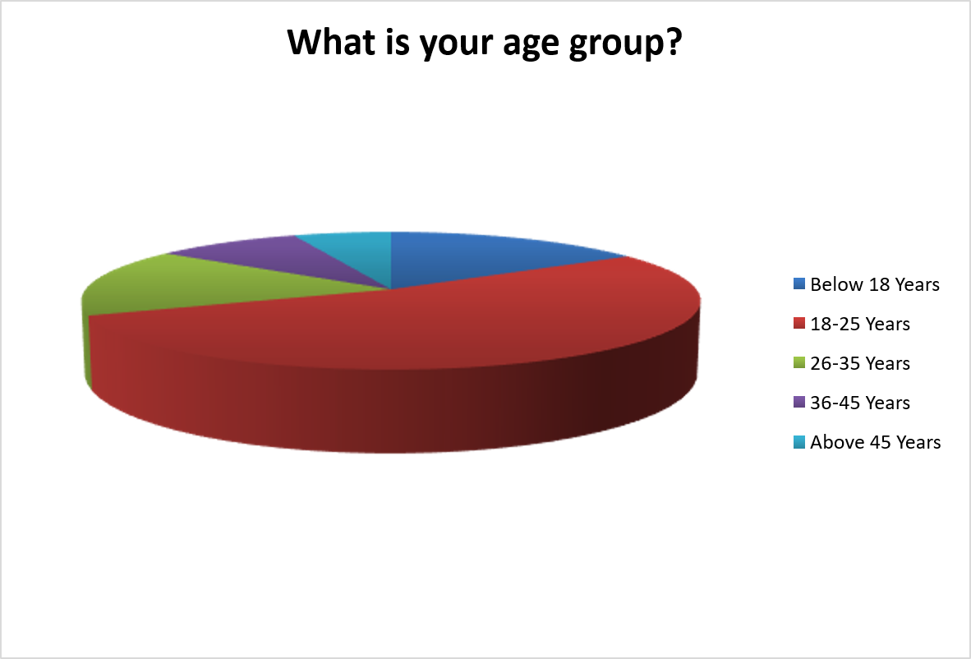

INTERPRETATION:s
From the above table, it is interpreted that 53% of respondents belong to the 18-25 age group, making them the dominant demographic. 16% are below 18 years and another 16% fall in the 26-35 range. Only 9% belong to the 36-45 group and 6% are above 45 years, indicating the survey largely captures youth and young adults actively using digital financial services.
2Q. What is your gender?
Table 4.2
S.No | Options | No. of respondents | Percentage
1 | Male | 54 | 54%
2 | Female | 43 | 43%
3 | Prefer not to say | 3 | 3%
 | Total | 100 | 100%
SOURCE: Primary data

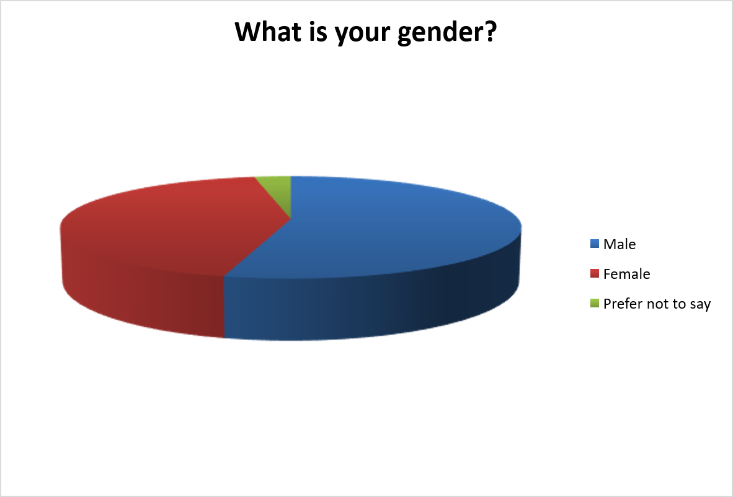

INTERPRETATION:
From the about table It is interpreted that 54% of respondents are male, and 43 are female. With only
Preferring not to disclose their gender. The near balanced gender distribution adds credibility and
Representation To this survey. Through males are slightly more dominat ’. Among participants in their
Digital finance study.

3Q. What is your current occupation?
Table 4.3
S.No | Options | No. of respondents | Percentage
1 | Student | 41 | 41%
2 | Private sector employee | 38 | 38%
3 | Government employee | 8 | 8%
4 | Business/Self-employed | 12 | 12%
5 | Other | 1 | 1%
 | Total | 100 | 100%
SOURCE: Primary data

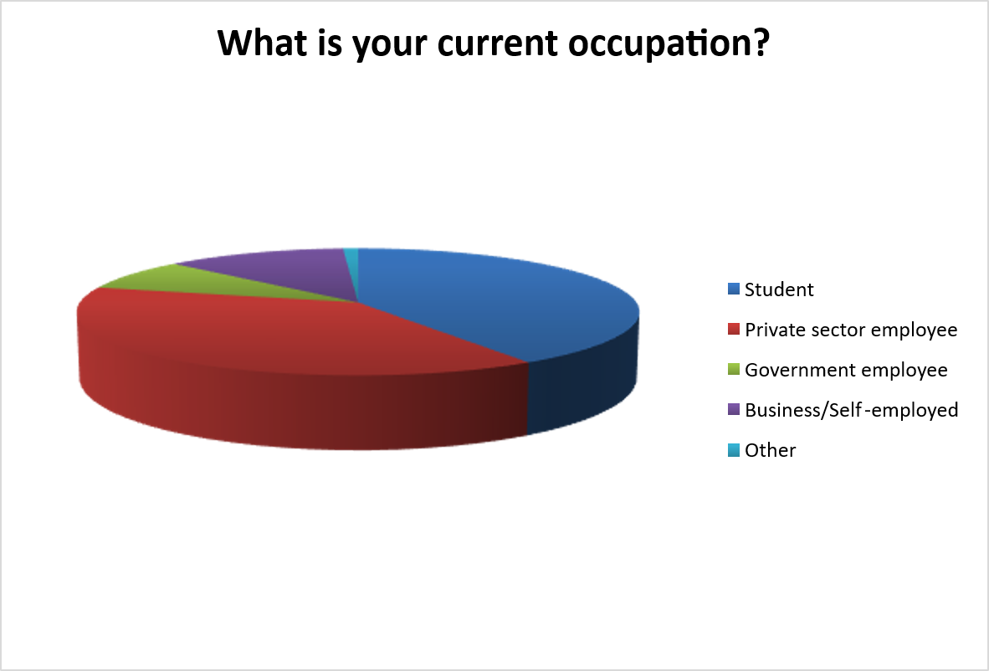

INTERPRETATION:
From the above table, it is interpreted that 41% of respondents are students and 38% are private sector employees, together forming nearly 80% of the survey population. 12% are business or self-employed individuals, 8% are government employees, and only 1% fall in the Other category. This aligns with the younger age profile observed in the previous question.

4Q. How frequently do you use digital financial services (such as UPI, mobile banking, or online banking)?
Table 4.4
S.No | Options | No. of respondents | Percentage
1 | Daily | 65 | 65%
2 | Weekly | 17 | 17%
3 | Occasionally | 12 | 12%
4 | Rarely | 6 | 6%
 | Total | 100 | 100%
SOURCE: Primary data

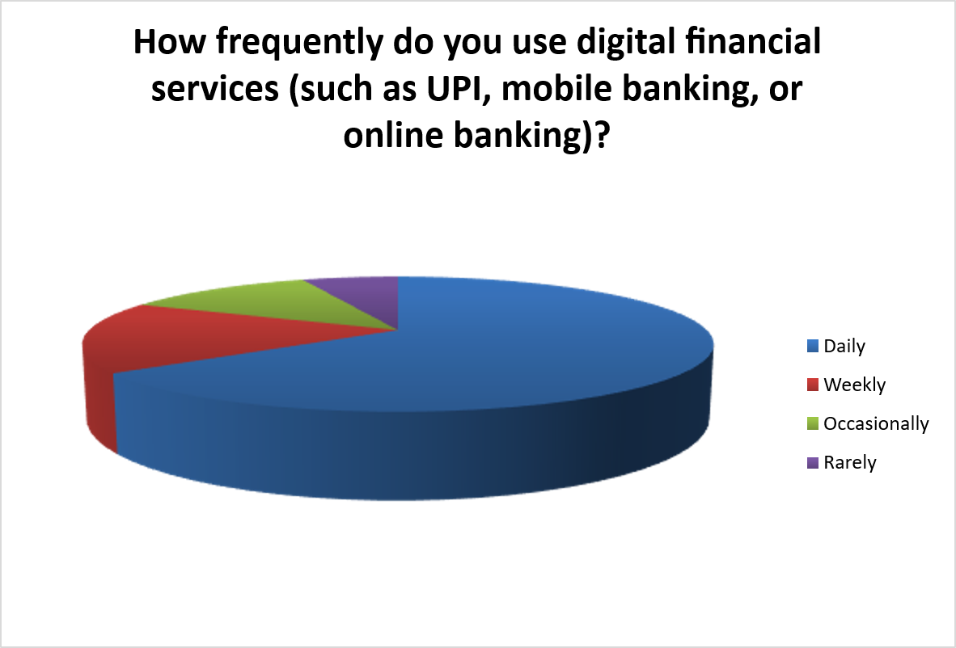

INTERPRETATION:
From the above table, it is interpreted that 65% of respondents use digital financial services on a daily basis, reflecting the deep penetration of UPI and mobile banking in India. 17% use them weekly and 12% occasionally. Only 6% rarely use such services, confirming that digital finance has become a mainstream and indispensable tool in everyday life.

5Q. Which of the following digital payment methods do you use most frequently?
Table 4.5
S.No | Options | No. of respondents | Percentage
1 | UPI applications (Google Pay, PhonePe, Paytm, etc.) | 83 | 83%
2 | Internet banking | 5 | 5%
3 | Mobile banking applications | 4 | 4%
4 | Digital wallets | 4 | 4%
5 | Debit/Credit cards | 4 | 4%
 | Total | 100 | 100%
SOURCE: Primary data
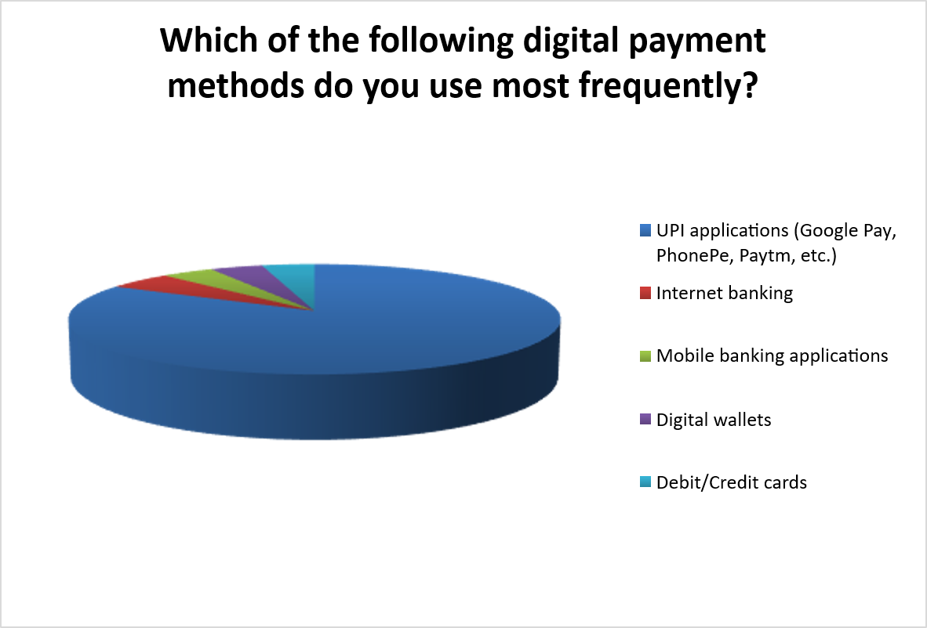

INTERPRETATION:
From the above table, it is interpreted that an overwhelming 83% of respondents prefer UPI applications such as Google Pay, PhonePe, and Paytm as their primary digital payment method. All other methods — internet banking, mobile banking apps, digital wallets, and debit/credit cards — collectively account for only 17%. This highlights the dominant success of India's UPI ecosystem.

6Q. For what purposes do you usually use digital payment services?
Table 4.6
S.No | Options | No. of respondents | Percentage
1 | Money transfers | 13 | 11%
2 | Bill payments | 12 | 11%
3 | Online shopping | 26 | 23%
4 | Mobile recharge/services | 14 | 12%
5 | All of the above | 49 | 43%
 | Total | 114 | 100%
SOURCE: Primary data
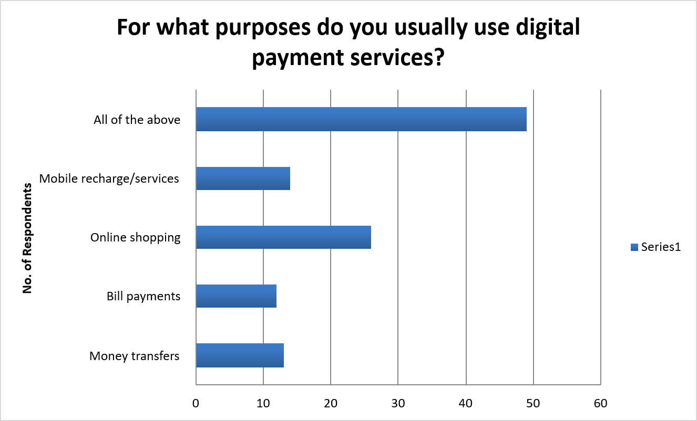

INTERPRETATION:
From the above table, it is interpreted that 49% of respondents use digital payment services for all the mentioned purposes combined, indicating versatile and multi-dimensional usage. Among individual categories, online shopping is the most popular at 26%, followed by mobile recharge/services at 14%, money transfers at 13%, and bill payments at 12%.

7Q. Are you aware of common types of online financial fraud such as phishing, OTP scams, and fake payment links?
Table 4.7
S.No | Options | No. of respondents | Percentage
1 | Yes | 76 | 76%
2 | No | 12 | 12%
3 | Maybe | 12 | 12%
 | Total | 100 | 100%
SOURCE: Primary data

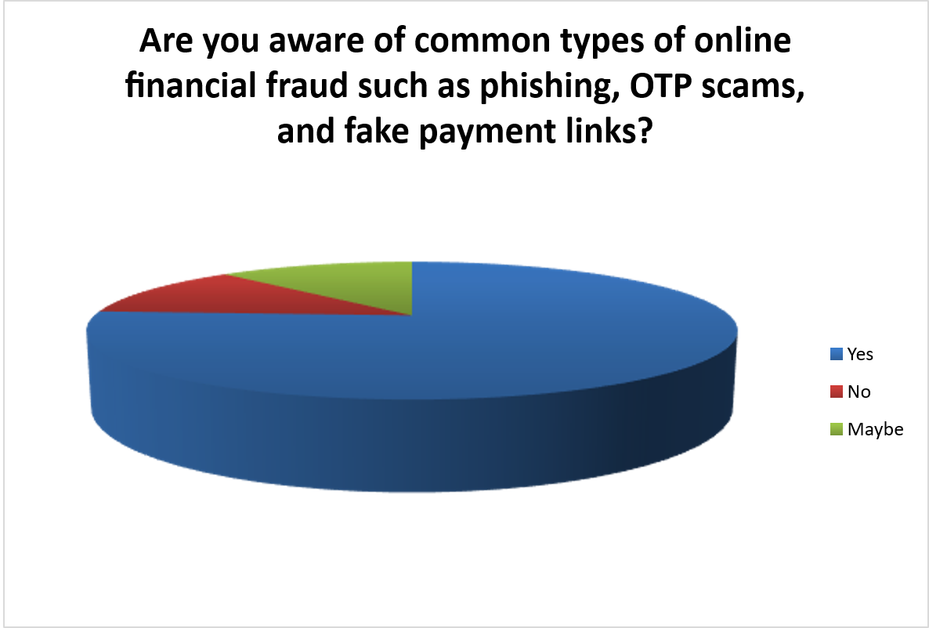

INTERPRETATION:
From the above table, it is interpreted that 76% of respondents are aware of common types of online financial fraud including phishing, OTP scams, and fake links. However, 12% said No and 12% said Maybe, meaning nearly a quarter of users are partially or fully uninformed about such threats, representing a significant vulnerability in digital financial security.

8Q. Through which source did you first learn about online financial fraud?
Table 4.8
S.No | Options | No. of respondents | Percentage
1 | Social media | 34 | 34%
2 | Television or news | 25 | 25%
3 | Bank awareness campaigns | 6 | 6%
4 | Friends or family | 24 | 24%
5 | Other sources | 11 | 11%
 | Total | 100 | 100%
SOURCE: Primary data

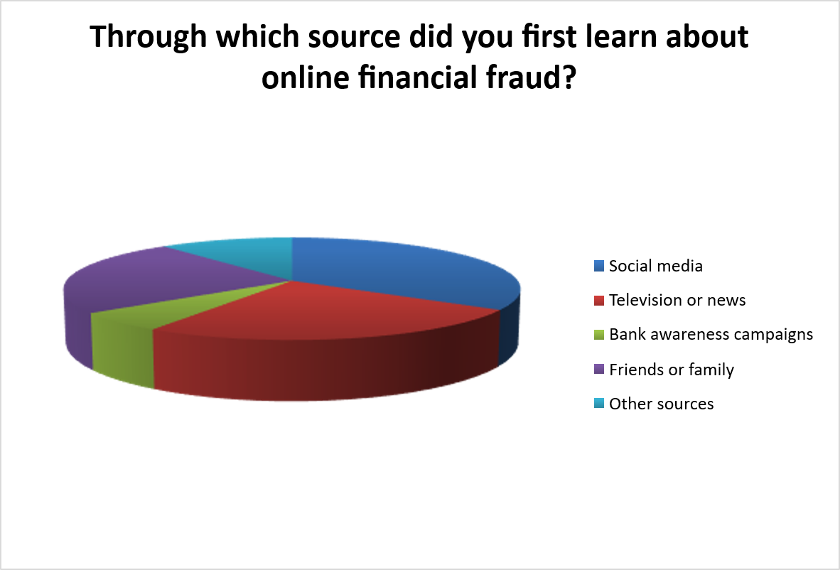

INTERPRETATION:
From the above table, it is interpreted that 34% of respondents first learned about online financial fraud through social media, followed by television or news at 25% and friends or family at 24%. Bank awareness campaigns account for only 6%, suggesting that financial institutions need to significantly strengthen their direct public outreach and fraud prevention communication efforts.

9Q. Do you know that sharing sensitive information such as OTP, PIN, or banking details can lead to financial fraud?
Table 4.9
S.No | Options | No. of respondents | Percentage
1 | Yes | 89 | 89%
2 | No | 11 | 11%
 | Total | 100 | 100%
SOURCE: Primary data

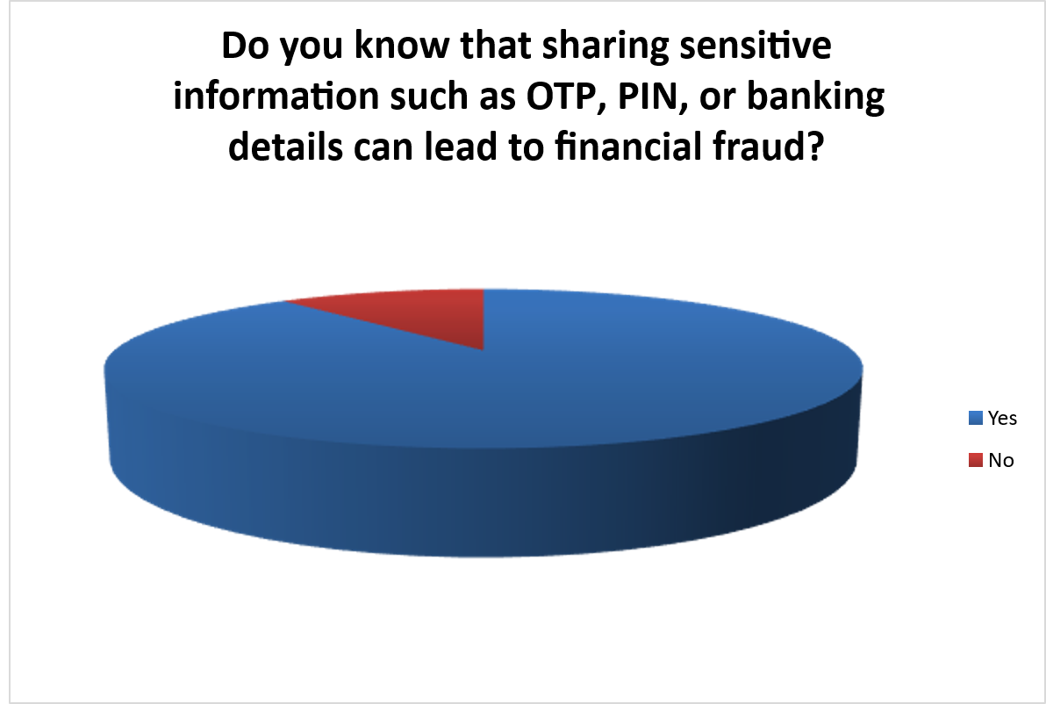

INTERPRETATION:
From the above table, it is interpreted that 89% of respondents are aware that sharing sensitive information such as OTPs, PINs, or banking details can lead to financial fraud. However, 11% still remain unaware of this critical fact, making them highly susceptible to social engineering attacks, impersonation fraud, and phishing schemes.

10Q. Have you ever been a victim of online financial fraud?
Table 4.10
S.No | Options | No. of respondents | Percentage
1 | Yes | 26 | 26%
2 | No | 74 | 74%
 | Total | 100 | 100%
SOURCE: Primary data

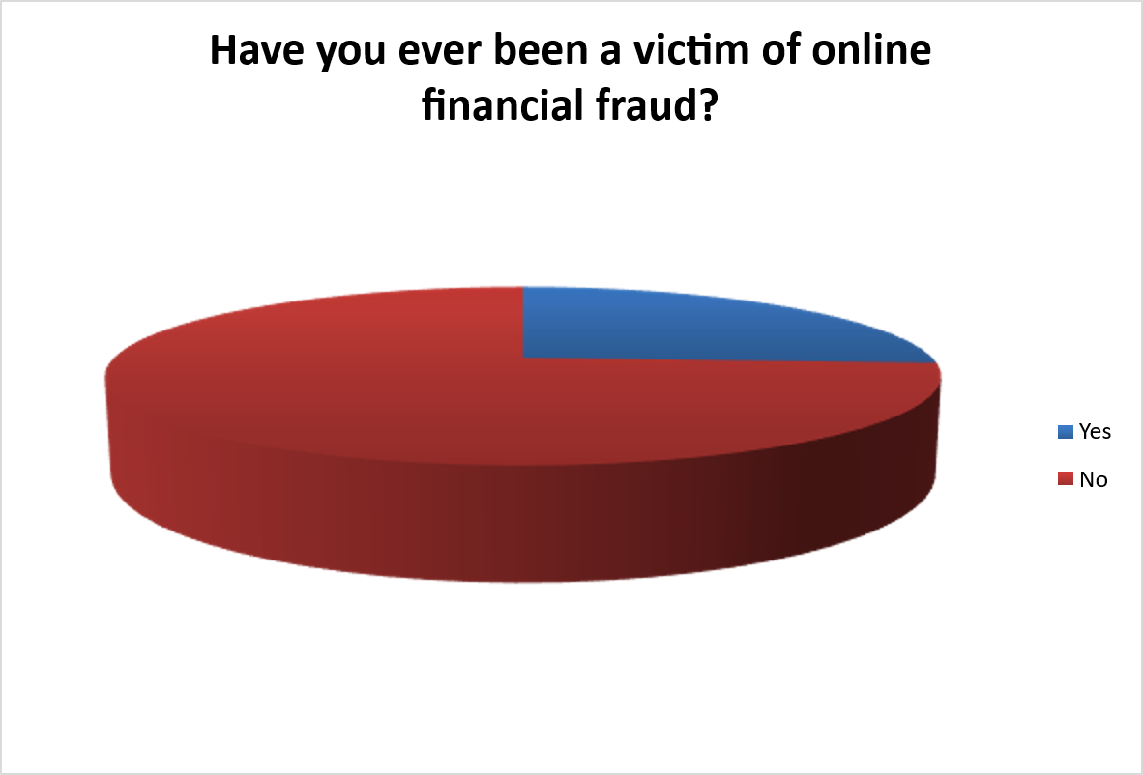

INTERPRETATION:
From the above table, it is interpreted that 26% of respondents have been victims of online financial fraud, which means approximately 1 in 4 people surveyed has experienced such an incident. The remaining 74% have not been victimized. This high victimization rate underscores the severity and prevalence of digital fraud in India despite growing awareness.

11Q. If yes, what type of fraud did you experience?
Table 4.11
S.No | Options | No. of respondents | Percentage
1 | Phishing message or email | 7 | 7%
2 | Fraudulent phone calls pretending to be bank officials | 7 | 7%
3 | Fake websites or mobile applications | 4 | 4%
4 | Unauthorized bank transactions | 5 | 5%
5 | Not applicable | 77 | 77%
 | Total | 100 | 100%
SOURCE: Primary data

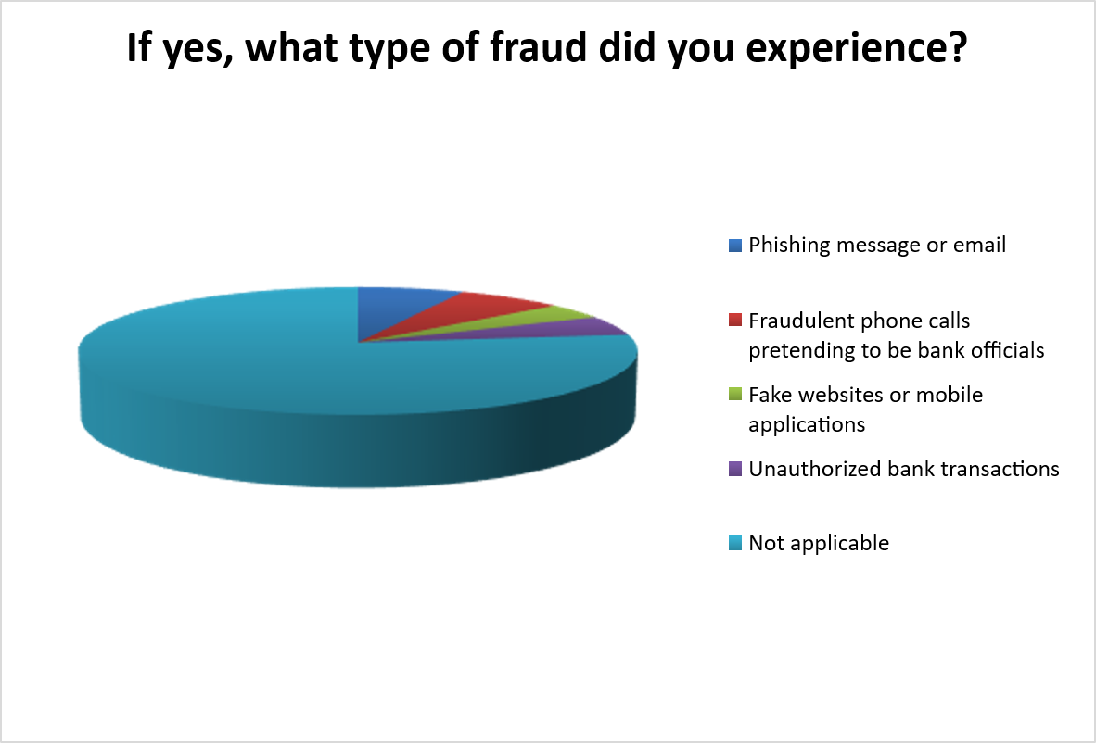

INTERPRETATION:
From the above table, it is interpreted that 77% (Not applicable) of respondents have not experienced any fraud, consistent with earlier findings. Among those who did experience fraud, phishing messages/emails and fraudulent phone calls from fake bank officials were equally the most common types, highlighting the prevalence of impersonation and deception-based fraud.

12Q. Did you report the incident to your bank or the appropriate authorities?
Table 4.12
S.No | Options | No. of respondents | Percentage
1 | Yes | 27 | 27%
2 | No | 73 | 73%
 | Total | 100 | 100%
SOURCE: Primary data

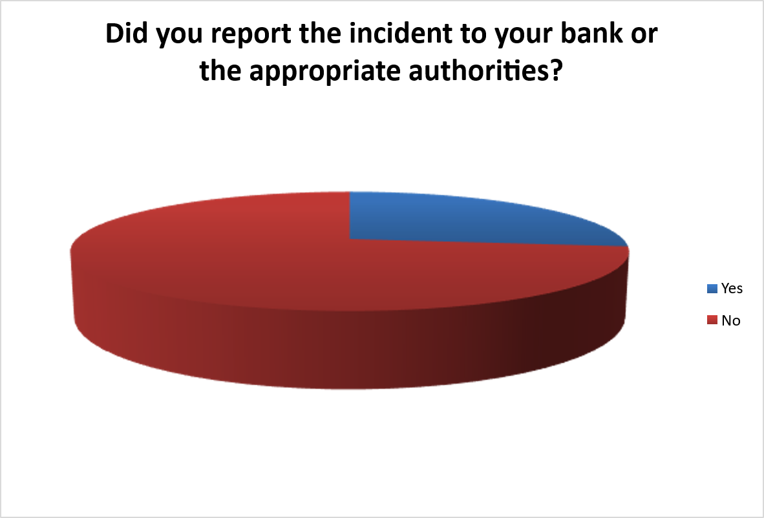

INTERPRETATION:
From the above table, it is interpreted that only 27% of fraud victims reported the incident to their bank or relevant authorities, while a significant 73% did not report it. This very low reporting rate indicates lack of awareness about grievance mechanisms, fear of complex procedures, or distrust in the system, allowing fraudsters to operate without accountability.

13Q. Do you regularly update your banking applications and mobile device security settings?
Table 4.13
S.No | Options | No. of respondents | Percentage
1 | Always | 39 | 39%
2 | Sometimes | 33 | 33%
3 | Rarely | 19 | 19%
4 | Never | 9 | 9%
 | Total | 100 | 100%
SOURCE: Primary data

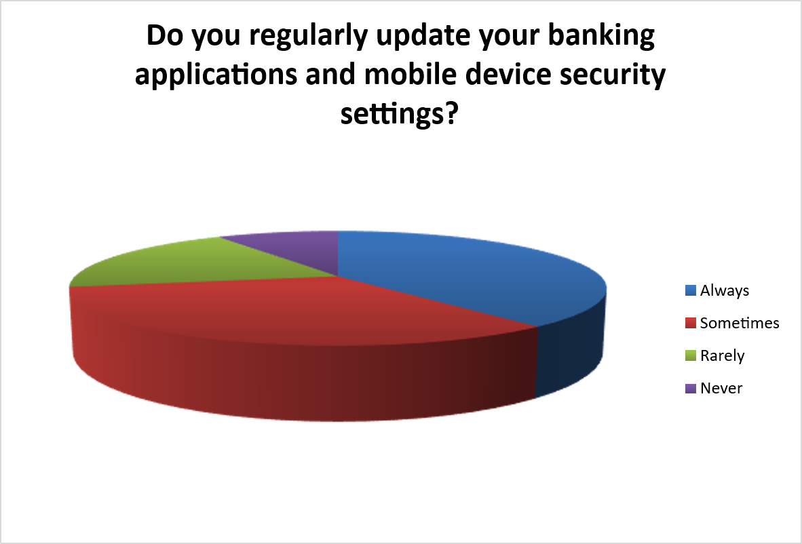

INTERPRETATION:
From the above table, it is interpreted that 39% of respondents always update their banking applications and security settings, while 33% do so only sometimes. A concerning 19% rarely update and 9% never update their apps, indicating significant gaps in basic cybersecurity hygiene that can expose users to known vulnerabilities and fraud risks.

14Q. Do you use strong and unique passwords for your digital banking accounts?
Table 4.14
S.No | Options | No. of respondents | Percentage
1 | Yes | 81 | 81%
2 | No | 19 | 19%
 | Total | 100 | 100%
SOURCE: Primary data

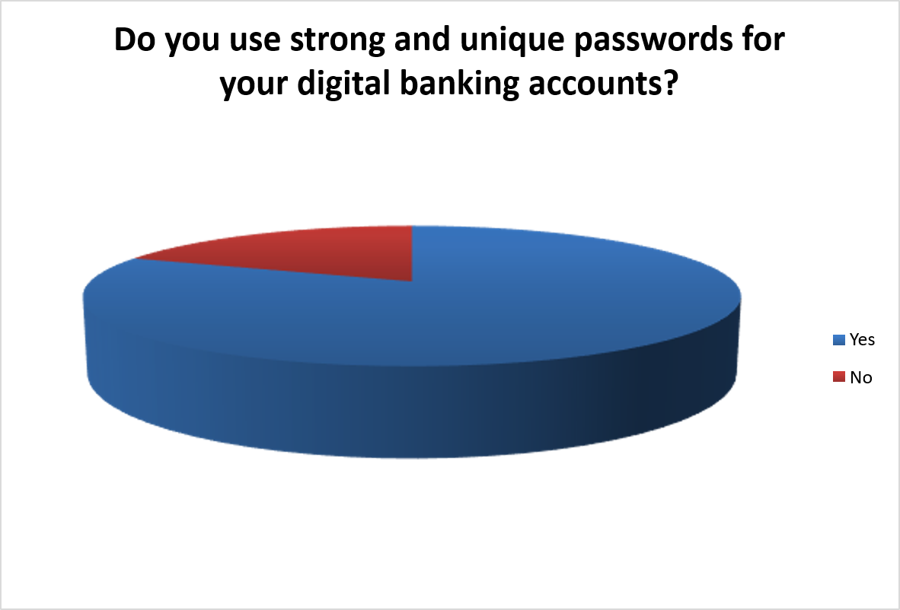

INTERPRETATION:
From the above table, it is interpreted that 81% of respondents claim to use strong and unique passwords for their digital banking accounts, which is an encouraging sign of password security awareness. However, the remaining 19% who do not use strong passwords remain highly vulnerable to credential theft, brute force attacks, and unauthorized account access.

15Q. Before making online payments, do you verify the authenticity of the website or application?
Table 4.15
S.No | Options | No. of respondents | Percentage
1 | Always | 50 | 50%
2 | Sometimes | 33 | 33%
3 | Rarely | 11 | 11%
4 | Never | 6 | 6%
 | Total | 100 | 100%
SOURCE: Primary data

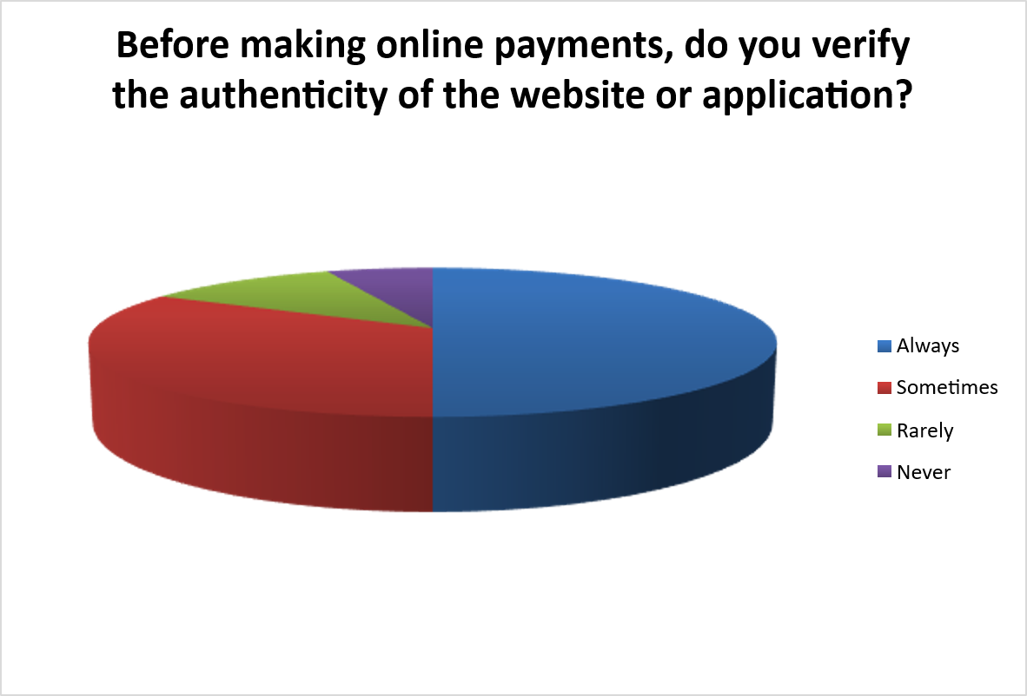

INTERPRETATION:
From the above table, it is interpreted that 50% of respondents always verify the authenticity of websites or applications before making online payments. However, 33% only sometimes verify, and 11% rarely or 6% never verify, indicating that nearly half the respondents take inconsistent or no precautions — making them vulnerable to fake websites and phishing attacks.

16Q. Do you believe financial institutions provide sufficient awareness programs about online financial fraud prevention?
Table 4.16
S.No | Options | No. of respondents | Percentage
1 | Yes | 39 | 39%
2 | No | 28 | 28%
3 | Not sure | 33 | 33%
 | Total | 100 | 100%
SOURCE: Primary data

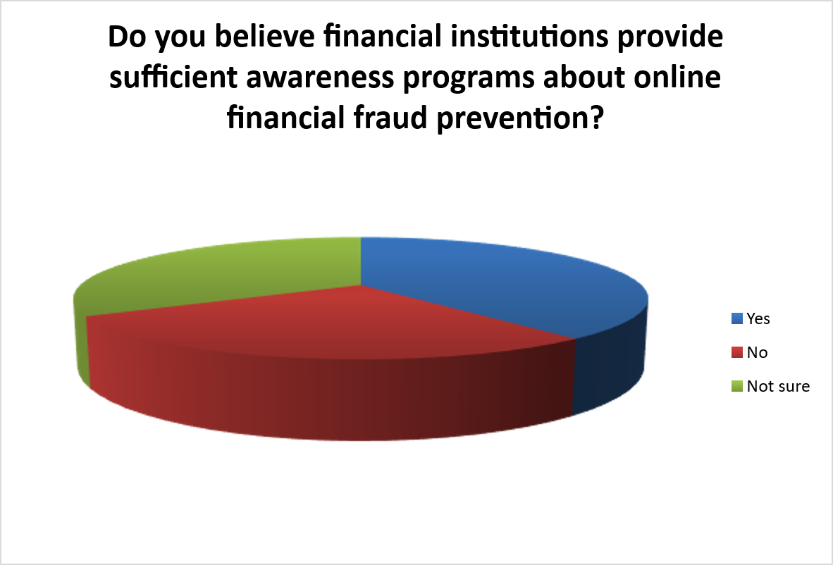
INTERPRETATION:
From the above table, it is interpreted that 39% of respondents believe financial institutions provide sufficient awareness programs about fraud prevention, while 28% disagree. A significant 33% are unsure, which indicates that the existing awareness campaigns by banks lack clarity, consistency, or adequate reach to effectively inform the general public.

17Q. In your opinion, how effective are current cybersecurity measures in preventing online financial fraud?
Table 4.17
S.No | Options | No. of respondents | Percentage
1 | Highly effective | 20 | 20%
2 | Moderately effective | 48 | 48%
3 | Slightly effective | 26 | 26%
4 | Not effective | 6 | 6%
 | Total | 100 | 100%
SOURCE: Primary data

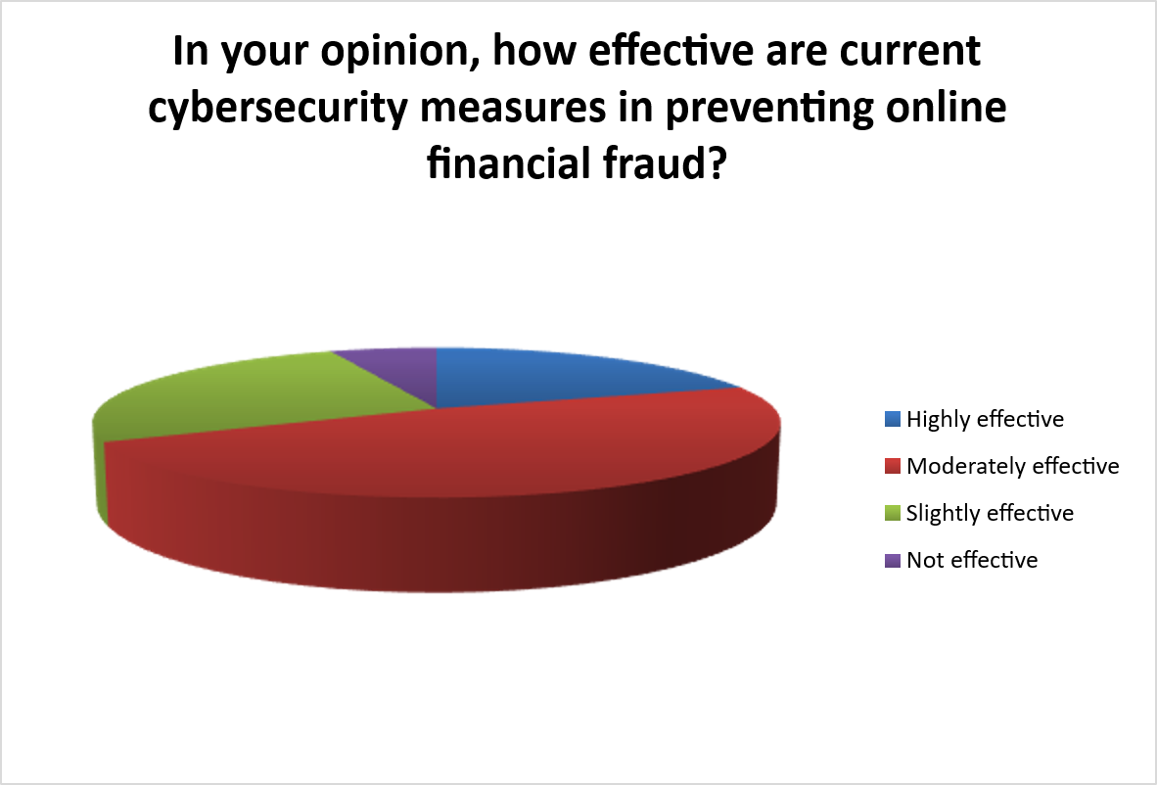

INTERPRETATION:
From the above table, it is interpreted that 48% of respondents find current cybersecurity measures only moderately effective, and 26% find them slightly effective. Only 20% consider them highly effective, while 6% believe they are not effective at all. This reflects widespread public skepticism about the robustness of India's digital financial security infrastructure.
18Q. What do you think is the primary cause of online financial fraud in India?
Table 4.18
S.No | Options | No. of respondents | Percentage
1 | Lack of user awareness | 29 | 29%
2 | Weak cybersecurity systems | 18 | 18%
3 | Increasing cybercriminal activities | 17 | 17%
4 | Combination of all factors | 36 | 36%
 | Total | 100 | 100%
SOURCE: Primary data
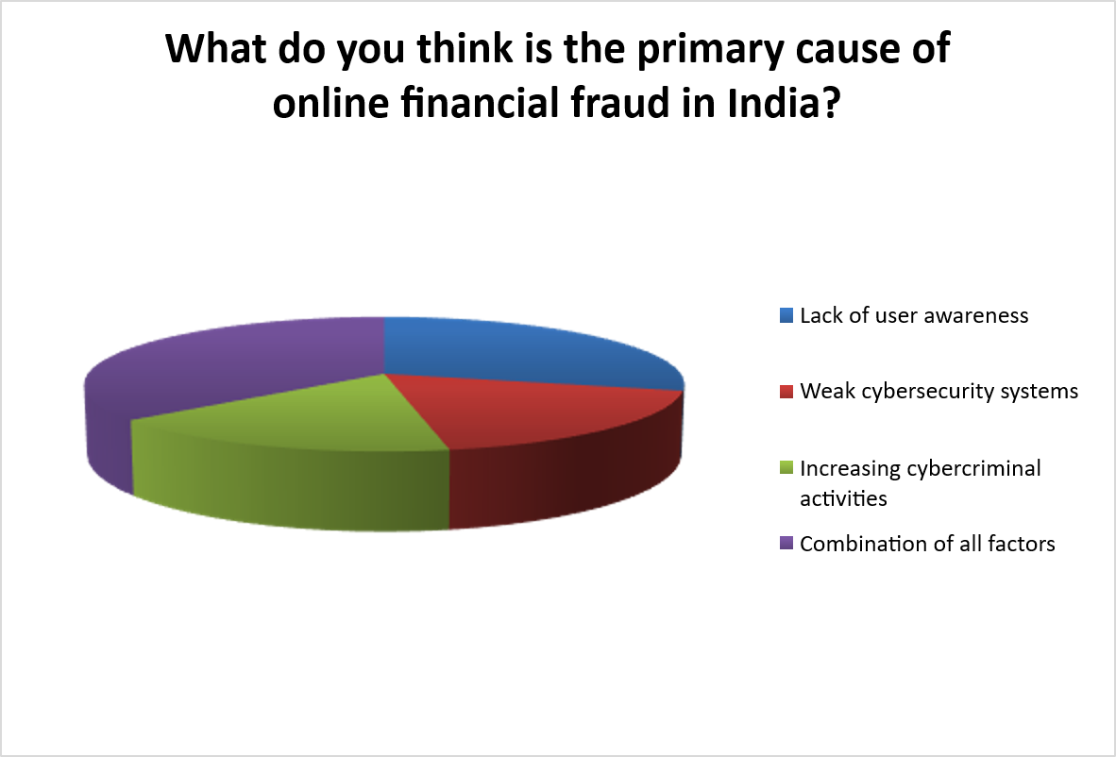

INTERPRETATION:
From the above table, it is interpreted that 36% of respondents believe a combination of all factors is the primary cause of online financial fraud in India. Among individual factors, 29% attribute it to lack of user awareness, 18% to weak cybersecurity systems, and 17% to increasing cybercriminal activities, reinforcing the need for a multi-pronged approach to fraud prevention.

19Q. What do you think is the primary cause of online financial fraud in India?
Table 4.18
Options | No. of respondents | Percentage
Lack of user awareness | 29 | 29%
Weak cybersecurity systems | 18 | 18%
Increasing cybercriminal activities | 17 | 17%
Combination of all factors | 36 | 36%
Total | 100 | 100%
SOURCE: Primary data
Statistical Tool: Chi-Square
Formulation of hypothesis
- Null Hypothesis (H₀) = The primary causes of online financial fraud as perceived by respondents are equally distributed.
- Alternative Hypothesis (H₁) = The primary causes of online financial fraud as perceived by respondents are not equally distributed.
Expected Frequency (ΣX/N) = 100/4 = 25

Where,

Σ is number of respondents
N is total number of options in the question
No. of options | O | E | (O-E) | (O-E)² | (O-E)²/E
Lack of user awareness | 29 | 25 | 4 | 16 | 0.64
Weak cybersecurity systems | 18 | 25 | -7 | 49 | 1.96
Increasing cybercriminal activities | 17 | 25 | -8 | 64 | 2.56
Combination of all factors | 36 | 25 | 11 | 121 | 4.84
 | ΣX=100 |  |  |  | X²=10
Degree of freedom (DF) = 3
Significance value (α) = 5% = 0.05
Table value = 7.815
RESULT: In the above problem Alternative Hypothesis (H₁) will be accepted.
INTERPRETATION:
The calculated value of X² = 10 which is greater than the table value that is 7.815. Therefore, we can conclude that the primary causes of online financial fraud as perceived by respondents are not equally distributed. The respondents significantly favour "Combination of all factors" (36%) as the primary cause, followed by "Lack of user awareness" (29%), indicating a strong and statistically significant pattern in public perception about the root causes of online financial fraud in India.

CHAPTER V
FINDINGS SUGGESTIONS AND CONCLUSION

5.1 FINDINGS
The present study is focused on the analysis of online financial frauds in India with reference to trends, causes, and cybersecurity measures. Based on the primary data collected from 100 respondents through a structured questionnaire and supported by secondary data from published research, RBI reports, and government cybercrime statistics, the following findings have been drawn:

1. Online Financial Fraud in India Is Growing at an Alarming Rate Over the past few years, online financial fraud in India has grown at a pace that is hard to ignore. As more and more people embraced digital payments through UPI, mobile banking, and e-wallets, criminals found newer and smarter ways to exploit them. Fraud cases involving phishing, OTP theft, and fake payment links have become almost everyday occurrences, reflecting just how vulnerable India's rapidly digitizing population has become.
2. Ordinary People Are the Easiest Target More than any technical loophole, it is the common person's lack of awareness that fraudsters exploit the most. A retired government employee receiving a fake KYC call, a farmer in a small town clicking a fraudulent payment link, a young student falling for a fake job offer — these are not rare stories. They happen daily. The study found that low digital literacy, especially outside major cities, remains one of the biggest and most underaddressed causes of financial fraud in India.
3. Banks and Financial Institutions Are Not Doing Enough While large private banks have made progress, a significant number of smaller banks, cooperative banks, and NBFCs are still running on outdated security systems. Weak passwords, poor encryption, and delayed responses to fraud complaints paint a picture of institutions that treat cybersecurity as a formality rather than a responsibility. The gap between what institutions claim to offer and what they actually deliver in terms of security is a serious concern.
4. Laws Exist on Paper But Justice Is Hard to Find India does have laws to deal with cybercrime — the IT Act, RBI guidelines, CERT-In directives — but for most fraud victims, getting justice feels like an uphill battle. Police stations are ill-equipped, cybercrime cells are understaffed, and cases drag on for months with little resolution. This not only leaves victims without relief but also sends a message to fraudsters that the consequences of their actions are minimal

5. Technology Like AI Can Be a Game Changer — But It's Not Being Used Enough The good news is that solutions exist. Artificial Intelligence and Machine Learning can scan millions of transactions in real time, catch suspicious activity instantly, and stop fraud before it even completes. The bad news is that most Indian financial institutions, especially smaller ones, have not yet adopted these tools due to cost and lack of expertise. The potential is enormous, but the implementation is lagging far behind.
6. Everyone Is Working Alone When They Should Be Working Together Perhaps the most frustrating finding is that banks, regulators, and law enforcement agencies rarely share fraud-related information with each other in real time. A fraud pattern that one bank detects today could easily hit another bank tomorrow — but without a proper information-sharing system, the same tricks keep working over and over again. Fighting online financial fraud effectively requires all stakeholders to stop working in silos and start treating this as a shared national problem that needs a united response.

5.2 SUGGESTIONS
- Given that only 6% of respondents first learned about online financial fraud through bank awareness campaigns, financial institutions must significantly increase the frequency and reach of customer education programs. Banks should deploy multilingual fraud awareness content across SMS alerts, in-app notifications, social media, and television, particularly targeting first-time users, senior citizens, and rural populations who are most vulnerable to digital fraud.
- Since UPI applications dominate digital payments with 83% usage, NPCI and payment service providers should implement additional safeguards such as device binding, daily transaction limits for new users, and intelligent anomaly detection for unusual payment
patterns. A mandatory brief verification delay for first-time high-value transactions should be introduced to reduce impulsive fraud-driven transfers.
- As 73% of fraud victims did not report their incidents to authorities, the government and financial institutions must actively and widely promote the National Cyber Crime Reporting Portal (cybercrime.gov.in) and helpline 1930. RBI's zero-liability policy guaranteeing refunds for fraud reported within three days must be clearly communicated to all digital banking users through mandatory bank notifications.
- Since social engineering and OTP-sharing remain leading causes of fraud despite high awareness (89%), banks should move beyond text-based OTP authentication toward stronger multi-factor authentication methods including behavioral biometrics, device-based authentication, and fingerprint or face recognition. The RBI has already recommended phasing out text OTPs, and financial institutions should fast-track this transition.
- Given that 28% of respondents rarely or never update their banking applications and security settings, banking platforms should introduce mandatory update prompts and automated security patch notifications. Apps that have not been updated for a specified period should restrict access to high-value transactions until the update is completed.
- Cyber-safety education must be formally integrated into school and college curricula at the national level. With 53% of fraud-exposed respondents in the 18–25 age group, students are a high-risk demographic. Following Karnataka's model of incorporating cyber-safety training targeting 40% of students by 2024, a national rollout would substantially reduce youth vulnerability to digital fraud.
- As only 50% of respondents always verify the authenticity of websites and applications before transacting, banks and government agencies should run targeted campaigns teaching users to check for HTTPS, official domain names, and app store credibility before making any online payment. Browser-based phishing alert tools should be promoted as essential digital safety tools.
- Financial institutions must deploy Artificial Intelligence and Machine Learning-based real-time fraud detection systems across all banking platforms. AI-driven tools such as MuleHunter.AI — developed by the RBI Reserve Bank Innovation Hub to detect mule accounts — should be expanded nationally across all public and private sector banks to disrupt large-scale fraud laundering networks.
- The government should enact comprehensive and specific legislation on digital financial fraud with fast-track cyber courts, simplified evidentiary standards, and strong
- deterrent penalties. The Digital Personal Data Protection Act (DPDPA) 2023 must be fully operationalised, and the Central Payments Fraud Information Registry (CPFIR) should mandate real-time cross-bank fraud data sharing for faster detection and response.
- Banks and fintech companies must conduct mandatory periodic cybersecurity audits and penetration testing on all digital platforms, APIs, and mobile applications. Compliance with RBI's Master Direction on IT Governance, Risk, Controls and Assurance Practices 2023 must be strictly enforced, with non-compliance attracting significant financial penalties.
- Individual users must be consistently reminded never to share OTPs, PINs, CVV numbers, or banking passwords with anyone — including individuals claiming to be bank officials or government representatives. They should enable transaction alerts, regularly monitor account statements, immediately report suspicious transactions, and avoid accessing banking platforms on public Wi-Fi networks.

5.3 CONCLUSION

- Online financial fraud has emerged as one of the most serious threats to India's rapidly growing digital economy. The study titled "Analysis of Online Financial Frauds in India: Trends, Causes and Cybersecurity Measures" was carried out with the objective of understanding the nature, trends, and causes of online financial fraud and the effectiveness of existing cybersecurity measures, based on primary data from 100 respondents and secondary data from government reports, RBI publications, and academic research.

- The findings of the study reveal that while India's digital payment revolution — powered by UPI, internet banking, and mobile finance — has dramatically improved financial access and convenience, it has simultaneously created an expanding attack surface for cybercriminals. India recorded over 20 lakh cybercrime complaints in 2024, with total financial losses reaching Rs 22,845 crore — a 206% increase over the previous year — and the Indian Cybercrime Coordination Centre (I4C) warns that losses could exceed Rs 1.2 lakh crore in 2025 if present trends continue. The primary survey data mirrors this national crisis, with 26% of respondents having personally experienced online financial fraud.

- The study also highlights that awareness, while growing, remains uneven and insufficient. 76% of respondents are aware of common fraud types such as phishing and OTP scams, and 89% know the risks of sharing sensitive information. Yet fraud continues to escalate because awareness does not consistently translate into safe behaviour. Social engineering, impersonation, and phishing attacks continue to victimize users who know the risks but lower their guard in moments of urgency or misplaced trust. The critically low reporting rate — only 27% of victims reported to authorities — further enables fraudsters to operate without accountability and discourages institutional action.

- The study further identifies significant institutional and technological gaps. Bank-led fraud awareness reaches only a small fraction of users, current cybersecurity measures are considered highly effective by only 20% of respondents, and many users continue to practice poor digital hygiene such as not updating banking applications and failing to verify website authenticity. The transition to AI-driven fraud detection, behavioral biometrics, and device-based authentication — while underway — needs massive acceleration to keep pace with increasingly sophisticated fraud methods powered by artificial intelligence and social engineering.

- In conclusion, the findings of this study conclusively establish that no single intervention can adequately address India's online financial fraud crisis. As 51% of respondents themselves indicated, a comprehensive combination of enhanced public awareness and digital literacy, stronger cybersecurity systems, stricter government regulation, improved fraud reporting mechanisms, and consistent individual safe behaviour is the only credible pathway to a safer digital financial ecosystem. The government's Union Budget 2025–26 allocation of Rs 782 crore for cybersecurity, the enactment of the Digital Personal Data Protection Act 2023, and the deployment of AI-based fraud detection tools signal growing institutional resolve. However, these efforts must be matched by equivalent investments in consumer education, regulatory enforcement, and behavioral change. In the age of digital finance, cybersecurity is not merely a technical concern — it is a fundamental pillar of financial inclusion, economic justice, and national development.

BIBILOGRAPHY

- Artificial Intelligence for Fraud Detection in Financial Systems — IEEE Study (2024)
- Cyber Fraud in India's Digital Payment Ecosystem — Hansraj College Journal (2025)
- Financial Security in the Indian Banking Sector — IGI Global (2024)
- Socio-Economic Impact of Financial Cybercrime — SAGE Journals (2024)

WEBILOGRAPHY
1.https://www.researchgate.net/profile/Simriti-Koul/publication/358629659_Analyzing_Cyber_Trends_in_Online_Financial_Frauds_Paper/links/620c576b7b05f82592ef6f04/Analyzing-Cyber-Trends-in-Online-Financial-Frauds-Paper.pdf
2.https://www.researchgate.net/profile/Md-Haris-Sharif/publication/362363620_A_literature_review_of_financial_losses_statistics_for_cyber_security_and_future_trend/links/62edad4f505511283e94b5ed/A-literature-review-of-financial-losses-statistics-for-cyber-security-and-future-trend.pdf
3.https://www.academia.edu/download/93748982/A05720109.pdf
4.https://ieeexplore.ieee.org/abstract/document/11211749/
5.https://www.benthamdirect.com/content/books/9798898812133.chapter-13
6.https://arxiv.org/abs/2505.23770
7.https://arxiv.org/abs/2505.23770
8.https://www.researchgate.net/profile/Leandre-Gomes/publication/362013259_Cyber_Security_and_Internet_Banking_Iss
ues_and_Preventive_Measures/links/62d1839666bd1654d667b59c/Cyber-Security-and-Internet-Banking-Issues-and-Preventive-Measures.pdf
9.https://jisis.org/wp-content/uploads/2023/12/2023.I4.010.pdf
10.https://search.proquest.com/openview/6ba6fe965db0efc6ad127c4fd2c464df/1?pq-origsite=gscholar&cbl=2045096
11.https://www.tandfonline.com/doi/abs/10.1080/23742917.2024.2347674

12.https://www.hansrajcollege.ac.in/uploads/researchinnovation/callforpapersposter/issue3_vol3/Vol%203,%20Issue%203%20July-Sept%202025.pdf#page=84
13.https://www.emerald.com/ajim/article/75/2/246/60840
14.https://www.voiceofresearch.org/doc/Jun-2021/Jun-2021_9.pdf
15.https://www.researchgate.net/profile/Sanjeev-Kumar-150/publication/351902133_CYBER_CRIMES_IN_INDIA_TRENDS_AND_PREVENTION/links/60af10f7299bf13438eb9ba7/CYBER-CRIMES-IN-INDIA-TRENDS-AND-PREVENTION.pdf
16.https://www.igi-global.com/chapter/an-analysis-on-frauds-affecting-the-financial-security-of-the-indian-banking-sector/347148
17.https://www.emerald.com/dprg/article/26/6/678/1229998
18.http://137.59.67.20/xmlui/bitstream/handle/123456789/18368/Artificial%20Intelligence.pdf?sequence=1&isAllowed=
19.http://117.239.78.102:8080/jspui/bitstream/123456789/4262/1/M%20SANJANA.pdf
20.https://journals.sagepub.com/doi/abs/10.1177/00219096241300444

ANNEXURE
Q1. Name
Answer: ______________
Q2. What is your age group?
(a) Below 18 Years
(b) 18–25 Years
(c) 26–35 Years
(d) 36–45 Years
(e) Above 45 Years
Q3. What is your gender?
(a) Male
(b) Female
(c) Prefer not to say
Q4. What is your current occupation?
(a) Student
(b) Private sector employee
(c) Government employee
(d) Business/Self-employed
(e) Other
Q5. How frequently do you use digital financial services (such as UPI, mobile banking, or online banking)?
(a) Daily
(b) Weekly
(c) Occasionally
(d) Rarely

Q6. Which of the following digital payment methods do you use most frequently?
(a) UPI applications (Google Pay, PhonePe, Paytm, etc.)
(b) Internet banking
(c) Mobile banking application
(d) Digital wallets
(e) Debit/Credit cards
Q7. For what purposes do you usually use digital payment services?
(a) Money transfers
(b) Bill payments
(c) Online shopping
(d) Mobile recharge/services
(e) All of the above
Q8. Are you aware of common types of online financial fraud such as phishing, OTP scams, and fake payment links?
(a) Yes
(b) No
(c) Maybe
Q9. Through which source did you first learn about online financial fraud?
(a) Social media
(b) Television or news
(c) Bank awareness campaigns
(d) Friends or family
(e) Other sources
Q10. Do you know that sharing sensitive information such as OTP, PIN, or banking details can lead to financial fraud?
(a) Yes
(b) No

Q11. Have you ever been a victim of online financial fraud?
(a) Yes
(b) No
Q12. If yes, what type of fraud did you experience?
(a) Phishing message or email
(b) Fraudulent phone calls pretending to be bank officials
(c) Fake websites or mobile applications
(d) Unauthorized bank transactions
(e) Not applicable
Q13. Did you report the incident to your bank or the appropriate authorities?
(a) Yes
(b) No
Q14. Do you regularly update your banking applications and mobile device security settings?
(a) Always
(b) Sometimes
(c) Rarely
(d) Never

Q15. Do you use strong and unique passwords for your digital banking accounts?
(a) Yes
(b) No
Q16. Before making online payments, do you verify the authenticity of the website or application?
(a) Always
(b) Sometimes
(c) Rarely
(d) Never

Q17. Do you believe financial institutions provide sufficient awareness programs about online financial fraud prevention?
(a) Yes
(b) No
(c) Not sure
Q18. In your opinion, how effective are current cybersecurity measures in preventing online financial fraud?
(a) Highly effective
(b) Moderately effective
(c) Slightly effective
(d) Not effective
Q19. What do you think is the primary cause of online financial fraud in India?
(a) Lack of user awareness
(b) Weak cybersecurity systems
(c) Increasing cybercriminal activities
(d) Combination of all factors
Q20. Which of the following measures do you think would most effectively reduce online financial fraud in India?
(a) Increased public awareness and digital literacy
(b) Stronger cybersecurity systems in banks
(c) Stricter government regulations and monitoring
(d) Combination of all the above

