Q1. A sales person is paid commission based on the sales he makes as shown by the following
table:
SALES | COMMISSION
Under | 2 % of SALES
SR500
SR500 | 5 % of SALES
And
under
SR5000 | figure (a)
SR5000 | 8 % of SALES
and over
Write a class, Commission, which has an instance variable, sales; an appropriate
constructor; and a method, commission() that returns the commission.
Now write a demo class to test the Commission class by reading a sale from the user,
using it to create a Commission object after validating that the value is not negative.
Finally, call the commission() method to get and print the commission. If the sales are
negative, your demo should print the message “Invalid Input”.

Q2. The certain instructor assigns letter grade for his course based on the following table:
Score | Grade
>= 90 | A+
>= 85 | A
>= 80 | B+
>= 75 | B
>= 65 | C+ | figure (b)
>= 60 | C
>= 55 | D+
>= 50 | D
< 50 | F
Write a class, Grader, which has an instance variable, score, an appropriate constructor
and appropriate methods
• a method, letterGrade() that returns the letter grade as a String.
Now write a demo class to test the Grader class by reading a score from the user, using it
to create a Grader object after validating that the value is not negative and is not greater
then 100. Finally, call the letterGrade() method to get and print the grade. See figure (b)
for sample run.

Q3. Design a class Circle and implement the following methods:
• Define a circle method to compute its area  
  • Define a circle method to compute its perimeter  
• Define a method that takes a given point represented by a pair of numbers and
checks whether or not the point is inside the circle.  
The circle class needs to have instance variables to store the radius of the circle, and the x
and y coordinates of the center. Add main program to test the class Circle repeatedly, until
user enters negative value for the radius of the circle.

Q4. Define a class called fruit with the following attributes:
1. Name of the fruit.
2. Single fruit or bunch fruit.
3. Price.
Define a suitable constructor and displayFruit() method that displays values of all the
attributes. Write a program that creates 2 objects of fruit class and display their attributes.
Q5. Implement a superclass Person. Make two classes, Student and Instructor, inherit from
Person. A person has a name and a year of birth. A student has a major, and an instructor
has a salary. Write the class definitions, the constructors, and the methods toString for all
classes. Supply a test program that tests these classes and methods.
Q6. Define a class Employee having private members – id, name, department, salary. Define
default and parameterized constructors. Create a subclass called “Manager” with private
member bonus. Define methods accept and display in both the classes. Create n objects of
the Manager class and display the details of the manager having the maximum total salary
(salary+bonus)
Q7. Write a Java program to create a super class Vehicle having members Company and price.
Derive 2 different classes LightMotorVehicle (members – mileage) and
HeavyMotorVehicle (members – capacity-in-tons). Accept the information for n vehicles
and display the information in appropriate form. While taking data, ask the user about the
type of vehicle first.

Q8. A bank maintains two kinds of accounts - Savings Account and Current Account.The
savings account provides compound interest, deposit and withdrawal facilities. The
current account only provides deposit and withdrawal facilities. Current account holders
should also maintain a minimum balance. If balance falls below this level, a service
charge is imposed. Create a class Account that stores customer name, account number,
and type of account. From this derive the classes Curr-acct and Sav-acct. Include the
necessary methods in order to achieve the following tasks.
a. Accept deposit from a customer and update the balance.
b. Display the balance.
c. Compute interest and add to balance.
d. Permit withdrawal and update the balance (Check for the minimum balance, impose
penalty if necessary).

9. Write a program to demonstrate given fig.
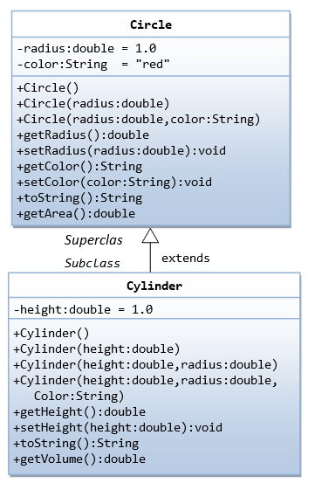
10. Write a program for user defined Exception that checks the external and internal marks if the internal marks is greater than 40 it raise the exception internal mark is exceed, if the external mark is greater than 60 exception is raised and display the message the external marks is exceed, create the above exception and use it in your program.

11. Write a base class called shape and derive the 2 classes as Circle & Rectangle and implement the appropriate functions in both classes.
13. Write a program for exception handling. Which will take two command line arguments from the user if the user does not provide that arguments it should throw exception.

14. Create a class Student with attributes roll no, name, age and course. Initialize values through parameterized constructor. If age of student is not in between 15 and 21 then generate user-defined exception “AgeNotWithinRangeException”. If name contains numbers or special symbols raise exception” NameNotValidException ”.

15. Write a program to demonstrate the finally block.

16. Write a program in java. A class Teacher contains two fields Name and Qualification. Extends the class to department it contains dept. no and Dept Name. An interface named as college it contains one field name of the college. Using the above classes and interface get the appropriate information and display it.

