# TOPOLOGY

• **Two nodes, one link** set ns [new Simulator]

set nf [open out.nam w]

$ns namtrace-all $nf

proc finish {} {

global ns nf $ns flush-trace close $nf exec nam out.nam & exit 0

}

set n0 [$ns node] set n1 [$ns node]

$ns duplex-link $n0 $n1 1Mb 10ms DropTail

$ns at 5.0 "finish"

$ns run

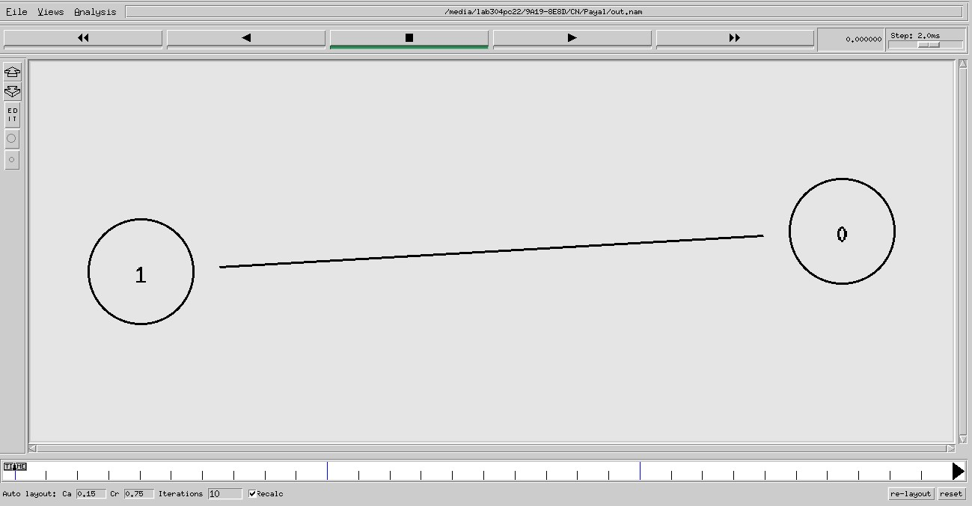

• **Creating a larger topology** set ns [new Simulator]

set nf [open out.nam w]

$ns namtrace-all $nf

proc finish {} {

global ns nf $ns flush-trace close $nf exec nam out.nam & exit 0

}

for {set i 0} {$i < 7} {incr i} {

set n($i) [$ns node]

}

for {set i 0} {$i < 7} {incr i} {

$ns duplex-link $n($i) $n([expr ($i+1)%7]) 1Mb 10ms DropTail

}

$ns at 5.0 "finish"

$ns run

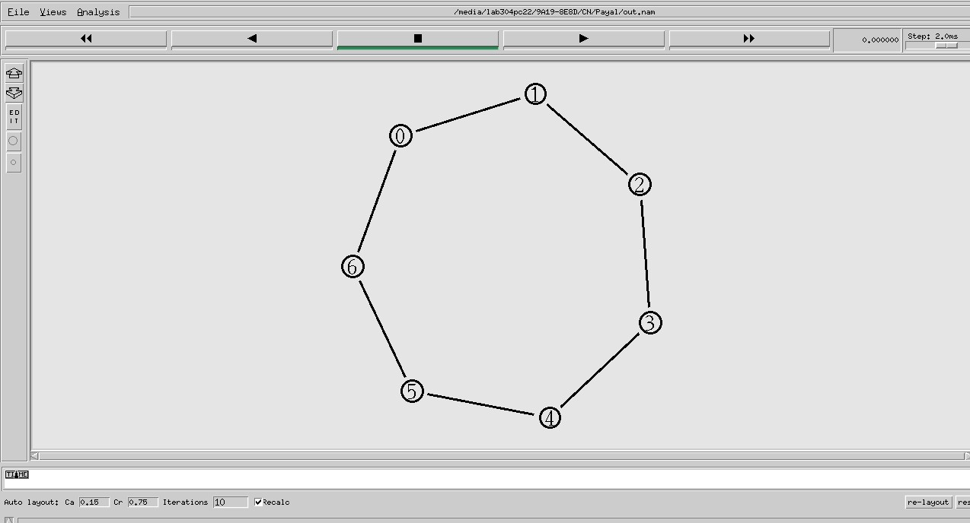

# CBR TRAFFIC FLOW

• **The topology**

set ns [new Simulator] set nf [open out.nam w] $ns namtrace-all $nf proc finish {} {

global ns nf $ns flush-trace close $nf exec nam out.nam & exit 0

}

set n0 [$ns node] set n1 [$ns node] set n2 [$ns node] set n3 [$ns node]

$ns duplex-link $n0 $n2 1Mb 10ms DropTail

$ns duplex-link $n1 $n2 1Mb 10ms DropTail

$ns duplex-link $n3 $n2 1Mb 10ms DropTail

$ns duplex-link-op $n0 $n2 orient right-down

$ns duplex-link-op $n1 $n2 orient right-up

$ns duplex-link-op $n2 $n3 orient right

$ns at 5.0 "finish"

$ns run

set ns [new Simulator]

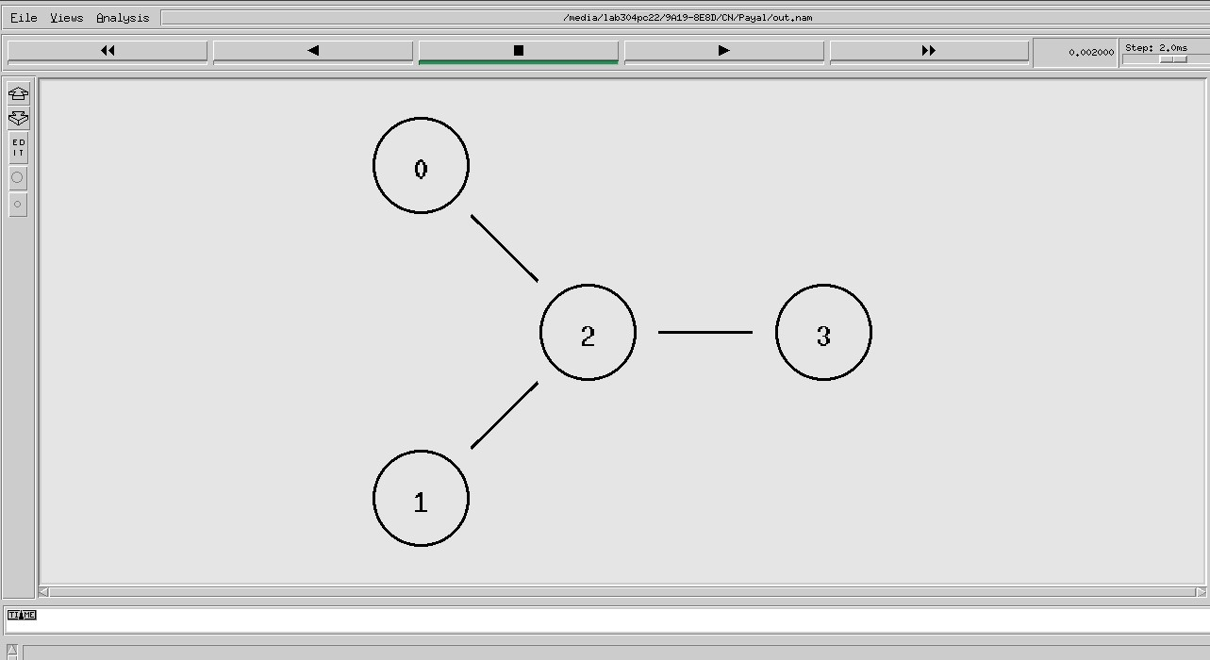

• **The events**

set nf [open out.nam w]

$ns namtrace-all $nf

proc finish {} {

global ns nf $ns flush-trace close $nf exec nam out.nam & exit 0

}

set n0 [$ns node] set n1 [$ns node] set n2 [$ns node] set n3 [$ns node]

$ns duplex-link $n0 $n2 1Mb 10ms DropTail

$ns duplex-link $n1 $n2 1Mb 10ms DropTail

$ns duplex-link $n3 $n2 1Mb 10ms DropTail

$ns duplex-link-op $n0 $n2 orient right-down

$ns duplex-link-op $n1 $n2 orient right-up

$ns duplex-link-op $n2 $n3 orient right

#Create a UDP agent and attach it to node n0 set udp0 [new Agent/UDP] $ns attach-agent $n0 $udp0

#Create a CBR traffic source and attach it to udp0 set cbr0 [new Application/Traffic/CBR]

$cbr0 set packetSize_ 500 $cbr0 set interval_ 0.005

$cbr0 attach-agent $udp0

#Create a UDP agent and attach it to node n1 set udp1 [new Agent/UDP] $ns attach-agent $n1 $udp1

#Create a CBR traffic source and attach it to udp1 set cbr1 [new Application/Traffic/CBR]

$cbr1 set packetSize_ 500 $cbr1 set interval_ 0.005 $cbr1 attach-agent $udp1 set null0 [new Agent/Null] $ns attach-agent $n3 $null0 $ns connect $udp0 $null0

$ns connect $udp1 $null0

$ns at 0.5 "$cbr0 start"

$ns at 1.0 "$cbr1 start"

$ns at 4.0 "$cbr1 stop"

$ns at 4.5 "$cbr0 stop"

$ns at 5.0 "finish" $ns run set ns [new Simulator]

• **Marking flows**

$ns color 1 Blue

$ns color 2 Red

set nf [open out.nam w]

$ns namtrace-all $nf

proc finish {} {

global ns nf $ns flush-trace close $nf exec nam out.nam & exit 0

}

set n0 [$ns node] set n1 [$ns node] set n2 [$ns node] set n3 [$ns node]

$ns duplex-link $n0 $n2 1Mb 10ms DropTail

$ns duplex-link $n1 $n2 1Mb 10ms DropTail

$ns duplex-link $n3 $n2 1Mb 10ms DropTail

$ns duplex-link-op $n0 $n2 orient right-down

$ns duplex-link-op $n1 $n2 orient right-up

$ns duplex-link-op $n2 $n3 orient right

#Create a UDP agent and attach it to node n0 set udp0 [new Agent/UDP] $ns attach-agent $n0 $udp0

$udp0 set class_ 1

#Create a CBR traffic source and attach it to udp0 set cbr0 [new Application/Traffic/CBR]

$cbr0 set packetSize_ 500

$cbr0 set interval_ 0.005

$cbr0 attach-agent $udp0

#Create a UDP agent and attach it to node n1 set udp1 [new Agent/UDP] $ns attach-agent $n1 $udp1

$udp1 set class_ 2

#Create a CBR traffic source and attach it to udp1 set cbr1 [new Application/Traffic/CBR]

$cbr1 set packetSize_ 500

$cbr1 set interval_ 0.005

$cbr1 attach-agent $udp1

set null0 [new Agent/Null] $ns attach-agent $n3 $null0

$ns connect $udp0 $null0

$ns connect $udp1 $null0

$ns at 0.5 "$cbr0 start"

$ns at 1.0 "$cbr1 start"

$ns at 4.0 "$cbr1 stop"

$ns at 4.5 "$cbr0 stop"

$ns at 5.0 "finish"

$ns

run

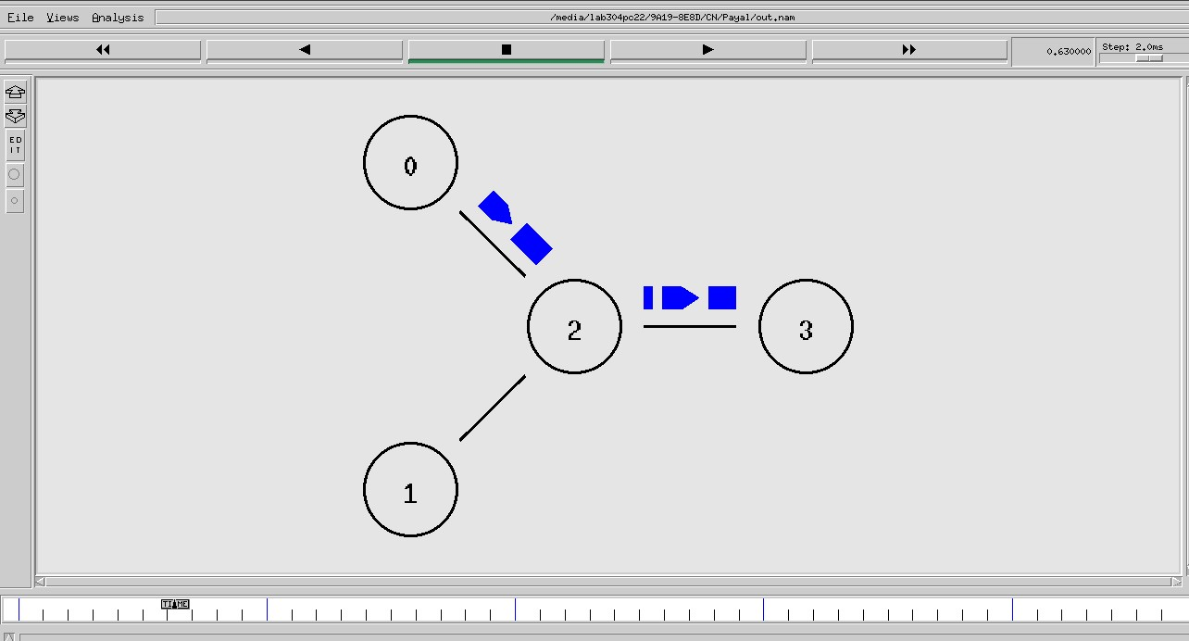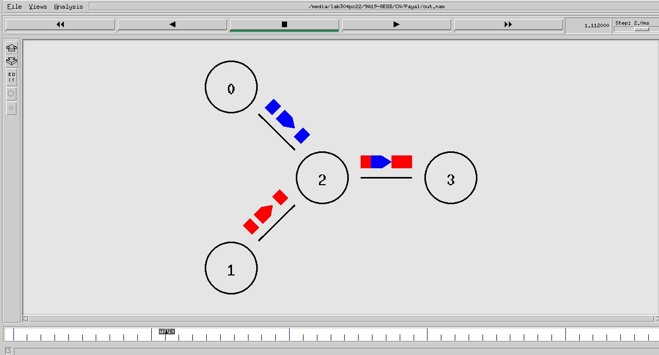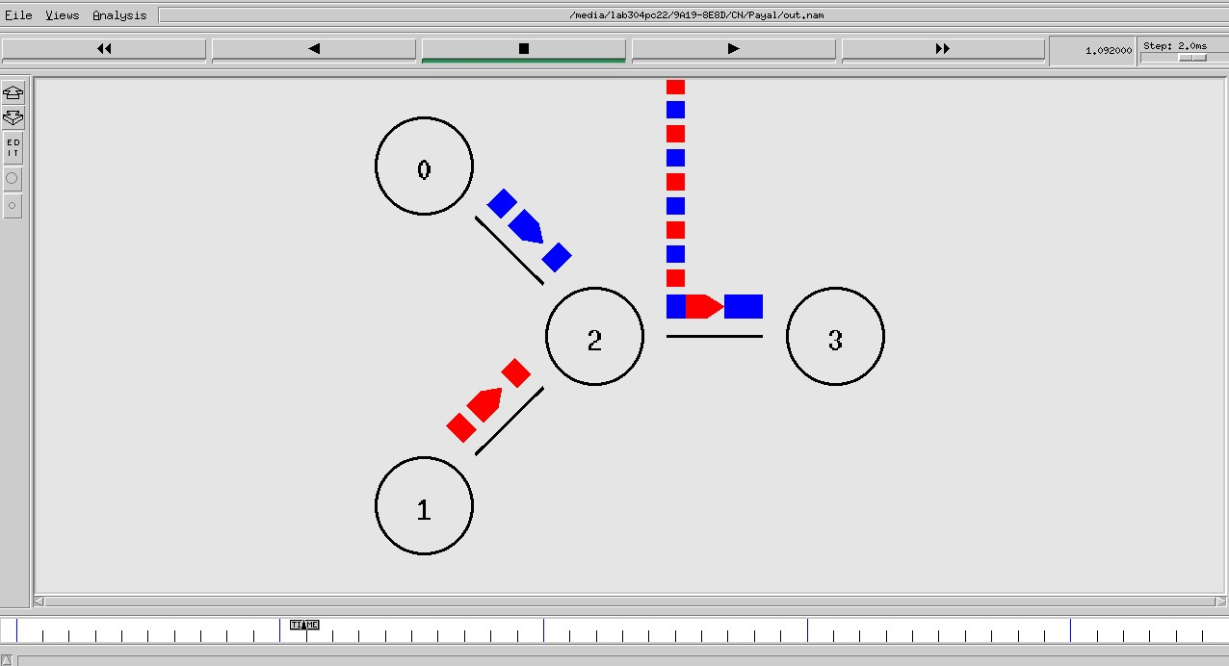

# LINK FAILURE

set ns [new Simulator] $ns rtproto DV set nf [open out.nam w] $ns namtrace-all $nf proc finish {} {

global ns nf $ns flush-trace close $nf exec nam out.nam & exit 0

} for {set i 0} {$i < 7} {incr i} { set n($i) [$ns node]

} for {set i 0} {$i < 7} {incr i} {

$ns duplex-link $n($i) $n([expr ($i+1)%7]) 1Mb 10ms DropTail

}

#Create a UDP agent and attach it to node n0 set udp0 [new Agent/UDP] $ns attach-agent $n(0) $udp0

#Create a CBR traffic source and attach it to udp0 set cbr0 [new Application/Traffic/CBR]

$cbr0 set packetSize_ 500 $cbr0 set interval_ 0.005 $cbr0 attach-agent $udp0 set null0 [new Agent/Null] $ns attach-agent $n(3) $null0

$ns connect $udp0 $null0

$ns at 0.5 "$cbr0 start"

$ns at 4.5 "$cbr0 stop"

$ns rtmodel-at 1.0 down $n(1) $n(2)

$ns rtmodel-at 2.0 up $n(1) $n(2)

$ns at 5.0 "finish"

$ns run

