**How to Use this Template**

1. Create a new document, and copy and paste the text from this template into your new document [ Select All → Copy → Paste into new document ]
2. Name your document file: “**Capstone_Stage1**”
3. Replace the text in green

Description

Intended User

Features

User Interface Mocks

Screen 1

Screen 2

Key Considerations

How will your app handle data persistence?

Describe any corner cases in the UX.

Describe any libraries you’ll be using and share your reasoning for including them.

Describe how you will implement Google Play Services.

Next Steps: Required Tasks

Task 1: Project Setup

Task 2: Implement UI for Each Activity and Fragment

Task 3: Your Next Task

Task 4: Your Next Task

Task 5: Your Next Task

**GitHub Username**: heymonheymon3000

NBA Schedule

# Description

The NBA Schedule App will give users immediate access to the NBA schedule and custom it for their favorite teams.

# Intended User

This application is intended to be used by NBA fans who want to know what teams are playing and when.

# Features

List the main features of your app.

* Displays the NBA schedule based on date along with the score.
* Displays detail box score when you click on the game.
* Allow users to add their favorite team to customize My Games tab

# User Interface Mocks

## Screen 1

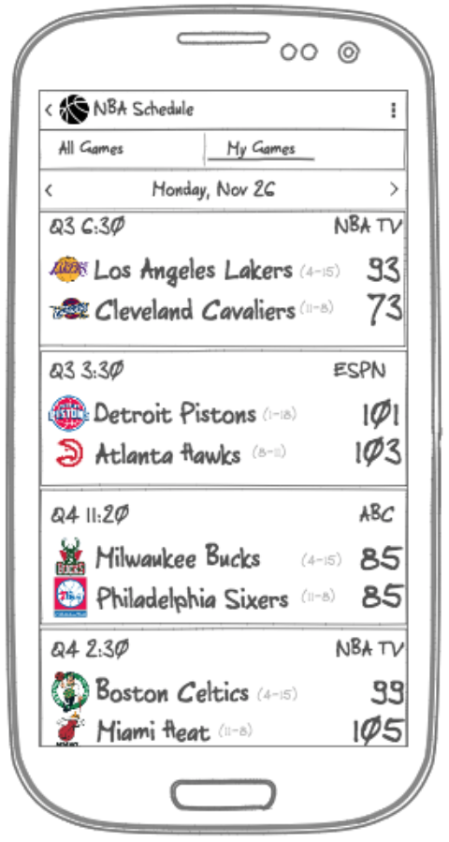

At the top of this screen the user can toggle between All Games and My Games. The All Games tab will display all games and the My Games will only display games that the user has chosen as their favorite team. Below the tab is a way to pick the date. When the app first loads, today date will be selected, and the user can click on the left arrow to go back a day or click to the right to go to tomorrow’s date. Finally, below the date selector there is a list of games, which displays the teams score, record, time remaining, and channel in which the game will be televised.

## Screen 2

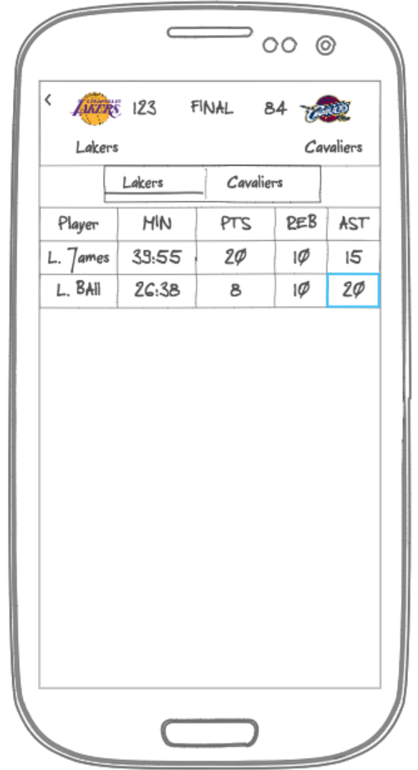

At the top is a summary of the teams score and below that is a tab to toggle between each team to get the box score.

# Key Considerations

### How will your app handle data persistence?

I will use Content Provider to store games.

### Describe any edge or corner cases in the UX.

None

### Describe any libraries you’ll be using and share your reasoning for including them.

Glide to handle the loading and caching of images.

### Describe how you will implement Google Play Services or other external services.

None

# Next Steps: Required Tasks

This is the section where you can take the main features of your app (declared above) and break them down into tangible technical tasks that you can complete one at a time until you have a finished app.

## Task 1: Project Setup

Working with the <https://developer.sportradar.com/> API

* To fetch NBA daily games, make a request to the nba/trial/v5/{language_code}/games/{year}/{month}/{day}/schedule{format} endpoint. This happen when the app first loads up.
* To fetch NBA game box score, make a request to the nba/trial/v5/{language_code}/games/{game_id}/boxscore{format} endpoint. This is called when the user clicks on the game to get more detail.

## 

## Task 2: Implement UI for Each Activity and Fragment

List the subtasks.

* Create layout for MainActivity
* Create fragment to represent the list of games

## Task 3: Your Next Task

List the subtasks.

* Create layout for DetailActivity
* Create Fragment for DetailFragment

## Task 4: Your Next Task

List the subtasks.

* Create layout for settings for add/remove favorite team