Assignments of Lab2

## Question1: Class diagram of Project Management System

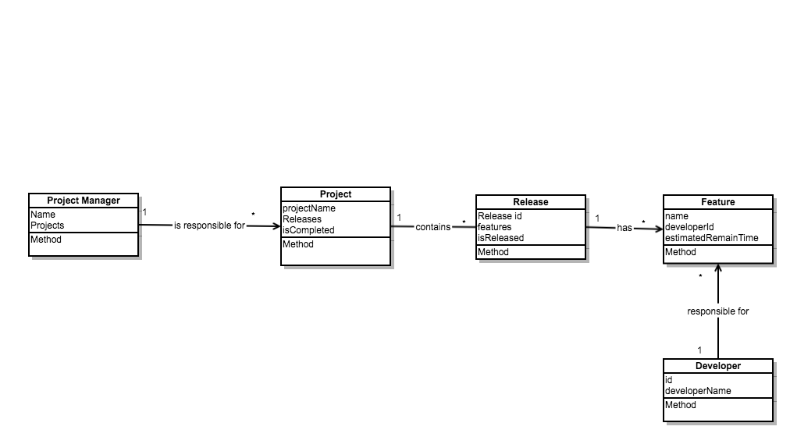

## Question3: Reflective Association Class diagram

