## PartA: Re-do the sequence diagram on Slide 16 of Lesson 4

## 

## PartB: sequence diagram of CheckoutBook

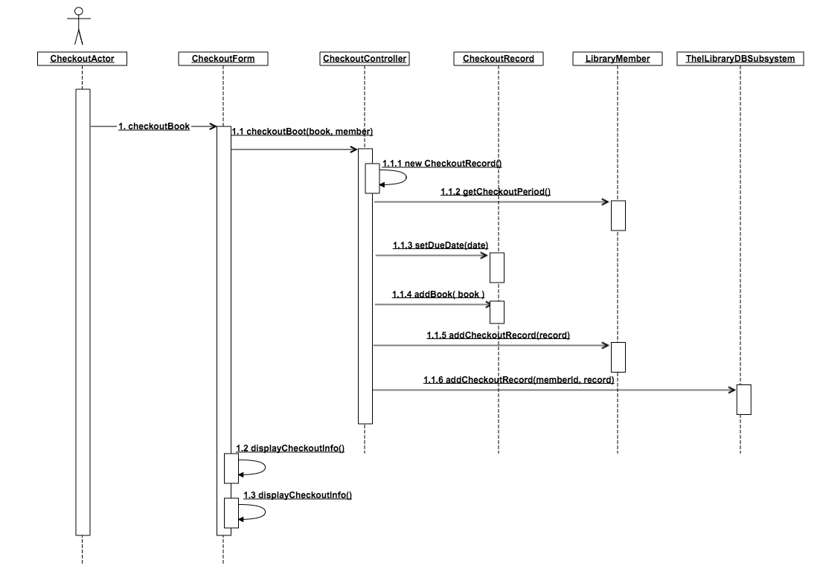

## PartD: Payroll Calculation Sequence diagram

